TRANSFIGURATION
SUNDAY
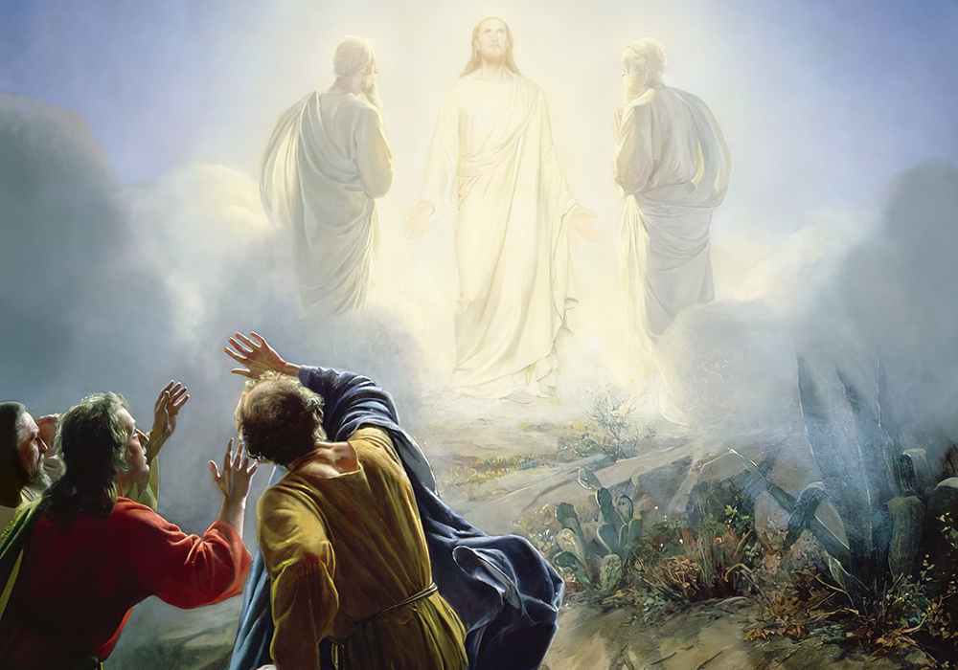

Mt. Zion Evangelical Lutheran Church

320 Mt. Zion Dr., Ripon, WI
www.mtzionripon.org
Facebook: Mt. Zion Evangelical Lutheran Church

Pastor Kurt Hagen (Vacancy Pastor)
Phone 651-764-3901
pastorhagen@gmail.com

Transfiguration Feb. 14, 2026
Handicapped accessible restrooms are located upstairs next to the Pastor’s Study and downstairs next to the elevator.
Attendance: Please remember to sign the friendship pads. Registration for communion will continue as usual at the table. If you have any questions or concerns, please contact Mike Meeker.


Hearing Loop: Our sanctuary is equipped with a hearing loop system. Those who have compatible hearing aids (with a T-switch) will be able to hear the sound system directly into their ear(s). The two main seating areas and the choir area are looped so that you may sit in any of the three areas. We also have four receivers available for those who do not have compatible hearing aids. If you wish to use a receiver please ask the ushers. Those who wish may bring their own headphones or ear buds.

A note for our visitors on member communion –
Out of sincere love for the truth of God’s Word and for precious human souls, we practice member communion in our synod and congregation. This teaching, as practiced by the Church for centuries, is thoroughly Scriptural. It questions the faith of no individual yet asks that there be full doctrinal agreement between those who commune. For this reason, we ask that only those who are members of a WELS or ELS congregation join us for the Lord’s Supper. If you wish to commune with us please speak with the pastor before the service. The Lord’s Supper will be celebrated for those who desire it.
The front row on the pulpit side is reserved for people who are unable to navigate the steps. Pastor will serve you Communion first.

Prayer Before Communion: Dearest Jesus, I thank you for the gift of your Holy Supper. As I come to your table, work true repentance in my heart. Teach me to confess my sins and to believe that I am forgiven for your sake. May your body and blood, which are in and with the bread and wine, nourish my faith and strengthen my will to live to the glory of your name. Amen.

Hymns: 380, 388, (660, 389), 884, Farewell to Alleluia (Insert)

Pastor Hanneman will conduct this evening’s service.

Order of Worship Setting One pg. 154

First Reading: Exodus 24:9-18 (EHV)
Then Moses, Aaron, Nadab, Abihu, and seventy of the elders of Israel went up. ¹⁰They saw the God of Israel. Under his feet they saw what looked like a pavement of sapphire as clear as the sky. ¹¹The Lord did not lay his hand on the dignitaries of the people of Israel. They gazed at God, and they ate and drank.
¹²The Lord said to Moses, “Come up to me on the mountain. Wait there, and I will give you the stone tablets with the law and the commands that I have written, so that you can teach them.”
¹³Moses set out with his assistant Joshua and went up onto the mountain of God. ¹⁴He said to the elders, “Wait here for us, until we come back to you. Look, here are Aaron and Hur. They will be with you. Whoever is involved in a dispute can go to them.”
¹⁵Moses went up onto the mountain, and the cloud covered the mountain. ¹⁶The Glory of the Lord settled on Mount Sinai, and the cloud covered the mountain for six days. On the seventh day the Lord called to Moses out of the middle of the cloud. ¹⁷The appearance of the Glory of the Lord looked like a devouring fire on the top of the mountain in the sight of the people of Israel. ¹⁸Moses entered into the middle of the cloud and climbed up the mountain. Moses was on the mountain forty days and forty nights.

Psalm: 2A You Are My Son

Second Reading: 2 Peter 1:16-21 (EHV)
To be sure, we were not following cunningly devised fables when we made known to you the powerful appearance of our Lord Jesus Christ, but we were eyewitnesses of his majesty. ¹⁷For he received honor and glory from God the Father, when the voice came to him from within the Majestic Glory, saying, “This is my Son, whom I love; with him I am well pleased.” ¹⁸We heard this voice, which came out of heaven when we were with him on the holy mountain.
¹⁹We also have the completely reliable prophetic word. You do well to pay attention to it, as to a lamp shining in a dark place, until the day dawns and the Morning Star rises in your hearts, ²⁰since we know this above all else: No prophecy of Scripture comes about from someone’s own interpretation. ²¹In fact, no prophecy ever came by the will of man, but men spoke from God as they were being carried along by the Holy Spirit.

Gospel Acclamation
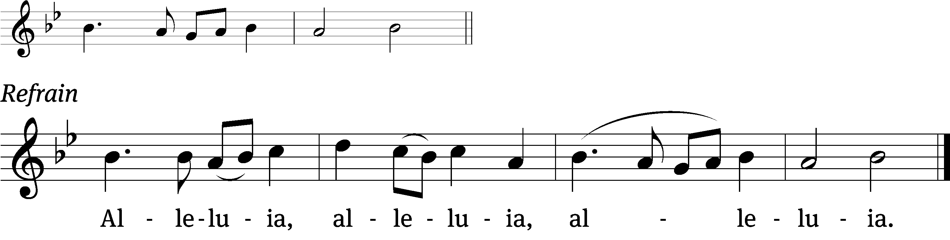
You are my Son, /whom I love:
With you I am / well pleased. (Refrain)

Gospel Reading & Sermon Text: Matthew 17:1-9 (EHV)
Six days later Jesus took with him Peter, James, and John the brother of James; and he led them up onto a high mountain by themselves. ²There he was transfigured in front of them. His face was shining like the sun. His clothing became as white as the light. ³Just then, Moses and Elijah appeared to them, talking with Jesus.
⁴Peter said to Jesus, “Lord, it is good for us to be here. If you want, I will make three shelters here: one for you, one for Moses, and one for Elijah.”
⁵While he was still speaking, suddenly a bright cloud overshadowed them. Just then, a voice came out of the cloud, saying, “This is my Son, whom I love; with him I am well pleased. Listen to him.”
⁶When the disciples heard this, they fell face down and were terrified. ⁷Jesus approached and as he touched them, he said, “Get up, and do not be afraid.” ⁸When they opened their eyes, they saw no one except Jesus alone. ⁹As they were coming down the mountain, Jesus commanded them, “Do not tell anyone what you have seen until the Son of Man has been raised from the dead.”

Choir Song: I Prepare a Place for You
The words of Jesus sing to the heart with the assurance of a heavenly home.

Sermon Theme: “Stay Close to Jesus”
- Things May Still be Frightening
- Jesus Calms Every Fear

OFFERING: The offerings are brought forward to the altar.

Keep in Your Prayers: Harley Dorsey, Karen Reiser, Ginny Verch, Gary Wichman and Dick Zellmer.

Announcements
Thank You from Pastor & Sue: Dear members of Mt. Zion- thank you for your generous gift cards to Kwik Trip and Culvers. They will certainly come in handy in our first weeks in La Crosse. May God bless and keep you all until we meet again! Our new address is: 803 Saint Paul St., La Crosse, WI 54603.
Thank You to Ken Hielke for building the beautiful tables located in the back of the sanctuary.

Easter Lilies: A sign-up sheet has been posted on the flower chart for those who would like to purchase Easter lilies for the services. If you have any questions or if you are purchasing as a memorial let her know. Marilyn’s number is 748-6474.

Communion setup and cleanup: Since communion is every week we are in need of more help. None of it is hard to do and does not take long. If you are interested please sign up on the sheet by the library. If you have questions please talk to Jo Meeker.

ATTENTION ALL MEMBERS OF MT. ZION: Our vacancy pastor will be Pastor Kurt Hagen of Zion in Kingston. Due to a shortage of pastors in our area our services will be held on Saturdays at 5PM. If you have any questions see Mike Meeker or any member of the Council. The Lenten services will be on Wednesday like normal.

Parents of Mt. Zion Sunday School Children: With the change in time and date of church services, the teachers will be putting together packets for the children to take home and study their lessons. No formal Sunday School will be held until further notice.

Special Announcement: Due to problems in Shepherd’s Staff some of the offering envelopes you picked up are numbered incorrectly. Jo Meeker has a list of what the numbers should be. Please contact her at the church office or in church to get your correct number. Sorry for the inconvenience.

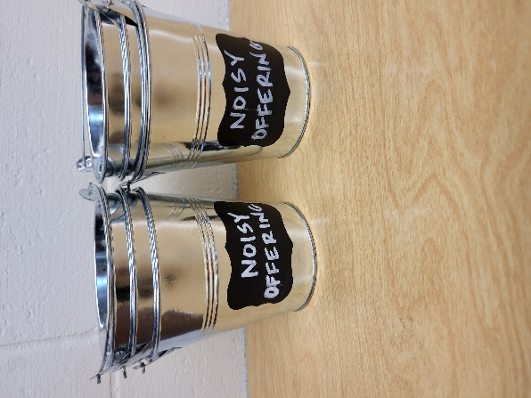
Noisy Offering: Please keep saving your spare change for our noisy offering on Mar. 7th. Your offering will be given to Ripon’s Community Food Pantry. The Community Food Pantry provides fresh produce, meats, dairy products, breakfast options, whole grains & many shelf stable choices for up to 200 families every month. We make accommodations for our neighbors with special dietary needs, based on our inventory and availability. No one is ever turned away. We have appreciated your support for our various projects and activities.


During the month of February will be having a “Souper Bowl” donation. We will be collecting a variety of soups for the Community Food Pantry in Ripon. Hy-Vee has generously offered to match all Hy-Vee soups that are donated up to $500. There is a box in the entryway for your donations. Thank you for your support. The Evangelism Committee
Mailbox and table: The February Forward In Christ is available and also the March 1, 2026-May 30, 2026 Meditations are available.

Birthday Celebration: Birthday celebration for February TBD.

If you would like the Lord’s Supper privately, please contact Pastor Kurt Hagen at 651-764-3901, or by email pastorkhagen@gmail.com.

The Helping Hands Ministry is ready to serve the needs of our members. Please contact one of the following if you or someone you know needs assistance: Joanne Gregor at 920-896-1518 and Lisa Tremore at 920-229-1297.
For Your Information
Attendance 2/7/2026 79
Offerings for 2/7/2026 $4,739.00

Serving Our Lord

Thank you to everyone for your service to our Lord!

Ushers:

Feb. 14 & 18: Mark Roeder, Ferd Roeder, Jason Roeder

Feb. 22 & 25: Gary Quade, Travis Schmudlach, Kyle Stollfuss

PowerPoint:

February 14: Grunert Family

February 18: The Grunerts (Ash Wednesday)

February 21: Jo Meeker

February 25: Jo Meeker

February 28: Jan Ohlrich

Feb. Communion Set up: Joanne Gregor

Feb. Communion Clean up: Donna Mueller

Saturday (14th) 5:00 PM Worship with Communion
Sunday 2:00 PM Call meeting (Sanctuary)
Wednesday 4:30 – 6:00 PM Lenten Supper
6:30 PM Ash Wednesday Service with Communion
Thursday 9:00 AM Women’s Bible Study
Saturday (2/21) 5:00 PM Worship Service with Communion

