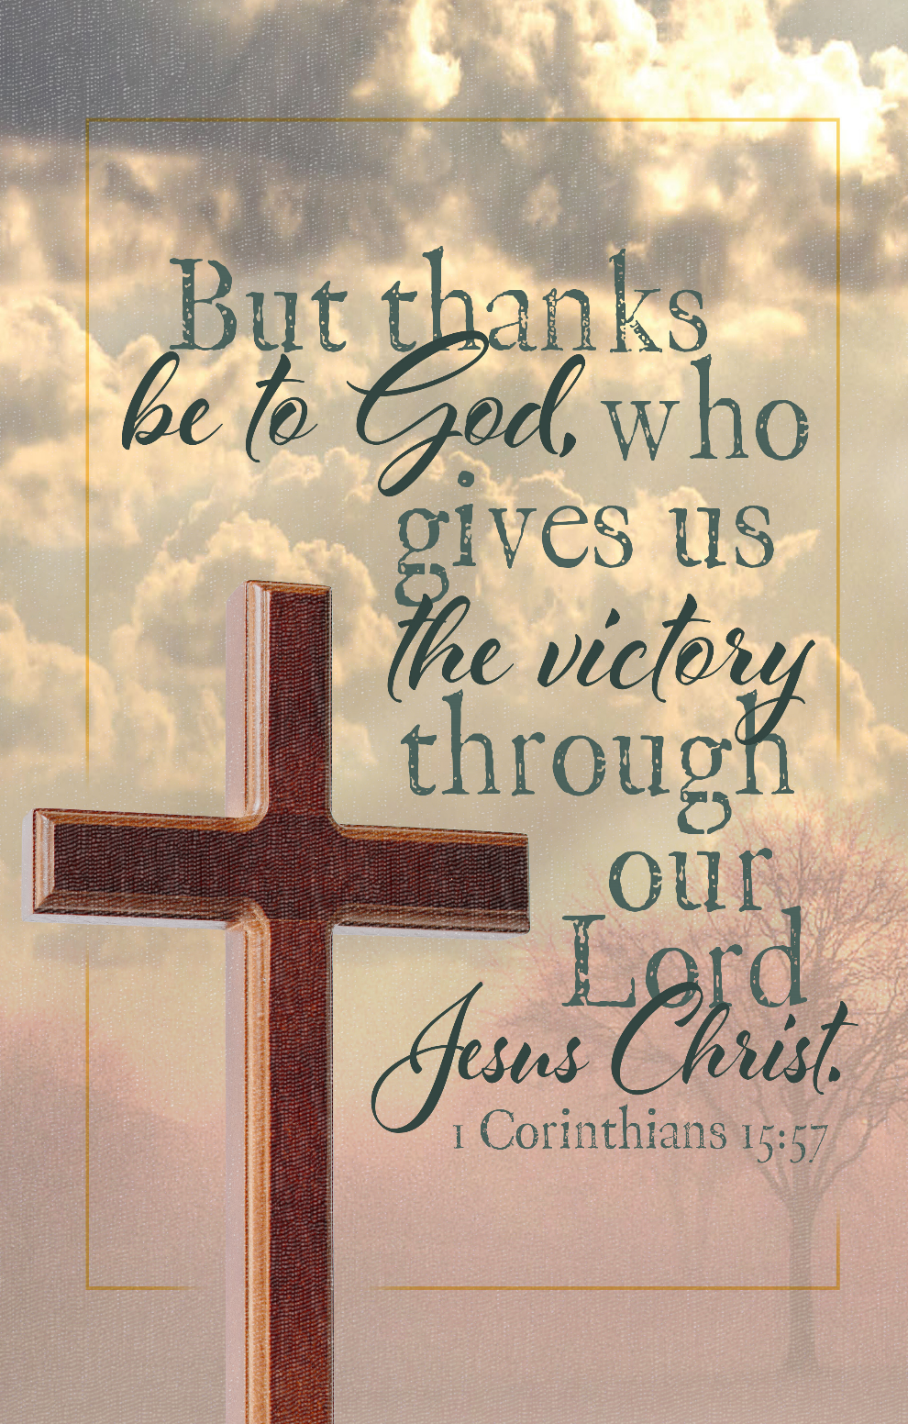


320 Mt. Zion Dr., Ripon, WI

Thanksgiving November 26, 2025

A note for our visitors on member communion –
Out of sincere love for the truth of God’s Word and for precious human souls, we practice member communion in our synod and congregation. This teaching, as practiced by the Church for centuries, is thoroughly Scriptural. It questions the faith of no individual yet asks that there be full doctrinal agreement between those who commune. For this reason, we ask that only those who are members of a WELS or ELS congregation join us for the Lord’s Supper. If you wish to commune with us please speak with the pastor before the service.
The front row on the pulpit side is reserved for people who are unable to navigate the steps. Pastor will serve you Communion first.

Order of Service: The Service Setting 1 pg. 154
Hymns: 606, 597, (660), 783 vs. 1,2,5,6
Prayer of the Day: Almighty God, your mercies are new every morning, and you graciously provide for all our needs of body and soul. Grant us your Holy Spirit that we may acknowledge your goodness, give thanks for your benefits, and serve you in willing obedience all our days; through your Son, Jesus Christ our Lord.
Amen.

First Reading: Genesis 8: 18-22 (EHV)
Noah went out with his sons, his wife, and his sons’ wives along with him. ¹⁹Every animal, every creeping thing, every bird, and whatever swarms on the earth went out of the ship, species by species.
²⁰Noah built an altar to the Lord and took from every clean animal and every clean bird and offered burnt offerings on the altar. ²¹The Lord smelled the pleasant aroma. The Lord said in his heart, “I will never again curse the soil anymore because of man, for the thoughts he forms in his heart are evil from his youth. Neither will I ever again strike every living thing, as I have done. ²²While the earth remains, seedtime and harvest, cold and heat, summer and winter, and day and night shall not cease.”

Psalm 100B Insert All People That on Earth Do Dwell

Second Reading: James 1:16-18 (EHV)
Do not be deceived, my dear brothers. ¹⁷Every good act of giving and every perfect gift is from above, coming down from the Father of the lights, who does not change or shift like a shadow. ¹⁸Just as he planned, he gave us birth by the word of truth so that we would be a kind of firstfruits of his creations.

Gospel Acclamation
Alleluia, Alleluia, Alleluia Psalm 136:1
Give thanks to the Lord, for / he is good.
His love endures for/ever.
Alleluia, Alleluia, Alleluia

Gospel & Sermon Text: Luke 19:1-10 (EHV)
Jesus entered Jericho and was passing through. ²A man named Zacchaeus was there. He was a chief tax collector, and he was rich. ³He was trying to see who Jesus was, but since he was short, he could not see because of the crowd. ⁴He ran on ahead and climbed up into a sycamore tree to see Jesus, because he was about to pass by that way. ⁵When Jesus came to the place, he looked up and said to him, “Zacchaeus, hurry and come down, for I must stay at your house today.” ⁶He came down quickly and welcomed Jesus joyfully. ⁷When the people saw it, they were all grumbling because he went to be a guest of a sinful man.
⁸Zacchaeus stood up and said to the Lord, “Look, Lord, I am going to give half of my possessions to the poor. And if I have cheated anyone out of anything, I will pay back four times as much.”
⁹Jesus said to him, “Today, salvation has come to this house, because he too is a son of Abraham. ¹⁰For the Son of Man came to seek and to save the lost.”
Sermon: “The Son of Man Came to Seek and Save the Lost.”

OFFERING: The offerings are brought forward to the altar.

