SEVENTEENTH SUNDAY OF PENTECOST
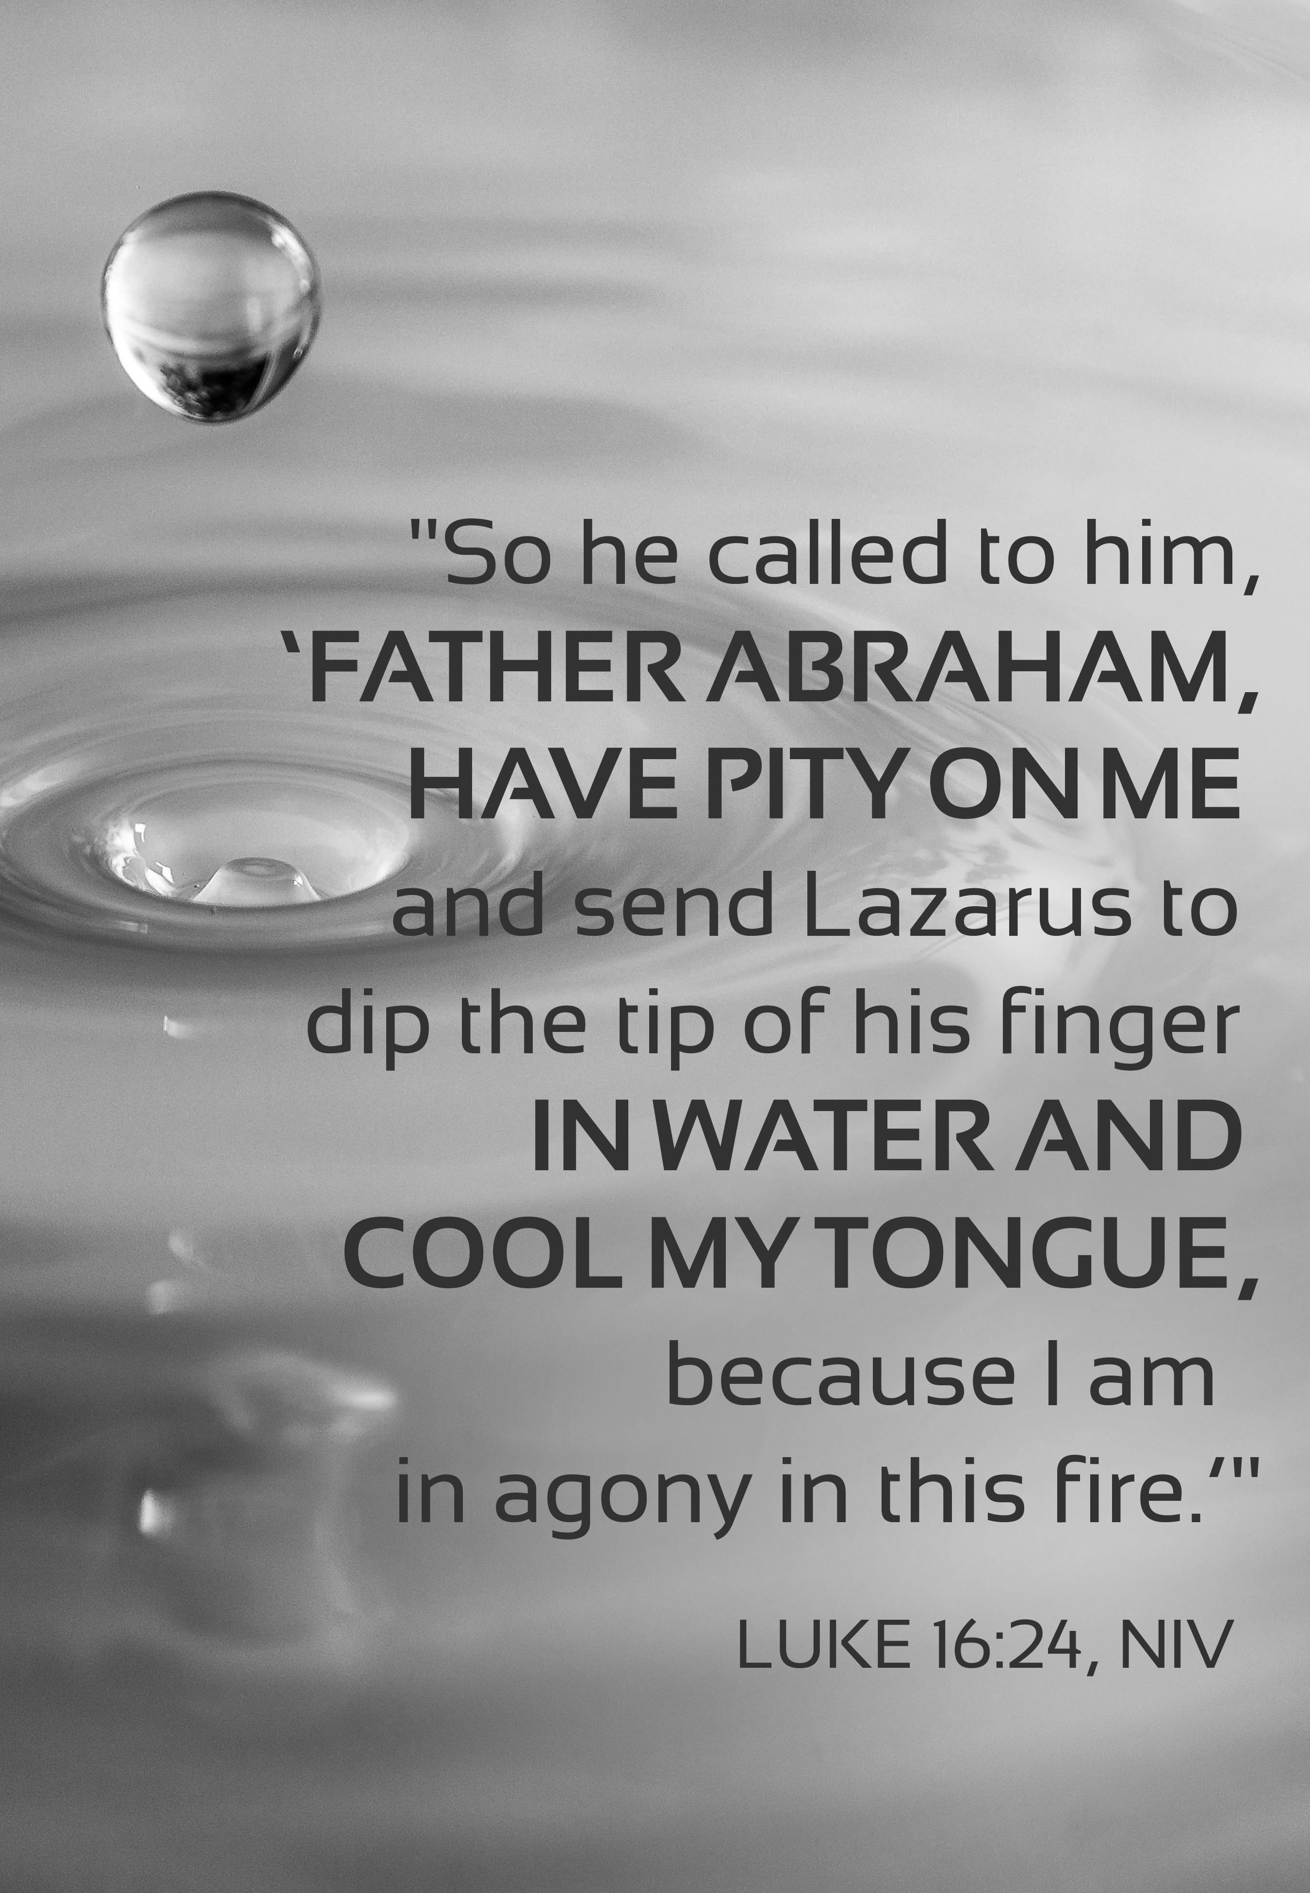
Mt. Zion Evangelical Lutheran Church

320 Mt. Zion Dr., Ripon, WI
www.mtzionripon.org
Facebook: Mt. Zion Evangelical Lutheran Church

Pastor Michael Sheppard
Pastor’s Study: 920-748-9734
E-mail: revmikesheppard@gmail.com
17th Sunday of Pentecost Sept. 28, 2025
Handicapped accessible restrooms are located upstairs next to the Pastor’s Study and downstairs next to the elevator.
Attendance: Please remember to sign the friendship pads. Registration for communion will continue as usual at the table. If you have any questions or concerns, please contact Pastor Sheppard or Mike Meeker.


Hearing Loop: Our sanctuary is equipped with a hearing loop system. Those who have compatible hearing aids (with a T-switch) will be able to hear the sound system directly into their ear(s). The two main seating areas and the choir area are looped so that you may sit in any of the three areas. We also have four receivers available for those who do not have compatible hearing aids. If you wish to use a receiver please ask the ushers. Those who wish may bring their own headphones or ear buds.

Hymns: 632, 817, (670), 718

Order of Worship Setting Three pg. 188

First Reading Amos 6:1-7 (EHV)
Woe to you who are complacent in Zion,
you who feel secure on Mount Samaria,
you distinguished people of the leading nation,
to whom the house of Israel comes.
²Travel to Kalneh and look.
Go from there to Hamath Rabbah,
and go down to Gath of the Philistines.
Are you better than those kingdoms?
Are their territories greater than your territory?
³You who are trying to put off the evil day,
you bring near the session for violence!
⁴Those who lie on ivory beds,
sprawling upon their couches,
eating lambs from the flock
and calves straight from the stall,
⁵improvising tunes on the lyre,
composing music for themselves on musical instruments like David,
⁶drinking large bowls of wine—
they slather themselves with the most expensive perfumed oils,
but they do not grieve over the ruin of Joseph.
⁷That is why they will go into exile as the first of the exiles.
Those who sprawl out at their feasts for the dead will depart.

Psalm: 146A I Will Praise the Lord All My Life

Second Reading: Hebrews 13: 1-6 (EHV)
Continue to show brotherly love. ²Do not fail to show love to strangers, for by doing this some have welcomed angels without realizing it. ³Remember those in prison, as if you were fellow prisoners, and those who are mistreated, as if you yourselves were also suffering bodily.
⁴Marriage is to be held in honor by all, and the marriage bed is to be kept undefiled, for God will judge sexually immoral people and adulterers. ⁵Keep your life free from the love of money, and be content with what you have. For God has said:

I will never leave you,
and I will never forsake you.

⁶So then we say with confidence:
The Lord is my helper, and I will not be afraid.
What will man do to me?
Gospel Acclamation
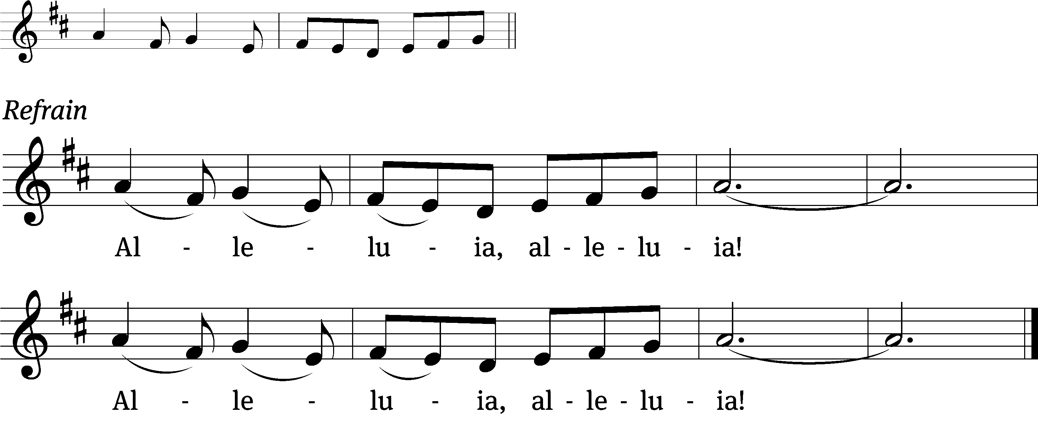
These words are written that you / may believe,
That Jesus is the Christ, the / Son of God. Refrain

Gospel & Sermon Text: Luke 16: 19-31 (EHV)
“There was a rich man who was dressed in purple and fine linen, living in luxury every day. ²⁰A beggar named Lazarus had been laid at his gate. Lazarus was covered with sores and ²¹longed to be fed with what fell from the rich man’s table. Besides this, the dogs also came and licked his sores. ²²Eventually the beggar died, and the angels carried him to Abraham’s side. The rich man also died and was buried. ²³In hell, where he was in torment, he lifted up his eyes and saw Abraham far away and Lazarus at his side. ²⁴He called out and said, ‘Father Abraham, have mercy on me! Send Lazarus to dip the tip of his finger in water and cool my tongue, because I am in misery in this flame.’
²⁵“But Abraham said, ‘Son, remember that in your lifetime you received your good things, and Lazarus received bad things. But now he is comforted here, and you are in misery. ²⁶Besides all this, a great chasm has been set in place between us and you, so that those who want to cross from here to you cannot, nor can anyone cross over from there to us.’
²⁷“He said, ‘Then I beg you, father, send him to my father’s home, ²⁸because I have five brothers—to warn them, so that they will not also come to this place of torment.’
²⁹“Abraham said, ‘They have Moses and the Prophets. Let them listen to them.’ ³⁰“‘No, father Abraham,’ he said, ‘but if someone from the dead goes to them, they will repent.’
³¹“Abraham replied to him, ‘If they do not listen to Moses and the Prophets, they will not be convinced even if someone rises from the dead.’”

Choir Song: A Joyful Song to the Lord

Sermon Theme: “God’s Word Tells Us All We Need to Know.”

OFFERING: The offerings are brought forward to the altar.

Keep in Your Prayers: Harley Dorsey, Carol Henning, Karen Reiser, Gary Wichman and Dick Zellmer.

Announcements
Message from Pastor Ziebell: I would first of all like to thank the congregation for the restaurant gift cards. I’m enjoying using them. I would further like to thank Joanne Gregor, Jan Ohlrich, Darlene Patchett and Rhonda Schwandt for their much needed help in downsizing my home and packing things for moving. I would also like to thank Pastor and Sue Sheppard for hauling things away for me in their truck. As you know I could not have done it without your help. In appreciation I’m giving a monetary gift to be used at their discretion.

Thank You: The family of June Lynch would like to thank everyone who contributed to June’s memorial. $3,200 will be given to several different church funds.


Cereal Donations: Mt. Zion has received a request from Shannon Wright from the Traded Treasures Community Food Pantry for donations. They are in desperate need of cereal. There is a box in the entryway for your cereal donations. This is a great opportunity for us to reach out to members of our community in need of our help. Thank you from the Evangelism committee for your support.

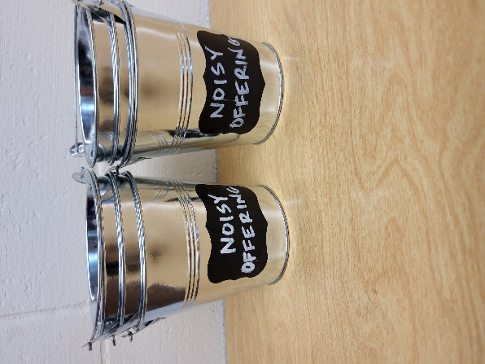
Noisy Offering: Please keep saving your spare change for our noisy offering on Oct 5th. Your offering will be given to WLA (Winnebago Lutheran Academy). We have appreciated your support for our various projects and activities. Thank you for your generosity.
Peace Children Sing October 5th: The children from Peace Lutheran School will be here on Sunday October 5th to beautify our service.

New Member Welcome and Pine Car Derby: On October 5th, Mt. Zion will have a potluck dinner after church for our newest members. We will welcome Jim and Deb Paulus, Judy Doll, Michelle Doll and David Thiele and Matt and Ethel Behm. Mark your calendars and join us after Bible Study and Sunday School. Also, that day we will be having a pine car derby for both youth and adults. A box of pine car wood blocks is outside the church office. If you have questions about the New Member Welcome or Pine car derby, please contact Dave Smith.

LWMS Rally: On October 18th St. Stephens of Beaver Dam will be hosting the Fall Rally. More information is upcoming.

Mission Festival: On October 19th Pastor Abram Degner will be here to preach on the WELS 175th Anniversary, Christ THROUGH Us. Following the service, he will make a presentation in the fellowship hall. We will then join in a potluck dinner. No Sunday School or Bible Study will be held that Sunday.

Friendly Reminder: Children’s offering envelopes and children’s bulletins are available on the back table. The prayer box is also there for any prayer requests.

Greeters: Thank you to all who have greeted so far. A new signup sheet for August through December is available. If you would like to be greeters for this year, please sign up on the sheet on the podium by the library.

You are invited to Auxiliary Day at Martin Luther College!

The Ladies' Auxiliary promotes interest in Martin Luther College, provides Christian fellowship opportunities for our members, and supports students through scholarships, special non-budgeted projects, events, and your prayers.

Our Annual Auxiliary Day is Saturday, October 4, on the beautiful MLC campus in New Ulm, Minnesota. Enjoy fellowship, hear student presentations—including a sneak peek at the fall presentation of Little Women: The Broadway Musical—and help us choose the 2025-26 classroom projects we will fund. Join us and get in on the fun!

If you can't make it in person, check our website after the meeting to see what projects were selected. Visit mlc-wels.edu/ladies-auxiliary.

Hymn Sing: The next hymn sing will be October 12th. If you have any requests for future hymn sings please talk to Sue Sheppard or Jo Meeker.

Birthday Celebration: The October birthday celebration TBD.

Mailbox and table: The September Forward In Christ is available and also the August 31, 2025-November 29, 2025 Meditations are available.

If you would like the Lord’s Supper privately, please contact Pastor Sheppard on his cell 920-745-0883, or by email revmikesheppard@gmail.com.
The Helping Hands Ministry is ready to serve the needs of our members. Please contact one of the following if you or someone you know needs assistance: Joanne Gregor at 920-896-1518, Lisa Tremore at 920-229-1297 or Tammy Niemuth at 920-299-0240.
For Your Information
Attendance 9/21 90
Offerings for 9/21 $6,624.00

Serving Our Lord

Thank you to everyone for your service to our Lord!

Ushers:

Sept. 28: Mark Roeder, Ferd Roeder, Jason Roeder

Oct. 5 & 12: Gary Quade, Travis Schmudlach, Kyle Stollfuss

PowerPoint:

Sept. 28: Jo Meeker

October 5: Grunert Family

October 12: Jean Lynch

Oct.19: Jan Ohlrich

Sept. Communion Set up: Jo Meeker

Sept. Communion Clean up: Marilyn Ninneman

Sunday (28th) 9:00 AM Worship Service with Communion
10:15 AM Sunday School; Bible Study will be held in the fellowship hall viewing Season 5 of The Chosen
5:00 PM Confirmation Class
Tuesday 9:00 AM Bible Study (book of John)
Wednesday 6:15 PM Choir Practice
Thursday 9:00 AM Women’s Bible Study (Fellowship Hall)
Sunday 9:00 AM Worship Service with noisy offering and children’s sermon, Peace School Children
10:15 AM Sunday School & Bible Study
11:15 AM New member potluck and Pine car Derby
5:00 PM Confirmation Class

