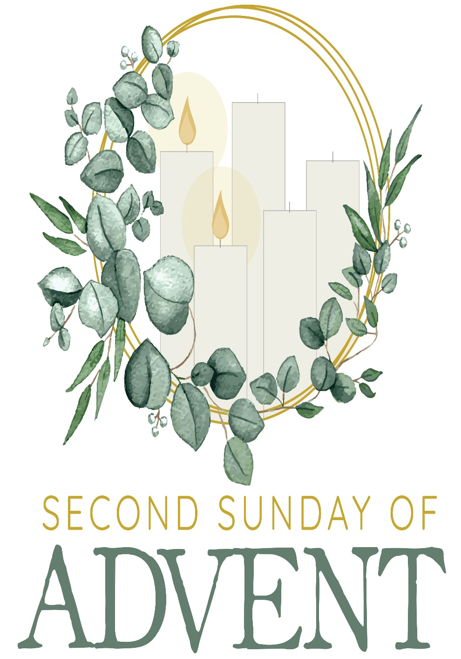

Mt. Zion Evangelical Lutheran Church
320 Mt. Zion Dr., Ripon, WI
www.mtzionripon.org
Facebook: Mt. Zion Evangelical Lutheran Church

Pastor Michael Sheppard
Pastor’s Study: 920-748-9734
E-mail: revmikesheppard@gmail.com
Second Sunday of Advent December 4, 2022

Welcome to Mt. Zion!
Handicapped accessible restrooms are located upstairs next to the Pastor’s Study and downstairs next to the elevator.
Attendance: Please remember to sign the friendship pads. Registration for communion will continue as usual at the table. If you have any questions or concerns please contact Pastor Sheppard or Mark Roeder.

Hearing Loop: Our sanctuary is equipped with a hearing loop system. Those who have compatible hearing aids (with a T-switch) will be able to hear the sound system directly into their ear(s). The two main seating areas and the choir area are looped so that you may sit in any of the three areas. We also have four receivers available for those who do not have compatible hearing aids. If you wish to use a receiver please ask the ushers. Those who wish may bring their own headphones or ear buds.

Prayer Before Worship: O Lord our Maker, Redeemer, and comforter, we assembled in your presence to hear your holy Word. We pray that you would open our hearts by your Holy Spirit, that through the preaching of your Word we may repent of our sins, believe in Jesus, and grow day by day in grace and holiness. Hear us for Jesus’ sake. Amen
Hymns: 308, 316, 488

Order of Worship: Morning Prayer pg. 207

Let All the Earth Cry Out to the Lord Psalm 66

First Reading: Isaiah 11:1-10 (EHV)
A shoot will spring up from the stump of Jesse,
and a Branch from his roots will bear fruit.
²The Spirit of the Lord will rest on him:
the Spirit of wisdom and understanding,
the Spirit of counsel and might,
the Spirit of knowledge and the fear of the Lord.
³He will be delighted with the fear of the Lord.
He will not judge by what he sees with his eyes,
nor will he render decisions based on what he hears with his ears,
⁴but with righteousness he will judge the poor,
and he will render fair decisions in favor of the oppressed on the earth.
He will strike the earth with the rod of his mouth,
and with the breath from his lips he will put the wicked to death.
⁵Righteousness will be the belt around his waist,
and faithfulness the belt around his hips.
⁶The wolf will dwell with the lamb,
and the leopard will lie down with the young goat,
the calf, the young lion, and the fattened calf together,
and a little child will lead them.
⁷The cow and the bear will graze together,
and their young ones will lie down together.
The lion will eat straw like the cattle.
⁸The nursing child will play near a cobra’s hole,
and the weaned child will put his hand into a viper’s den.
⁹They will not hurt or destroy anywhere on my holy mountain,
for the earth will be full of the knowledge of the Lord,
as the waters cover the sea.
¹⁰This is what will take place on that day. The peoples will seek the Root of Jesse, who will be standing like a banner for the peoples, and his resting place will be glorious.

Gospel: Matthew 3: 1-12 (EHV)
In those days, John the Baptist appeared, preaching in the wilderness of Judea and saying, ²“Repent, because the kingdom of heaven is near!” ³Yes, this is he of whom this was spoken through the prophet Isaiah:
A voice of one crying out in the wilderness,
“Prepare the way of the Lord. Make his paths straight.”
⁴John wore clothing made of camel’s hair, with a leather belt around his waist. His food was locusts and wild honey. ⁵Then Jerusalem, all of Judea, and all the region around the Jordan were going out to him. ⁶They were baptized by him in the Jordan River as they confessed their sins. ⁷But when he saw many of the Pharisees and Sadducees coming for his baptism, he said to them, “You offspring of vipers, who warned you to flee from the coming wrath? ⁸Therefore produce fruit in keeping with repentance! ⁹Do not think of saying to yourselves, ‘We have Abraham as our father.’ For I tell you that God is able to raise up children for Abraham from these stones. ¹⁰Already the ax is ready to strike the root of the trees. So every tree that does not produce good fruit is cut down and thrown into the fire. ¹¹I baptize you with water for repentance. But the one who comes after me is mightier than I. I am not worthy to carry his sandals. He will baptize you with the Holy Spirit and fire. ¹²His winnowing shovel is in his hand, and he will thoroughly clean out his threshing floor. He will gather his wheat into the barn, but he will burn up the chaff with unquenchable fire.”

Choir: "Soft the Evening Shadows Fall"
Picture in your mind Mary and Joseph on their journey to Bethlehem so our Savior could be born.

Sermon Text: Romans 15: 4-13 (EHV)
Indeed, whatever was written in the past was written for our instruction, so that, through patient endurance and the encouragement of the Scriptures, we would have hope. ⁵And may God, the source of patient endurance and encouragement, grant that you agree with one another in accordance with Christ Jesus, ⁶so that with one mind, in one voice, you may glorify the God and Father of our Lord Jesus Christ.
⁷For this reason, accept one another as Christ also accepted you to the glory of God. ⁸For I am saying that Christ became a servant of those who are circumcised for the sake of God’s truth, to confirm the promises made to the patriarchs. ⁹He also did this so that the Gentiles would glorify God for his mercy, as it is written:
For this reason I will praise you among the Gentiles,
and I will sing to your name.
¹⁰And again it says:
Rejoice, you Gentiles, with his people.
¹¹And again:
Praise the Lord, all you Gentiles,
and let all the peoples give him praise.
¹²And again Isaiah says:
There will be a Root of Jesse,
and he is the one who will rise up to rule the Gentiles;
on him the Gentiles will place their hope.
¹³Now may the God of hope fill you with complete joy and peace as you continue to believe, so that you overflow with hope by the power of the Holy Spirit.

Sermon Theme: “The Lord Gives Hope In His Word.”

OFFERING: The offerings are brought forward to the altar.

Door Offering: We will have a door offering today for Pastor Ziebell to thank him for his help during the year. Baskets are located at each door as you leave the church.

Announcements
Cookies for Shut-ins: Please bring 1 dozen cookies on December 11th for our shut-ins. They will be delivered that week.
Poinsettias are now available for purchase to help beautify our church again this year. The price is $12.00 and the plants were grown in Wisconsin. A sign-up sheet is on the wall by the flower chart, please sign up by Dec. 11th. Also, you may designate a plant as a memorial if you wish. Checks should be made out to Webster’s and given to Marilyn Ninneman. Cash is also acceptable. Any questions, please call her at 748-6474.
100 Missions in 10 Years: At the 2021 Synod Convention, delegates enthusiastically approved a WELS Home Missions initiative to plant 100 home mission churches and enhance 75 ministries in 10 years beginning in 2023. During the same time, we want to support 75 enhancement grants to help existing congregations reach more souls, often in other cultures. This is a BIG challenge. An impossible one you might say. But this initiative isn’t as much about planting more churches but about sharing the gospel of Jesus Christ. It’s about aggressively reaching lost souls. We pray that God will bless our efforts, trusting that he is able to do immeasurably more than all we ask or imagine. Learn more about this initiative, stay up-to-date on progress, and learn how you can get involved in this synod wide church planting effort at wels100in10.net.

Hymn Sing: Our next hymn sing will be Sunday December 11th.

Sound System: We have started a fund for a new Audio/Visual system. The improvements are necessary to accommodate our recent and future technology additions. We have applied for a grant from The Antioch Foundation, if it is approved Mt Zion’s share of the cost will be approximately $16,000.00. You may use the regular church envelopes just write Audio System next to your donation. Thank you.

Birthday Celebration: Cake will be served today to celebrate the birthdays for December.

Confirmation: Confirmation classes will be held on December 7th, 14th, and 21st. There will be no class on Wednesday, December 28th. Classes will resume after the holidays on Wednesday, January 4th.
Bible Study: Today after we have Birthday cake, we begin a new Bible Study series called “Irreconcilable”. There will be no Bible Study next Sunday because of the Budget Meeting.
Mailbox and table: The NOVEMBER Forward In Christ is available and also the November 27th, 2022-February 25th, 2023 Meditations are available.
If you would like the Lord’s Supper privately, please contact Pastor Sheppard on his cell 920-745-0883, or by email revmikesheppard@gmail.com.

The Helping Hands Ministry is ready to serve the needs of our members. Please contact one of the following if you or someone you know needs assistance: Joanne Gregor at 920-896-1518, Lisa Tremore at 920-229-1297 or Tammy Niemuth at 920-299-0240.

Red Hymnals: It was decided that whoever would like to take one or more old hymnals home may do so at no cost. They are located on the table by the entrance to the sanctuary. Please feel free to take.

For Your Information
Attendance 11/23 - 11/27/2022: 164
Offerings for 11/23 - 11/27/2022: $4,244.00*
*Cumulative amount since 7/28/22 is $8,071 towards the new sound system*

Serving Our Lord

Thank you to everyone for your service to our Lord!

Ushers:

Dec. 4: Tim Lynch, Logan Lynch, TJ Sitter, Travis Schmudlach

Dec. 11 & 18: Ken Hielke, Todd, Jonathan and Dustin Zellmer

PowerPoint:

Dec 4: Arjeta Rushani

Dec 11: Jan Ohlrich

Dec 18: The Grunert Family

Dec. 25: Jo Meeker

Dec. Communion Set up: Jo Meeker

Dec. Communion Clean up: Janet & Al Brooks and Sue Sheppard

This week at Mt. Zion
Sunday (4th) 9:00 AM Worship
10:15 AM Bible Study & Sunday School WITH CHRISTMAS PRACTICE
Birthday Cake
Monday 6:30 PM Bible Study
Tuesday 9:00 AM Bible Study
Wednesday 5:00 PM Catechism Class
6:15 PM Choir Practice
Sunday 8:45 AM Hymn Sing
9:00 AM Worship with Communion
10:15 AM Sunday School WITH CHRISTMAS PRACTICE
BUDGET MEETING

Secretary Jo Meeker
Church Office: 920-748-5641
Office Hours: Mon. 9-12, Tues. & Wed. 9-11
E-mail: mountzionripon@gmail.com

Acknowledgments
Unless otherwise indicated, Scripture quotations are from The Holy Bible, New International Version®, NIV®. Copyright © 1973, 1978, 1984, 2011 by Biblica, Inc.TM Used by permission of Zondervan. All rights reserved worldwide.
Software distributed in partnership with Northwestern Publishing House.
Created by Christian Worship: Service Builder © 2022 Concordia Publishing House.

