Reformation Sunday
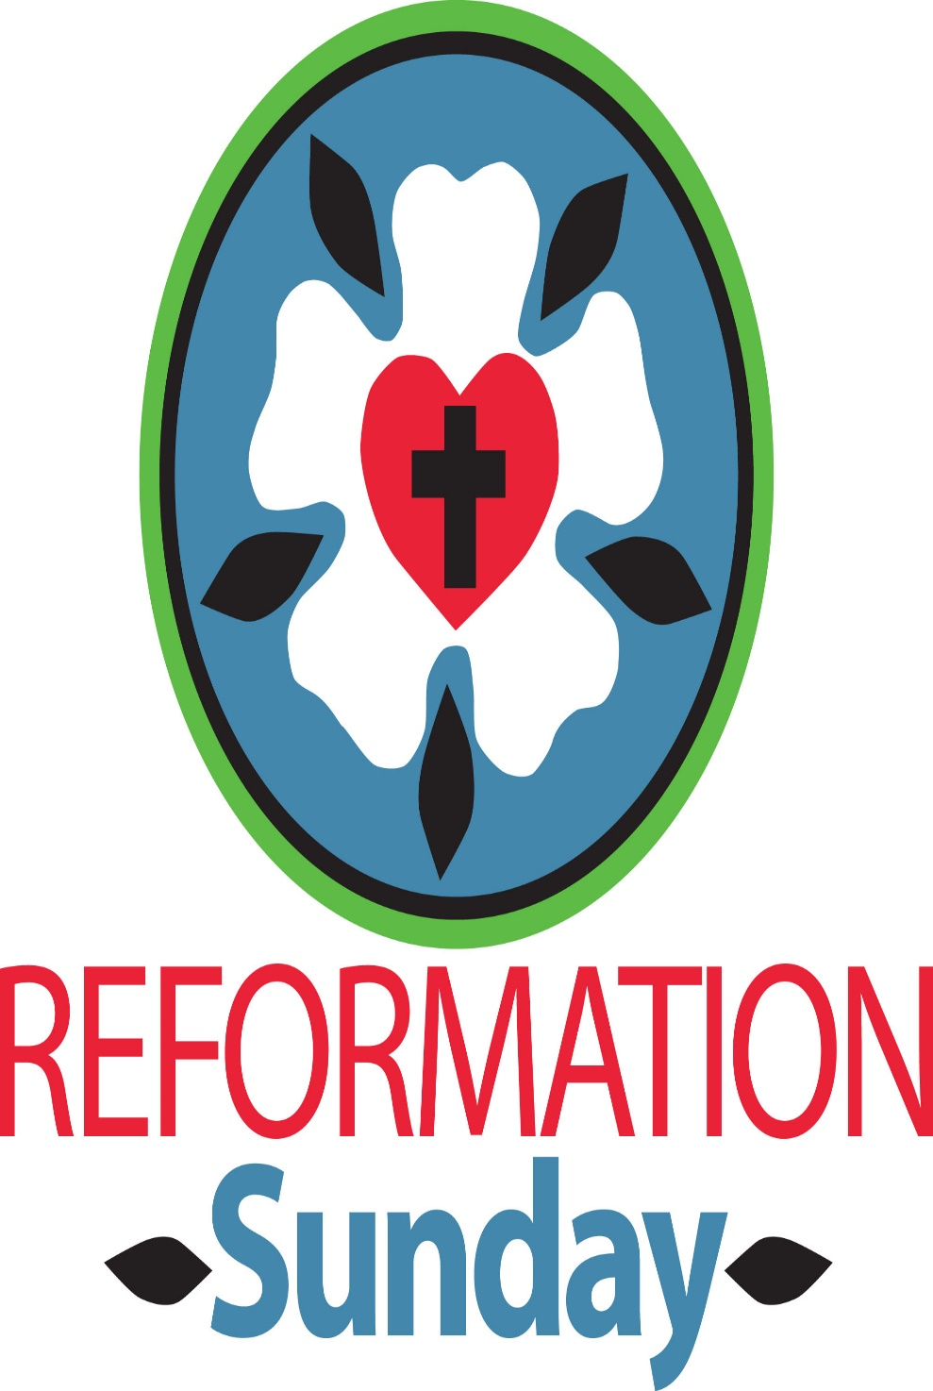

Mt. Zion Evangelical Lutheran Church
320 Mt. Zion Dr., Ripon, WI
www.mtzionripon.org
Facebook: Mt. Zion Evangelical Lutheran Church

Pastor Michael Sheppard
Pastor’s Study: 920-748-9734
E-mail: revmikesheppard@gmail.com
Reformation Oct 27 & 30, 2022

Welcome to Mt. Zion!
Handicapped accessible restrooms are located upstairs next to the Pastor’s Study and downstairs next to the elevator.
Attendance: Please remember to sign the friendship pads. Registration for communion will continue as usual at the table. If you have any questions or concerns please contact Pastor Sheppard or Mark Roeder.

Hearing Loop: Our sanctuary is equipped with a hearing loop system. Those who have compatible hearing aids (with a T-switch) will be able to hear the sound system directly into their ear(s). The two main seating areas and the choir area are looped so that you may sit in any of the three areas. We also have four receivers available for those who do not have compatible hearing aids. If you wish to use a receiver please ask the ushers. Those who wish may bring their own headphones or ear buds.

A note for our visitors on member communion –
Out of sincere love for the truth of God’s Word and for precious human souls, we practice member communion in our synod and congregation. This teaching, as practiced by the Church for centuries, is thoroughly Scriptural. It questions the faith of no individual yet asks that there be full doctrinal agreement between those who commune. For this reason, we ask that only those who are members of a WELS or ELS congregation join us for the Lord’s Supper. If you wish to commune with us please speak with the pastor before the service.
The front row on the pulpit side is reserved for people who are unable to navigate the steps. Pastor will serve you Communion first.

Luther’s Morning Prayer: I thank you, my Heavenly Father, through Jesus Christ, Your dear Son, that You have kept me this night from all harm and danger; and I pray that You would keep me this day also from sin and every evil, that all my doings and life may please You. For into Your hands I commend myself, my body and soul, and all things. Let Your holy angel be with me, that the evil foe may have no power over
me. Amen.

Luther’s Evening Prayer: I thank You, my heavenly Father, through Jesus Christ, Your dear Son, that You have graciously kept me this day; and I pray that You would forgive me all my sins where I have done wrong, and graciously keep me this night. For into Your hands I commend myself, my body and soul, and all things. Let Your holy angel be with me, that the evil foe may have no power over me. Amen.

Hymns: 558 vs 1-6, 863, 670, 558 vs 7-10

Order of Worship: The Service CW 21 pg. 154

First Reading: Jeremiah 31: 31-34 (EHV)
Yes, the days are coming, declares the Lord,
when I will make a new covenant with the house of Israel
and with the house of Judah.
³²It will not be like the covenant I made with their fathers,
when I took them by the hand
and led them out of the land of Egypt.
They broke that covenant of mine,
although I was a husband to them, declares the Lord.
³³But this is the covenant I will make with the house of Israel after those days,
declares the Lord.
I will put my law in their minds,
and I will write it on their hearts.
I will be their God,
and they will be my people.
³⁴No longer will each one teach his neighbor,
or each one teach his brother, saying, “Know the Lord,”
because they will all know me,
from the least of them to the greatest, declares the Lord,
for I will forgive their guilt,
and I will remember their sins no more.

The LORD Almighty Is with Us Psalm 46

Second Reading: Galatians 5: 1-6 (EHV)
It is for freedom that Christ has set us free. Stand firm, then, and do not allow anyone to put the yoke of slavery on you again. ²Look, I, Paul, tell you that if you allow yourselves to be circumcised, Christ will be of no benefit to you. ³I testify again to every man who allows himself to be circumcised that he is obligated to do the whole law. ⁴You who are trying to be declared righteous by the law are completely separated from Christ. You have fallen from grace.
⁵Indeed, through the Spirit, we by faith are eagerly waiting for the sure hope of righteousness. ⁶For in Christ Jesus neither circumcision nor uncircumcision matters. Rather, it is faith working through love that matters.

Gospel Acclamation John 8:31,32
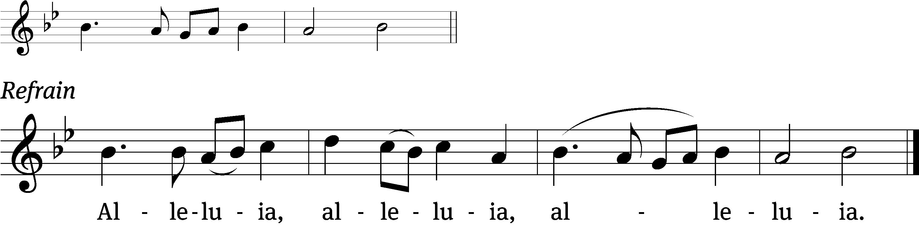

If you hold to my teaching, you are really my dis / ciples.
Then you will know the truth, and the truth will / set you free.

Refrain
Tune: © 2021 Northwestern Publishing House. Used by permission: OneLicense no. 716381

Gospel & Sermon Text: John 8: 31-36 (EHV)
So Jesus said to the Jews who had believed him, “If you remain in my word, you are really my disciples. ³²You will also know the truth, and the truth will set you free.”
³³“We are Abraham’s descendants,” they answered, “and we have never been slaves of anyone. How can you say, ‘You will be set free’?”
³⁴Jesus answered, “Amen, Amen, I tell you: Everyone who keeps committing sin is a slave to sin. ³⁵But a slave does not remain in the family forever. A son does remain forever. ³⁶So if the Son sets you free, you really will be free.

Sermon Theme: “If the Son Sets You Free, You Are Free Indeed.”

OFFERING: The offerings are brought forward to the altar.

Announcements

WLA Presents The Music Man: Our theater program will be offering showings on November 10, 11, & 12 at 7:00 PM, with a matinee showing at 2:00 PM on November 13. Tickets for the public go on sale October 21 and will be available in the school office or online at www.hometowntickets.com. (The show will be listed on the online site for ticket sales starting that date.) Those requiring handicap accessibility should purchase their tickets through the school office.

LWMS Fall Rally: I am happy to report that we collected over 1600 crosses October 15th at the Beaver Dam Fall Rally (Mt Zion made over 500). Praise be to God! We also collected over three thousand pill bottles.
We received in donations $716.00 for postage to send the crosses and pill bottles. We are anxiously waiting on the packing and shipping procedures so they may be sent to Africa. With that said we will NOT be collecting any more crosses or pill bottles.

Thanks for your support of this project.
United to serve,

Dianne Witkowski LWMS President Beaver Dam Circuit
Joanne Gregor Spiritual Growth Woman
Pastor Sheppard Spiritual Growth Pastoral Advisor

100 Missions in 10 Years
At the 2021 Synod Convention, delegates enthusiastically approved a WELS Home Missions initiative to plant 100 home mission churches and enhance 75 ministries in 10 years beginning in 2023. During the same time, we want to support 75 enhancement grants to help existing congregations reach more souls, often in other cultures. This is a BIG challenge. An impossible one you might say. But this initiative isn’t as much about planting more churches but about sharing the gospel of Jesus Christ. It’s about aggressively reaching lost souls. We pray that God will bless our efforts, trusting that he is able to do immeasurably more than all we ask or imagine. Learn more about this initiative, stay up-to-date on progress, and learn how you can get involved in this synod wide church planting effort at wels100in10.net.

Blue Hymnal Project: Please come to church on Thursday, November 17th, at 10:00 a.m. for the hymnal project. We will be taking the bookmarks out of the red hymnals and transferring them to the blue hymnals. Our work will be done in the comfort of the gathering room upstairs. Pastries, breads, and refreshments will be served. Please sign up on the bulletin board upstairs to help us in planning.

PowerPoint: We are in need of 1 or 2 more people to do the service once a month on Sunday. You do not have to be a “Techie” to do this. It can all be setup for you and all that’s needed is for you to push a button. Please let Sara Grunert know if you can help her out. Contact her at grunertfamily@charter.net.

Favorite Hymn Service: We need your help. In January we will have a favorite hymn service and would like to know your favorite hymns. After we tally your suggestions, we will include the favorite hymns in a special service. Please include your favorite hymns on the form and return it to us by the end of November.

Hymn Sing: Our next hymn sing will be Sunday November 6th. If you have a favorite hymn please let Jo Meeker or Sue Sheppard know.

Sound System: We have started a fund for a new Audio/Visual system. The improvements are necessary to accommodate our recent and future technology additions. We are applying for a grant from The Antioch Foundation. If it is approved Mt Zion’s share of the cost will be approximately $16,000.00. You may use the regular church envelopes and write Audio System next to your donation. Thank you.

Red Hymnals: It was decided that whoever would like to take one or more old hymnals home may do so at no cost. They are located on the table by the entrance to the sanctuary. Please feel free to take.

Birthday Celebration: Cake will be served Sunday November 6th to celebrate the birthdays for November.
Mailbox and table: The October Forward In Christ is available and also the August 28th, 2022-November 26th, 2022 Meditations are available.
If you would like the Lord’s Supper privately, please contact Pastor Sheppard on his cell 920-745-0883, or by email revmikesheppard@gmail.com.

The Helping Hands Ministry is ready to serve the needs of our members. Please contact one of the following if you or someone you know needs assistance: Joanne Gregor at 920-896-1518, Lisa Tremore at 920-229-1297 or Tammy Niemuth at 920-299-0240.

For Your Information
Attendance 10/20 - 10/23/2022: 88
Offerings for 10/20 - 10/23/2022: $3,485.75*
*Cumulative amount since 7/28/22 is $2,733 towards the new sound system*

Serving Our Lord

Thank you to everyone for your service to our Lord!

Ushers:

Oct. 30 & Nov. 6: Kyle Stollfuss, Dennis Hamer, Mike Jung, Sam Jung

Nov. 13, 20 & 23: Mike Schaub, Kevin Schenning, Eric Eckert, Adam Covach

PowerPoint:

Oct 27: Jo Meeker

Oct 30: Grunert Family

Nov 6: Jan Ohlrich

Nov 3: Jo Meeker

Nov Communion Set up: Jo Meeker

Nov Communion Clean up: Janet & Al Brooks and Sue Sheppard

This week at Mt. Zion
Sunday (30th) 9:00 AM Worship with Communion
10:15 AM Sunday School & Bible Study
Monday 6:30 PM Bible Study
Tuesday 9:00 AM Bible Study
Wednesday 5:00 PM Catechism Class
6:15 PM Choir Practice
Thursday 6:30 PM Worship
Sunday 8:45 AM Hymn Sing
9:00 AM Worship
10:15 AM Sunday School & Bible Study
Birthday Cake

Secretary Jo Meeker
Church Office: 920-748-5641
Office Hours: Mon. 9-12, Tues. & Wed. 9-11
E-mail: mountzionripon@gmail.com

Acknowledgments
Unless otherwise indicated, Scripture quotations are from The Holy Bible, New International Version®, NIV®. Copyright © 1973, 1978, 1984, 2011 by Biblica, Inc.TM Used by permission of Zondervan. All rights reserved worldwide.
Software distributed in partnership with Northwestern Publishing House.
Created by Christian Worship: Service Builder © 2022 Concordia Publishing House.

