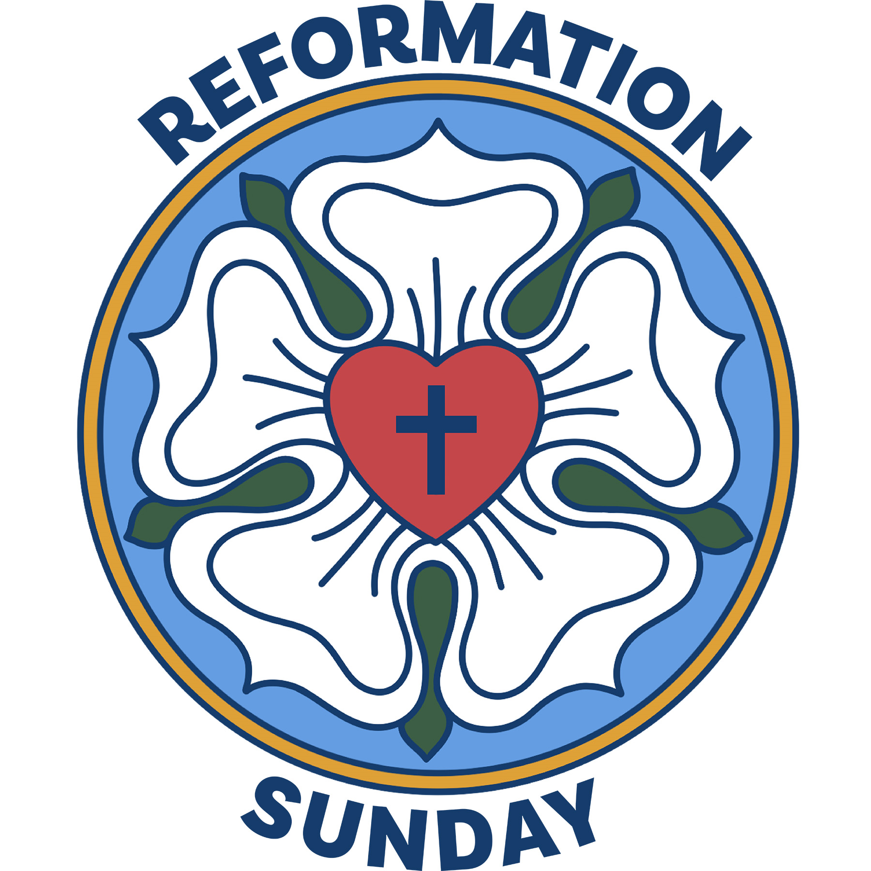

Mt. Zion Evangelical Lutheran Church

320 Mt. Zion Dr., Ripon, WI
www.mtzionripon.org
Facebook: Mt. Zion Evangelical Lutheran Church

Pastor Michael Sheppard
Pastor’s Study: 920-748-9734
E-mail: revmikesheppard@gmail.com
Reformation Day Oct. 26, 2025
Handicapped accessible restrooms are located upstairs next to the Pastor’s Study and downstairs next to the elevator.
Attendance: Please remember to sign the friendship pads. Registration for communion will continue as usual at the table. If you have any questions or concerns, please contact Pastor Sheppard or Mike Meeker.


Hearing Loop: Our sanctuary is equipped with a hearing loop system. Those who have compatible hearing aids (with a T-switch) will be able to hear the sound system directly into their ear(s). The two main seating areas and the choir area are looped so that you may sit in any of the three areas. We also have four receivers available for those who do not have compatible hearing aids. If you wish to use a receiver please ask the ushers. Those who wish may bring their own headphones or ear buds.

A note for our visitors on member communion –
Out of sincere love for the truth of God’s Word and for precious human souls, we practice member communion in our synod and congregation. This teaching, as practiced by the Church for centuries, is thoroughly Scriptural. It questions the faith of no individual yet asks that there be full doctrinal agreement between those who commune. For this reason, we ask that only those who are members of a WELS or ELS congregation join us for the Lord’s Supper. If you wish to commune with us please speak with the pastor before the service.
The front row on the pulpit side is reserved for people who are unable to navigate the steps. Pastor will serve you Communion first.

Prayer Before Communion: Dearest Jesus, I marvel that you came to this earth as the Word made flesh. With similar awe I contemplate how you give me your body and blood in the bread and wine of Holy Communion. Touch me with your grace that moved you to reach out to me, a poor, miserable sinner! Use this sacred supper to bring me closer to you. Amen.

Hymns: 563, 863, 583

Order of Worship Setting Three pg. 188

First Reading & Sermon Text: Jeremiah 31:31-34 (EHV)
Yes, the days are coming, declares the Lord,
when I will make a new covenant with the house of Israel
and with the house of Judah.
³²It will not be like the covenant I made with their fathers,
when I took them by the hand
and led them out of the land of Egypt.
They broke that covenant of mine,
although I was a husband to them, declares the Lord.
³³But this is the covenant I will make with the house of Israel after those days,
declares the Lord.
I will put my law in their minds,
and I will write it on their hearts.
I will be their God,
and they will be my people.
³⁴No longer will each one teach his neighbor,
or each one teach his brother, saying, “Know the Lord,”
because they will all know me,
from the least of them to the greatest, declares the Lord,
for I will forgive their guilt,
and I will remember their sins no more.

Psalm: 46A The LORD Almighty Is With Us
Second Reading: Galatians 5:1-6 (EHV)
It is for freedom that Christ has set us free. Stand firm, then, and do not allow anyone to put the yoke of slavery on you again. ²Look, I, Paul, tell you that if you allow yourselves to be circumcised, Christ will be of no benefit to you. ³I testify again to every man who allows himself to be circumcised that he is obligated to do the whole law. ⁴You who are trying to be declared righteous by the law are completely separated from Christ. You have fallen from grace.
⁵Indeed, through the Spirit, we by faith are eagerly waiting for the sure hope of righteousness. ⁶For in Christ Jesus neither circumcision nor uncircumcision matters. Rather, it is faith working through love that matters.

Gospel Acclamation
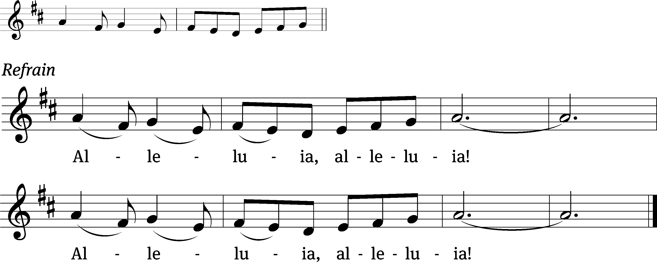
These words are written that you / may believe,
That Jesus is the Christ, the / Son of God. Refrain

Gospel: John 8:31-36 (EHV)
So Jesus said to the Jews who had believed him, “If you remain in my word, you are really my disciples. ³²You will also know the truth, and the truth will set you free.”
³³“We are Abraham’s descendants,” they answered, “and we have never been slaves of anyone. How can you say, ‘You will be set free’?”
³⁴Jesus answered, “Amen, Amen, I tell you: Everyone who keeps committing sin is a slave to sin. ³⁵But a slave does not remain in the family forever. A son does remain forever. ³⁶So if the Son sets you free, you really will be free.

Sermon Theme: “The Lord Established a New Covenant.”

OFFERING: The offerings are brought forward to the altar.

Keep in Your Prayers: Harley Dorsey, Carol Henning, Carol Hielke, Karen Reiser, Gary Wichman and Dick Zellmer.

Choir Song: In Remembrance of Me
Announcements
Flowers: The flowers on the altar are in memory of Linda Schliepp.
Voters’ Meeting: The quarterly voters’ meeting will be held after church today near the choir section.

Birthday Celebration: The October birthday celebration will be TODAY in the fellowship hall. Join us for fellowship, cake and refreshments.

Members of Mt. Zion: We are hoping to start a program to make sure all our shut-ins are receiving consistent visits from members here at church. If you would like to coordinate a schedule to plan monthly visits or if you would like to volunteer to visit a shut-in please see the sign up sheet on the table by the office.

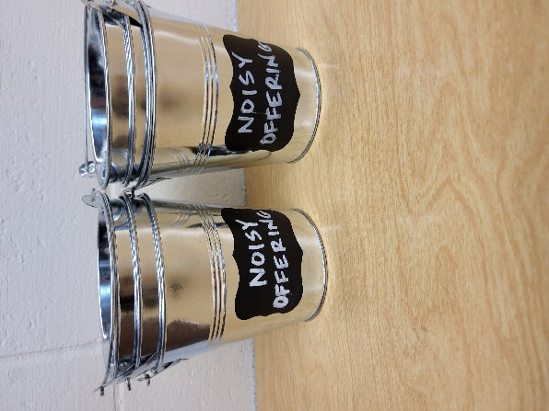
Noisy Offering: Please keep saving your spare change for our noisy offering on Nov. 2nd. Your offering will be given to the LWMS Kids C.A.R.E. project Academia Cristo, through the One Latin America Team. Academia Cristo is a multi-faceted effort that seeks to make disciples by sharing the message of God’s grace and to build small groups of believers throughout Latin America. We have appreciated your support for our various projects and activities. Thank you for your generosity.
Hymn Sing: The next hymn sing will be Sunday November 2nd. If you have any requests for future hymn sings please talk to Sue Sheppard or Jo Meeker.

Guest Preacher Nov. 9th: On Sunday November 9th, Pastor James Buske from Lighthouse Youth Center in Milwaukee will talk about his ministry at the Center during the sermon portion of the service.

Pie and Ice Cream Social: Ladies Aid and LWMS are having a Pie and Ice Cream Social on Sunday November 9th following the service. A signup sheet for pies is posted on the podium by the library. The freewill offering will be given to the LWMS program Send One Sister. This will send one woman to the national convention.

JUNIOR ACTIVITY DAY: The Junior Youth Group will meet on Saturday, Nov. 8th, 9:30-11:00. It will be filled with a variety of games, crafts, creating cards to be added to our shut-ins Thanksgiving box meals and snacks for our shut-in meals. We are hoping that your child/ren will join us.

Advent By Candlelight – Unwrapping the Names of Jesus
Jesus, King of kings, Immanuel, Prince of Peace—we hear these names referring to God’s Son often during this time of year. They’re in the hymns we sing, the passages preached, the words on our lips. Do we ever stop to consider what they mean? In fact, each name reveals to us truth. They remind us of what God has accomplished. Each name confesses something uniquely special that he has done for you and for me.

This Advent by Candlelight program seeks to focus our attention right on Jesus by taking a deeper look—through Scripture, narrative, and song—at the names we hear him often called during Advent. Each name reveals a priceless gift just waiting to be opened and treasured for a lifetime. Each name is a perfect gift to unwrap. We are planning this event for November 30th, the first Sunday in Advent. There will be a sign-up sheet by the library soon. Contact Jo Meeker or Kari Hielke with any questions.

Friendly Reminder: Children’s offering envelopes and children’s bulletins are available on the back table. The prayer box is also there for any prayer requests.

Greeters: Thank you to all who have greeted so far. A new signup sheet for August through December is available. If you would like to be greeters for this year, please sign up on the sheet on the podium by the library.

Mailbox and table: The October Forward In Christ is available and also the August 31, 2025-November 29, 2025 Meditations are available.
If you would like the Lord’s Supper privately, please contact Pastor Sheppard on his cell 920-745-0883, or by email revmikesheppard@gmail.com.
The Helping Hands Ministry is ready to serve the needs of our members. Please contact one of the following if you or someone you know needs assistance: Joanne Gregor at 920-896-1518, Lisa Tremore at 920-229-1297 or Tammy Niemuth at 920-299-0240.
For Your Information
Attendance 10/19 84
Offerings for 10/19 $2,081.00

Serving Our Lord

Thank you to everyone for your service to our Lord!

Ushers:

Oct. 26: Steve Ohlrich, Derek Chitwood, Alex Kranz

Nov. 2 & 9: Terry Dolderer, Dawson Niemuth, Rick Niemuth

PowerPoint:

Oct. 26: Judy Doll

November 2: Grunert Family

Nov. 9: Jan Ohlrich

Nov.16: Judy Doll

Nov. Communion Set up: Jo Meeker

Nov. Communion Clean up: Janet/Al Brooks & Sue Sheppard

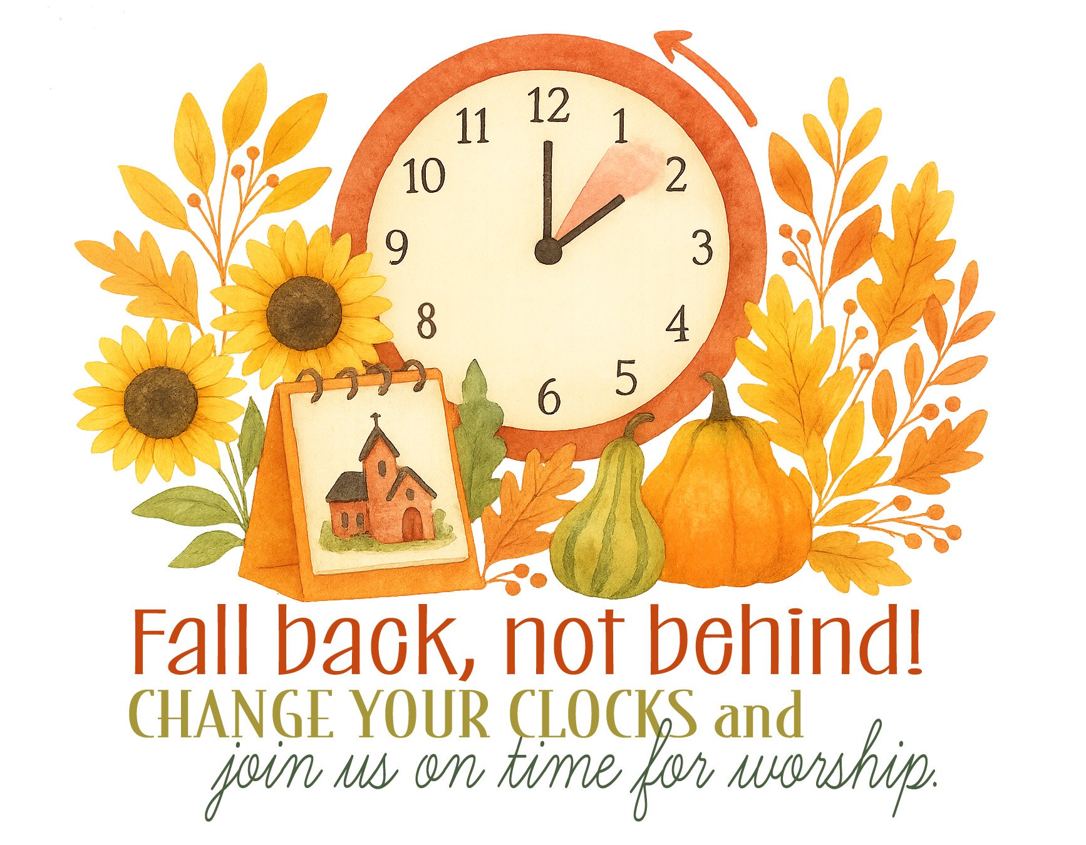

Sunday (26th) 9:00 AM Worship Service with Communion
10:15 AM Sunday School
Voter’s Meeting
3-5 PM Trunk or Treat
5:00 PM Confirmation Class
Tuesday 9:00 AM Bible Study (book of Acts)
Wednesday 6:15 PM Choir Practice
Thursday 9:00 AM Women’s Bible Study (Fellowship Hall)
Sunday 8:45 AM Hymn Sing
9:00 AM Worship Service
10:15 AM Sunday School & Bible Study
5:00 PM Confirmation Class

