Pentecost Sunday
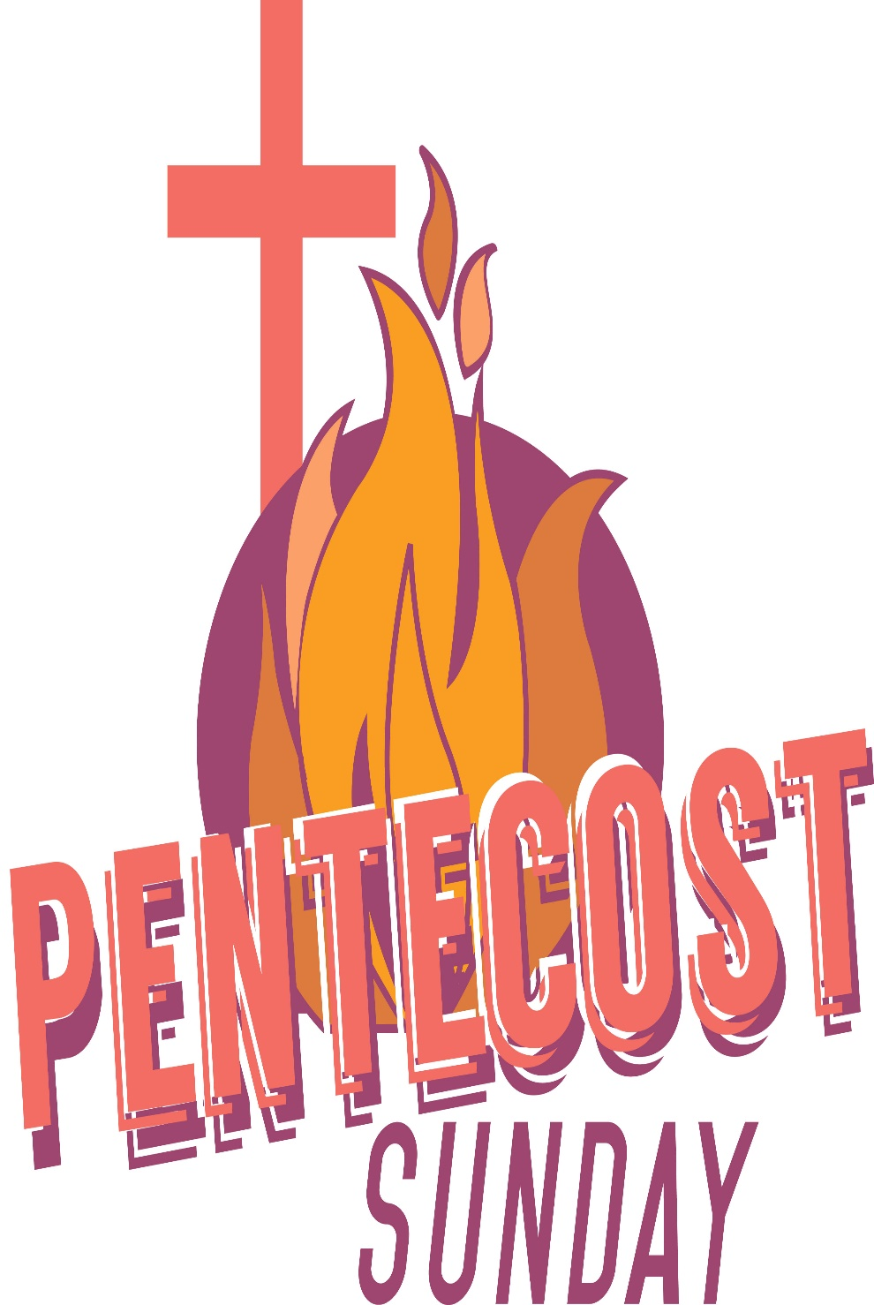
Mt. Zion Evangelical Lutheran Church
320 Mt. Zion Dr., Ripon, WI
www.mtzionripon.org
Facebook: Mt. Zion Evangelical Lutheran Church

Pastor Michael Sheppard
Pastor’s Study: 920-748-9734
E-mail: revmikesheppard@gmail.com
Pentecost June 2 & 5, 2022

Welcome to Mt. Zion!
Handicapped accessible restrooms are located upstairs next to the Pastor’s Study and downstairs next to the elevator.
Attendance: Please remember to sign the friendship pads. Registration for communion will continue as usual at the table. If you have any questions or concerns please contact Pastor Sheppard or Mark Roeder.

Please feel free to ask Pastor Sheppard any questions you may have concerning COVID-19. May the Lord be with us as we worship together at church. (The services will continue to be posted on Facebook, Rumble, and the church website, and available on DVD.)

Hearing Loop: Our sanctuary is equipped with a hearing loop system. Those who have compatible hearing aids (with a T-switch) will be able to hear the sound system directly into their ear(s). The two main seating areas and the choir area are looped so that you may sit in any of the three areas. We also have four receivers available for those who do not have compatible hearing aids. If you wish to use a receiver please ask the ushers. Those who wish may bring their own headphones or ear buds.

Baptism Today: Reuben Nicholas Goeldi, son of Nick & Caitlin Goeldi, will be baptized in the name of the Father, Son and Holy Spirit. His witnesses are: Jim Cardinal and Leigh Briody. May God be with him and his family. The order of Holy Baptism is on page 261 of the hymnal.

Hymns: Thursday: 639, 585, 898
Sunday: 685, 585, 898

Order of Worship: Thursday Evening Prayer CW21 Pg. 215
Sunday Morning Prayer CW21 Pg. 207

Lord, Send Out Your Spirit Psalm 104A

Reading: Genesis 11: 1-9 (EHV)
The whole earth had one language and a single vocabulary. As people traveled in the east, they found a plain in the land of Shinar, and they settled there. ³They said to one another, “Come, let’s make bricks and bake them thoroughly.” They used mud brick instead of stone for building material, and they used tar for mortar. ⁴They said, “Come, let’s build a city for ourselves and a tower whose top reaches to the sky, and let’s make a name for ourselves, so that we will not be scattered abroad over the face of the whole earth.”
⁵The Lord came down to see the city and the tower that the people were building. ⁶The Lord said, “If this is the first thing they are doing as one people, who all have one language, then nothing that they intend to do will be too difficult for them. ⁷Come, let’s go down there and confuse their language, so that they cannot understand one another’s speech.”
⁸So the Lord scattered them from there over the face of the whole earth, and they stopped building the city. ⁹It was named Babel, because there the Lord confused the language of the whole earth. From there the Lord scattered them over the face of the whole earth.

Gospel: John 14: 23-27 (EHV)
Jesus answered him, “If anyone loves me, he will hold on to my word. My Father will love him, and we will come to him and make our home with him. ²⁴The one who does not love me does not hold on to my words. The word that you are hearing is not mine, but it is from the Father who sent me.
²⁵“I have told you these things while staying with you. ²⁶But the Counselor, the Holy Spirit, whom the Father will send in my name, will teach you all things and remind you of everything I told you.
²⁷“Peace I leave with you. My peace I give to you. Not as the world gives do I give to you. Do not let your heart be troubled, and do not let it be afraid.

Sermon Text: Acts 2: 1-21 (EHV)
When the day of Pentecost came, they were all together in one place. ²Suddenly a sound like the rushing of a violent wind came from heaven, and it filled the whole house where they were sitting. ³They saw divided tongues that were like fire resting on each one of them. ⁴They were all filled with the Holy Spirit and began to speak in other languages, since the Spirit was giving them the ability to speak fluently.
⁵Now there were godly Jewish men from every nation under heaven living in Jerusalem. ⁶When this sound was heard, a crowd came together and was confused, because each one heard them speaking in his own language. ⁷They were completely baffled and said to each other, “Look, are not all these men who are speaking Galileans? ⁸Then how is it that each of us hears them speaking in his own native language? ⁹Parthians, Medes, and Elamites; residents of Mesopotamia, and of Judea, Cappadocia, Pontus and Asia, ¹⁰Phrygia and Pamphylia, Egypt, and the parts of Libya around Cyrene; visitors from Rome, both Jews and proselytes; ¹¹Cretans and Arabs—we hear them declaring in our own languages the wonderful works of God.” ¹²They were all amazed and perplexed. They kept saying to one another, “What does this mean?” ¹³But others mocked them and said, “They are full of new wine.”
¹⁴Then Peter stood up with the Eleven, raised his voice, and spoke loudly and clearly to them: “Men of Judea, and all you residents of Jerusalem, understand this, and listen closely to my words. ¹⁵These men are not drunk, as you suppose, for it is only the third hour of the day. ¹⁶On the contrary, this is what was spoken by the prophet Joel:
¹⁷This is what God says will happen in the last days:
I will pour out my Spirit on all flesh.
Your sons and your daughters will prophesy.
Your young men will see visions.
Your old men will dream dreams.
¹⁸Even on my servants, both men and women,
I will pour out my Spirit in those days,
and they will prophesy.
¹⁹I will show wonders in the sky above,
and signs on the earth below,
blood and fire and a rising cloud of smoke.
²⁰The sun will be turned to darkness
and the moon to blood
before the coming of the great and glorious day of the Lord.
²¹And this will happen: Everyone who calls on the name of the Lord will be saved.”
The Holy Bible, Evangelical Heritage Version® (EHV®)
copyright © 2018 The Wartburg Project. All rights reserved. www.wartburgproject.org

Sermon Theme: “The Holy Spirit Is Poured Out On His People.”

OFFERING: The offerings are brought forward to the altar.

Please remember in your prayers: Ted Machmueller

Announcements
Mark your calendar for Sunday, June 12th
Who: All members of Mt. Zion
What: Pie and Ice Cream Social
When: After church on Sunday June 12th
Where: Church fellowship hall
You may eat in the fellowship hall or take the wonderful dessert home and enjoy at your leisure. Please stop down have a piece of pie with or without ice cream. Yum!!!!!!!
A Free will offering will be accepted for the Lutheran Women’s Missionary Society Send One Sister (SOS) Fund. Send One Sister (SOS) was designed to give a woman, who might not otherwise be able to attend a national convention because of financial reasons, a chance to attend her first convention by using SOS funds. Mt Zion ladies would like to help the Beaver Dam LWMS Circuit send a few women to the convention in La Crosse in 2023.
Timber Rattlers Game: Once again this year we will be attending a TimberRattler's game. The date is Friday, Auugst 12. Supper will be served beginning at 5pm and includes BBQ grilled chicken breast, hotdogs, BBQ pulled pork, baked beans, chips, pasta salad, dessert, and 2 beverages. The cost will be $29 for adults, pending some kind of discount. Price for childrens' tickets is yet to be determined. Please sign up on the sheet on the bulletin board by the office, and watch the bulletin for added details.

Kids C.A.R.E. The 2021-2022 Kids C.A.R.E. project, Outreach to Roma, has come to an end. Mt. Zion contributed $564. Thank you so much for your generosity which will help our Bulgarian missionaries share the gospel message with the Roma people. Please continue to keep Kids C.A.R.E. in your prayers.

Bus Trip: The Zion/St.John’s Fellowship Travel Group is hosting a WELS Fellowship Road trip in August to Washington DC. Only 8 seats are available. See the information and itinerary sheet on the bulletin board by the office. Or take one home.

Red Hymnals: It was decided that whoever would like to take one or more old hymnals home may do so at no cost. They are located on the table by the entrance to the sancuary. Please feel free to take.

Birthday Celebration: Cake will be served Sunday June 19th to celebrate the birthdays for June.
Mailbox and table: The June Forward In Christ is available and also the May 29th, 2022-August 27th, 2022 Meditations are available.
If you would like the Lord’s Supper privately, please contact Pastor Sheppard on his cell 920-745-0883, or by email revmikesheppard@gmail.com.

The Helping Hands Ministry is ready to serve the needs of our members. Please contact one of the following if you or someone you know needs assistance: Joanne Gregor at 920-896-1518, Lisa Tremore at 920-229-1297 or Tammy Niemuth at 920-299-0240.

For Your Information
Attendance 5/19 - 5/22/2022 94
Offerings for 5/19 - 5/22/2022: $2,321.00

Serving Our Lord

Thank you to everyone for your service to our Lord!

Ushers:

June 5: Tobin Storzer, Rick Retelle, Kelly Frank

June 12 & 19: Dennis Scott, Dave Patchett, Dawson Niemuth, Rick Niemuth

PowerPoint:

June 5: Miya Grunert

June 9: Deb Weiske

June 12: Arjeta Rushani

June 16: Jo Meeker

June Communion Set up: Mary Clement

June Communion Clean up: Paul & Peggy Walkowicz

This week at Mt. Zion
Sunday (5th) 9:00 AM Worship
Wednesday 7:15 PM Council Meeting
Thursday 6:30 PM Worship with Communion
Sunday 9:00 AM Worship with Communion
10:15 AM Ice Cream & Pie Social

Secretary Jo Meeker
Church Office: 920-748-5641
Office Hours: Mon. 9-12, Tues. & Wed. 9-11
E-mail: mountzionripon@gmail.com

Acknowledgments
Unless otherwise indicated, Scripture quotations are from The Holy Bible, New International Version®, NIV®. Copyright © 1973, 1978, 1984, 2011 by Biblica, Inc.TM Used by permission of Zondervan. All rights reserved worldwide.
Software distributed in partnership with Northwestern Publishing House.
Created by Christian Worship: Service Builder © 2022 Concordia Publishing House.

