9th Sunday of Pentecost
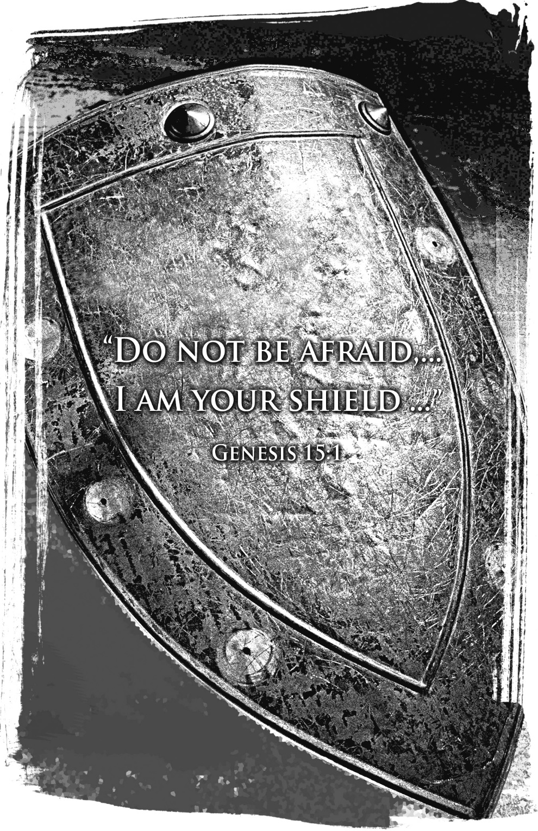
Mt. Zion Evangelical Lutheran Church
320 Mt. Zion Dr., Ripon, WI
www.mtzionripon.org
Facebook: Mt. Zion Evangelical Lutheran Church

Pastor Michael Sheppard
Pastor’s Study: 920-748-9734
E-mail: revmikesheppard@gmail.com
Pentecost 9 Aug. 4 & 7, 2022

Welcome to Mt. Zion!
Handicapped accessible restrooms are located upstairs next to the Pastor’s Study and downstairs next to the elevator.
Attendance: Please remember to sign the friendship pads. Registration for communion will continue as usual at the table. If you have any questions or concerns please contact Pastor Sheppard or Mark Roeder.

Please feel free to ask Pastor Sheppard any questions you may have concerning COVID-19. May the Lord be with us as we worship together at church. (The services will continue to be posted on Facebook, Rumble, and the church website, and available on DVD.)

Hearing Loop: Our sanctuary is equipped with a hearing loop system. Those who have compatible hearing aids (with a T-switch) will be able to hear the sound system directly into their ear(s). The two main seating areas and the choir area are looped so that you may sit in any of the three areas. We also have four receivers available for those who do not have compatible hearing aids. If you wish to use a receiver please ask the ushers. Those who wish may bring their own headphones or ear buds.

Prayer Before Worship: O Lord our Maker, Redeemer, and comforter, we assembled in your presence to hear your holy Word. We pray that you would open our hearts by your Holy Spirit, that through the preaching of your Word we may repent of our sins, believe in Jesus, and grow day by day in grace and holiness. Hear us for Jesus’ sake. Amen

Hymns: 567, 800, 581

Order of Worship: Thursday Evening Prayer CW21 Pg. 215
Sunday: Morning Prayer CW 21 Pg. 207

I Lift Up My Eyes to the Mountains Psalm 121

Reading: Hebrews 11: 1-3, 8-16 (EHV)
Faith is being sure about what we hope for, being convinced about things we do not see. ²For by this faith the ancients were commended in Scripture.
³By faith we know that the universe was created by God’s word, so that what is seen did not come from visible things.
⁸By faith Abraham obeyed when he was called to go to a place that he was going to receive as an inheritance, and he left without knowing where he was going.
⁹By faith he lived as a stranger in the Promised Land, as if it did not belong to him, dwelling in tents along with Isaac and Jacob, who were heirs with him of the same promise. ¹⁰For he was looking forward to the city that has foundations, whose architect and builder is God.
¹¹By faith Abraham also received the ability to conceive children, even though Sarah herself was barren and he was past the normal age, because he considered him faithful who made the promise. ¹²And so from one man, and he as good as dead, descendants were born as numerous as the stars in the sky and as countless as the sand along the seashore.
¹³One by one, all of these died in faith, without having received the things that were promised, but they saw and welcomed them from a distance. They confessed that they were strangers and pilgrims on the earth. ¹⁴Indeed, people who say things like that make it clear that they are looking for a land of their own. ¹⁵And if they were remembering the land they had come from, they would have had an opportunity to return. ¹⁶Instead, they were longing for a better land—a heavenly one. For that reason, God is not ashamed to be called their God, because he prepared a city for them.

Gospel: Luke 12: 22-34 (EHV)
Jesus said to his disciples, “For that reason I tell you, stop worrying about your life, about what you will eat, or about your body, what you will wear. ²³Certainly life is more than food, and the body is more than clothing. ²⁴Consider the ravens: They do not sow or reap; they have no warehouse or barn; and yet God feeds them. How much more valuable are you than birds! ²⁵And who of you by worrying can add a single hour to his lifespan? ²⁶Since you are not able to do this little thing, why do you worry about the rest? ²⁷Consider how the wild flowers grow. They do not labor or spin. But I tell you, not even Solomon in all his glory was dressed like one of these. ²⁸If this is how God clothes the grass in the field, which is alive today and tomorrow is thrown into the furnace, how much more will he clothe you, you of little faith? ²⁹Do not constantly chase after what you will eat or what you will drink. Do not be worried about it. ³⁰To be sure, the nations of the world chase after all of these things, but your Father knows that you need them. ³¹Instead, continue to seek the kingdom of God, and all these things will be added to you. ³²Do not be afraid, little flock, because your Father is pleased to give you the kingdom. ³³Sell your possessions and give to the needy. Provide money bags for yourselves that do not become old, a treasure in the heavens that will not fail, where no thief comes near and no moth destroys. ³⁴For where your treasure is, there your heart will be also.

Sermon Text: Genesis 15: 1-6 (EHV)
After these events the word of the Lord came to Abram in a vision. He said, “Do not be afraid, Abram. I am your shield, your very great reward.”
²Abram said, “Lord God what can you give me, since I remain childless, and the one who will inherit my estate is Eliezer of Damascus?” ³Abram also said, “Look, you have given me no offspring, so a servant born in my house will be my heir.”
⁴Just then, the word of the Lord came to him. God said, “This man will not be your heir, but instead one who will come out of your own body will be your heir.” ⁵The Lord then brought him outside and said, “Now look toward the sky and count the stars, if you are able to count them.” He said to Abram, “This is what your descendants will be like.” ⁶Abram believed in the Lord, and the Lord credited it to him as righteousness.

Sermon Theme: “The Lord Credits Righteousness Through Faith In Jesus”

OFFERING: The offerings are brought forward to the altar.

Announcements

Altar Flowers: The flowers have been placed by Paul & Peggy Wachowicz in honor of their second wedding anniversary.

Sound System: We are starting a fund for a new Audio/Visual system. The improvements are necessary to accommodate our recent and future technology additions. We are applying for a grant from The Antioch Foundation, if it is approved Mt Zion’s share of the cost will be approximately $16,000.00. You may use the regular church envelopes just write Audio System next to your donation. Thank you.

Sunday School: We are in need of a teacher for the 7th and 8th grades starting this fall. Please talk to Pastor Sheppard or Jo Meeker if you are interested.

September 11th: This will be our 1st day of Sunday School. We will be having games, the church picnic and we would also like to have a Pine Car Derby. The derby is open to children and adults. There is a signup sheet on the bulletin board by the office.

Red Hymnals: It was decided that whoever would like to take one or more old hymnals home may do so at no cost. They are located on the table by the entrance to the sanctuary. Please feel free to take.

Birthday Celebration: Cake will be served August 21st to celebrate the birthdays for Aug.
Mailbox and table: The August Forward In Christ is available and also the August 28th, 2022-November 26th, 2022 Meditations are available.
If you would like the Lord’s Supper privately, please contact Pastor Sheppard on his cell 920-745-0883, or by email revmikesheppard@gmail.com.

The Helping Hands Ministry is ready to serve the needs of our members. Please contact one of the following if you or someone you know needs assistance: Joanne Gregor at 920-896-1518, Lisa Tremore at 920-229-1297 or Tammy Niemuth at 920-299-0240.

For Your Information
Attendance 7/28 - 7/31/2022 94
Offerings for 7/28 - 7/31/2022: $4,450.25*
*Includes $195 towards the new sound system

Serving Our Lord

Thank you to everyone for your service to our Lord!

Ushers:

Aug. 7 & 14: Mark Roeder, Ferd Roeder, Jason Roeder

Aug. 21 & 28: Steve Ohlrich, Legrand Stibb, Austin Fischer, Alex Kranz

PowerPoint:

Aug 4: Jo Meeker

Aug. 7: Jan Ohlrich

Aug 11: Grunert Family

Aug. 14: Arjeta Rushani

Aug Communion Set up: Mary Clement

Aug Communion Clean up: Sue Sheppard

This week at Mt. Zion
Sunday (7th) 9:00 AM Worship
Thursday 6:30 PM Worship with Communion
Tuesday 7:00 PM Ladies Aid
Wednesday 6:30 PM Council Meeting
Sunday 9:00 AM Worship with Communion
10:15 AM Brief Sunday School Teachers Mtg

Secretary Jo Meeker
Church Office: 920-748-5641
Office Hours: Mon. 9-12, Tues. & Wed. 9-11
E-mail: mountzionripon@gmail.com

Acknowledgments
Unless otherwise indicated, Scripture quotations are from The Holy Bible, New International Version®, NIV®. Copyright © 1973, 1978, 1984, 2011 by Biblica, Inc.TM Used by permission of Zondervan. All rights reserved worldwide.
Software distributed in partnership with Northwestern Publishing House.
Created by Christian Worship: Service Builder © 2022 Concordia Publishing House.

