NINETH SUNDAY AFTER PENTECOST
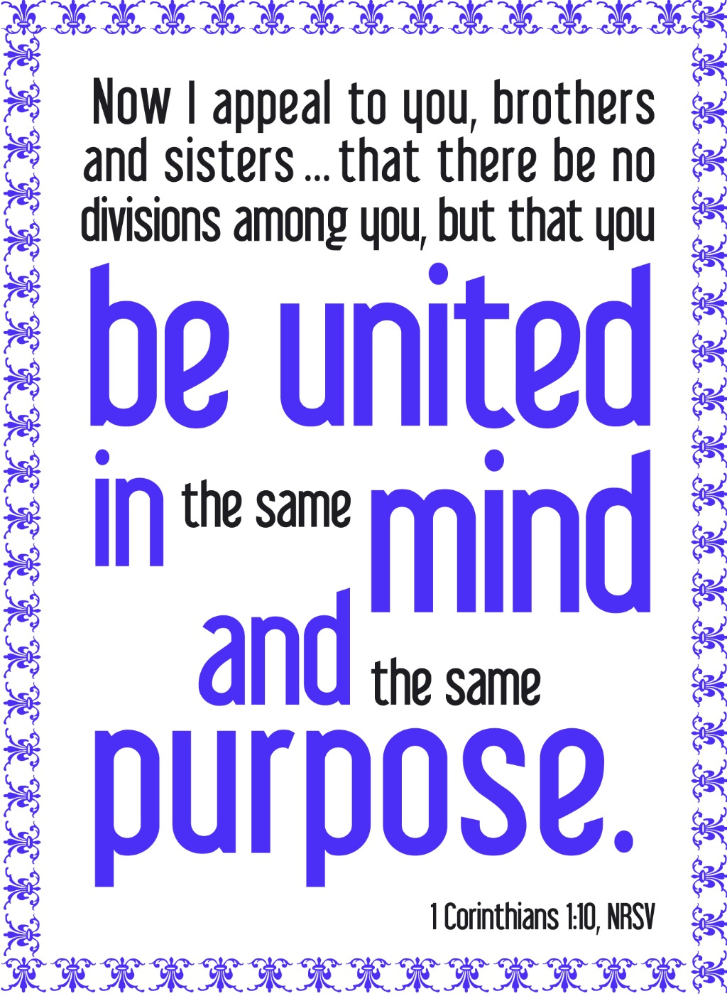
Mt. Zion Evangelical Lutheran Church

320 Mt. Zion Dr., Ripon, WI
www.mtzionripon.org
Facebook: Mt. Zion Evangelical Lutheran Church

Pastor Kurt Hagen (Vacancy Pastor)
Phone 651-764-3901
pastorhagen@gmail.com

Pentecost 9 July 26, 2026
Handicapped accessible restrooms are located upstairs next to the Pastor’s Study and downstairs next to the elevator.
Attendance: Please remember to sign the friendship pads. Registration for communion will continue as usual at the table. If you have any questions or concerns, please contact Mike Meeker.


Hearing Loop: Our sanctuary is equipped with a hearing loop system. Those who have compatible hearing aids (with a T-switch) will be able to hear the sound system directly into their ear(s). The two main seating areas and the choir area are looped so that you may sit in any of the three areas. We also have four receivers available for those who do not have compatible hearing aids. If you wish to use a receiver please ask the ushers. Those who wish may bring their own headphones or ear buds.

A note for our visitors on member communion –
Out of sincere love for the truth of God’s Word and for precious human souls, we practice member communion in our synod and congregation. This teaching, as practiced by the Church for centuries, is thoroughly Scriptural. It questions the faith of no individual yet asks that there be full doctrinal agreement between those who commune. For this reason, we ask that only those who are members of a WELS or ELS congregation join us for the Lord’s Supper. If you wish to commune with us please speak with the pastor before the service. The Lord’s Supper will be celebrated for those who desire it. The front row on the pulpit side is reserved for people who are unable to navigate the steps. Pastor will serve you Communion first.

Prayer Before Communion: Lord Jesus, I thank you for the gift of your Holy Supper. As I come to your table, work true repentance in my heart. Teach me to confess my sins and to believe that I am forgiven for your sake. May your body and blood, in and with the bread and wine, nourish my faith and strengthen my will to live in a way that is pleasing to you. Help me see what a blessing your sacrament is for my soul, and lead me to your altar often to receive your forgiveness. Amen.

Thank you to our guest organist Isaac Lundberg. He is a member of Redeemer in Fond du Lac.

Hymns: 776, 730, (663), 726

Order of Worship Setting One pg. 154

Psalm: 67A Let the Peoples Praise You

Reading: I Kings 3:5-12 (EHV)
The Lord appeared to Solomon in Gibeon in a dream at night.
God said, “Ask for whatever you want me to give you.”
⁶Solomon said, “You have shown great mercy and faithfulness to your servant, my father David, just as he walked before you in truth, righteousness, and uprightness of heart toward you. You have shown this great mercy and faithfulness to him and have given him a son who is seated on his throne to this very day. ⁷O Lord my God, now you have made your servant king in the place of my father David, but I am a little child. I do not know how to go out or come in. ⁸And I, your servant, am among your people whom you have chosen, a great people, who cannot be counted or numbered because they are so many. ⁹Now give to your servant a perceptive heart to judge your people, to distinguish between good and evil, for who is able to judge this great people of yours?”
¹⁰In the eyes of the Lord, Solomon’s request was good. ¹¹So God said to him, “Because you have asked for this, and you have not asked for a long life, nor have you asked for riches, nor have you asked for the lives of your enemies, but you have asked for discernment to reach just verdicts, ¹²therefore I will act according to your words. Yes, I will give you a wise and discerning heart, so that there will never have been anyone like you before you, nor will anyone like you rise up after you.

Reading: I Timothy 6:17-21 (EHV)
Instruct those who are rich in this present age not to be arrogant or to put their hope in the uncertainty of riches, but rather in God, who richly supplies us with all things for our enjoyment. ¹⁸Instruct them to do good, to be rich in good works, to be generous and willing to share. ¹⁹In this way they are storing up for themselves the treasure of a good foundation for the future, so that they may take hold of that which is truly life.
²⁰O Timothy, guard what has been entrusted to you, turning away from godless, empty talk and the contradictions of what is falsely called “knowledge.” ²¹By professing it, some have veered away from the faith. Grace be with you. Amen.

Gospel Acclamation
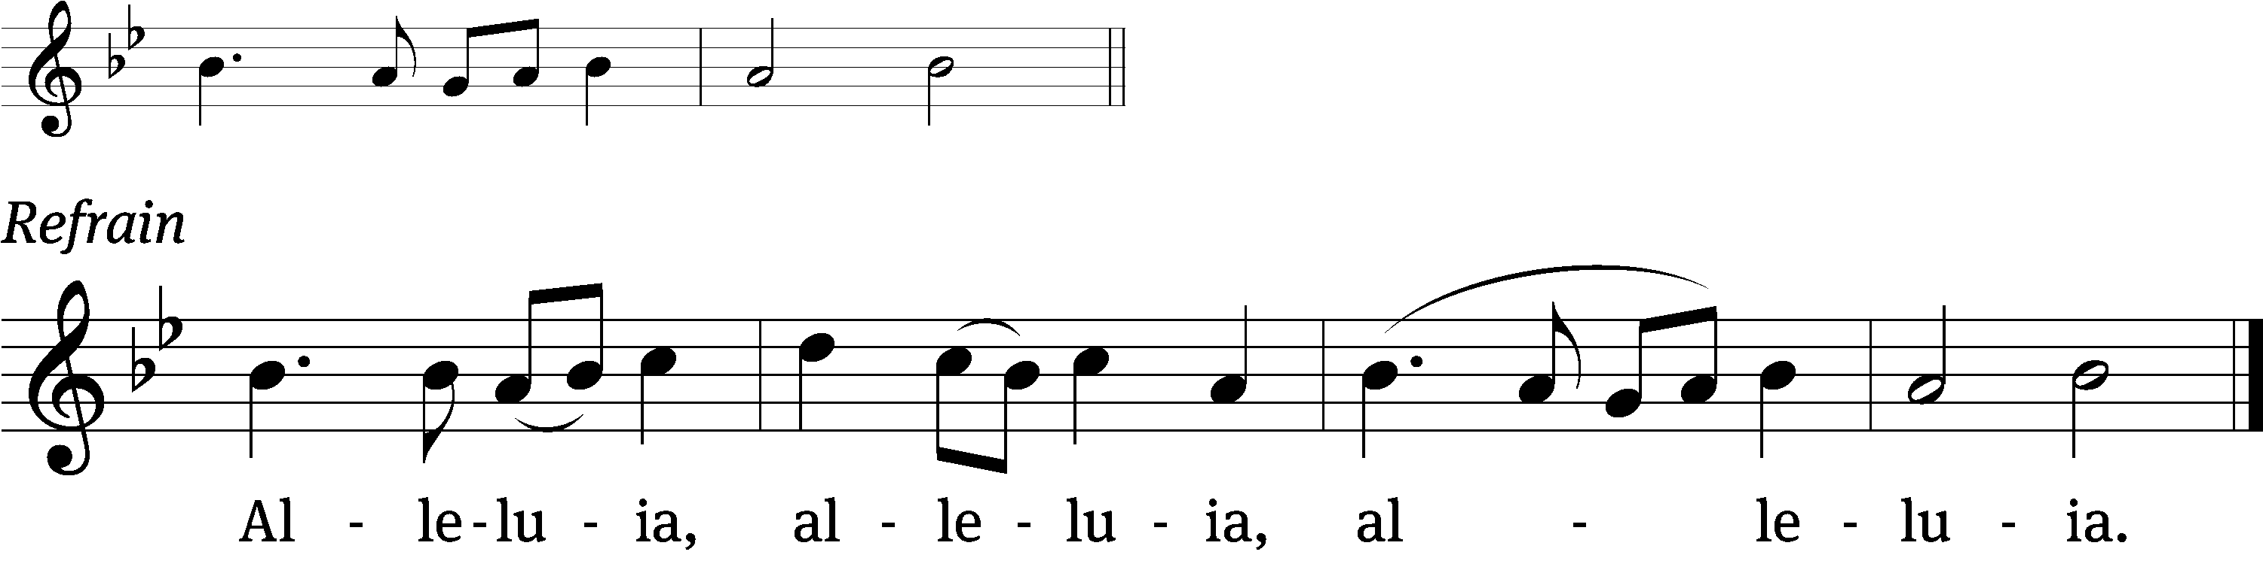
Since, then, you have been / raised with Christ,
Set your minds on things above, not / earthly things. Refrain

Gospel Matthew 13:44-52 (EHV)
“The kingdom of heaven is like a treasure hidden in a field, which a man found and hid again. In his joy, he goes away and sells all that he has and buys that field.
⁴⁵“Again, the kingdom of heaven is like a merchant seeking fine pearls. ⁴⁶When he found one very valuable pearl, he went and sold all that he had and bought it.
⁴⁷“Again, the kingdom of heaven is like a dragnet that was cast into the sea and gathered fish of every kind. ⁴⁸When the net was filled, they pulled it onto the shore. They sat down and gathered the good fish into containers, but threw the bad ones away. ⁴⁹That is how it will be at the end of the world. The angels will go out and separate the wicked from the righteous who are among them. ⁵⁰And they will throw the wicked into the fiery furnace where there will be weeping and gnashing of teeth.” ⁵¹Jesus said to them, “Did you understand all these things?”
They answered him, “Yes.”
⁵²He said to them, “Therefore every expert in the law who has been trained as a disciple in the kingdom of heaven is like the owner of a house who brings out of his treasure both new things and old things.”

FYI: The Forward In Christ has a commentary series about the parables. It supplies many ways to look at a parable. This month is about the The Good Samaritan.

Sermon Text: I Corinthians 1:10-17 (EHV)
Brothers, I am making an appeal to you using the name of our Lord Jesus Christ. I ask that you all express the same view and not have any divisions among you, but that you be joined together in the same mind and in the same judgment. ¹¹ For the news I heard about you, my brothers, from members of Chloe’s household, is that there are rivalries among you. ¹² What I mean is that each of you says, “I belong to Paul,” or “I belong to Apollos,” or “I belong to Cephas,” or “I belong to Christ.” ¹³ Is Christ divided? Was Paul crucified for you? Or were you baptized into the name of Paul? ¹⁴ I thank God that I did not baptize any of you except Crispus and Gaius, ¹⁵ so that no one can say that I baptized you into my own name. ¹⁶ (I also baptized the household of Stephanas. Besides them, I do not know whether I baptized anyone else.) ¹⁷ For Christ did not send me to baptize but to preach the gospel—not with the wisdom used in speeches, so that the cross of Christ would not be emptied of its power.

Sermon Theme: “A Fractured Family.”

OFFERING: The offerings are brought forward to the altar.

Keep in Your Prayers: Harley Dorsey, Allan Brooks, Matt Dubey, Eric Eckert, Myrtle Giese, Carol Henning, Nancy Kemnitz, Dennis Schliepp, Joan Stibb, Kathy Strook, Ginny Verch, Gary Wichman.

Announcements
Flowers: The flowers on the altar have been placed by Dick Kutz in commemoration of his 70 years of membership here at Mt. Zion.
Pastor Meier’s Bible Study: Pastor Meier is having a Bible Study on the 100 words from the Bible we should know. It is only a few minutes weekly Bible Study that will last a few Weeks. Come join him today after the July birthday celebration in the fellowship hall.
Birthdays: Our July birthday celebration will be TODAY. Please join us in the fellowship hall for fellowship, cake and beverages.

Sunday School: School will be starting on September 20th, the Sunday after Mt. Zion Fest. I am looking for one teacher to help with the Kindergarten class. Please take prayerful consideration to teach our young lambs God’s saving stories. Please contact Jo Meeker if you have questions or you are interested in teaching.

Timber Rattlers Game: There is a signup sheet available by the library. The game is August 21st. We will be using the food pavilion before the game. Brenda has the bus scheduled, we will leave the church by 4:45 with a stop at the park and ride area in Oshkosh. The cost will be $22 per person. PLEASE SIGN UP BY TODAY!! The tickets will be digital this year more information will be available.

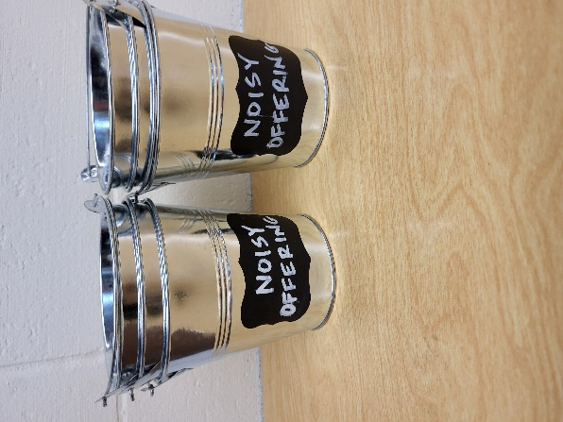
Noisy Offering: Please keep saving your spare change for our noisy offering on August 9th. Your offering will be given to Peace Lutheran School. The purpose of Peace Lutheran School is to provide Christ-centered education for our children. The school is a full-time educational institution, affording to every student a program which feeds the soul, the mind, and the body. We believe that an education without Christ is an education without foundation and purpose We have appreciated your support for our various projects and activities.

Mailbox and table: The July Forward In Christ is available and also the May 31, 2026-Aug. 29, 2026 Meditations are available. July (revised) calendars are also available.

For Your Information
Attendance 7/19/2026 66
Offerings for 7/19/2026 $2,170.31
Year to Date (thru June 30th).
Income : $95,902.17
Expenses : $87,946.43
Our planned budget for this time frame was $115,974.84.

Serving Our Lord

Thank you to everyone for your service to our Lord!

Ushers:

July 26 & Aug. 2: Tobin Storzer, Rick Retelle, Kelly Frank

Aug. 9 & 16: TJ Sitter, Adam Covach, Lyle Strook

PowerPoint:

July 26: Grunert family

Aug 2: Jo Meeker

July Communion Set up: Donna Mueller

July Communion Clean up: Jan Ohlrich, Deb Picciotino

Sunday 26th 9:00 AM Worship Service with Communion
10:15 AM July Birthday Celebration and Bible Study in the Fellowship Hall
Sunday 9:00 AM Worship Service
10:15 AM Bible Study Fellowship Hall

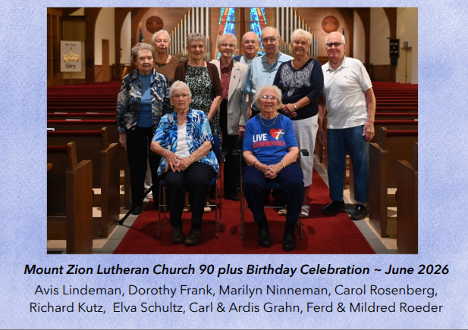

The only person missing was Myrtle Giese (102) due to a fall. She is doing better now.

UPCOMING EVENTS:
Saturday Aug. 29th: Bratfry at Hy-Vee
Zionfest Sunday Sept. 13 Following the service (More Information on the way.)
Check the August Calendar for more information

