EIGHTH SUNDAY AFTER PENTECOST

Mt. Zion Evangelical Lutheran Church

320 Mt. Zion Dr., Ripon, WI
www.mtzionripon.org
Facebook: Mt. Zion Evangelical Lutheran Church

Pastor Kurt Hagen (Vacancy Pastor)
Phone 651-764-3901
pastorhagen@gmail.com

Pentecost 8 July 19, 2026
Handicapped accessible restrooms are located upstairs next to the Pastor’s Study and downstairs next to the elevator.
Attendance: Please remember to sign the friendship pads. Registration for communion will continue as usual at the table. If you have any questions or concerns, please contact Mike Meeker.


Hearing Loop: Our sanctuary is equipped with a hearing loop system. Those who have compatible hearing aids (with a T-switch) will be able to hear the sound system directly into their ear(s). The two main seating areas and the choir area are looped so that you may sit in any of the three areas. We also have four receivers available for those who do not have compatible hearing aids. If you wish to use a receiver please ask the ushers. Those who wish may bring their own headphones or ear buds.

Thank you to our guest organist Dawn Panoch. Also thank you to Doug Jahnke and Barry Hay for donating their time to tune the organ.

Hymns: 488, 645, 612, 502

Order of Worship Setting One pg. 154

Psalm: 72B (Insert) A King on High Is Reigning

Reading: Isaiah 44:6-11 (EHV)
This is what the Lord, the King of Israel,
Israel’s Redeemer, the Lord of Armies, says.
I am the first, and I am the last.
Except for me, there is no god.
⁷For who is like me? Let him declare it.
Let him recite in order for me the things that took place
since the time I established an ancient people.
Or let them declare what is yet to come,
and what is going to take place.
⁸Do not tremble, and do not be frightened.
Did I not announce this to you,
and declare it already long ago?
You are my witnesses.
Is there any god except me?
There is no other Rock. I am not aware of any other.
⁹All those who form an idol are good for nothing.
All the things which delight them provide no benefit.
As for their witnesses—they do not see.
They know nothing, so they will be ashamed.
¹⁰Who is this who forms a god or casts a metal image that can provide no profit? ¹¹Look at him! All his associates will be ashamed. The craftsmen are merely men. Let them all gather themselves and take a stand. They will be terrified and ashamed together.

Reading: Romans 1:18-25 (EHV)
Indeed, God’s wrath is being revealed from heaven against all the ungodliness and unrighteousness of people who try to suppress the truth by unrighteousness. ¹⁹This happens because what can be known about God is evident among them, because God made it evident among them. ²⁰In fact, his invisible characteristics—his eternal power and divine nature—have been clearly seen since the creation of the world, because they are understood from the things he made. As a result, people are without excuse, ²¹because, even though they knew God, they did not honor him or give him thanks as God. Instead, their thinking became nonsense, and their senseless heart was darkened.
²²Although they claim to be wise, they have become fools ²³and exchanged the glory of the immortal God for images made to look like a mortal human, or like birds, four-footed animals, and crawling things. ²⁴So, as they followed the sinful desires of their hearts, God handed them over to the impurity of degrading their own bodies among themselves. ²⁵Such people have traded the truth about God for the lie, worshipping and serving the creation rather than the Creator, who is worthy of praise forever. Amen.

Gospel Acclamation
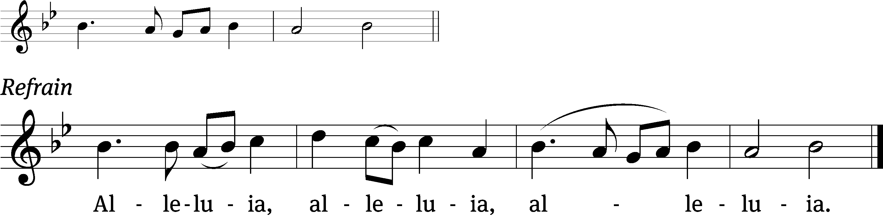
Oh, the depth of the riches of the wisdom and knowledge / of God!
How unsearchable his judgments, and his paths beyond / tracing out! Refrain

Gospel Matthew 13:24-30, 36-43 (EHV)
²⁴He presented another parable to them: “The kingdom of heaven is like a man who sowed good seed in his field. ²⁵But while people were sleeping, his enemy came and sowed weeds among the wheat and went away. ²⁶When the plants sprouted and produced heads of grain, the weeds also appeared. ²⁷The servants of the owner came and said to him, ‘Sir, did you not sow good seed in your field? Where did the weeds come from?’ ²⁸He said to them, ‘An enemy did this.’ The servants asked him, ‘Do you want us to go and gather up the weeds?’ ²⁹‘No,’ he answered, ‘because when you gather up the weeds, you might pull up the wheat along with them. ³⁰Let both grow together until the harvest, and at harvest time I will tell the reapers, “First, gather up the weeds, bind them in bundles, and burn them. Then, gather the wheat into my barn.”’”
³⁶Then Jesus sent the people away and went into the house. His disciples came to him and said, “Explain to us the parable of the weeds in the field.”
³⁷He answered them, “The one who sows the good seed is the Son of Man. ³⁸The field is the world. The good seeds are the sons of the kingdom. The weeds are the sons of the Evil One. ³⁹The enemy who sowed them is the Devil. The harvest is the end of the world. The reapers are angels. ⁴⁰Therefore, just as the weeds are gathered up and burned with fire, so it will be at the end of the world. ⁴¹The Son of Man will send out his angels, and they will pull out of his kingdom everything that causes sin and those who continue to break the law. ⁴²The angels will throw them into the fiery furnace where there will be weeping and gnashing of teeth. ⁴³Then the righteous will shine like the sun in the kingdom of their Father. Whoever has ears to hear, let him hear.”

FYI: The Forward In Christ has a commentary series about the parables. It supplies many ways to look at a parable. This month is about the The Good Samaritan.

Sermon Text: Psalm 119:105 (EHV)
Your words are a lamp for my feet and a light for my path.

Sermon Theme: “The Light of God’s Word Keeps Us on the Right Path.”

OFFERING: The offerings are brought forward to the altar.

Keep in Your Prayers: Harley Dorsey, Allan Brooks, Matt Dubey, Eric Eckert, Myrtle Giese, Carol Henning, Nancy Kemnitz, Dennis Schliepp, Joan Stibb, Kathy Strook, Ginny Verch, Gary Wichman.

Announcements
Flowers: The flowers on the altar have been placed by Allan and Janet Brooks in commemoration of their 55th wedding anniversary. The plant has been placed by Carl & Ardis Grahn for their 70th wedding anniversary and by Annette & Brian O’Hern for their 37th wedding anniversary. Congratulations to all our couples.

Birthdays: Our July birthday celebration will be Sunday July 26th. Please join us in the fellowship hall for fellowship, cake and beverages.
FYI: Nancy Kemnitz is now living in Texas near her daughter. Here is her address and phone number: 1620 Union Hill Rd, Ennis, TX 75119, 945-271-9758.

Sunday School: School will be starting on September 20th, the Sunday after Mt. Zion Fest. I am looking for one teacher to help with the Kindergarten class. Please take prayerful consideration to teach our young lambs God’s saving stories. Please contact Jo Meeker if you have questions or you are interested in teaching.

Timber Rattlers Game: There is a signup sheet available by the library. The game is August 21st. We will be using the food pavilion before the game. Brenda has the bus scheduled, we will leave the church by 4:45 with a stop at the park and ride area in Oshkosh. The cost will be $22 per person. PLEASE SIGN UP BY SUNDAY JULY 26TH. The tickets will be digital this year more information will be available.

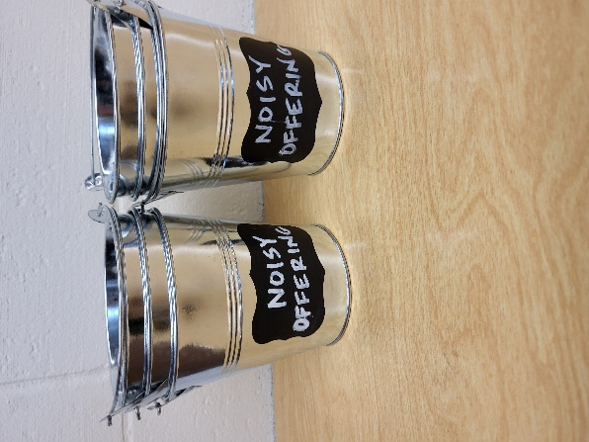
Noisy Offering: Please keep saving your spare change for our noisy offering on August 9th. Your offering will be given to Peace Lutheran School. The purpose of Peace Lutheran School is to provide Christ-centered education for our children. The school is a full-time educational institution, affording to every student a program which feeds the soul, the mind, and the body. We believe that an education without Christ is an education without foundation and purpose We have appreciated your support for our various projects and activities.

Mailbox and table: The July Forward In Christ is available and also the May 31, 2026-Aug. 29, 2026 Meditations are available. July (revised) calendars are also available.

For Your Information
Attendance 7/12/2026 82
Offerings for 7/12/2026 $1,534.00
Year to Date (thru June 30th).
Income : $95,902.17
Expenses : $87,946.43
Our planned budget for this time frame was $115,974.84.

Serving Our Lord

Thank you to everyone for your service to our Lord!

Ushers:

July 19: Terry Dolderer, Dawson Niemuth, Rick Niemuth

July 26 & Aug. 2: Tobin Storzer, Rick Retelle, Kelly Frank

Aug. 9 & 16: TJ Sitter, Adam Covach, Lyle Strook

PowerPoint:

July 12: Kari Hielke

July 19: Jan Ohlrich

July 26: Grunert family

Aug 2: Jo Meeker

July Communion Set up: Donna Mueller

July Communion Clean up: Jan Ohlrich, Deb Picciotino

Sunday 19th 9:00 AM Worship Service
10:15 AM Bible Study Fellowship Hall
Sunday 9:00 AM Worship Service with Communion
10:15 AM July Birthday Celebration
Bible Study Fellowship Hall
Thank you to Ken Hielke for making the wonderful tribute to our nation’s 250th anniversary. Also, to Robin Sitter, Ken and TJ for getting the fountain working again with a new water pump. The fountain was donated by Carol Rosenberg in memory of her husband Bob. Looks Great!
