6th Sunday of Pentecost

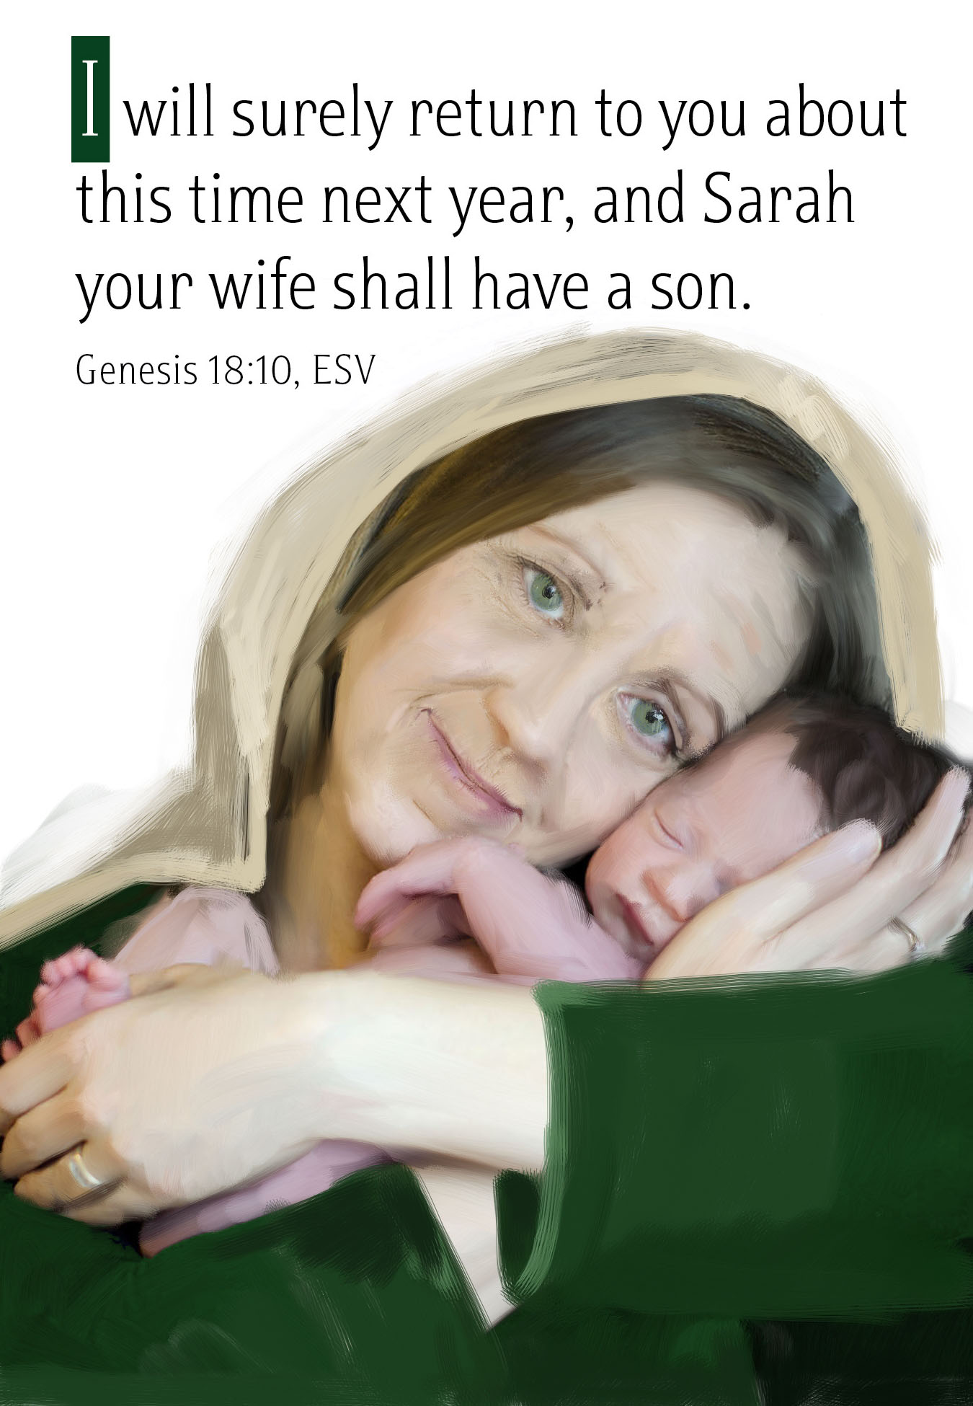
Mt. Zion Evangelical Lutheran Church
320 Mt. Zion Dr., Ripon, WI
www.mtzionripon.org
Facebook: Mt. Zion Evangelical Lutheran Church

Pastor Michael Sheppard
Pastor’s Study: 920-748-9734
E-mail: revmikesheppard@gmail.com
Pentecost 6 July 14 & July 17, 2022

Welcome to Mt. Zion!
Handicapped accessible restrooms are located upstairs next to the Pastor’s Study and downstairs next to the elevator.
Attendance: Please remember to sign the friendship pads. Registration for communion will continue as usual at the table. If you have any questions or concerns please contact Pastor Sheppard or Mark Roeder.

Please feel free to ask Pastor Sheppard any questions you may have concerning COVID-19. May the Lord be with us as we worship together at church. (The services will continue to be posted on Facebook, Rumble, and the church website, and available on DVD.)

Hearing Loop: Our sanctuary is equipped with a hearing loop system. Those who have compatible hearing aids (with a T-switch) will be able to hear the sound system directly into their ear(s). The two main seating areas and the choir area are looped so that you may sit in any of the three areas. We also have four receivers available for those who do not have compatible hearing aids. If you wish to use a receiver please ask the ushers. Those who wish may bring their own headphones or ear buds.

Prayer Before Worship: O Lord our Maker, Redeemer, and comforter, we assembled in your presence to hear your holy Word. We pray that you would open our hearts by your Holy Spirit, that through the preaching of your Word we may repent of our sins, believe in Jesus, and grow day by day in grace and holiness. Hear us for Jesus’ sake. Amen

Hymns: 806, 645, 739, 803

Order of Worship: The Service CW21 pg. 154

First Reading & Sermon Text: Genesis 18: 1-14 (EHV)
The Lord appeared to Abraham by the oaks of Mamre, as he was sitting by the door to his tent during the heat of the day. ²Abraham looked up, and he saw three men standing in front of him. When he saw them, he ran from the tent door to meet them, and he bowed down to the ground. ³He said, “My lord, if I have now found favor in your sight, please do not pass your servant by. ⁴Now let me get a little water so that all of you can wash your feet and rest under the tree. ⁵Let me get some bread so that you can refresh yourselves. After that you may go your way. That is why you have come to your servant.”
They said, “Yes, do as you have said.”
⁶Abraham hurried into the tent to Sarah and said, “Quickly prepare twenty quarts of fine flour, knead it, and make some loaves of bread.” ⁷Abraham ran to the herd, brought a good, tender calf, and gave it to the servant. He hurried to prepare it. ⁸He took cheese curds, milk, and the calf that he had prepared and set it before them. He stood beside them under the tree while they ate.
⁹They asked him, “Where is Sarah, your wife?”
He said, “She is over there in the tent.”
¹⁰One of the men said, “I will certainly return to you when this season comes around next year. Then Sarah your wife will have a son.”
Sarah was listening to this from the tent door, which was behind him. ¹¹Now Abraham and Sarah were old, well into old age. Sarah was past the age for childbearing. ¹²Sarah laughed to herself, saying, “After I am worn out, will I have pleasure, since my lord is also old?”
¹³The Lord said to Abraham, “Why did Sarah laugh and say, ‘Will I really give birth to a child though I am old?’ ¹⁴Is anything impossible for the Lord? At the set time next year I will return to you, and Sarah will have a son.”

Teach Me, O Lord Psalm 119B

Second Reading: Colossians 1: 1-14 (EHV)
Paul, an apostle of Christ Jesus by the will of God, and Timothy our brother,
²To the holy and faithful brothers in Christ at Colossae:
Grace to you and peace from God our Father.
³We always thank God, the Father of our Lord Jesus Christ, when we pray for you, ⁴because we have heard of your faith in Christ Jesus and the love that you have for all the saints ⁵because of the hope that is stored up for you in heaven. You have already heard about this in the word of truth, the gospel ⁶that is present with you now. The gospel is bearing fruit and growing in the entire world, just as it also has been doing among you from the day you heard it and came to know the grace of God in truth. ⁷You learned this from Epaphras, our dear fellow servant, who is a faithful minister of Christ on your behalf. ⁸He is the one who told us about your love in the Spirit.
⁹For this reason, from the day we heard about your love, we also have not stopped praying for you. We keep asking that you would be filled with the knowledge of his will in all wisdom and spiritual understanding, ¹⁰so that you might live in a way that is worthy of the Lord. Our goal is that you please him by bearing fruit in every kind of good work and by growing in the knowledge of God, ¹¹as you are being strengthened with all power because of his glorious might working in you. Then you will have complete endurance and patience, joyfully ¹²giving thanks to the Father, who qualified us to share in the inheritance of the saints in the kingdom of light.
¹³The Father rescued us from the domain of darkness and transferred us into the kingdom of the Son he loves, ¹⁴in whom we have redemption, the forgiveness of sins.

Gospel: Luke 10: 38-42 (EHV)
As they went on their way, Jesus came into a village, and a woman named Martha welcomed him into her home. ³⁹She had a sister named Mary, who was sitting at the Lord’s feet and was listening to his word. ⁴⁰But Martha was distracted with all her serving. She came over and said, “Lord, don’t you care that my sister has left me to serve alone? Tell her to help me.”
⁴¹The Lord answered and told her, “Martha, Martha, you are worried and upset about many things, ⁴²but one thing is needed. In fact, Mary has chosen that better part, which will not be taken away from her.”

The Holy Bible, Evangelical Heritage Version® (EHV®)
copyright © 2018 The Wartburg Project. All rights reserved. www.wartburgproject.org

Sermon Theme: “The Lord Gives Us What We Need.”

OFFERING: The offerings are brought forward to the altar.

Announcements
Voter’s Meeting: The next meeting will be held July 24th after the church service in the fellowship hall.

Sunday School: We are in need of a teacher for the 7th and 8th grades starting this fall. Please talk to Pastor Sheppard or Jo Meeker if you are interested.

Timber Rattlers Game: Once again this year we will be attending a TimberRattler's game. The date is Friday, August 12. Gates open at 5pm, supper will be served beginning at 7pm and includes BBQ grilled chicken breast, hotdogs, BBQ pulled pork, baked beans, chips, pasta salad, dessert, and 2 beverages. The cost will be $29 for adults, pending some kind of discount. Price for childrens' tickets is yet to be determined. Please sign up on the sheet on the bulletin board by the office, and watch the bulletin for added details.

Red Hymnals: It was decided that whoever would like to take one or more old hymnals home may do so at no cost. They are located on the table by the entrance to the sanctuary. Please feel free to take.

Birthday Celebration: Cake will be served Today to celebrate the birthdays for July.
Mailbox and table: The July Forward In Christ is available and also the May 29th, 2022-August 27th, 2022 Meditations are available.
If you would like the Lord’s Supper privately, please contact Pastor Sheppard on his cell 920-745-0883, or by email revmikesheppard@gmail.com.

The Helping Hands Ministry is ready to serve the needs of our members. Please contact one of the following if you or someone you know needs assistance: Joanne Gregor at 920-896-1518, Lisa Tremore at 920-229-1297 or Tammy Niemuth at 920-299-0240.

For Your Information
Attendance 7/3 - 7/10/2022 100
Offerings for 7/3 - 7/10/2022: $3,927.50*
*$165.00 given in memory of Betty Rohde

Serving Our Lord

Thank you to everyone for your service to our Lord!

Ushers:

July 17: Tim Lynch, Logan Lynch, TJ Sitter, Travis Schmudlach

July 24 & 31: Ken Hielke, Todd Zellmer, Jonathan Zellmer, Dustin Zellmer

PowerPoint:

July 14: Jo Meeker

July 17: Jan Ohlirch

July 21: Jo Meeker

July 24: Arjeta Rushani

July Communion Set up: Mary Clement

July Communion Clean up: Sue Sheppard

This week at Mt. Zion
Sunday (17th) 9:00 AM Worship
Tuesday 6:30 PM Sunday School Teachers Meeting
Thursday 6:30 PM Worship
Sunday 9:00 AM Worship

Secretary Jo Meeker
Church Office: 920-748-5641
Office Hours: Mon. 9-12, Tues. & Wed. 9-11
E-mail: mountzionripon@gmail.com

Acknowledgments
Unless otherwise indicated, Scripture quotations are from The Holy Bible, New International Version®, NIV®. Copyright © 1973, 1978, 1984, 2011 by Biblica, Inc.TM Used by permission of Zondervan. All rights reserved worldwide.
Software distributed in partnership with Northwestern Publishing House.
Created by Christian Worship: Service Builder © 2022 Concordia Publishing House.

