SUNDAY OF PENTECOST
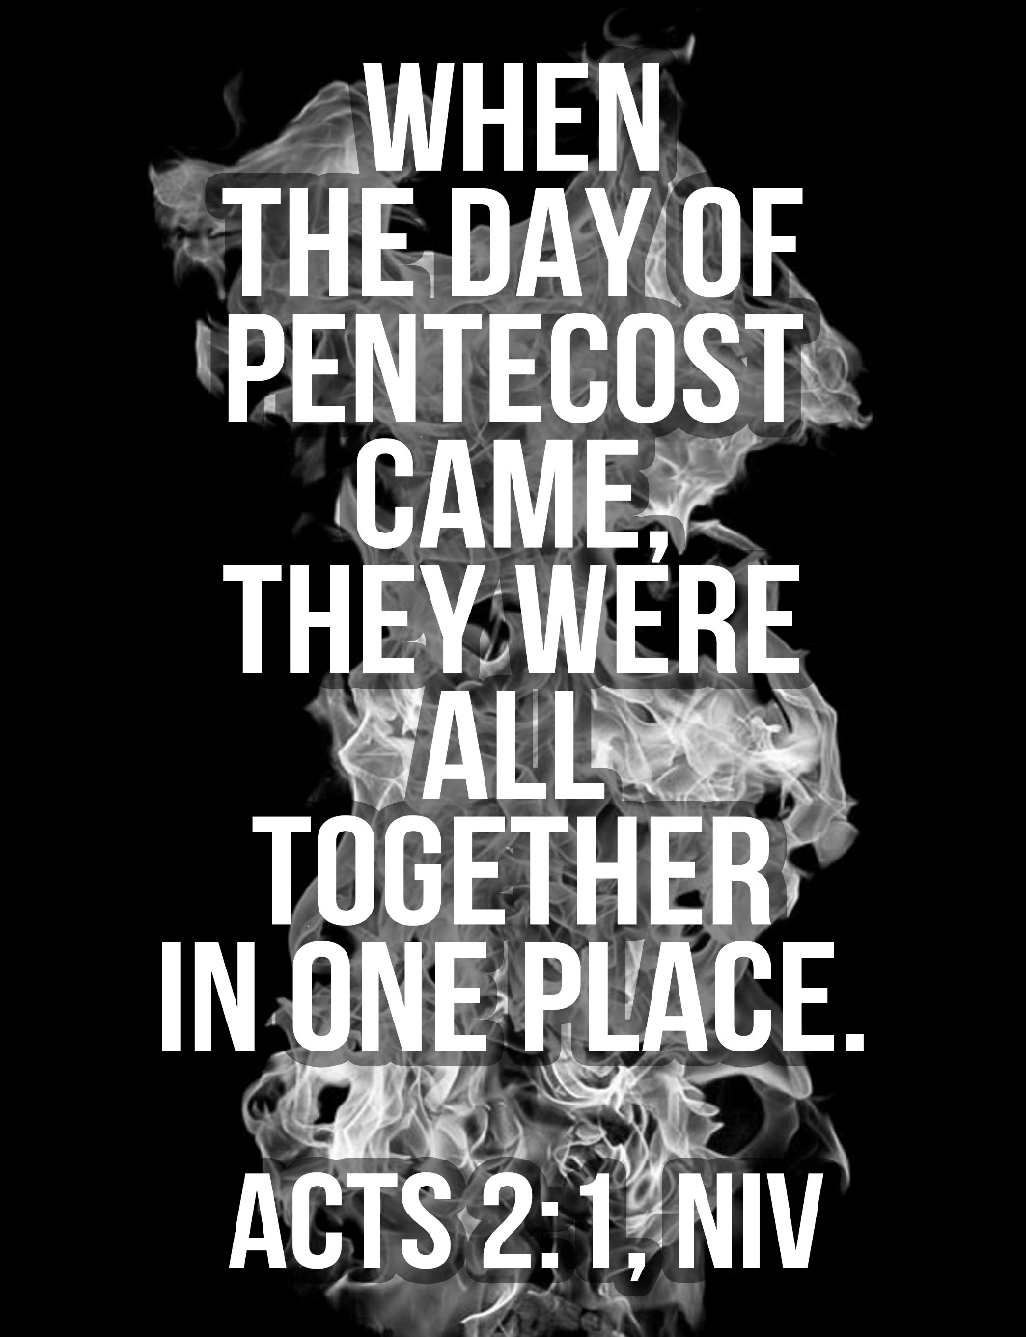
Mt. Zion Evangelical Lutheran Church

320 Mt. Zion Dr., Ripon, WI
www.mtzionripon.org
Facebook: Mt. Zion Evangelical Lutheran Church

Pastor Kurt Hagen (Vacancy Pastor)
Phone 651-764-3901
pastorhagen@gmail.com

Pentecost Sunday May 23, 2026
Handicapped accessible restrooms are located upstairs next to the Pastor’s Study and downstairs next to the elevator.
Attendance: Please remember to sign the friendship pads. Registration for communion will continue as usual at the table. If you have any questions or concerns, please contact Mike Meeker.


Hearing Loop: Our sanctuary is equipped with a hearing loop system. Those who have compatible hearing aids (with a T-switch) will be able to hear the sound system directly into their ear(s). The two main seating areas and the choir area are looped so that you may sit in any of the three areas. We also have four receivers available for those who do not have compatible hearing aids. If you wish to use a receiver please ask the ushers. Those who wish may bring their own headphones or ear buds.

A note for our visitors on member communion –
Out of sincere love for the truth of God’s Word and for precious human souls, we practice member communion in our synod and congregation. This teaching, as practiced by the Church for centuries, is thoroughly Scriptural. It questions the faith of no individual yet asks that there be full doctrinal agreement between those who commune. For this reason, we ask that only those who are members of a WELS or ELS congregation join us for the Lord’s Supper. If you wish to commune with us please speak with the pastor before the service. The Lord’s Supper will be celebrated for those who desire it. The front row on the pulpit side is reserved for people who are unable to navigate the steps. Pastor will serve you Communion first.

Prayer Before Communion: Lord Jesus, I thank you for the gift of your Holy Supper. As I come to your table, work true repentance in my heart. Teach me to confess my sins and to believe that I am forgiven for your sake. May your body and blood, in and with the bread and wine, nourish my faith and strengthen my will to live in a way that is pleasing to you. Help me see what a blessing your sacrament is for my soul, and lead me to your altar often to receive your forgiveness. Amen.

Hymns: 585, 586, (783), 596

Pastor Hagen is conducting this evening’s service.
Guest Organist is Doug Jahnke

Order of Worship Setting One pg. 154

First Reading: Acts 2:1-21 (EHV)
When the day of Pentecost came, they were all together in one place. ²Suddenly a sound like the rushing of a violent wind came from heaven, and it filled the whole house where they were sitting. ³They saw divided tongues that were like fire resting on each one of them. ⁴They were all filled with the Holy Spirit and began to speak in other languages, since the Spirit was giving them the ability to speak fluently.
⁵Now there were godly Jewish men from every nation under heaven living in Jerusalem. ⁶When this sound was heard, a crowd came together and was confused, because each one heard them speaking in his own language. ⁷They were completely baffled and said to each other, “Look, are not all these men who are speaking Galileans? ⁸Then how is it that each of us hears them speaking in his own native language? ⁹Parthians, Medes, and Elamites; residents of Mesopotamia, and of Judea, Cappadocia, Pontus and Asia, ¹⁰Phrygia and Pamphylia, Egypt, and the parts of Libya around Cyrene; visitors from Rome, both Jews and proselytes; ¹¹Cretans and Arabs—we hear them declaring in our own languages the wonderful works of God.” ¹²They were all amazed and perplexed. They kept saying to one another, “What does this mean?” ¹³But others mocked them and said, “They are full of new wine.”
¹⁴Then Peter stood up with the Eleven, raised his voice, and spoke loudly and clearly to them: “Men of Judea, and all you residents of Jerusalem, understand this, and listen closely to my words. ¹⁵These men are not drunk, as you suppose, for it is only the third hour of the day. ¹⁶On the contrary, this is what was spoken by the prophet Joel:
¹⁷This is what God says will happen in the last days:
I will pour out my Spirit on all flesh.
Your sons and your daughters will prophesy.
Your young men will see visions.
Your old men will dream dreams.
¹⁸Even on my servants, both men and women,
I will pour out my Spirit in those days,
and they will prophesy.
¹⁹I will show wonders in the sky above,
and signs on the earth below,
blood and fire and a rising cloud of smoke.
²⁰The sun will be turned to darkness
and the moon to blood
before the coming of the great and glorious day of the Lord.
²¹And this will happen: Everyone who calls on the name of the Lord will be saved.

Psalm: 104A Lord, Send Out Your Spirit

Second Reading: I Corinthians 12:3-11 (EHV)
Therefore I am informing you that no one speaking by God’s Spirit says, “A curse be upon Jesus,” and no one can say, “Jesus is Lord,” except by the Holy Spirit.
⁴There are various kinds of gifts, but the same Spirit. ⁵There are different kinds of ministries, and yet the same Lord. ⁶There are various kinds of activity, but the same God, who produces all of them in everyone.
⁷Each person is given a manifestation of the Spirit for the common good. ⁸To one person a message of wisdom is given by the Spirit; to another, a message of knowledge, as the same Spirit provides it; ⁹by the same Spirit, faith is given to someone else; and to another, the same Spirit gives healing gifts. ¹⁰Another is given powers to do miracles; another, the gift of prophecy; another, the evaluating of spirits; someone else, different kinds of tongues; and another, the interpretation of tongues. ¹¹One and the same Spirit produces all of these, distributing them to each one individually as he desires.

Gospel Acclamation
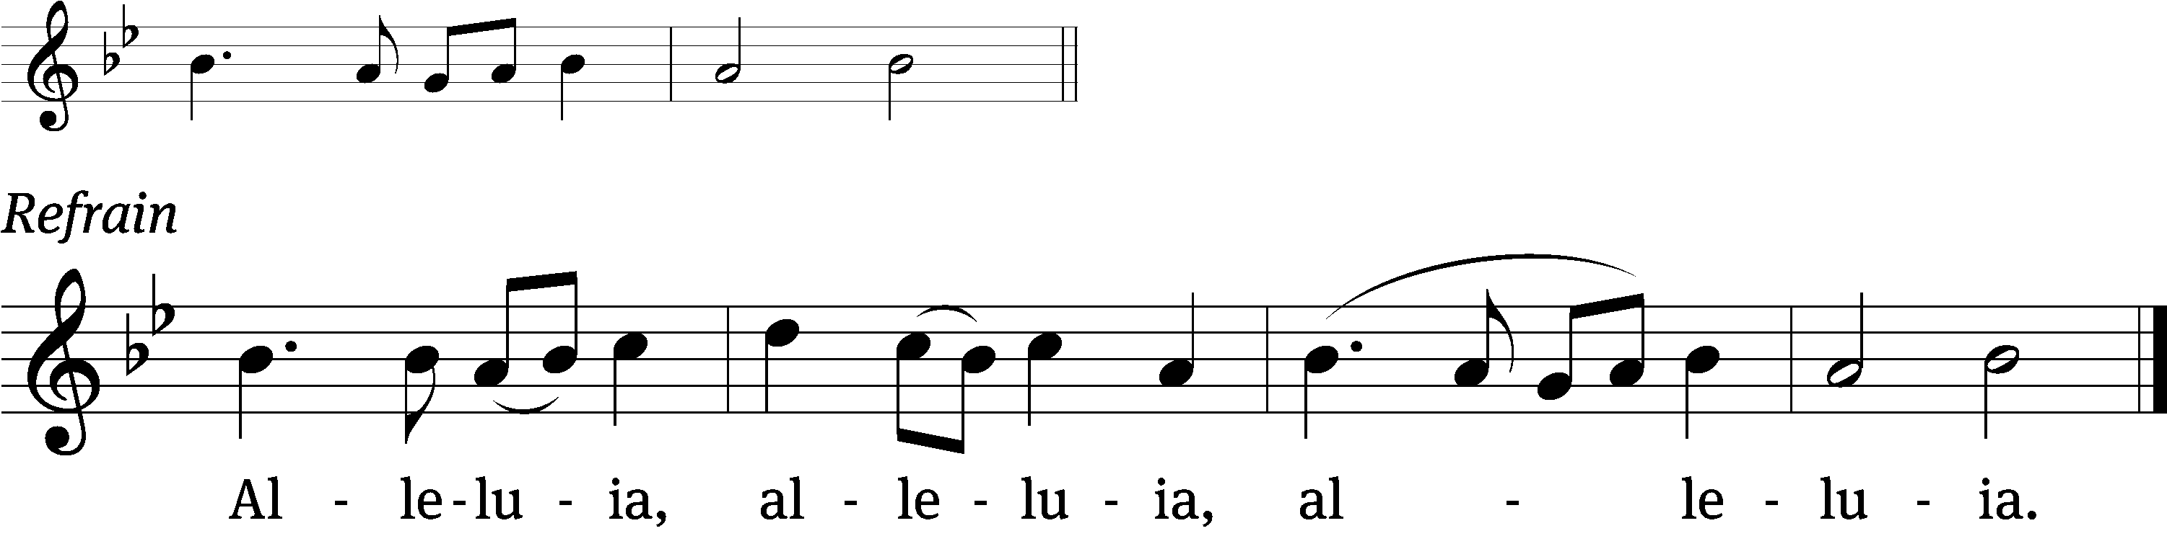
Come, Holy Spirit, fill the hearts of your faithful / people,
And kindle in them the fire /of your love. (Refrain)

Gospel Reading & Sermon Text: John 7:37-39 (EHV)
On the last and most important day of the festival, Jesus stood up and called out, “If anyone is thirsty, let him come to me and drink! ³⁸As the Scripture has said, streams of living water will flow from deep within the person who believes in me.” ³⁹By this he meant the Spirit, whom those who believed in him were going to receive. For the Holy Spirit had not yet come, because Jesus had not yet been glorified.

Sermon Theme: “Receive Jesus’ Gifts to Stay Faithful to Him.”

OFFERING: The offerings are brought forward to the altar.

Keep in Your Prayers: Harley Dorsey, Matt Dubey, Carol Henning, Nancy Kemnitz, Ginny Verch, Gary Wichman.

Announcements
Celebrating Our Graduates: We joyfully recognize and celebrate our graduates this month: Christian Grunert from Ripon College, Miya Grunert from Moraine Park Technical College, and Paige Wichman and Isaac Stollfuss from Ripon High School. We wish them all the best and pray for God’s richest blessings as they begin this exciting new chapter in their

lives!

The June 6th “Noisy Offerings will be for Lutheran Military Support Group. The Lutheran Military Support Group (LMSG) is a Christ-centered organization that provides support to military service members, veterans, and their families. LMSG aims to offer practical support and resources to those in need, celebrating its commitment to serving the military community. As always, we appreciate your generous contributions.
Lutheran Military Support Group Ammo Can Campaign – Each May and November, Lutheran Military Support Group (LMSG) seeks donations in support of our military men, women, and families. LMSG, a partnership of ELS and WELS Veterans, is working to grow awareness of and bring Christian support to our Christian Warriors and their families in our congregations. By placing your gift in the Ammo Can located (in the narthex, on the table by the office) starting TODAY, you are supporting the spiritual and mental health of our Christian Warriors through programs like our retreats and workshops, educational support for pastors serving military families, Veterans pursuing a second career in public ministry, and more. Visit www.lutheranmilitary.org for more information. Thank you for standing Shoulder to Shoulder in Service with those who serve our Nation!

Mailbox and table: The May Forward In Christ is available and also the May 31, 2026-May 30, 2026 Meditations are available. May calendars are also available.

If you would like the Lord’s Supper privately, please contact Pastor Kurt Hagen at 651-764-3901, or by email pastorkhagen@gmail.com.

The Helping Hands Ministry is ready to serve the needs of our members. Please contact one of the following if you or someone you know needs assistance: Joanne Gregor at 920-896-1518 and Lisa Tremore at 920-229-1297.
For Your Information
Attendance 5/16/2026 63
Offerings for 5/16/2026 $2,663.32
Year to Date (thru April 25th).
Income : $53,115.85
Expenses : $68,289.50
Shortfall: $15,173.65
Our planned budget for this time frame was $77,316.56.

Serving Our Lord

Thank you to everyone for your service to our Lord!

Ushers:

May 23: Dave Smith, Josh Niemuth, Justin Niemuth

May 30 & June 6: Mark Roeder, Ferd Roeder, Jason Roeder

June 13 & 20: Gary Quade, Travis Schmudlach, Kyle Stollfuss

PowerPoint:

May 23: Jean Lynch

May 30: Jo Meeker

June 6: Jo Meeker

May Communion Set up: Robin Sitter

May Communion Clean up: Jan Ohlrich, Deb Picciotino

Saturday (23rd) 5:00 PM Worship with Communion
Monday & Tuesday Church Office will be closed
Thursday 9:00 AM Women’s Bible Study
Saturday (5/23) 5:00 PM Worship Service with Communion

