FOURTH SUNDAY AFTER PENTECOST
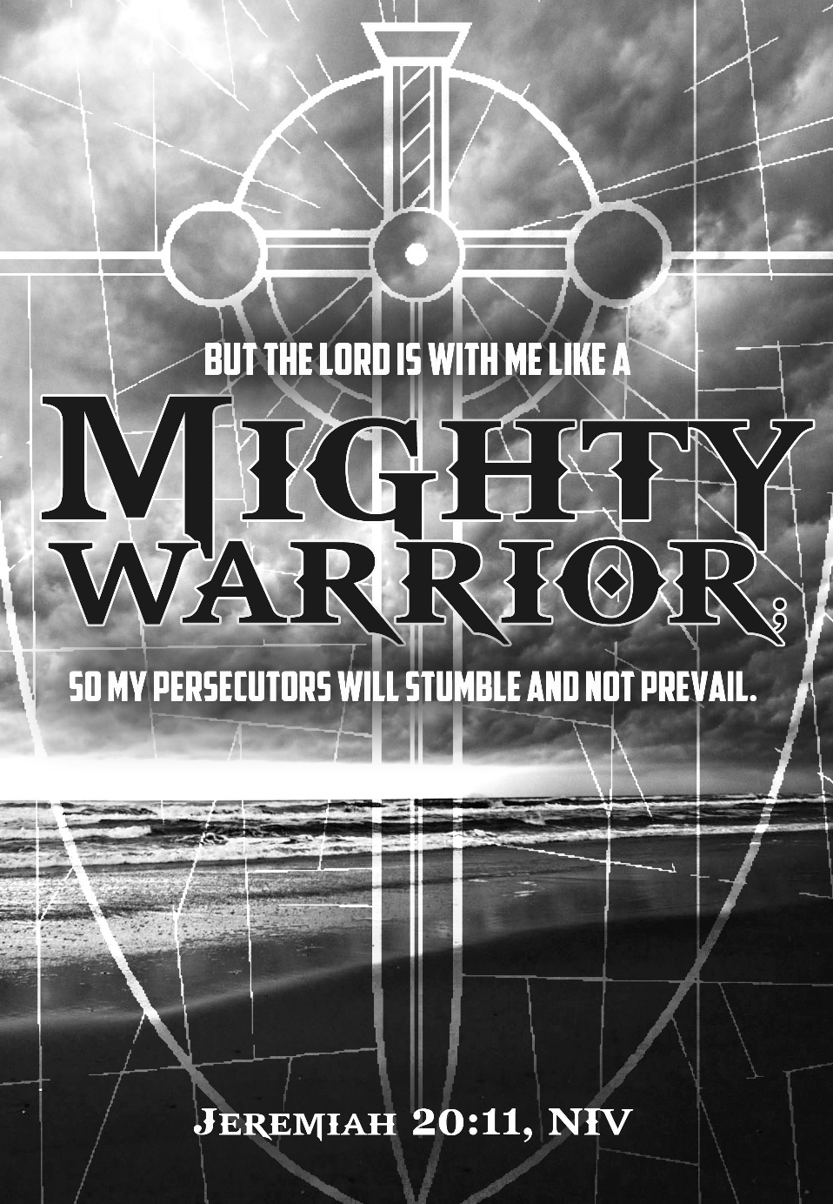
Mt. Zion Evangelical Lutheran Church

320 Mt. Zion Dr., Ripon, WI
www.mtzionripon.org
Facebook: Mt. Zion Evangelical Lutheran Church

Pastor Kurt Hagen (Vacancy Pastor)
Phone 651-764-3901
pastorhagen@gmail.com

Pentecost 4 June 21, 2026
Handicapped accessible restrooms are located upstairs next to the Pastor’s Study and downstairs next to the elevator.
Attendance: Please remember to sign the friendship pads. Registration for communion will continue as usual at the table. If you have any questions or concerns, please contact Mike Meeker.


Hearing Loop: Our sanctuary is equipped with a hearing loop system. Those who have compatible hearing aids (with a T-switch) will be able to hear the sound system directly into their ear(s). The two main seating areas and the choir area are looped so that you may sit in any of the three areas. We also have four receivers available for those who do not have compatible hearing aids. If you wish to use a receiver please ask the ushers. Those who wish may bring their own headphones or ear buds.

Hymns: 621, 694, 862

Order of Worship Morning Prayer pg. 207

Psalm: 91D (See Insert) On Eagle’s Wings

Reading 2 Timothy 4:1–8
I solemnly charge you in the presence of God and Christ Jesus, who is going to judge the living and the dead, and in view of his appearing and his kingdom: ²Preach the word. Be ready whether it is convenient or not. Correct, rebuke, and encourage, with all patience and teaching. ³For there will come a time when people will not put up with sound doctrine. Instead, because they have itching ears, they will accumulate for themselves teachers in line with their own desires. ⁴They will also turn their ears away from the truth and will turn aside to myths.
⁵As for you, keep a clear head in every situation. Bear hardship. Do the work of an evangelist. Fulfill your ministry.
⁶You see, I am already being poured out like a drink offering, and the time of my departure has come. ⁷I have fought the good fight; I have finished the race; I have kept the faith. ⁸From now on, there is reserved for me the crown of righteousness. The Lord, the righteous Judge, will give it to me on that day, and not only to me but also to everyone who loved his appearing.

Reading: Matthew 10:5a, 21-33 (EHV)
⁵Jesus sent these twelve out and commanded them,
²¹“Brother will hand over his brother to death, and a father will do the same with his child. Children will rise up against parents and have them put to death. ²²You will be hated by all people because of my name, but whoever endures to the end will be saved. ²³And when they persecute you in one town, flee to the next. Amen I tell you: You will not finish going through the cities of Israel before the Son of Man comes.
²⁴“A disciple is not above his teacher, nor is a servant above his master. ²⁵It is enough for the disciple to be like his teacher and the servant like his master. If the master of the house was called Beelzebul, how much more the members of his household!
²⁶“So do not be afraid of them, because there is nothing concealed that will not be revealed, and nothing hidden that will not be made known. ²⁷What I tell you in the dark, speak in the daylight; and what you hear whispered in your ear, proclaim from the housetops. ²⁸Do not fear those who kill the body but cannot kill the soul. Rather, fear the one who is able to destroy both soul and body in hell.
²⁹“Are not two sparrows sold for a small coin? Yet not one of them will fall to the ground without the knowledge and consent of your Father. ³⁰And even the hairs of your head are all numbered. ³¹So do not be afraid. You are worth more than many sparrows.
³²“Everyone who confesses me before others, I will also confess before my Father who is in heaven. ³³But whoever denies me before others, I will also deny before my Father who is in heaven.”

Reading & Sermon Text: Jermiah 20:7-13 (EHV)
You persuaded me, Lord, and I agreed to it.
You are stronger than I am, and you won out.
I have become a laughingstock all day long,
and everyone is mocking me.
⁸Whenever I speak, I cry out.
I cry out, “Violence and destruction!”
But the word of the Lord has brought scorn on me.
I am mocked all day long.
⁹If I say, “I will not mention him
or speak in his name anymore,”
then there is a burning fire in my heart,
shut up in my bones,
and I am weary of holding it in.
I cannot!
¹⁰I hear many whispering,
“Terror on every side!”
All my close friends,
those who are watching for my fall, say,
“Denounce him! Let’s denounce him.
Perhaps he can be pressured into making a mistake.
Then we will have the upper hand against him,
and we will take our revenge on him.”
¹¹But the Lord is with me like a terrifying warrior.
So my persecutors will stumble,
and they will not gain the upper hand.
They will be put to shame completely,
because they have not been successful.
Their eternal disgrace will never be forgotten.
¹²Lord of Armies, you test the righteous.
You see the heart and the mind.
Let me see your vengeance on them,
for I have laid out my case before you.
¹³Sing to the Lord!
Praise the Lord,
for he has delivered the life of the needy
from the hand of the wicked.

Sermon Theme: “God, We Need to Talk.”

OFFERING: The offerings are brought forward to the altar.

Keep in Your Prayers: Harley Dorsey, Matt Dubey, Eric Eckert, Carol Henning, Nancy Kemnitz, Ginny Verch, Gary Wichman.

Announcements
ATTN. MT. ZION CONGREGATION: Please check your mailboxes for a letter from Pastor Hagen. USHERS: Your July to December schedule is in your mailboxes please pick one up so you don’t miss your dates.

Mt. Zion Congregation: I am beyond grateful for each and every one of you! What a blessing it is to be surrounded by such love and kindness. I appreciate the offerings that were brought out of generosity and care. Thank you for letting your Christian light shine and helping not only me but many others. It goes to show that God’s work is being done and carried out just as he intended, by regularly giving to the church. Thank you again! God’s Blessings, Gracie Niemuth

NOISY OFFERING: Thank you for your generous donation of $294.49 supporting Lutheran Military Support Group. Due to the Fourth of July holiday, the next “Noisy Offering” will be July 12th. Your donations will go to WLA (Winnebago Lutheran Academy).

Mt. Zion Bible Sisters: Despite a separation of thousands of years and miles, we’re much more like them than we first realize. This summer, you’re invited to join women’s Ministry for an online Bible study focusing on “Our Bible Sisters.” Throughout this five week series. We’ll look at more than just the heroic actions of biblical women. We’ll consider how our unchanging God met these flawed, real women in their daily struggles and learn to find his grace, faithfulness, and purpose in our own daily realities. The study is offered twice each week 8:00 am on Saturday morning and 7:00 pm on Monday evenings starting July 11th. To signup go to Wels.net and find Women’s Ministry it will show you how to register.

Birthday Celebration: We will be celebrating November -June birthdays next Sunday the 28th. We would like to especially honor our members 90 years old and older. Dorothy Frank, Carl & Ardis Grahn, Dick Kutz, Avis Lindeman, Marilyn Ninneman, Ferd Roeder, Carol Rosenberg and Myrtle Giese (102)

WLA News: We are excited to share that visible activity will begin on the new campus site in mid-June. Crews will start moving dirt and preparing the property for the next steps toward our new campus. Throughout the summer, site work will continue with grading, utility installation, and other critical infrastructure improvements. This work is an important step in preparing the site for a groundbreaking anticipated in spring 2027, contingent upon reaching our funding goals.
These first visible signs of progress represent years of planning, prayer, and preparation. What has long been a vision for the future is now becoming a reality, and the upcoming work marks an important milestone in the journey toward a new campus. To learn more about the project and opportunities to support the mission, please contact Kevin Ehlke at WLA.


The Northern Wisconsin District of WELS gathered June 9–10 at Fox Valley Lutheran High School in Appleton for its Fifty-Fifth Biennial Convention under the theme Joy Made Strong. Drawn from Nehemiah 8:10, “The joy of the LORD is your strength,” the theme commemorated the 350th anniversary of the death of Lutheran hymn writer Paul Gerhardt. Though Gerhardt endured war, loss, and hardship, his hymns continue to testify to the enduring joy found in Christ. Through worship, devotions, and presentations, delegates were reminded that Christian joy is rooted not in circumstances but in the Savior who conquered sin, death, and the devil. Convention worship reinforced that message with meditations on Christ’s presence in suffering, Christian love, and the confidence that Fear Can’t Win because God is for us.
Special presentations expanded on the convention theme and its application to ministry today. Pastor Paul Prange explored Gerhardt’s life and legacy, highlighting how the theology of the cross shaped both his faith and hymn writing. Pastor Mike Helwig addressed mental health in Christian leadership, offering biblical encouragement and practical guidance for recognizing and responding to mental and emotional distress. Each presentation was well received by attendees.

Delegates and guests also heard encouraging reports from WELS ministries, schools, and agencies. Home Missions highlighted continued progress in the “100 Missions in 10 Years” initiative, while district leaders shared updates on local mission work, campus ministry, Christian giving, and the training of future pastors, teachers, and staff ministers.
The convention also conducted the business necessary to support the district’s ministry in the years ahead. Pastor Kevin Westra was elected as the new District President, succeeding Pastor Joel Zank after twelve years of faithful service in that office. Delegates adopted resolutions supporting continuing education, mentoring, and leadership development for called workers and congregations. The convention concluded with expressions of thanks for God’s many blessings, support for mission congregations, and the installation of district officers and circuit pastors. Throughout the gathering, delegates were strengthened by God’s Word and left encouraged to carry out the work of sharing the gospel with confidence, knowing that the joy of the Lord remains the strength of his people.

For video and print copies of the two keynote essays, detailed minutes of convention proceedings and more, visit the convention website at https://sites.google.com/view/nwidc.

Mailbox and table: The June Forward In Christ is available and also the May 31, 2026-Aug. 29, 2026 Meditations are available. June calendars are also available.

If you would like the Lord’s Supper privately, please contact Pastor Kurt Hagen at 651-764-3901, or by email pastorkhagen@gmail.com.

The Helping Hands Ministry is ready to serve the needs of our members. Please contact one of the following if you or someone you know needs assistance: Joanne Gregor at 920-896-1518 and Lisa Tremore at 920-229-1297.
For Your Information
Attendance 6/13/2026 51
Offerings for 6/13/2026 $13,849.49
Year to Date (thru May 31st).
Income : $69,770.17
Expenses : $76,609.15
Shortfall: -$6,838.98
Our planned budget for this time frame was $96,645.70.

Serving Our Lord

Thank you to everyone for your service to our Lord!

Ushers:

June 21: Gary Quade, Travis Schmudlach, Kyle Stollfuss

June 28 & July 5: Steve Ohlrich, Derek Chitwood, Alex Kranz

PowerPoint:

June 21: Jo Meeker

June 28: Jo Meeker

July 5: Grunert family

July 12: Keri Heilke

June Communion Set up: Donna Mueller

June Communion Clean up: Jan Ohlrich, Deb Picciotino

SUNDAY (21ST) 9:00 am Worship Service
Sunday 28th 9:00 AM Worship Service with Communion

Upcoming: A Call meeting is scheduled for July 12th at 2:30 PM in the sanctuary
Sunday July 12th: A pre-voters’ meeting will be held following the church service.
Sunday July 19th: Quarterly Voters’ Meeting following the church service.

