23rd SUNDAY OF PENTECOST
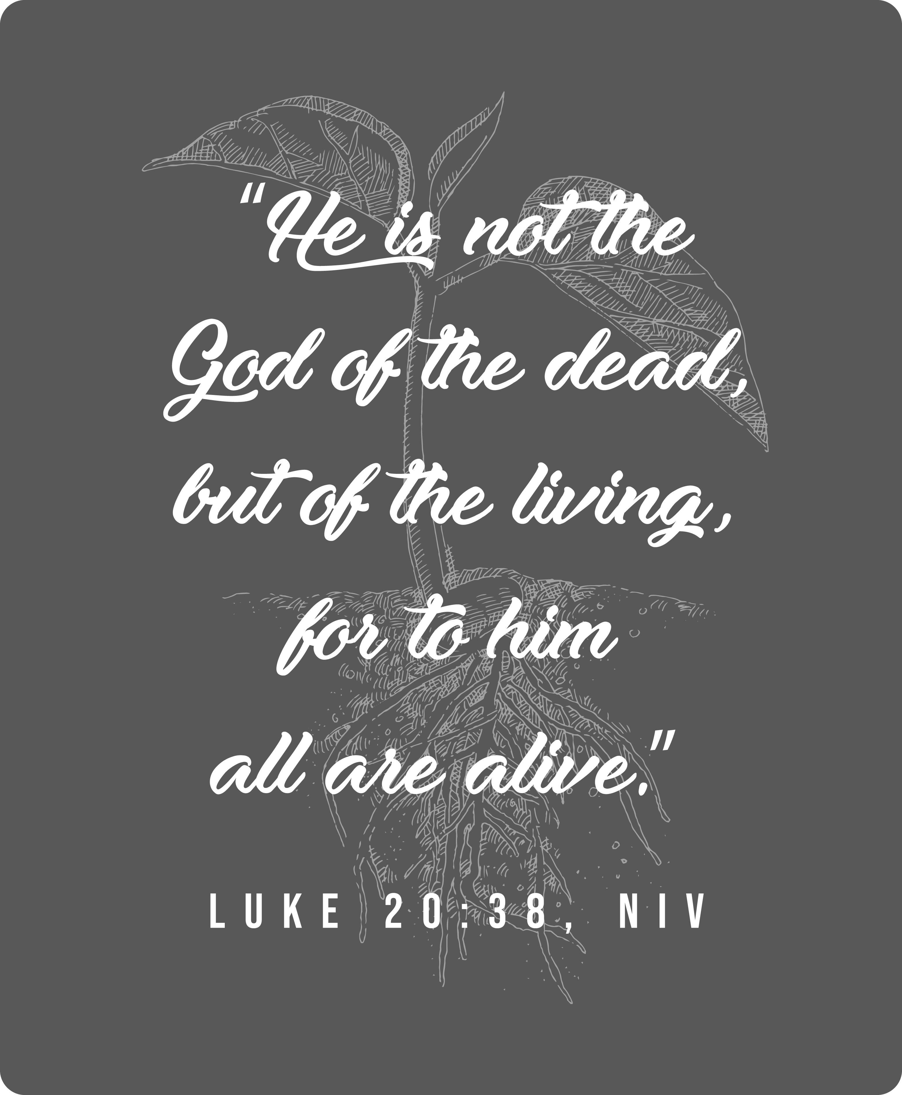
Mt. Zion Evangelical Lutheran Church

320 Mt. Zion Dr., Ripon, WI
www.mtzionripon.org
Facebook: Mt. Zion Evangelical Lutheran Church

Pastor Michael Sheppard
Pastor’s Study: 920-748-9734
E-mail: revmikesheppard@gmail.com
Pentecost 23 Nov. 9, 2025
Handicapped accessible restrooms are located upstairs next to the Pastor’s Study and downstairs next to the elevator.
Attendance: Please remember to sign the friendship pads. Registration for communion will continue as usual at the table. If you have any questions or concerns, please contact Pastor Sheppard or Mike Meeker.


Hearing Loop: Our sanctuary is equipped with a hearing loop system. Those who have compatible hearing aids (with a T-switch) will be able to hear the sound system directly into their ear(s). The two main seating areas and the choir area are looped so that you may sit in any of the three areas. We also have four receivers available for those who do not have compatible hearing aids. If you wish to use a receiver please ask the ushers. Those who wish may bring their own headphones or ear buds.

A note for our visitors on member communion –
Out of sincere love for the truth of God’s Word and for precious human souls, we practice member communion in our synod and congregation. This teaching, as practiced by the Church for centuries, is thoroughly Scriptural. It questions the faith of no individual yet asks that there be full doctrinal agreement between those who commune. For this reason, we ask that only those who are members of a WELS or ELS congregation join us for the Lord’s Supper. If you wish to commune with us please speak with the pastor before the service.
The front row on the pulpit side is reserved for people who are unable to navigate the steps. Pastor will serve you Communion first.

Prayer Before Communion: Dearest Jesus, I marvel that you came to this earth as the Word made flesh. With similar awe I contemplate how you give me your body and blood in the bread and wine of Holy Communion. Touch me with your grace that moved you to reach out to me, a poor, miserable sinner! Use this sacred supper to bring me closer to you. Amen.

Hymns: 920, 904, (659), 520

Order of Worship Setting One pg. 154

Adult Baptism: Matt Behm

Hymn: 938 This is the Feast (in place of Glory Be to God on High)

First Reading: Isaiah 60:1-6 (EHV)
Arise, shine, for your light has come,
and the glory of the Lord is dawning upon you.
² Look, darkness covers the earth,
and deep darkness covers the peoples,
but the Lord will dawn upon you,
and his glory will be seen over you.
³ Nations will walk to your light,
and kings to the brightness of your dawn.
⁴ Look up. Look all around and see!
All of them have been gathered. They are coming to you.
Your sons will come from far away,
and people will carry your daughters on their side.
⁵ Then you will look and be radiant.
Your heart will race with excitement and burst with joy.
For great riches from the sea will be delivered to you.
The wealth of the nations will come to you.
⁶ Caravans of camels will cover your land,
young camels from Midian and Ephah.
All those from Sheba will come.
They will carry gold and incense,
and they will announce the good news of the praise of the Lord.

Psalm: 148A Let All Praise the Name of the LORD

Second Reading: Romans 10:8-15 (EHV)
⁴ So then, how can they call on the one they have not believed in? And how can they believe in the one about whom they have not heard? And how can they hear without a preacher? ¹⁵ And how can they preach unless they are sent? Just as it is written, “How beautiful are the feet of those who preach the good news of peace, who preach the gospel of good things!”

Gospel Acclamation
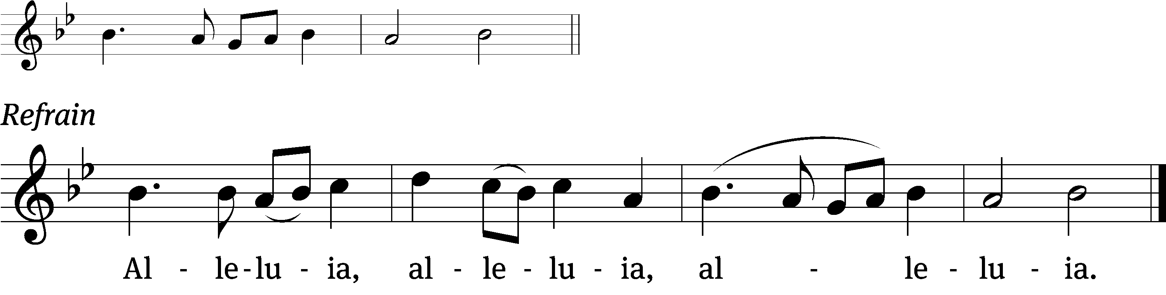
These words are written that you / may believe,
That Jesus is the Christ, the / Son of God. Refrain

Gospel & Sermon Text: Matthew 5:13-16 (EHV)
¹³ “You are the salt of the earth, but if salt has lost its flavor, how will it become salty again? Then it is no good for anything except to be thrown out and trampled on by people. ¹⁴ You are the light of the world. A city located on a hill cannot be hidden. ¹⁵ People do not light a lamp and put it under a basket. No, they put it on a stand, and it gives light to all who are in the house. ¹⁶ In the same way let your light shine in people’s presence, so that they may see your good works and glorify your Father who is in heaven.

Choir Song: “My Lord is Like a Shepherd.”
“I will live within His house through all the length of time.”
Sermon Theme: “You are.”

OFFERING: The offerings are brought forward to the altar.

Adult Confirmation: Matt and Ethel Behm

Keep in Your Prayers: Harley Dorsey, Carol Henning, Carol Hielke, Karen Reiser, Gary Wichman and Dick Zellmer.

Thank you to Pastor James Buske from Lighthouse Youth Center in Milwaukee for telling us about his ministry at the Center.
Announcements
Pie and Ice Cream Social: Ladies Aid and LWMS are having a Pie and Ice Cream Social TODAY following the service. The freewill offering will be given to the LWMS program Send One Sister. This will send one woman to the national convention.

Lighthouse Youth Center Presentation: Please stay after the pie and ice cream social for a presentation by Pastor James Buske on Lighthouse Youth Center. The presentation will take place downstairs.
Poinsettias are now available for purchase to help beautify our church again this year. The price is $12.00. A sign-up sheet is on the wall by the flower chart; please sign up by Nov. 23rd. Our order needs to be in by Thanksgiving. Also, you may designate a plant as a memorial if you wish. Checks should be made out to HY-VEE and given to Marilyn Ninneman. Cash is also acceptable. Any questions, please call her at 748-6474.

Advent By Candlelight – Unwrapping the Names of Jesus
Jesus, King of kings, Immanuel, Prince of Peace—we hear these names referring to God’s Son often during this time of year. They’re in the hymns we sing, the passages preached, the words on our lips. Do we ever stop to consider what they mean? In fact, each name reveals to us truth. They remind us of what God has accomplished. Each name confesses something uniquely special that he has done for you and for me.

This Advent by Candlelight program seeks to focus our attention right on Jesus by taking a deeper look—through Scripture, narrative, and song—at the names we hear him often called during Advent. Each name reveals a priceless gift just waiting to be opened and treasured for a lifetime. Each name is a perfect gift to unwrap. We are planning this event for November 30^{th,} the first Sunday in Advent, beginning at 6:00pm. There is a sign-up sheet by the office. PLEASE SIGN UP BY NOV. 16TH. Include how many you will be bringing. Contact Jo Meeker or Kari Hielke with any questions.

Befriend A Mission (BAM): During November LWMS encourages congregations to remember our missionaries with cards that show our support and gives them needed encouragement. Mt. Zion has participated in this project for several years and will do so again this year from November 9th to December 7th. We are asking our members to write cards to Pastor Jeremy Belter, Pastor Kevin Schultz, and Pastor Matt Behmer. As you enter church, you will see a display table with information about each of our missionaries. There will be paper bags with Christmas cards you can take with you to write to each of our missionaries, or if you prefer to use your own cards that is another option. Please return cards to Mt. Zion by December 7th, so they can be mailed to the missionaries for Christmas. Thank you for taking a moment to send our missionaries cards and keeping them in your prayers.

Shut-in Visits: We are hoping to start a program to make sure all our shut-ins are receiving consistent visits from members here at church. If you would like to coordinate a schedule to plan monthly visits or if you would like to volunteer to visit a shut-in please see the sign up sheet on the table by the office.

Ammo Can Campaign: In honor of Veterans Day, The Lutheran Military Support Group is sponsoring this campaign. They support spiritual retreats, workshops, educational scholarships and assistance grants for service members. TODAY there will be an Ammo Can set up by the library door for your donations to this worthy cause.

Birthday Cake: Our next celebration will be November 16th. Please join us for fellowship, cake and refreshments.

Thanksgiving Shut-in Boxes: On November 22nd the Evangelism Committee and Ladies Aid will be assembling Thanksgiving meals for our shut-ins. We will have turkey; mashed potatoes; sides like dressing, green bean casserole, or a side of your choice; and pie. If you would like to donate, help to assemble boxes or deliver meals, there is a sign up sheet on the podium by the library. We will be assembling boxes at 9:00am so please have your donation at church by 8:45. Thanks so much.

Hymn Sing: The next hymn sing is TBD. If you have any requests for future hymn sings please talk to Sue Sheppard or Jo Meeker.

Mailbox and table: The November Forward In Christ is available and also the Nov. 30 2025-Feb. 28, 2026 Meditations are available.
If you would like the Lord’s Supper privately, please contact Pastor Sheppard on his cell 920-745-0883, or by email revmikesheppard@gmail.com.
The Helping Hands Ministry is ready to serve the needs of our members. Please contact one of the following if you or someone you know needs assistance: Joanne Gregor at 920-896-1518, Lisa Tremore at 920-229-1297.
For Your Information
Attendance 11/2 91
Offerings for 11/2 $3,273.30

Serving Our Lord

Thank you to everyone for your service to our Lord!

Ushers:

Nov. 9: Terry Dolderer, Dawson Niemuth, Rick Niemuth

Nov. 16, 23, 26, 30: Mike Schaub, Kevin Schenning, Eric Eckert, Adam Covach

PowerPoint:

Nov. 9: Jan Ohlrich

Nov.16: Judy Doll

Nov. 23: Sara Retelle

Nov. Communion Set up: Jo Meeker

Nov. Communion Clean up: Janet/Al Brooks & Sue Sheppard

Sunday (9th) 9:00 AM Worship Service with Communion
10:15 AM Pie & Ice Cream Social. NO Sunday School or Bible Study
5:00 PM Confirmation Class
Tuesday 9:00 AM Bible Study (book of Acts)
6:30 PM Ladies Aid Meeting
Wednesday 6:15 PM Choir Practice
Pastor and Sue on Vacation through the 18th
Thursday 9:00 AM Women’s Bible Study (Fellowship Hall)
7:00 PM WLA Presents Brigadoon
Sunday 9:00 AM Worship Service
10:15 AM Sunday School & Bible Study
5:00 PM Confirmation Class

