Twenty-first Sunday of Pentecost

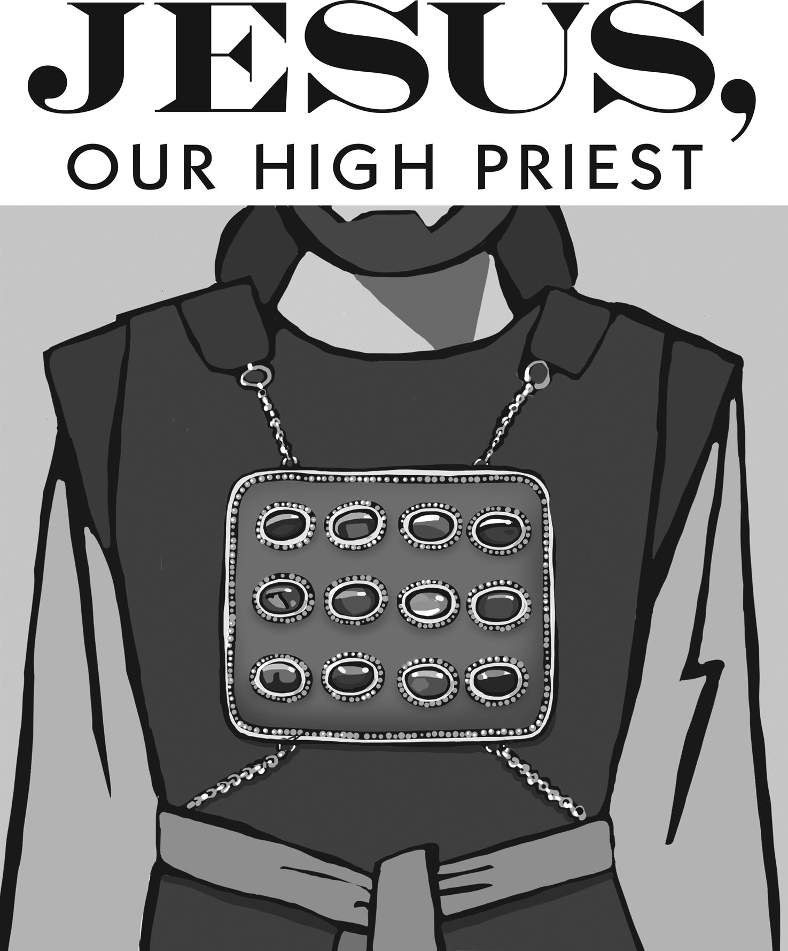
Mt. Zion Evangelical Lutheran Church
320 Mt. Zion Dr., Ripon, WI
www.mtzionripon.org
Facebook: Mt. Zion Evangelical Lutheran Church

Pastor Michael Sheppard
Pastor’s Study: 920-748-9734
E-mail: revmikesheppard@gmail.com
Twenty-first Sunday of Pentecost Oct. 14 & Oct. 17, 2021

Welcome to Mt. Zion!
Handicapped accessible restrooms are located upstairs next to the Pastor’s Study and downstairs next to the elevator.
Attendance: Please remember to sign the friendship pads. Registration for communion will continue as usual at the table. If you have any questions or concerns please contact Pastor Sheppard or Mark Roeder.

Please feel free to ask Pastor Sheppard any questions you may have concerning COVID-19. May the Lord be with us as we worship together at church. (The services will continue to be posted on Facebook, Rumble, and the church website, and available on DVD.)

Hearing Loop: Our sanctuary is equipped with a hearing loop system. Those who have compatible hearing aids (with a T-switch) will be able to hear the sound system directly into their ear(s). The two main seating areas and the choir area are looped so that you may sit in any of the three areas. We also have four receivers available for those who do not have compatible hearing aids. Those who wish may bring their own headphones or ear buds. If you wish to use a receiver please ask the ushers.

Prayer Before Worship: Heavenly Father, I have come to worship you. Draw near to me in your gracious Word, and assure me of your loving kindness. Curb my wandering thoughts, that with undivided attention I may hear your voice and sing your praise. Amen.

Hymn Sing (Sunday): Day by Day, 397, 537, 538

Hymns: 395, 401, 749 (Insert), 252

Order of Worship: Service of the Word pg 38

Peace Lutheran School: We thank the children from Peace in Green Lake for singing and playing hand chimes during the service today.

First Lesson: II Kings 5: 14-27 (EHV)
So he went down and dipped in the Jordan seven times, just as the man of God had said. Then his flesh was restored like the flesh of a small child, and he was clean. ¹⁵ Then he and his whole escort went back to the man of God. He stood in front of Elisha and said, “To be sure, now I know that there is no God in all the earth except in Israel. Now accept a gift from your servant.”
¹⁶ But Elisha said, “As surely as the Lord lives, in whose presence I stand, I will not take anything.” Even though Na’aman urged him to accept something, he refused.
¹⁷ Then Na’aman said, “If you do not want anything, please give me, your servant, as much dirt as two donkeys can carry, for your servant will never again burn incense or sacrifice to other gods, but only to the Lord. ¹⁸ But may the Lord forgive your servant this one thing: When my master goes into the house of Rimmon to bow down there and he supports himself on my arm, then I too have to bow down in the house of Rimmon. When I bow down in the house of Rimmon, may the Lord forgive your servant this one thing.”
¹⁹ Then Elisha said to him, “Go in peace.”
When Na’aman had gone some distance from him, ²⁰ Gehazi, the servant of Elisha the man of God, said, “My master was too easy on this Aramean, Na’aman, when he did not accept anything that he brought. As surely as the Lord lives, I will run after him and get something from him.”
²¹ So Gehazi chased after Na’aman. When Na’aman saw him running after him, he got down from his chariot to meet him. He said, “Is everything all right?”
²² Then Gehazi said, “Yes, everything is all right. My master sent me to say, ‘Look, just now two young men from the hill country of Ephraim, from the sons of the prophets, have come to me. Please give them a talent of silver and two sets of clothing.”
²³ Na’aman said, “Certainly! Take two talents!” He urged Gehazi and tied up the two talents of silver in two bags with the two sets of clothing. Then Na’aman gave them to his two servants, and they carried them ahead of Gehazi. ²⁴ When he came to the hill, he took the gifts from them. Then he hid them in the house and sent the men back, so they left. ²⁵ Then he went in and attended his master.
Elisha said to him, “Where were you, Gehazi?”
Gehazi said, “Your servant didn’t go anywhere.”
²⁶ Then Elisha said to him, “Didn’t my heart go along when the man got down from his chariot to meet you? Is this the time to take silver, or to accept clothing or olive groves or vineyards or sheep or cattle or male and female servants? ²⁷ Na’aman’s leprosy will cling to you and to your descendants forever.” Then Gehazi went out from his presence, leprous like snow.

Psalm 90 Pg. 99 of Christian Worship

Second Lesson & Sermon Text: Hebrews 3: 1-6 (EHV)
Therefore, holy brothers, who share in the heavenly calling, focus your attention on Jesus, the apostle and high priest whom we confess. ² He was faithful to the one who appointed him, as also Moses was faithful in God’s whole house. ³ In fact, Jesus is worthy of greater glory than Moses, in the same way that the builder of a house has more honor than the house. ⁴ For every house is built by someone, and God is the one who built everything.
⁵ Moses was faithful as a servant within God’s whole house by testifying to the things that would be spoken. ⁶ But Christ is faithful as a Son over God’s house. We are his house, if we hold on firmly to our confidence and the hope about which we boast until the end.

Gospel Lesson: Mark 10: 17-27 (EHV)
As Jesus was setting out on a journey, one man ran up to him and knelt in front of him. He asked, “Good teacher, what must I do to inherit eternal life?”
¹⁸ Jesus said to him, “Why do you call me good? No one is good except one—God. ¹⁹ You know the commandments. ‘You shall not murder. You shall not commit adultery. You shall not steal. You shall not give false testimony. You shall not defraud. Honor your father and mother.’”
²⁰ The man replied, “Teacher, I have kept all these since I was a child.”
²¹ Jesus looked at him, loved him, and said to him, “One thing you lack. Go, sell whatever you have, and give to the poor, and you will have treasure in heaven. Then come, follow me.”
²² When he heard this, he looked sad and went away grieving, because he had great wealth. ²³ Jesus looked around and said to his disciples, “How hard it will be for those who have riches to enter the kingdom of God!”
²⁴ The disciples were amazed at his words. But Jesus told them again, “Children, how hard it is for those who trust in their riches to enter the kingdom of God! ²⁵ It is easier for a camel to go through the eye of a needle than for a rich man to enter the kingdom of God.”
²⁶ They were even more astonished and said to one another, “Who then can be saved?”
²⁷ Jesus looked at them and said, “For people, it is impossible, but not for God, because all things are possible for God.”

The Holy Bible, Evangelical Heritage Version® (EHV®)
copyright © 2018 The Wartburg Project. All rights reserved. www.wartburgproject.org

Sermon Theme: “Our Contentment Is In The Lord God.”

Affirmation of Faith: Cherie Anderson

Please remember in your prayers: Benjie Niemuth & Dick Zellmer

Announcements

Birthday Club: Cake will be served today to celebrate the birthdays for October.

Joint Reformation Service: After a year’s hiatus, The WLA Association Joint Reformation Service will be on Sunday, October 31st, at 3:00 p.m., at St. Peter’s Lutheran Church, 1600 South Main Street, Fond du Lac, Wisconsin. The WLA Traveling Choir will be bringing God’s Word to us in song under the direction of Mr. Dale Witte, who will also serve as organist. Wisconsin Lutheran Seminary’s Dean of Chapel, Rev. Aaron Christie, will be our guest preacher. The presiding minister will be St. Peter’s new pastor, Rev. Luke Boehringer. We pray you will come and praise God for allowing our congregations to build on the three pillars of the Lutheran Reformation—that we are saved: Sola Gratia (by Grace Alone), Sola Fide (by Faith Alone), and Sola Scriptura (by Scripture Alone).

WLA: WLA Theater Presents Bye Bye Birdie November 4-6 at 7 PM and November 7th at 2 PM. A poster with more information and a sign up sheet if you are interested in car-pooling to the play are on the bulletin board by the church office.

Forward in Christ: The printer for Forward in Christ informed Northwestern Publishing House this week that their printing of the October issue was delayed because of paper shortages and challenges with their workforce. The issue is currently scheduled to be mailed in early October. Although the editorial staff will continue to meet its future deadlines with the printer, the ongoing nationwide supply chain and labor issues are beyond its control.
To make sure you receive the valuable content of the magazine as soon as possible despite this challenge, Northwestern Publishing House and the Forward in Christ team are making the digital issue for October available for everyone. Simply go to the link below, and you will be able to access the issue: nph.net/digitalfic

New Hymnals: If you are interested in purchasing a new hymnal, please sign the sheet on the bulletin board by the office.

Hymn Sing: Our next hymn sing will be on November 14th. If you have favorite hymns you wish to add to our selections, please contact Jo at the church office.

Flowers: Any special birthdays or anniversaries coming up in 2021? Please sign up on the flower chart to have flowers put on the altar and contact Marilyn Ninneman at 748-6474.

Mailbox and table: The August 29th – November 27th, 2021 Meditations are available.

Online Offerings: Don’t forget, you can now give offerings online with the Give Plus app. There is a $1 fee for each transaction – you can choose to add a dollar to your offering to cover that fee, or it will be subtracted from the total amount you give. There is a Donation button on the church website, and members may contribute to several funds. If the one you need is not available please talk to Todd Zellmer.

If you would like the Lord’s Supper privately, please contact Pastor Sheppard on his cell 920-745-0883, or by email revmikesheppard@gmail.com.

The Helping Hands Ministry is ready to serve the needs of our members. Please contact one of the following if you or someone you know needs assistance: Joanne Gregor at 920-896-1518, Lisa Tremore at 920-229-1297 or Tammy Niemuth at 920-299-0240.

For Your Information
Attendance 9/30-10/3/21 117
Offerings for 9/30-10/3/21: $6,669.25
Offerings include: $100.00 in memory of Lloyd Weisnicht

Serving Our Lord

Thank you to everyone for your service to our Lord!

Ushers:

Oct 17: Ken Hielke, Todd Zellmer, Jonathan Zellmer, Dustin Zellmer

Oct 24 & 31: Mark Roeder, Ferd Roeder, Jason Roeder

PowerPoint:

Oct. 14: Alicia Bradley

Oct. 17: Kim Mueller

Oct. 21: Alicia Bradley

Oct. 24: Arjeta Rushani

Oct Communion Set up: Ardis Grahn

Oct Communion Clean up: Marilyn Ninneman, Tammy Niemuth

This week at Mt. Zion
Sunday (17th) 8:45 AM Hymn Sing
9:00 AM Worship Service
10:15 AM Sunday School & Bible Study
Birthday Club
Monday 6:30 PM Bible Study
Wednesday 5:00 PM Catechism Class
6:15 PM Choir Practice
Thursday 6:30 PM Worship Service
Sunday 9:00 AM Worship Service
10:15 AM Sunday School & Bible Study

Secretary Jo Meeker
Church Office: 920-748-5641
Office Hours: Mon. 9-12, Tues. & Wed. 9-11
E-mail: mountzionripon@gmail.com

