20th Sunday of Pentecost
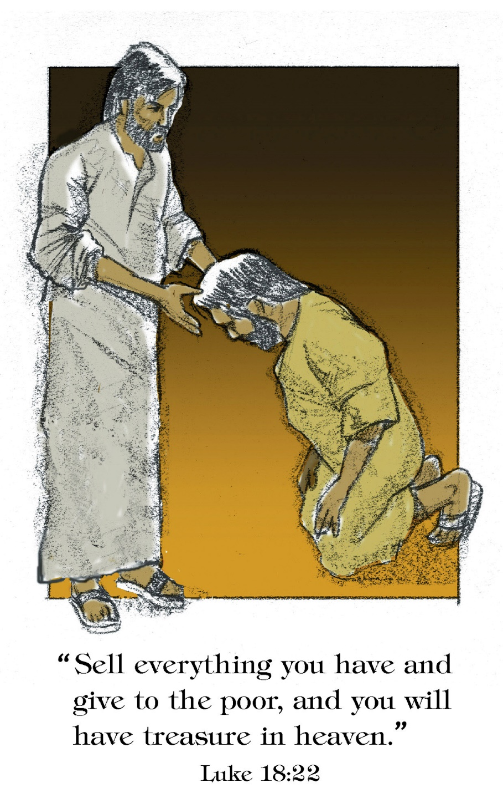

Mt. Zion Evangelical Lutheran Church
320 Mt. Zion Dr., Ripon, WI
www.mtzionripon.org
Facebook: Mt. Zion Evangelical Lutheran Church

Pastor Michael Sheppard
Pastor’s Study: 920-748-9734
E-mail: revmikesheppard@gmail.com
Pentecost 20 Oct 20 & 23, 2022

Welcome to Mt. Zion!
Handicapped accessible restrooms are located upstairs next to the Pastor’s Study and downstairs next to the elevator.
Attendance: Please remember to sign the friendship pads. Registration for communion will continue as usual at the table. If you have any questions or concerns please contact Pastor Sheppard or Mark Roeder.

Hearing Loop: Our sanctuary is equipped with a hearing loop system. Those who have compatible hearing aids (with a T-switch) will be able to hear the sound system directly into their ear(s). The two main seating areas and the choir area are looped so that you may sit in any of the three areas. We also have four receivers available for those who do not have compatible hearing aids. If you wish to use a receiver please ask the ushers. Those who wish may bring their own headphones or ear buds.

Prayer Before Worship: O Lord our Maker, Redeemer, and comforter, we assembled in your presence to hear your holy Word. We pray that you would open our hearts by your Holy Spirit, that through the preaching of your Word we may repent of our sins, believe in Jesus, and grow day by day in grace and holiness. Hear us for Jesus’ sake. Amen

Hymns: 582, 717, 698, 924

Order of Worship: German Hymn Setting

First Reading: Deuteronomy 10: 12-22 (EHV)
So now, Israel, what is the Lord your God asking of you but to fear the Lord your God, to walk in all his ways, and to love him and to serve the Lord your God with all your heart and with all your soul, ¹³to keep the commandments of the Lord and his statutes that I am commanding you today for your own good.
¹⁴Indeed, the heavens and the heaven of heavens, the earth and everything that is on it—these belong to the Lord your God. ¹⁵Still, the Lord attached himself to your fathers, loved them, and he chose their descendants after them (that’s you!) from all peoples, as it is today.
¹⁶So cut away the tough shell of your sinful nature, and do not be stubborn any longer.
¹⁷The Lord your God is God of Gods and Lord of Lords, the great God, the mighty one and the awesome one, who does not show favoritism and does not take a bribe. ¹⁸He carries out justice for the fatherless and widows. He loves the alien who dwells among you and gives him food and clothing. ¹⁹So you are to love the alien, because you were aliens in the land of Egypt.
²⁰Fear the Lord your God, serve him, cling to him, and take your oaths in his name.
²¹He is your glory. He is your God, who performed for you these great and awesome things that your own eyes have seen.
²²When your fathers went down to Egypt, they numbered seventy people, but now the Lord your God has made you as numerous as the stars of the sky.

Fill Us with Your Love, O Lord Psalm 90

Second Reading: I John 2: 15-17 (EHV)
Do not love the world or the things in the world. If anyone loves the world, the love of the Father is not in him. ¹⁶For everything in the world—the lust of the flesh, the desire of the eyes, boasting about material possessions—is not from the Father but from the world. ¹⁷The world and its desires pass away, but the one who does the will of God remains forever.

Gospel Acclamation Matthew 22:37
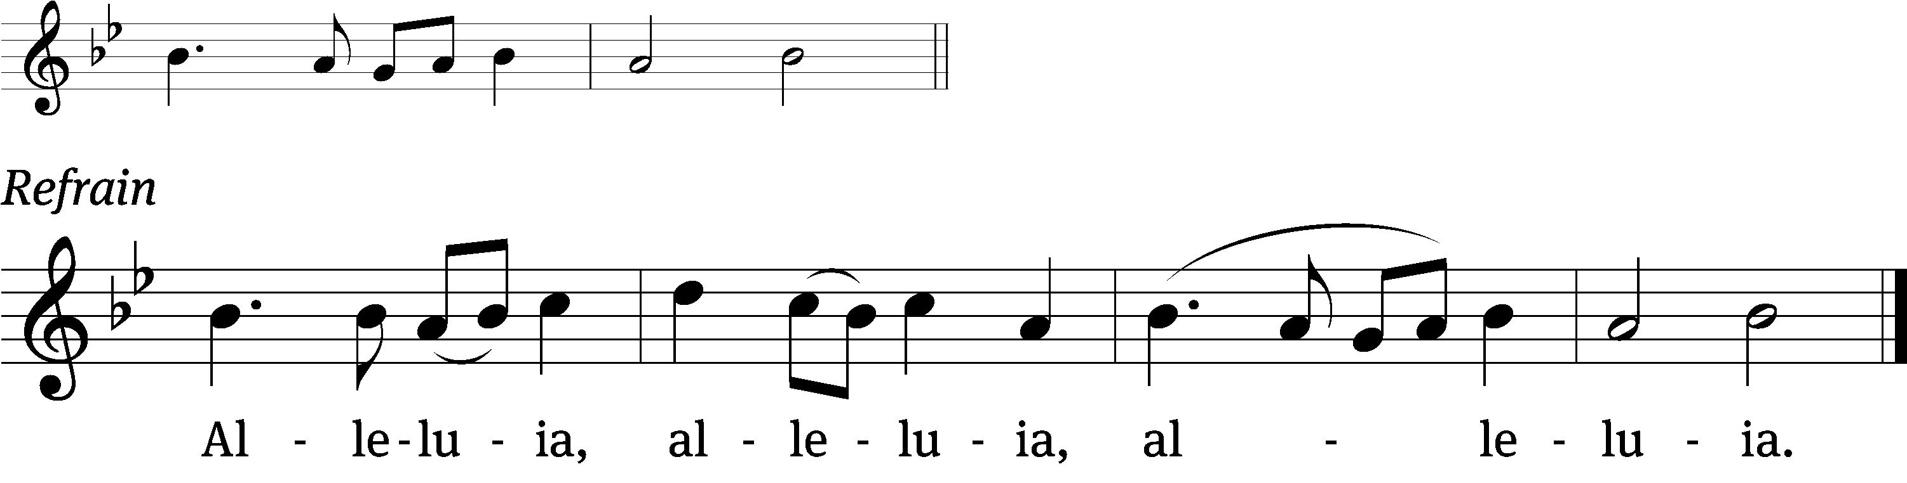

Love the Lord your God with / all your heart
and with all your soul and with / all your mind.

Refrain
Tune: © 2021 Northwestern Publishing House. Used by permission: OneLicense no. 716381

Gospel & Sermon Text: Luke 18: 18-30 (EHV)
A certain ruler asked Jesus, “Good teacher, what must I do to inherit eternal life?”
¹⁹Jesus asked him, “Why do you call me good? No one is good, except one—God. ²⁰You know the commandments: ‘You shall not commit adultery. You shall not murder. You shall not steal. You shall not give false testimony. Honor your father and mother.’”
²¹“I have kept all these since I was a child,” he said.
²²When Jesus heard this, he said to him, “You still lack one thing. Sell all that you have and give to the poor, and you will have treasure in heaven. Then come, follow me.”
²³But when the ruler heard these words, he became very sad, because he was very rich.
²⁴When Jesus saw that the man became very sad, he said, “How hard it is for those who have riches to enter the kingdom of God! ²⁵In fact, it is easier for a camel to go through the eye of a needle than for a rich man to enter the kingdom of God.”
²⁶Those who heard this said, “Then who can be saved?”
²⁷He replied, “What is impossible for people is possible for God.”
²⁸And Peter said, “Look, we have left our possessions and followed you.”
²⁹He said to them, “Amen I tell you: Anyone who has left house or wife or brothers or parents or children for the sake of the kingdom of God ³⁰will most certainly receive many times more in this time, and in the age to come, eternal life.”

Choir Song: “Give Me a Song”
A contemporary piece that shares unbridled joy and praise to sing to the Lord!

Sermon Theme: “Who Then Can Be Saved?”

OFFERING: The offerings are brought forward to the altar.

Announcements

Voter’s Meeting: Sunday TODAY after the service in the sanctuary.

New Bible Study: Our new Bible Study, Irreconcilable!, will begin tomorrow at 6:30 PM. For more information, please see the insert in today's bulletin.

LWMS Fall Rally: I am happy to report that we collected over 1600 crosses October 15th at the Beaver Dam Fall Rally. ( Mt Zion made over 500) Praise be to God.
We also collected over three thousand pill bottles.
We received in donations $716.00 for postage to send the crosses and pill bottles. We are anxiously waiting on the packing and shipping procedures so they may be sent to Africa. With that said we will NOT be collecting any more crosses or pill bottles.

Thanks for your support of this project.
United to serve

Dianne Witkowski LWMS President Beaver Dam Circuit
Joanne Gregor Spiritual Growth Woman
Pastor Sheppard Spiritual Growth Pastoral Advisor

100 Missions in 10 Years
At the 2021 Synod Convention, delegates enthusiastically approved a WELS Home Missions initiative to plant 100 home mission churches and enhance 75 ministries in 10 years beginning in 2023. During the same time, we want to support 75 enhancement grants to help existing congregations reach more souls, often in other cultures. This is a BIG challenge. An impossible one you might say. But this initiative isn’t as much about planting more churches but about sharing the gospel of Jesus Christ. It’s about aggressively reaching lost souls. We pray that God will bless our efforts, trusting that he is able to do immeasurably more than all we ask or imagine. Learn more about this initiative, stay up-to-date on progress, and learn how you can get involved in this synod wide church planting effort at wels100in10.net.

Blue Hymnal Project: Please come to church on Thursday, November 17th, at 10:00 a.m. for the hymnal project. We will be taking the bookmarks out of the red hymnals and transferring them to the blue hymnals. Our work will be done in the comfort of the gathering room upstairs. Pastries, breads, and refreshments will be served. Please sign up on the bulletin board upstairs to help us in planning.

PowerPoint: We are in need of 1 or 2 more people to do the service once a month on Sunday. You do not have to be a “Techie” to do this. It can all be setup for you and all that’s needed is for you to push a button. Please let Sara Grunert know if you can help her out. Contact her at grunertfamily@charter.net.

Favorite Hymn Service: We need your help. In January we will have a favorite hymn service and would like to know your favorite hymns. After we tally your suggestions, we will include the favorite hymns in a special service. Please include your favorite hymns on the form and return it to us by the end of November.

Hymn Sing: Our next hymn sing will be Sunday November 6th. If you have a favorite hymn please let Jo Meeker or Sue Sheppard know.

Sound System: We have started a fund for a new Audio/Visual system. The improvements are necessary to accommodate our recent and future technology additions. We are applying for a grant from The Antioch Foundation, if it is approved Mt Zion’s share of the cost will be approximately $16,000.00. You may use the regular church envelopes just write Audio System next to your donation. Thank you.

Red Hymnals: It was decided that whoever would like to take one or more old hymnals home may do so at no cost. They are located on the table by the entrance to the sanctuary. Please feel free to take.

Birthday Celebration: Cake will be served Sunday November 6th to celebrate the birthdays for November.
Mailbox and table: The October Forward In Christ is available and also the August 28th, 2022-November 26th, 2022 Meditations are available.
If you would like the Lord’s Supper privately, please contact Pastor Sheppard on his cell 920-745-0883, or by email revmikesheppard@gmail.com.

The Helping Hands Ministry is ready to serve the needs of our members. Please contact one of the following if you or someone you know needs assistance: Joanne Gregor at 920-896-1518, Lisa Tremore at 920-229-1297 or Tammy Niemuth at 920-299-0240.

For Your Information
Attendance 10/13 - 10/16/2022: 200
Offerings for 10/13 - 10/16/2022: $2,745.00*
*Includes $2,583 towards the new sound system*
$300 given in celebration of the 58th wedding anniversary of Dave & Darlene Patchett

Serving Our Lord

Thank you to everyone for your service to our Lord!

Ushers:

Oct. 23: Dennis Scott, Dave Patchett, Dawson Niemuth, Rick Niemuth

Oct. 30 & Nov. 6: Kyle Stollfuss, Dennis Hamer, Mike Jung, Sam Jung

PowerPoint:

Oct 20: Kari Hielke

Oct 23: Grunert Family

Oct 27: Jo Meeker

Oct 30: Grunert Family

Nov 3: Jo Meeker

Oct Communion Set up: Jo Meeker

Oct Communion Clean up: Marilyn Ninneman & Tammy Niemuth

This week at Mt. Zion
Sunday (23rd) 9:00 AM Worship
10:15 AM Sunday School & Bible Study
Monday 6:30 PM Bible Study
Tuesday 9:00 AM Bible Study
Wednesday 5:00 PM Catechism Class
6:15 PM Choir Practice
Thursday 6:30 PM Worship with Communion
Sunday 9:00 AM Worship with Communion
10:15 AM Sunday School & Bible Study

Secretary Jo Meeker
Church Office: 920-748-5641
Office Hours: Mon. 9-12, Tues. & Wed. 9-11
E-mail: mountzionripon@gmail.com

Acknowledgments
Unless otherwise indicated, Scripture quotations are from The Holy Bible, New International Version®, NIV®. Copyright © 1973, 1978, 1984, 2011 by Biblica, Inc.TM Used by permission of Zondervan. All rights reserved worldwide.
Software distributed in partnership with Northwestern Publishing House.
Created by Christian Worship: Service Builder © 2022 Concordia Publishing House.

