TWENTIETH SUNDAY AFTER
PENTECOST
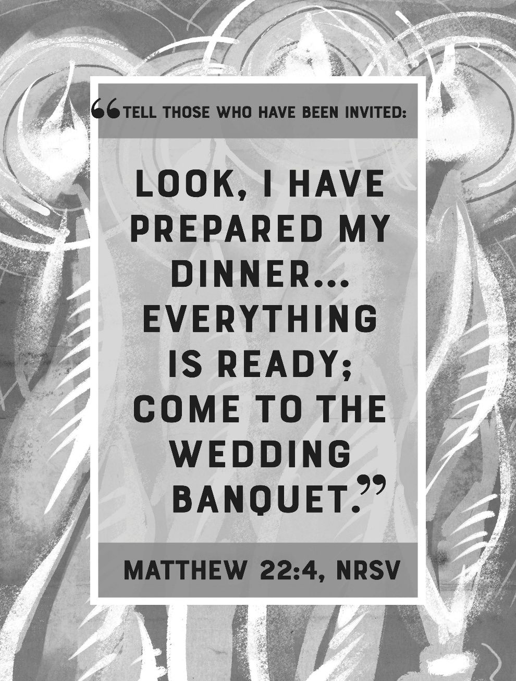
Mt. Zion Evangelical Lutheran Church

320 Mt. Zion Dr., Ripon, WI
www.mtzionripon.org
Facebook: Mt. Zion Evangelical Lutheran Church

Pastor Mark Kock
Phone 414-755-9021
mkock315@gmail.com
Pentecost 20 Oct. 11, 2026
Welcome! The Lord is with us as we gather in his name. Through his Word he brings to you the forgiving, faith-strengthening love of Jesus Christ. Come, let us worship the Lord! Please sign the friendship pads in the pews.

If you have a prayer request for a service, please speak to Pastor Kock. Perhaps a prayer of thanks for a special occasion – birthday, wedding anniversary, or a prayer of intercession for a relative or friend. Throughout the week Pastor Kock is here to serve you in Christ, counseling with the Word, and encouraging your faith. Contact him at 414-755-9021 or mkock315@gmail.com.

Holy Communion is offered to Communicant members of Mount Zion and of other Wisconsin Evangelical Lutheran Synod (WELS) churches who have prepared themselves in faith to receive Jesus’ body and blood. In Communion, Jesus gives the blessings of the forgiveness of sins and intimate fellowship with him! Visitors, Pastor Kock offers a Bible Class to prepare you for this wonderful meal. Ask him about it. Members, please register for communion at the table in back. If you have any questions or concerns, please contact Mike Meeker.

The front row is reserved for people who are unable to navigate the steps to the altar. Pastor will serve them Communion first.

Handicapped accessible restrooms are located upstairs next to the Pastor’s Study and downstairs next to the elevator.
Attendance: Please remember to sign the friendship pads. Registration for communion will continue as usual at the table. If you have any questions or concerns, please contact Mike Meeker.


Hearing Loop: Our sanctuary is equipped with a hearing loop system. Those who have compatible hearing aids (with a T-switch) will be able to hear the sound system directly into their ear(s). The two main seating areas and the choir area are looped so that you may sit in any of the three areas. We also have four receivers available for those who do not have compatible hearing aids. If you wish to use a receiver please ask the ushers. Those who wish may bring their own headphones or ear buds.

Focus of today’s service: God has prepared an extraordinary spiritual meal for all people. It is the salvation of his Son Jesus Christ. It’s offered by God as a wedding banquet to which he invites all to attend. The proclaiming of the gospel of Christ in this service is his invitation to you to attend. There still is room!

Please Note: The offering plates are located behind the last pews on each side of the sanctuary and also by the organ. Our offerings are given all to the glory of God.

Hymns: 938, 573, (816), 884

Order of Worship Setting One pg. 154

Lord, Have Mercy (As used in the red hymnal “Christian Worship”)

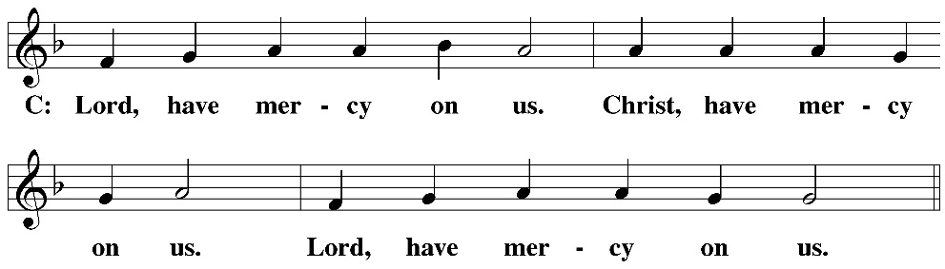

Reading: Isaiah 25: 6-9 (EHV)
On this mountain
the Lord of Armies will prepare for all peoples
a banquet of rich food,
a banquet of aged wines,
with the best cuts of meat,
and with the finest wines.
⁷On this mountain
he will destroy the shroud that covers all peoples,
the burial cloth stretched over all nations.
⁸He has swallowed up death forever!
The Lord God will wipe away the tears from every face.
He will take away the shame of his people throughout the earth.
For the Lord has spoken.
⁹On that day it will be said,
“Look, here is our God!
We waited for him, and he saved us!
This is the Lord!
We waited for him.
Let us be glad and rejoice in his salvation!”

Reading: Romans 1:16-17 (EHV)
For I am not ashamed of the gospel, because it is the power of God for salvation to everyone who believes—to the Jew first, and also to the Greek. ¹⁷For in the gospel a righteousness from God is revealed by faith, for faith, just as it is written, “The righteous will live by faith.”

Gospel Acclamation Isaiah 25:6
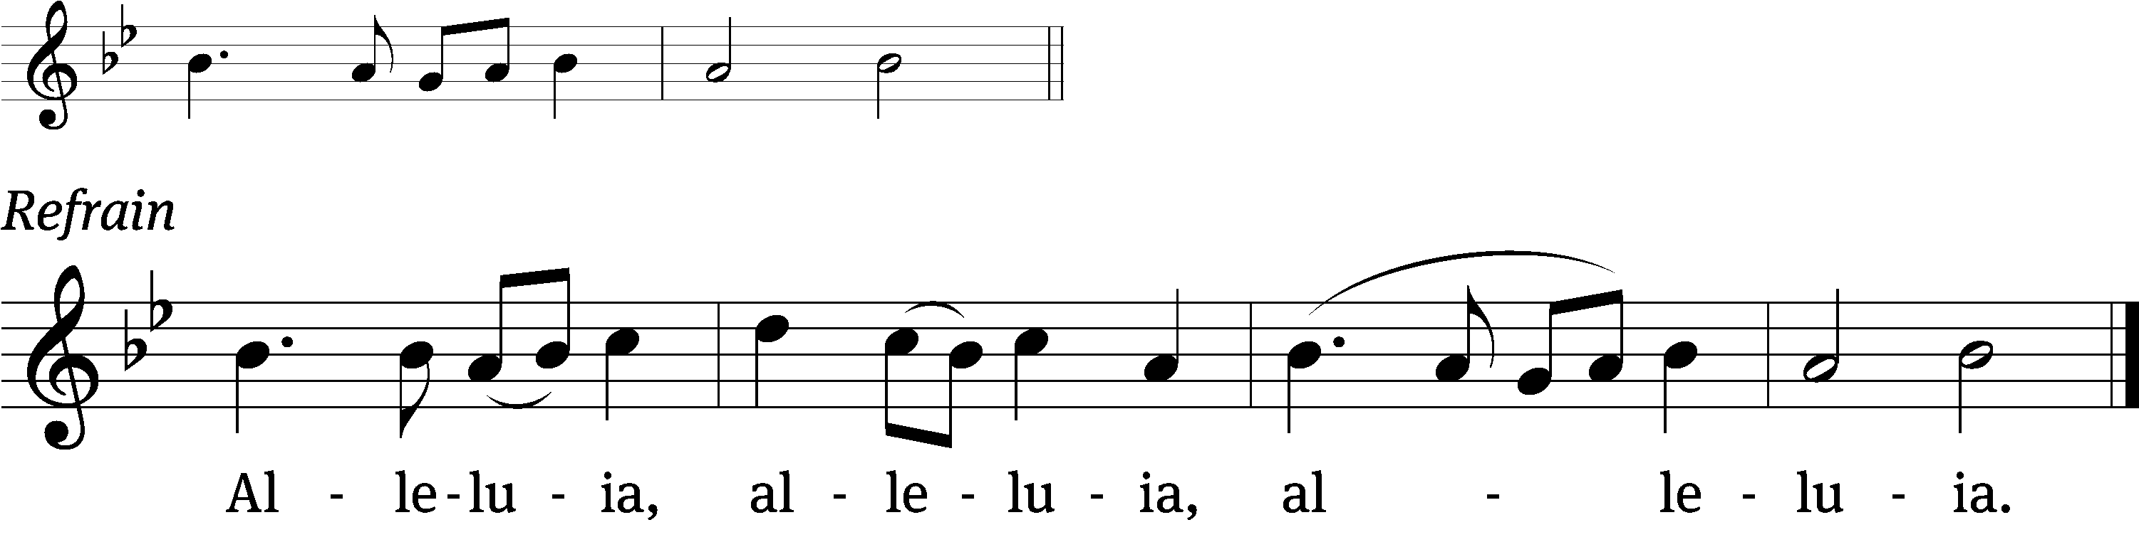
Out of the depths I cry to you / O Lord
Lord / hear my voice. Refrain

Gospel & Sermon Text: Matthew 22:1-14 (EHV)
Jesus spoke to them again in parables. He said, ²“The kingdom of heaven is like a certain king who prepared a wedding banquet for his son. ³He sent out his servants to summon those who were invited to the wedding banquet, but they did not want to come.
⁴“Then he sent out other servants and said, ‘Tell those who are invited: Look, I have prepared my dinner. My oxen and my fattened cattle have been butchered, and everything is ready. Come to the wedding banquet!’
⁵“But those who were invited paid no attention and went off, one to his own farm, another to his business. ⁶The rest seized the king’s servants, mistreated them, and killed them. ⁷As a result, the king was very angry. He sent his army and killed those murderers and burned their town.
⁸“Then he said to his servants, ‘The wedding banquet is ready, but those who were invited were not worthy. ⁹So go to the main crossroads and invite as many as you find to the wedding banquet.’ ¹⁰Those servants went out to the roads and gathered together everyone they found, both good and bad, and the wedding hall was filled with guests. ¹¹But when the king came in to see the guests, he saw a man there who was not wearing wedding clothes. ¹²He said to him, ‘Friend, how did you get in here without wearing wedding clothes?’ The man was speechless. ¹³Then the king told the servants, ‘Tie him hand and foot and throw him into the outer darkness where there will be weeping and gnashing of teeth.’ ¹⁴For many are called, but few are chosen.”

Children’s Message

Sermon Theme: “Many Are Invited, but Few Are Chosen”

OFFERING: The offerings are brought forward to the altar.

Keep in Your Prayers: Harley Dorsey, Allan Brooks, Eric Eckert (operation), Myrtle Giese, Carol Henning, Nancy Kemnitz, Terry Loechelt (recovering from an operation), Dennis Schliepp, Joan Stibb, Kathy Strook, Ginny Verch, Gary Wichman, Sue Wichman.

Announcements
Noisy Offering: We collected $211.55 for Christ Alone Academy in Montello. The next Noisy Offering will be on Sunday October 18th. The children will be collecting for Lutheran Women’s Missionary Society. Thank you so much.

Birthdays: Our next birthday celebration will be Oct. 18th after church. Please join us in the fellowship hall for cake, refreshments and fellowship.

Hymn Sing: Our next hymn sing will be October 18th at 8:45 AM. If you have a favorite hymn you would like sung please contact Jo Meeker.

DATE CHANGE: Our next Quarterly Voters’ Meeting will be NOVEMBER 8th immediately after church in the Fellowship Hall. Per Pastor Kock.

Volunteers Needed: We are in need of drivers for some of our members who cannot get to appointments etc. There is a sign-up sheet on the podium by the library for all those who can help.

Trunk or Treat: On October 25th from 3-5 we will be having Trunk or Treat on the lower parking lot. Last year we had over 360 trick or treaters and their parents come to this event. There will be a box outside of the church office for candy donation. There is a sign up sheet for anyone who will be participating by decorating their vehicle to help hand out candy. Anyone interested in helping in other ways please contact DuWayne Wichman at 920-570-1106. Thank you for your support of this community outreach program.

We are offering the Lord's Supper on the 2nd and last Sunday of the month.

Mailbox and table: The October Forward In Christ is available and also the Aug. 30-Nov. 28, 2026 Meditations are available. October calendars are also available.
For Your Information
Attendance 10/4/2026 131
Offerings for 10/4/2026 $4,268.00
Year to Date (thru Sept. 30th).
Income : $134,910.36
Expenses : $120,862.07
YTD +$14,048.29

Serving Our Lord

Thank you to everyone for your service to our Lord!

Ushers:

Oct. 11: Mark Roeder, Jason Roeder

Oct. 18 & 25: Gary Quade, Travis Schmudlach, Kyle Stollfuss

PowerPoint:

Oct. 11: Sara Retelle

Oct. 18: Jo Meeker

Oct. 25: Kari Hielke

Nov. 1: Grunert Family

Oct. Communion Set up: Jo Meeker

Oct. Communion Clean up: Marilyn Ninneman & Tammy Niemuth

Sunday 11th 9:00 AM Worship Service with communion Pastor Kock
10:15 AM Sunday School, Call Meeting with Fellowship
Tuesday 5:30 PM Council Meeting
6:30 PM Ladies Aid
Saturday LWMS Fall Rally
Sunday 8:45 AM Hymn Sing
9:00 AM Worship Service Pastor Meier
Noisy Offering
10:15 AM Sunday School
10:15 AM Birthday Celebration in the Fellowship Hall

UPCOMING EVENTS:
TODAY: Call Meeting in the Fellowship Hall
October 17th LWMS Fall Rally at St. John Pardeville
October 18th Fellowship Hall birthday celebration
October 25th Mission Festival followed by a presentation in the sanctuary by Rev. Nathan Seiltz, of WELS Multi-Language Publications, and potluck dinner in the fellowship hall
November 8th Quarterly Voters’ Meeting

Secretary Jo Meeker
Church Office: 920-748-5641
Office Hours: Mon. 9-12, Tues. & Wed. 9-11
E-mail: mountzionripon@gmail.com



