2nd Sunday of Pentecost
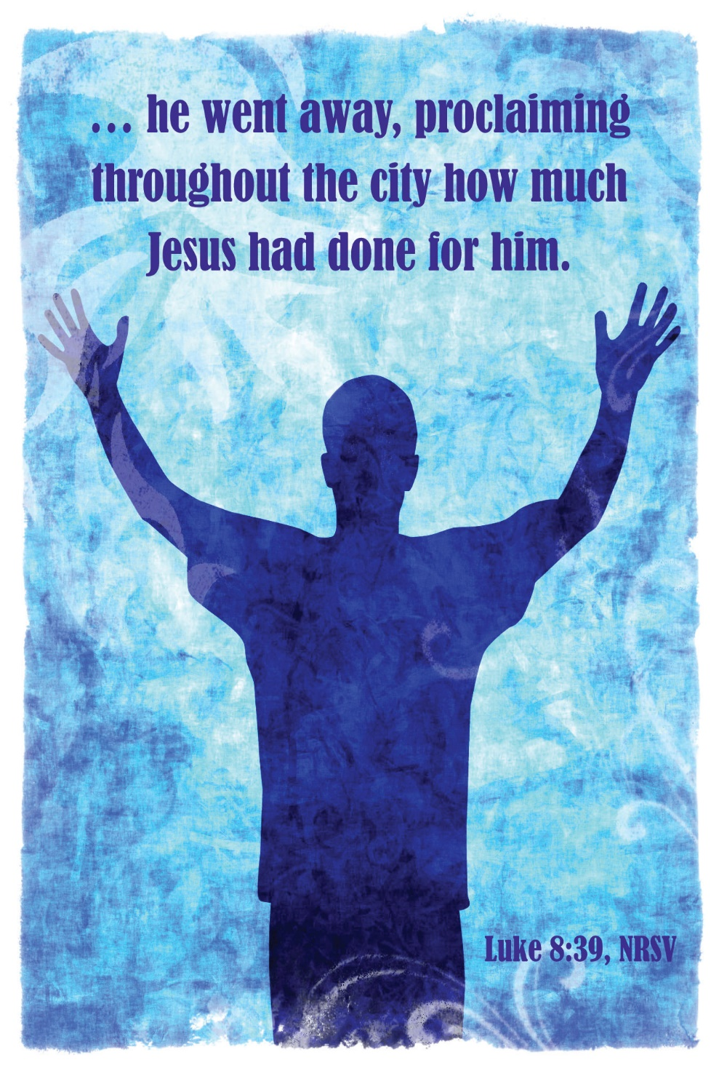
Mt. Zion Evangelical Lutheran Church
320 Mt. Zion Dr., Ripon, WI
www.mtzionripon.org
Facebook: Mt. Zion Evangelical Lutheran Church

Pastor Michael Sheppard
Pastor’s Study: 920-748-9734
E-mail: revmikesheppard@gmail.com
Pentecost 2 June 16 & 19, 2022

Welcome to Mt. Zion!
Handicapped accessible restrooms are located upstairs next to the Pastor’s Study and downstairs next to the elevator.
Attendance: Please remember to sign the friendship pads. Registration for communion will continue as usual at the table. If you have any questions or concerns please contact Pastor Sheppard or Mark Roeder.

Please feel free to ask Pastor Sheppard any questions you may have concerning COVID-19. May the Lord be with us as we worship together at church. (The services will continue to be posted on Facebook, Rumble, and the church website, and available on DVD.)

Hearing Loop: Our sanctuary is equipped with a hearing loop system. Those who have compatible hearing aids (with a T-switch) will be able to hear the sound system directly into their ear(s). The two main seating areas and the choir area are looped so that you may sit in any of the three areas. We also have four receivers available for those who do not have compatible hearing aids. If you wish to use a receiver please ask the ushers. Those who wish may bring their own headphones or ear buds.

Hymns: 916, 744, 698, 699

Order of Worship: Setting One CW21 Pg. 154

Reading: Isaiah 43: 8-13 (EHV)
Bring out the people who are blind, though they have eyes,
and the people who are deaf, though they have ears.
⁹Let all the nations be gathered together,
and let peoples be assembled.
Who among them has declared this?
Who has made known to us the former things?
Let them produce their witnesses to show that they were right,
so that people can hear and say, “This is truth.”
¹⁰You are my witnesses, declares the Lord.
You are my servant, whom I have chosen,
so that you may know me and believe in me,
so that you will understand that I am he.
Before me no god was formed,
and after me there will not be another.
¹¹I, yes I, am the Lord,
and apart from me there is no savior.
¹²I myself declared it.
I brought salvation, and I announced it.
It was not some strange god among you.
You are my witnesses, declares the Lord,
and I am God.
¹³Indeed, from the first day, I am he.
There is no one who can deliver anyone from my hand.
I act, and who can reverse it?

Let All the Earth Sing Out Insert Psalm 66C

Second Reading: 2 Timothy 1: 3-10 (EHV)
I thank God, whom I serve with a clean conscience as my ancestors did, as I constantly remember you in my prayers night and day. ⁴When I remember your tears, I long to see you, so that I may be filled with joy. ⁵I remember your sincere faith, which first lived in your grandmother Lois and your mother Eunice, and I am convinced that it also lives in you.
⁶For this reason I am reminding you to fan into flame the gift of God, which is in you through the laying on of my hands. ⁷For God did not give us a timid spirit, but a spirit of power and love and sound judgment. ⁸So do not be ashamed of the testimony about our Lord or of me his prisoner. Instead, join with me in suffering for the gospel while relying on the power of God. ⁹He saved us and called us with a holy calling, not because of our works, but because of his own purpose and grace. This grace was given to us in Christ Jesus before time began, ¹⁰and it has now been revealed through the appearance of our Savior Christ Jesus, who abolished death and brought life and immortality to light through the gospel.

Gospel & Sermon Text: Luke 8: 26-39 (EHV)
They sailed down to the region of the Gerasenes, which is across from Galilee. ²⁷When Jesus stepped ashore, a man from the town met him. He was possessed by demons and for a long time had not worn any clothes. He did not live in a house but in the tombs. ²⁸When he saw Jesus, he cried out, fell down before him, and said with a loud voice, “What do I have to do with you, Jesus, Son of the Most High God? I beg you, don’t torment me!” ²⁹For Jesus had commanded the unclean spirit to come out of the man. In fact, the unclean spirit had seized him many times. He was kept under guard, and although he was bound with chains and shackles, he would break the restraints and was driven by the demon into deserted places.
³⁰Jesus asked him, “What is your name?”
He said, “Legion,” because many demons had gone into him. ³¹They were begging Jesus that he would not order them to go into the abyss. ³²A herd of many pigs was feeding there on the mountain. The demons begged Jesus to let them go into the pigs, and he gave them permission. ³³The demons went out of the man and entered the pigs, and the herd rushed down the steep bank into the lake and drowned.
³⁴When those who were feeding the pigs saw what happened, they ran away and reported it in the town and in the countryside. ³⁵People went out to see what had happened. They came to Jesus and found the man from whom the demons had gone out, sitting at Jesus’ feet. He was clothed and in his right mind, and the people were afraid. ³⁶Those who saw it told them how the demon-possessed man was saved. ³⁷The whole crowd of people from the surrounding country of the Gerasenes asked Jesus to leave them, because they were gripped with great fear.
As Jesus got into the boat and started back, ³⁸the man from whom the demons had gone out begged to be with him. But Jesus sent him away, saying, ³⁹“Return to your home and tell how much God has done for you.” Then he went through the whole town proclaiming what Jesus had done for him.

The Holy Bible, Evangelical Heritage Version® (EHV®)
copyright © 2018 The Wartburg Project. All rights reserved. www.wartburgproject.org

Sermon Theme: “Connected To Christ Or Connected To This World?”

OFFERING: The offerings are brought forward to the altar.

Announcements
Church Picnic: We are invited to help celebrate the 100th anniversary of Grace Church at Pickett, Sunday June 26th, following a special worship service at 10:30. See the info on the bulletin board by the office.

LWMS News: As Pastor Sheppard stated in his sermon on June 12^{th,} we receive many blessings from the Triune God. The ice cream and pie social was evidence of that. It was wonderful to see over 50 people carrying out Christian fellowship in the fellowship hall eating pie and ice cream (there were also about 10 carry outs.) The generous blessing of donations, $345.00, will be much appreciated by the LWMS Send One Sister fund. Also, a big thank you to all the pie bakers and the donation of the ice cream. God’s blessing to you.
United to Serve:
Your LWMS Executive Board Members,
Pastor Sheppard, Spiritual Growth Pastor
Joanne Gregor, Spiritual Growth Leader
Dianne Witkowski, President of the Beaver Dam LWMS Circuit
Timber Rattlers Game: Once again this year we will be attending a TimberRattler's game. The date is Friday, August 12. Gates open at 5pm, supper will be served beginning at 7pm and includes BBQ grilled chicken breast, hotdogs, BBQ pulled pork, baked beans, chips, pasta salad, dessert, and 2 beverages. The cost will be $29 for adults, pending some kind of discount. Price for childrens' tickets is yet to be determined. Please sign up on the sheet on the bulletin board by the office, and watch the bulletin for added details.

Red Hymnals: It was decided that whoever would like to take one or more old hymnals home may do so at no cost. They are located on the table by the entrance to the sanctuary. Please feel free to take.

Birthday Celebration: Cake will be served Today to celebrate the birthdays for June.
Mailbox and table: The June Forward In Christ is available and also the May 29th, 2022-August 27th, 2022 Meditations are available.
If you would like the Lord’s Supper privately, please contact Pastor Sheppard on his cell 920-745-0883, or by email revmikesheppard@gmail.com.

The Helping Hands Ministry is ready to serve the needs of our members. Please contact one of the following if you or someone you know needs assistance: Joanne Gregor at 920-896-1518, Lisa Tremore at 920-229-1297 or Tammy Niemuth at 920-299-0240.

For Your Information
Attendance 6/9 - 6/12/2022 105
Offerings for 6/9 - 6/12/2022: $2,030.00

Serving Our Lord

Thank you to everyone for your service to our Lord!

Ushers:

June 5: Tobin Storzer, Rick Retelle, Kelly Frank

June 12 & 19: Dennis Scott, Dave Patchett, Dawson Niemuth, Rick Niemuth

PowerPoint:

June 16: Jo Meeker

June 19: Jan Ohlrich

June 23: Jo Meeker

June 26: Kim Mueller

June Communion Set up: Mary Clement

June Communion Clean up: Paul & Peggy Walkowicz

This week at Mt. Zion
Sunday (19th) 9:00 AM Worship
Thursday 6:30 PM Worship with Communion
Sunday 9:00 AM Worship with Communion

Secretary Jo Meeker
Church Office: 920-748-5641
Office Hours: Mon. 9-12, Tues. & Wed. 9-11
E-mail: mountzionripon@gmail.com

Acknowledgments
Unless otherwise indicated, Scripture quotations are from The Holy Bible, New International Version®, NIV®. Copyright © 1973, 1978, 1984, 2011 by Biblica, Inc.TM Used by permission of Zondervan. All rights reserved worldwide.
Software distributed in partnership with Northwestern Publishing House.
Created by Christian Worship: Service Builder © 2022 Concordia Publishing House.

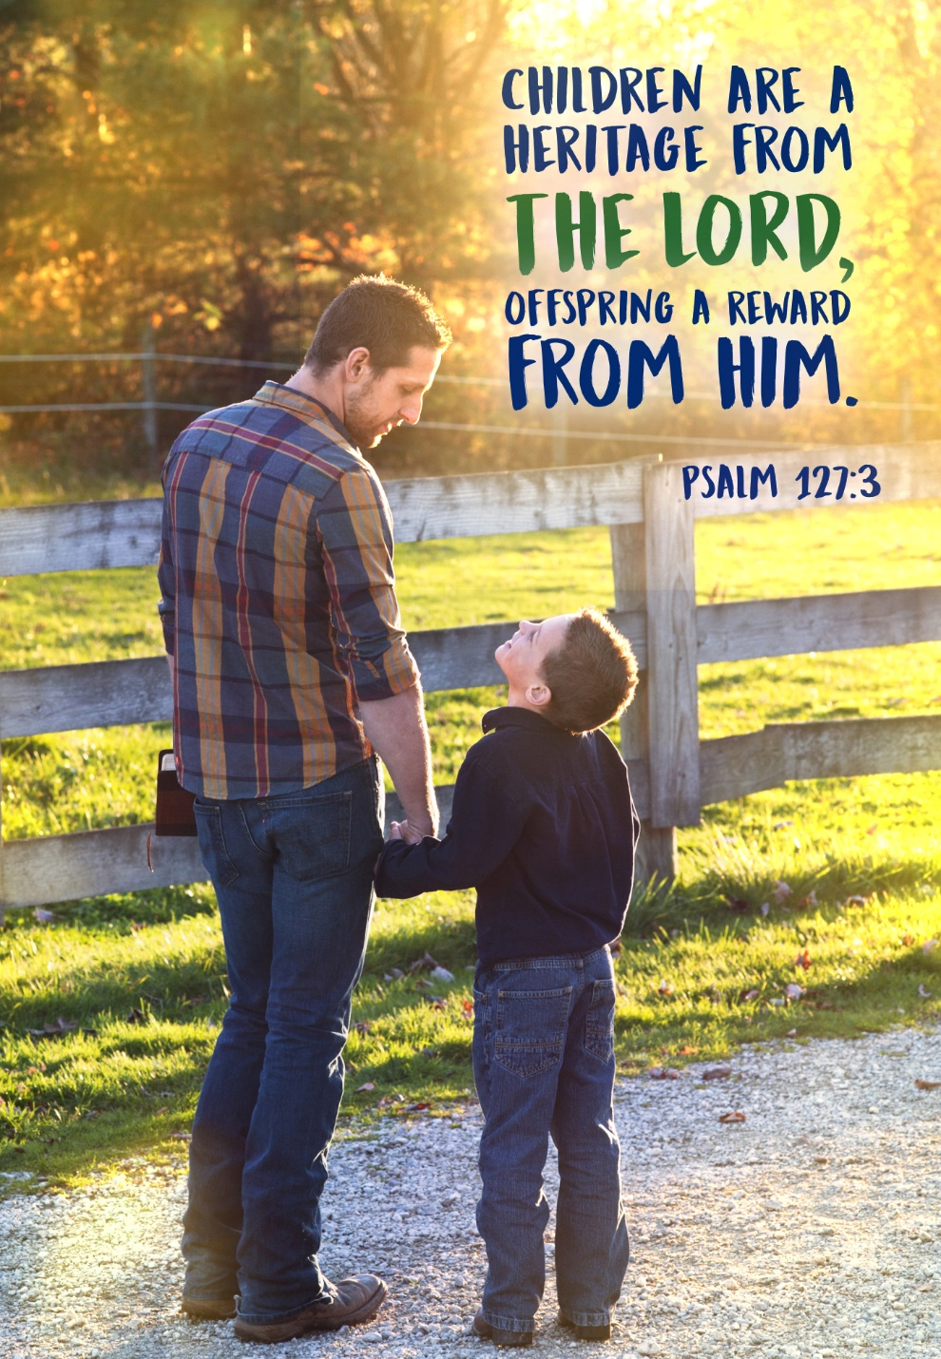

HAPPY FATHER’S DAY

