SECOND SUNDAY AFTER PENTECOST
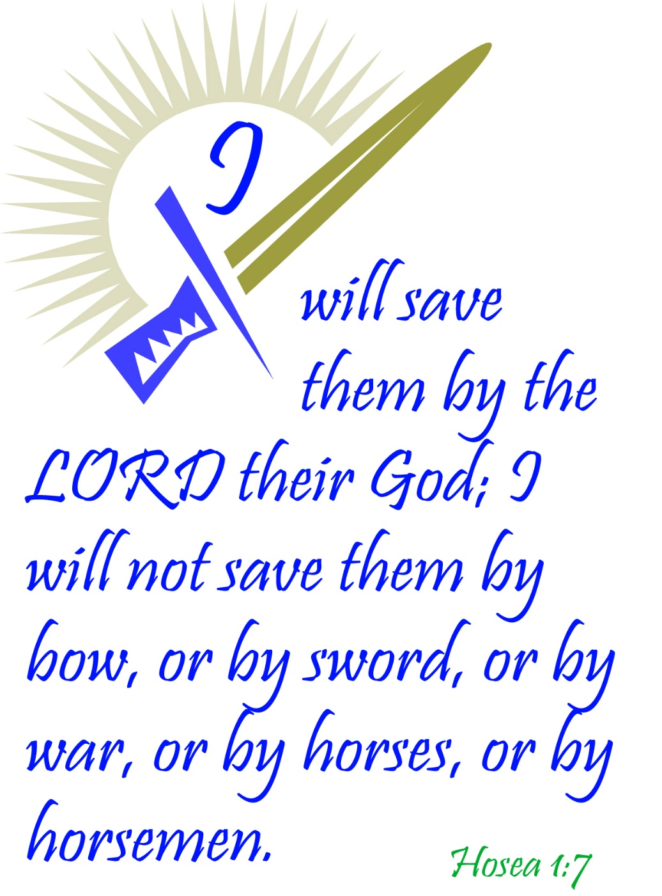
Mt. Zion Evangelical Lutheran Church

320 Mt. Zion Dr., Ripon, WI
www.mtzionripon.org
Facebook: Mt. Zion Evangelical Lutheran Church

Pastor Kurt Hagen (Vacancy Pastor)
Phone 651-764-3901
pastorhagen@gmail.com

Pentecost 2 June 6, 2026
Handicapped accessible restrooms are located upstairs next to the Pastor’s Study and downstairs next to the elevator.
Attendance: Please remember to sign the friendship pads. Registration for communion will continue as usual at the table. If you have any questions or concerns, please contact Mike Meeker.


Hearing Loop: Our sanctuary is equipped with a hearing loop system. Those who have compatible hearing aids (with a T-switch) will be able to hear the sound system directly into their ear(s). The two main seating areas and the choir area are looped so that you may sit in any of the three areas. We also have four receivers available for those who do not have compatible hearing aids. If you wish to use a receiver please ask the ushers. Those who wish may bring their own headphones or ear buds.

A note for our visitors on member communion –
Out of sincere love for the truth of God’s Word and for precious human souls, we practice member communion in our synod and congregation. This teaching, as practiced by the Church for centuries, is thoroughly Scriptural. It questions the faith of no individual yet asks that there be full doctrinal agreement between those who commune. For this reason, we ask that only those who are members of a WELS or ELS congregation join us for the Lord’s Supper. If you wish to commune with us please speak with the pastor before the service. The Lord’s Supper will be celebrated for those who desire it. The front row on the pulpit side is reserved for people who are unable to navigate the steps. Pastor will serve you Communion first.

Prayer Before Communion: Lord Jesus, I thank you for the gift of your Holy Supper. As I come to your table, work true repentance in my heart. Teach me to confess my sins and to believe that I am forgiven for your sake. May your body and blood, in and with the bread and wine, nourish my faith and strengthen my will to live in a way that is pleasing to you. Help me see what a blessing your sacrament is for my soul, and lead me to your altar often to receive your forgiveness. Amen.

Hymns: 711, 578, (576), 696

Pastor Hagen is conducting this evening’s service.
Guest Organist is Adah Hagen

Order of Worship Setting One pg. 154

First Reading: Exodus 3:1-15 (EHV)
Now Moses was shepherding the flock of Jethro, his father-in-law, a priest of Midian, and he led the flock to the far side of the wilderness and came to Horeb, the mountain of God. ²The Angel of the Lord appeared to him in blazing fire from within a bush. Moses saw that the bush was on fire, but the bush was not burning up. ³So he said, “I will go over and look at this amazing sight—to find out why the bush is not burning up.”
⁴When the Lord saw that Moses had gone over to take a look, God called to him from the middle of the bush and said, “Moses! Moses!”
Moses said, “I am here.”
⁵The Lord said, “Do not come any closer. Take your sandals off your feet, for the place where you are standing is holy ground.” ⁶He then said, “I am the God of your fathers, the God of Abraham, the God of Isaac, and the God of Jacob.”
Moses hid his face, because he was afraid to look at God.
⁷The Lord said, “I have certainly seen the misery of my people in Egypt, and I have heard their cry for help because of their slave drivers. Yes, I am aware of their suffering. ⁸So I have come down to deliver them from the hand of the Egyptians and to bring them up out of that land to a good and spacious land, to a land flowing with milk and honey, to the place of the Canaanites, the Hittites, the Amorites, the Perizzites, the Hivites, and the Jebusites. ⁹Now indeed, the Israelites’ cry for help has come to me. Yes, I have seen how the Egyptians are oppressing them. ¹⁰Come now, I will send you to Pharaoh to bring my people, the Israelites, out of Egypt.”
¹¹But Moses said to God, “Who am I, that I should go to Pharaoh, and that I should bring the Israelites out of Egypt?”
¹²So he said, “I will certainly be with you. This will be the sign to you that I have sent you: When you have brought the people out of Egypt, you will serve God on this mountain.”
¹³But Moses said to God, “If I go to the Israelites and say to them, ‘The God of your fathers has sent me to you,’ and they ask me, ‘What is his name?’ what should I say to them?”
¹⁴So God replied to Moses, “I am who I am.” He also said, “You will say this to the Israelites: I am has sent me to you.”
¹⁵God also told Moses, “Say this to the Israelites: ‘The Lord, the God of your fathers—the God of Abraham, the God of Isaac, and the God of Jacob—has sent me to you. This is my name forever, and this is how I am to be remembered from generation to generation.’”

Psalm: 119C (See Insert) Teach Me, O LORD

Second Reading: I Timothy 1:12-17 (EHV)
I give thanks to the one who empowered me, namely, Christ Jesus our Lord, that he treated me as trustworthy, appointing me into his ministry. ¹³He did this even though formerly I was a blasphemer, a persecutor, and a violent man. But I was shown mercy, because I acted ignorantly in unbelief. ¹⁴The grace of our Lord overflowed on me along with the faith and love that are in Christ Jesus. ¹⁵This saying is trustworthy and worthy of full acceptance: “Christ Jesus came into the world to save sinners,” of whom I am the worst. ¹⁶But I was shown mercy for this reason: that in me, the worst sinner, Christ Jesus might demonstrate his unlimited patience as an example for those who are going to believe in him, resulting in eternal life. ¹⁷Now to the King eternal, to the immortal, invisible, only God, be honor and glory forever and ever. Amen.

Gospel Acclamation
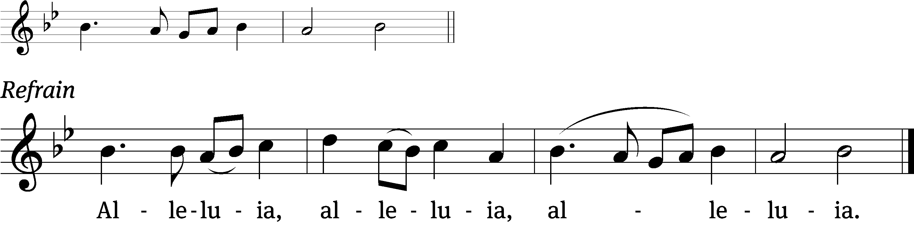
It is not the healthy who need a doctor, / but the sick.
I have not come to call the righteous, but /sinners. (Refrain)

Gospel Reading: Matthew 9:9-13 (EHV)
As Jesus went on from there, he saw a man named Matthew sitting in the tax collector’s booth. He said to him, “Follow me.” Matthew got up and followed him.
¹⁰As Jesus was reclining at the table in Matthew’s house, many tax collectors and sinners were actually there too, eating with Jesus and his disciples. ¹¹When the Pharisees saw this, they said to his disciples, “Why does your teacher eat with tax collectors and sinners?”
¹²When Jesus heard this, he said to them, “The healthy do not need a physician, but the sick do. ¹³Go and learn what this means: ‘I desire mercy, and not sacrifice.’ In fact, I did not come to call the righteous, but sinners.”

Sermon Text: Hosea 1:1-11 (EHV)
1 The word of the Lord that came to Hosea son of Be’eri, in the days of Uzziah, Jotham, Ahaz, and Hezekiah, the kings of Judah, and in the days of Jeroboam son of Joash, the king of Israel.
² When the Lord first spoke through Hosea, the Lord said to Hosea, “Go. Take for yourself an immoral wife and children produced by sexual immorality, because the land has been committing flagrant immorality, turning away from the Lord.”
³ So he went and took Gomer daughter of Diblaim. She conceived and gave birth to a son for him.
⁴ The Lord said to him, “Name him Jezre’el, because in a little while I will inflict punishment on the house of Jehu for the blood of Jezre’el. I will destroy the ruling power of the house of Israel. ⁵ In that day I will break the bow of Israel in the Valley of Jezre’el.”
⁶ She conceived again and gave birth to a daughter.
The Lord said to him, “Name her Lo Ruhamah, because I will no longer have compassion on the house of Israel. Indeed, I will certainly not forgive them. ⁷ But I will have compassion on the house of Judah. I will save them by the Lord their God. I will not save them by bow, sword, battle, horses, or horsemen.”
⁸ Gomer weaned Lo Ruhamah. Then she conceived and gave birth to a son.
⁹ The Lord said, “Name him Lo Ammi, because you are not my people, and I will not be the Lord for you.”
¹⁰ Nevertheless, the number of the people of Israel will be like the sand of the sea, which cannot be measured or counted. Then, in the place where they were told, “You are not my people,” they will be told, “You are children of the living God.” ¹¹ The people of Judah and the people of Israel will be gathered together. They will appoint one head for themselves, and they will go up from the land, for the day of Jezre’el will be great.

Sermon Theme: “God’s Faithful Love Makes Us His People.”

Reception of New Members: Please welcome Phil Hammermeister, his wife Jana, son Maxtyn and daughter Molly. Welcome to the Mt. Zion family of believers.

OFFERING: The offerings are brought forward to the altar.

Keep in Your Prayers: Harley Dorsey, Matt Dubey, Carol Henning, Nancy Kemnitz, Ginny Verch, Gary Wichman.

Announcements
Members of Mt. Zion: We will be going back to Sunday morning church services beginning Sunday June 21st. Pastor Meier will be conducting the services.

Mailbox and table: The June Forward In Christ is available and also the May 31, 2026-Aug. 29, 2026 Meditations are available. June calendars are also available.


Today’s “Noisy Offerings will be for Lutheran Military Support Group. The Lutheran Military Support Group (LMSG) is a Christ-centered organization that provides support to military service members, veterans, and their families. LMSG aims to offer practical support and resources to those in need, celebrating its commitment to serving the military community. As always, we appreciate your generous contributions.

Mailbox and table: The June Forward In Christ is available and also the May 31, 2026-Aug. 29, 2026 Meditations are available. June calendars are also available.

If you would like the Lord’s Supper privately, please contact Pastor Kurt Hagen at 651-764-3901, or by email pastorkhagen@gmail.com.

The Helping Hands Ministry is ready to serve the needs of our members. Please contact one of the following if you or someone you know needs assistance: Joanne Gregor at 920-896-1518 and Lisa Tremore at 920-229-1297.
For Your Information
Attendance 5/30/2026 61
Offerings for 5/30/2026 $1,693.00
Year to Date (thru May 31st).
Income : $69,770.17
Expenses : $76,609.15
Shortfall: $-6,838.98
Our planned budget for this time frame was $96,645.70.

Serving Our Lord

Thank you to everyone for your service to our Lord!

Ushers:

June 6: Mark Roeder, Ferd Roeder, Jason Roeder

June 13 & 21: Gary Quade, Travis Schmudlach, Kyle Stollfuss

June 28 & July 5: Steve Ohlrich, Derek Chitwood, Alex Kranz

PowerPoint:

June 6: Jo Meeker

June 13: Grunert family

June 21: Jo Meeker

June 28:

June Communion Set up: Donna Mueller

June Communion Clean up: Jan Ohlrich, Deb Picciotino

Saturday (6th) 5:00 PM Worship with Communion
Tuesday 5:30 PM Council Meeting
Saturday (13th) 5:00 PM Worship Service with Communion
Noisy Offering

