NINETEENTH SUNDAY AFTER
PENTECOST
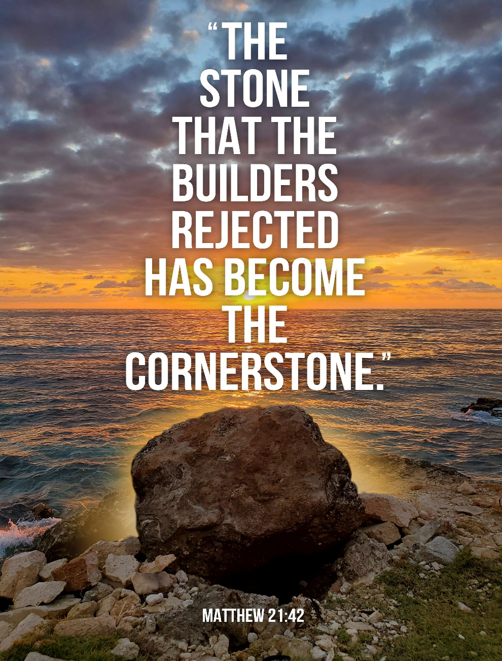
Mt. Zion Evangelical Lutheran Church

320 Mt. Zion Dr., Ripon, WI
www.mtzionripon.org
Facebook: Mt. Zion Evangelical Lutheran Church

Pastor Mark Kock
Phone 414-755-9021
mkock315@gmail.com
Pentecost 19 Oct. 4, 2026
Welcome! The Lord is with us as we gather in his name. Through his Word he brings to you the forgiving, faith-strengthening love of Jesus Christ. Come, let us worship the Lord! Please sign the friendship pads in the pews.

If you have a prayer request for a service, please speak to Pastor Kock. Perhaps a prayer of thanks for a special occasion – birthday, wedding anniversary, or a prayer of intercession for a relative or friend. Throughout the week Pastor Kock is here to serve you in Christ, counseling with the Word, and encouraging your faith. Contact him at 414-755-9021 or mkock315@gmail.com.

Handicapped accessible restrooms are located upstairs next to the Pastor’s Study and downstairs next to the elevator.
Attendance: Please remember to sign the friendship pads. Registration for communion will continue as usual at the table. If you have any questions or concerns, please contact Mike Meeker.


Hearing Loop: Our sanctuary is equipped with a hearing loop system. Those who have compatible hearing aids (with a T-switch) will be able to hear the sound system directly into their ear(s). The two main seating areas and the choir area are looped so that you may sit in any of the three areas. We also have four receivers available for those who do not have compatible hearing aids. If you wish to use a receiver please ask the ushers. Those who wish may bring their own headphones or ear buds.

Please Note: The offering plates are located behind the last pews on each side of the sanctuary and also by the organ. Our offerings are given all to the glory of God.

Hymns: Peace students “Sing and Celebrate” grades 4K-2, 520, 680, Peace students “Battle Belongs” grades 3-8

Order of Worship Setting One pg. 154

Psalm: Peace Students, “Shout for Joy” grades 4K-8

Reading: Isaiah 5: 1-7 (EHV)
Let me sing for my loved one a song about my loved one’s vineyard.
My loved one had a vineyard on a fertile ridge.
²He dug it up and gathered the stones out of it.
He planted it with the best vines.
He built a tower in the middle of it.
He also cut a winepress into it.
He expected it to produce clusters of sweet grapes,
but it produced only sour grapes.
³So now, you residents of Jerusalem and you men of Judah,
judge between me and my vineyard.
⁴What more could have been done for my vineyard
that I have not already done for it?
When I expected it to produce clusters of sweet grapes,
why did it produce sour grapes?
⁵Now, let me tell you what I will do to my vineyard.
I will take away its hedge, and it will become a pasture.
I will break down its wall, and it will be trampled down.
⁶I will make it a wasteland.
It will not be pruned or hoed.
So briers and thorns will shoot up.
I will also command the clouds not to pour rain on it.
⁷Yes, the vineyard of the Lord of Armies is the house of Israel,
and the men of Judah are the planting that was pleasing to him.
He expected justice, but instead there was oppression.
He expected righteousness, but there was an outcry.
Reading: Philippians 3:12-21 (EHV)
Not that I have already obtained this or have already reached the goal, but I press on to take hold of that for which Christ Jesus also took hold of me. ¹³Brothers, I do not consider myself to have taken hold of it yet, but there is one thing I do: Forgetting the things that are behind and straining toward the things that are ahead, ¹⁴I press on toward the goal, for the prize of the upward call of God in Christ Jesus. ¹⁵Therefore, let all of us who are mature continue to think this way. And if you think differently about anything, God will reveal this to you too. ¹⁶Only let us think the same thing and walk in line with what we already have attained.
¹⁷Brothers, join together in imitating me and in paying attention to those who are walking according to the pattern we gave you. ¹⁸To be sure, many walk as enemies of the cross of Christ. I told you about them often, and now I am saying it while weeping. ¹⁹Their end is destruction, their god is their appetite, and their glory is in their shame. They are thinking only about earthly things. ²⁰But our citizenship is in heaven. We are eagerly waiting for a Savior from there, the Lord Jesus Christ. ²¹By the power that enables him to subject all things to himself, he will transform our humble bodies to be like his glorious body.

Gospel Acclamation Ephesians 2:10
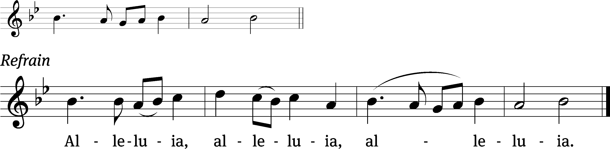
For we are God’s / Handiwork,
Created in Christ Jesus to / do good works. Refrain

Gospel: Matthew 21:33-46 (EHV)
“Listen to another parable. There was a landowner who planted a vineyard, put a fence around it, dug a winepress in it, and built a tower. He leased it out to some tenant farmers and went away on a journey. ³⁴When the time approached to harvest the fruit, he sent his servants to the tenants to get his fruit. ³⁵The tenant farmers seized his servants. They beat one, killed another, and stoned a third. ³⁶Then the landowner sent even more servants than the first time. The tenant farmers treated them the same way. ³⁷Finally, he sent his son to them. ‘They will respect my son,’ he said. ³⁸But when the tenant farmers saw the son, they said to each other, ‘This is the heir. Come, let’s kill him and take his inheritance!’ ³⁹They took him, threw him out of the vineyard, and killed him. ⁴⁰So when the landowner comes, what will he do to those tenant farmers?”
⁴¹They told him, “He will bring those wretches to a wretched end. Then he will lease out the vineyard to other tenants who will give him his fruit when it is due.”
⁴²Jesus said to them, “Have you never read in the Scriptures:
The stone the builders rejected has become the cornerstone.
This was the Lord’s doing, and it is marvelous in our eyes?
⁴³“That is why I tell you the kingdom of God will be taken away from you and given to a people that produces its fruit. ⁴⁴Whoever falls on this stone will be broken to pieces, and it will crush anyone on whom it falls.”
⁴⁵When the chief priests and the Pharisees heard his parables, they knew that he was talking about them. ⁴⁶Although they were looking for a way to arrest him, they were afraid of the crowds because the people regarded him as a prophet.

Choir Song: “Awake My Soul”
A lilting reminder of renewed life in Christ with a Celtic feel.

Sermon Text: Genesis 6: 1-8 (EHV)
This is what happened when mankind began to multiply on the face of the earth. When daughters were born to people, the sons of God saw that the daughters of men were beautiful, and they took as wives for themselves any of them they chose. The Lord said, “My Spirit will not struggle with man forever, because he is only flesh. His days will be 120 years.” The Nephilim were on the earth in those days. After that, the sons of God went to the daughters of men, who bore children for them. Those became the powerful, famous men of ancient times. The Lord saw that the wickedness of mankind was great on the earth, and that all the thoughts and plans they formed in their hearts were only evil every day. The Lord regretted that he had made man on the earth, and his heart was filled with sorrow. The Lord said, “I will wipe out mankind, whom I have created, from the face of the earth, along with the animals, the creeping things, and the birds of the sky, because I regret that I have made them.” But Noah found favor in the eyes of the Lord.

Sermon Theme: “Can You See the Savior Through the Pouring Rain?”
OFFERING: The offerings are brought forward to the altar.

Keep in Your Prayers: Harley Dorsey, Allan Brooks, Eric Eckert (operation), Myrtle Giese, Carol Henning, Nancy Kemnitz, Terry Loechelt (recovering from an operation), Dennis Schliepp, Joan Stibb, Kathy Strook, Ginny Verch, Gary Wichman, Sue Wichman.

Announcements
A big thank you to the Students of Peace School in Green Lake. We always look forward to hearing them joyfully sing their praises to God.

Noisy Offering: We collected $211.55 for Christ Alone Academy in Montello. The next Noisy Offering will be on Sunday October 18th. The children will be collecting for Lutheran Women’s Missionary Society. Thank you so much.

Birthdays: Our next birthday celebration will be Oct. 18th after church. Please join us in the fellowship hall for cake, refreshments and fellowship.

Hymn Sing: Our next hymn sing will be October 18th at 8:45 AM. If you have a favorite hymn you would like sung please contact Jo Meeker. Thanks Doug for offering to play.

Quarterly Voters’ Meeting: Our next meeting will be October 18th immediately after church in the Fellowship Hall.

Volunteers Needed: We are in need of drivers for some of our members who cannot get to appointments etc. There is a sign-up sheet on the podium by the library for all those who can help.

Trunk or Treat: On October 25th from 3-5 we will be having Trunk or Treat on the lower parking lot. Last year we had over 360 trick or treaters and their parents come to this event. There will be a box outside of the church office for candy donation which will start TODAY. We will have a sign up also for anyone who will be participating by decorating their vehicle to help hand out candy. Anyone interested in helping in other ways please contact DuWayne Wichman at 920-570-1106. Thank you for your support of this community outreach program.

We are offering the Lord's Supper on the 2nd and last Sunday of the month until further notice. This will be brought before the Voters in October.

Mailbox and table: The October Forward In Christ is available and also the Aug. 30-Nov. 28, 2026 Meditations are available. September calendars are also available.

For Your Information
Attendance 9/27/2026 79
Offerings for 9/27/2026 $2,596.00
Year to Date (thru Sept. 30th).
Income : $134,910.36
Expenses : $120,862.07
YTD +$14,048.29

Serving Our Lord

Thank you to everyone for your service to our Lord!

Ushers:

Oct. 4 & 11: Mark Roeder, Jason Roeder

Oct. 18 & 25: Gary Quade, Travis Schmudlach, Kyle Stollfuss

PowerPoint:

Oct. 4: Grunert Family

Oct. 11: Sara Retelle

Oct. 18: Jo Meeker

Oct. 25: Kari Hielke

Oct. Communion Set up: Jo Meeker

Oct. Communion Clean up: Marilyn Ninneman & Tammy Niemuth

Sunday 4th 9:00 AM Worship Service Pastor Meier
10:15 AM Sunday School, Fellowship and Bible Study
Wednesday 6:15 PM Choir Practice
Sunday 9:00 AM Worship Service with communion, Pastor Kock
10:15 AM Sunday School
10:15 AM Call Meeting in the Fellowship Hall

UPCOMING EVENTS:
October 11th Call Meeting in the Fellowship Hall
October 17th LWMS Fall Rally at St. John Pardeville
October 18th Voters’ Meeting in the Fellowship Hall with birthday celebration
October 25th Mission Festival followed by a presentation in the sanctuary by Rev. Nathan Seiltz, of WELS Multi-Language Publications, and potluck dinner in the fellowship hall

Secretary Jo Meeker
Church Office: 920-748-5641
Office Hours: Mon. 9-12, Tues. & Wed. 9-11
E-mail: mountzionripon@gmail.com

