18th Sunday of Pentecost

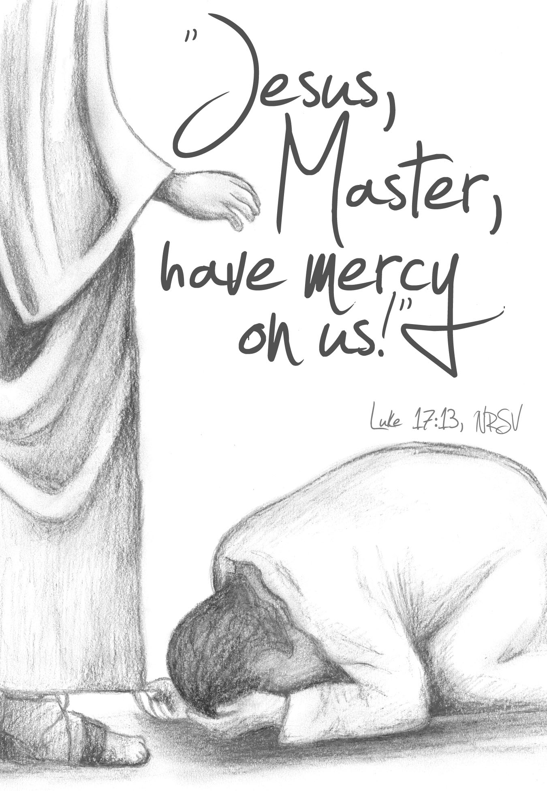
Mt. Zion Evangelical Lutheran Church
320 Mt. Zion Dr., Ripon, WI
www.mtzionripon.org
Facebook: Mt. Zion Evangelical Lutheran Church

Pastor Michael Sheppard
Pastor’s Study: 920-748-9734
E-mail: revmikesheppard@gmail.com
Pentecost 18 Oct 6 & 9, 2022

Welcome to Mt. Zion!
Handicapped accessible restrooms are located upstairs next to the Pastor’s Study and downstairs next to the elevator.
Attendance: Please remember to sign the friendship pads. Registration for communion will continue as usual at the table. If you have any questions or concerns please contact Pastor Sheppard or Mark Roeder.

Hearing Loop: Our sanctuary is equipped with a hearing loop system. Those who have compatible hearing aids (with a T-switch) will be able to hear the sound system directly into their ear(s). The two main seating areas and the choir area are looped so that you may sit in any of the three areas. We also have four receivers available for those who do not have compatible hearing aids. If you wish to use a receiver please ask the ushers. Those who wish may bring their own headphones or ear buds.

A note for our visitors on member communion –
Out of sincere love for the truth of God’s Word and for precious human souls, we practice member communion in our synod and congregation. This teaching, as practiced by the Church for centuries, is thoroughly Scriptural. It questions the faith of no individual yet asks that there be full doctrinal agreement between those who commune. For this reason, we ask that only those who are members of a WELS or ELS congregation join us for the Lord’s Supper. If you wish to commune with us please speak with the pastor before the service.
The front row on the pulpit side is reserved for people who are unable to navigate the steps. Pastor will serve you Communion first.

Prayer Before Communion: Dearest Jesus, I marvel that you came to this earth as the Word made flesh. With similar awe I contemplate how you give me your body and blood in the bread and wine of Holy Communion. Touch me with your grace that moved you to reach out to me, a poor, miserable sinner! Use this sacred supper to bring me closer to you. Amen.

Prayer After Communion: Thank you, Lord Jesus Christ, for nourishing me in this sacrament with your body and blood. You have given me forgiveness, life, and salvation. Let me always remain in you as a branch remains in the vine. Send me out in the power of your Spirit to live and work to your praise and glory. Amen

Hymn Sing: 809, 810 Hymnal only, 847, 623
Hymns: 754, 624, 659, 752

Order of Worship: The Service CW21 pg. 154

First Reading: Genesis 8: 15-22 (EHV)
God spoke to Noah. He said, ¹⁶“Go out of the ark—you, your wife, your sons, and your sons’ wives with you. ¹⁷Bring out with you every living thing of every sort that is with you, all flesh, including birds, livestock, and every creeping thing that creeps on the earth, so that they may swarm over the earth, and be fruitful and multiply on the earth.”
¹⁸Noah went out with his sons, his wife, and his sons’ wives along with him. ¹⁹Every animal, every creeping thing, every bird, and whatever swarms on the earth went out of the ship, species by species.
²⁰Noah built an altar to the Lord and took from every clean animal and every clean bird and offered burnt offerings on the altar. ²¹The Lord smelled the pleasant aroma. The Lord said in his heart, “I will never again curse the soil anymore because of man, for the thoughts he forms in his heart are evil from his youth. Neither will I ever again strike every living thing, as I have done. ²²While the earth remains, seedtime and harvest, cold and heat, summer and winter, and day and night shall not cease.”

Lord, I Must Praise You Psalm 111

Second Reading: 2 Corinthians 9: 10-15 (EHV)
And he who provides seed to the sower and bread for food will provide and multiply your seed for sowing, and will increase the harvest of your righteousness. ¹¹You will be made rich in every way so that you may be generous in every way, which produces thanksgiving to God through us.
¹²To be sure, the administration of this service is not only making up for what is lacking among the saints, but it is also overflowing in many prayers of thanksgiving to God. ¹³By proving yourselves in this service, many people are glorifying God, as they see the obedience shown in your confession of the gospel of Christ, and the generosity shown in your sharing with them and all people. ¹⁴At the same time as they pray for you, they also express their longing for you, because of the extraordinary measure of God’s grace given to you. ¹⁵Thanks be to God for his indescribable gift!
Gospel Acclamation Psalm 105:1
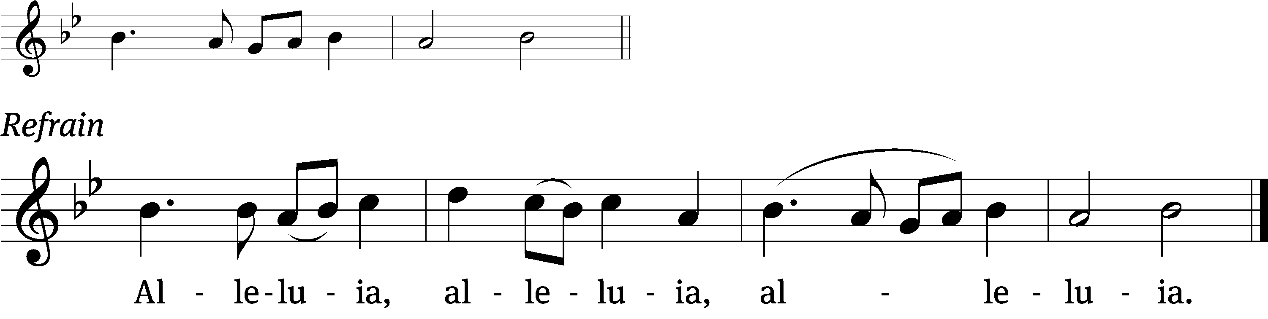

Give praise to the Lord, proclaim his name;
make known among the nations what he has done.

RefrainMelody
Tune: © 2021 Northwestern Publishing House. Used by permission: OneLicense no. 716381
Gospel & Sermon Text: Luke 17: 11-19 (EHV)
On another occasion, as Jesus was on his way to Jerusalem, he was passing along the border between Samaria and Galilee. ¹²When he entered a certain village, ten men with leprosy met him. Standing at a distance, ¹³they called out loudly, “Jesus, Master, have mercy on us!”
¹⁴When he saw them, he said, “Go, show yourselves to the priests.” As they went away they were cleansed.
¹⁵One of them, when he saw that he was healed, turned back, glorifying God with a loud voice. ¹⁶He fell on his face at Jesus’ feet, thanking him. And he was a Samaritan. ¹⁷Jesus responded, “Were not ten cleansed? Where are the other nine? ¹⁸Was no one found to return and give glory to God except this foreigner?” ¹⁹Then he said to him, “Get up and go your way. Your faith has saved you.”

Sermon Theme: “Gratitude Flows From A Trusting Heart.”

OFFERING: The offerings are brought forward to the altar.

Announcements

Please join us for the LWMS Beaver Dam Circuit’s fall rally at St. John’s Montello on Saturday Oct. 15th. Pastor Nate Bourman, our befriend a mission pastor for Mt. Lebanon, Milwaukee will be our speaker. We are planning to carpool to St. John’s leaving the church’s north parking at 9:00. There is a sign-up sheet on the bulletin board outside the office if you would like to carpool.
PowerPoint: We are in need of 1 or 2 more people to do the service once a month on Sunday. You do not have to be a “Techie” to do this. It can all be setup for you and all that’s needed is for you to push a button. Please let Sara Grunert know if you can help her out. Contact her at grunertfamily@charter.net.

Peace Lutheran School: The children of Peace Lutheran School will sing during our Sunday service on October 16th.

Favorite Hymn Service: We need your help. In January we will have a favorite hymn service and would like to know your favorite hymns. After we tally your suggestions, we will include the favorite hymns in a special service. Please include your favorite hymns on the form and return it to us by the end of November.

Hymn Sing: Our next hymn sing will be Sunday November 20th. If you have a favorite hymn please let Jo Meeker or Sue Sheppard know.

Sound System: We have started a fund for a new Audio/Visual system. The improvements are necessary to accommodate our recent and future technology additions. We are applying for a grant from The Antioch Foundation, if it is approved Mt Zion’s share of the cost will be approximately $16,000.00. You may use the regular church envelopes just write Audio System next to your donation. Thank you.

Red Hymnals: It was decided that whoever would like to take one or more old hymnals home may do so at no cost. They are located on the table by the entrance to the sanctuary. Please feel free to take.

Birthday Celebration: Cake will be served Sunday October 9th to celebrate the birthdays for October.
Mailbox and table: The October Forward In Christ is available and also the August 28th, 2022-November 26th, 2022 Meditations are available.
If you would like the Lord’s Supper privately, please contact Pastor Sheppard on his cell 920-745-0883, or by email revmikesheppard@gmail.com.

The Helping Hands Ministry is ready to serve the needs of our members. Please contact one of the following if you or someone you know needs assistance: Joanne Gregor at 920-896-1518, Lisa Tremore at 920-229-1297 or Tammy Niemuth at 920-299-0240.

For Your Information
Attendance 9/29 - 10/2/2022: 93
Offerings for 9/29 - 10/2/2022: $4,788.00*
*Includes $2,032 towards the new sound system

Serving Our Lord

Thank you to everyone for your service to our Lord!

Ushers:

Oct. 9: Tobin Storzer, Rick Retelle, Kelly Frank, Terry Dolderer

Oct. 16 & 23: Dennis Scott, Dave Patchett, Dawson Niemuth, Rick Niemuth

PowerPoint:

Oct 6: Kim Mueller

Oct 9: Jo Meeker

Oct 13: Grunert Family

Oct 16: Jo Meeker

Oct Communion Set up: Jo Meeker

Oct Communion Clean up: Marilyn Ninneman & Tammy Niemuth

This week at Mt. Zion
Sunday (9th) 8:45 AM Hymn Sing
9:00 AM Worship with Communion
10:15 AM Sunday School & Bible Study
Birthday Cake
Monday 6:30 PM Bible Study
Tuesday 9:00 AM Bible Study
7:00 PM Ladies Aid
Wednesday 5:00 PM Catechism Class
6:15 PM Choir Practice
7:15 PM Council Meeting
Thursday 6:30 PM Worship
Saturday LWMS Fall Rally at St. Johns Montello
Sunday 9:00 AM Worship
10:15 AM Sunday School & Bible Study

Secretary Jo Meeker
Church Office: 920-748-5641
Office Hours: Mon. 9-12, Tues. & Wed. 9-11
E-mail: mountzionripon@gmail.com

Acknowledgments
Unless otherwise indicated, Scripture quotations are from The Holy Bible, New International Version®, NIV®. Copyright © 1973, 1978, 1984, 2011 by Biblica, Inc.TM Used by permission of Zondervan. All rights reserved worldwide.
Software distributed in partnership with Northwestern Publishing House.
Created by Christian Worship: Service Builder © 2022 Concordia Publishing House.

