EIGHTEENTH SUNDAY AFTER
PENTECOST
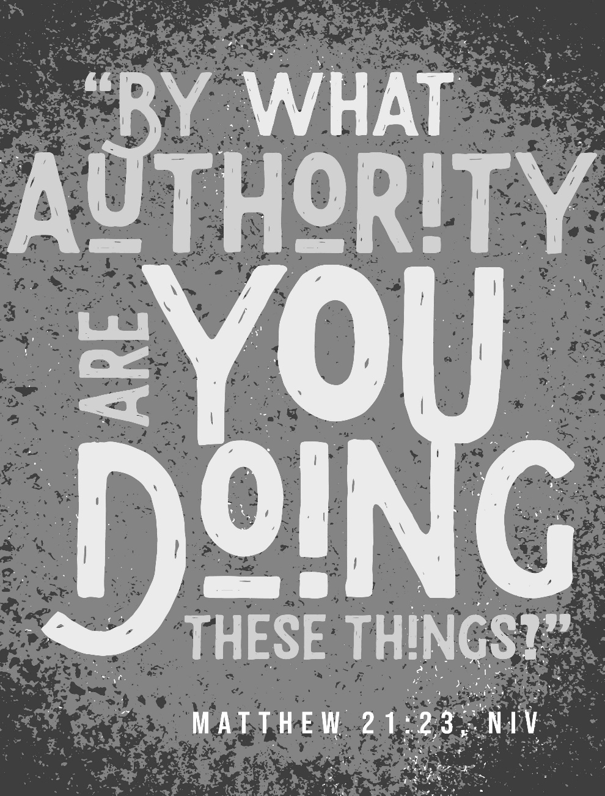
Mt. Zion Evangelical Lutheran Church

320 Mt. Zion Dr., Ripon, WI
www.mtzionripon.org
Facebook: Mt. Zion Evangelical Lutheran Church

Pastor Mark Kock
Phone 414-755-9021
mkock315@gmail.com
Pentecost 18 Sept. 27, 2026
Welcome! The Lord is with us as we gather in his name. Through his Word he brings to you the forgiving, faith-strengthening love of Jesus Christ. Come, let us worship the Lord! Please sign the friendship pads in the pews.

If you have a prayer request for a service, please speak to Pastor Kock. Perhaps a prayer of thanks for a special occasion – birthday, wedding anniversary, or a prayer of intercession for a relative or friend. Throughout the week Pastor Kock is here to serve you in Christ, counseling with the Word, and encouraging your faith. Contact him at 414-755-9021 or mkock315@gmail.com.

Holy Communion is offered to Communicant members of Mount Zion and of other Wisconsin Evangelical Lutheran Synod (WELS) churches who have prepared themselves in faith to receive Jesus’ body and blood. In Communion, Jesus gives the blessings of the forgiveness of sins and intimate fellowship with him! Visitors, Pastor Kock offers a Bible Class to prepare you for this wonderful meal. Ask him about it. Members, please register for communion at the table in back. If you have any questions or concerns, please contact Mike Meeker.

The front row is reserved for people who are unable to navigate the steps to the altar. Pastor will serve them Communion first.

Handicapped accessible restrooms are located upstairs next to the Pastor’s Study and downstairs next to the elevator.
Attendance: Please remember to sign the friendship pads. Registration for communion will continue as usual at the table. If you have any questions or concerns, please contact Mike Meeker.

Hearing Loop: Our sanctuary is equipped with a hearing loop system. Those who have compatible hearing aids (with a T-switch) will be able to hear the sound system directly into their ear(s). The two main seating areas and the choir area are looped so that you may sit in any of the three areas. We also have four receivers available for those who do not have compatible hearing aids. If you wish to use a receiver please ask the ushers. Those who wish may bring their own headphones or ear buds.

Focus of today’s service: “Show me your ways, Lord, teach me your paths. Guide me in your truth and teach me, for you are God my Savior, and my hope is in you all day long.” Psalm 25:4,5.

Hymns: 593, 655, (526), 697

Order of Worship Setting One pg. 154

Psalm: 25a To You, O LORD, I lift My Soul

Reading: Ezekiel 18:1-4,25-32 (EHV)
The word of the Lord came to me.
²What do you mean, you who keep repeating this proverb concerning the soil of Israel, “Fathers eat sour grapes, and their sons’ teeth are set on edge”? ³As surely as I live, declares the Lord God, you will never again use this proverb in Israel. ⁴Indeed, all souls are mine. The soul of the father is mine just like the soul of the son. The soul who sins is the one who will die.
²⁵But you say, “The Lord’s way is not fair.” Listen now, house of Israel. Is it my way that is not fair? Is it not your ways that are not fair? ²⁶If a righteous man turns away from his righteousness and practices unrighteousness, he will die because of it. Because of the unrighteousness that he has practiced, he will die.
²⁷But if a wicked man turns from his wickedness that he has done and practices justice and righteousness, he will preserve his life. ²⁸Because he has seen and turned away from all the rebellious acts that he had committed, he will surely live, and he will not die. ²⁹But the house of Israel says, “The Lord’s way is not fair.” Is it really my ways that are not fair, O house of Israel? Is it not your ways that are not fair?
³⁰Therefore, I will judge each one of you according to his ways, O house of Israel, declares the Lord God. Repent and turn away from all your rebellious acts, so that you will not set out a stumbling block that makes you guilty. ³¹Throw off from yourselves all your rebellious actions by which you have rebelled, and obtain a new heart and a new spirit for yourselves. Why should you die, O house of Israel? ³²For I take no pleasure in the death of anyone who dies, declares the Lord God. So repent and live!

Reading: Philippians 2:1-11 (EHV)
So if there is any encouragement in Christ, if any comfort from his love, if any fellowship with the Spirit, if any affection and compassion, ²then make my joy complete by being like-minded, having the same love, being united in spirit, and having one mind. ³Do nothing out of selfish ambition or empty conceit, but in humility consider one another better than yourselves. ⁴Let each of you look carefully not only to your own interests, but also to the interests of others.
⁵Indeed, let this attitude be in you, which was also in Christ Jesus. ⁶Though he was by nature God, he did not consider equality with God as a prize to be displayed, ⁷but he emptied himself by taking the nature of a servant. When he was born in human likeness, and his appearance was like that of any other man, ⁸he humbled himself and became obedient to the point of death—even death on a cross. ⁹Therefore God also highly exalted him and gave him the name that is above every name, ¹⁰so that at the name of Jesus every knee will bow, in heaven and on earth and under the earth, ¹¹and every tongue will confess that Jesus Christ is Lord, to the glory of God the Father.

Gospel Acclamation Philippians 2:8-9
Alleluia, Alleluia, Alleluia
Christ became obedient to the point of death, even death on a cross. Therefore God highly exalted him and gave him the name that is above every name.
Alleluia, Alleluia, Alleluia

Gospel & Sermon Text: Matthew 21:23-32 (EHV)
When Jesus went into the temple courts, the chief priests and the elders of the people came to him while he was teaching and said, “By what authority are you doing these things?” and “Who gave you this authority?”
²⁴Jesus answered them, “I will also ask you one question. If you answer it, I will tell you by what authority I do these things. ²⁵The baptism of John, where was it from? From heaven or from men?”
They discussed it among themselves, saying, “If we say, ‘From heaven,’ he will say to us, ‘Then why did you not believe him?’ ²⁶But if we say, ‘From men,’ we are afraid of the crowd, since they all regard John as a prophet.” ²⁷So they answered Jesus, “We do not know.”
He said to them, “Then I will not tell you by what authority I do these things.”
²⁸“What do you think? A man had two sons. He went to the first and said, ‘Son, go work today in my vineyard.’ ²⁹He answered, ‘I will not,’ but later he changed his mind and went. ³⁰He came to the second and said the same thing. The second son answered, ‘I will go, sir,’ but he did not go. ³¹Which of the two did the will of his father?”
They said to him, “The first.”
Jesus said to them, “Amen I tell you: The tax collectors and the prostitutes are entering the kingdom of God ahead of you. ³²For John came to you in the way of righteousness, but you did not believe him. However, the tax collectors and prostitutes did believe him. Even when you saw this, you did not change your mind and believe him.”

CHILDREN’S MESSAGE: All children are invited to come up to the steps to hear the message.

Sermon Theme: “The Tax Collectors and the Prostitutes are Entering the Kingdom of God Ahead of You.”

OFFERING: The offerings are brought forward to the altar.

Keep in Your Prayers: Harley Dorsey, Allan Brooks, Eric Eckert (operation), Myrtle Giese, Carol Henning, Nancy Kemnitz, Terry Loechelt (recovering from an operation), Dennis Schliepp, Joan Stibb, Kathy Strook, Ginny Verch, Gary Wichman, Sue Wichman.
Announcements
Call Returned: Pastor Frey sent a letter to let us know he has returned the call. The next call meeting will be October 11th, after church.

Noisy Offering: We collected $211.55 for Christ Alone Academy in Montello. The next Noisy Offering will be on Sunday October 18th. The children will be collecting for Lutheran Women’s Missionary Society. Thank you so much.

Birthdays: The birthday celebration will be TODAY after church. Please join us in the fellowship hall for cake, refreshments and fellowship.

Volunteers Needed: We are in need of drivers for some of our members who cannot get to appointments etc. There is a sign-up sheet on the podium by the library for all those who can help.

Hymn Sing: Our next hymn sing will be October 18th at 8:45 AM. If you have a favorite hymn you would like sung please contact Jo Meeker. Thanks Doug for offering to play.

Trunk or Treat: On October 25th from 3-5 we will be having Trunk or Treat on the lower parking lot. Last year we had over 360 trick or treaters and their parents come to this event. There will be a box outside of the church office for candy donation which will start TODAY. We will have a sign up also for anyone who will be participating by decorating their vehicle to help hand out candy. Anyone interested in helping in other ways please contact DuWayne Wichman at 920-570-1106. Thank you for your support of this community outreach program.

Facebook Posts: If you have any posts for the church’s Facebook please contact Sara or Terry Grunert about a week in advance using the following email: grunertfamily99@gmail.com. Thanks to the Grunerts for taking this over.

We are offering the Lord's Supper on the 2nd and last Sunday of the month until further notice. This will be brought before the Voters in October.

Mailbox and table: The September Forward In Christ is available and also the Aug. 30-Nov. 28, 2026 Meditations are available. September calendars are also available.

For Your Information
Attendance 9/20/2026 80
Offerings for 9/20/2026 $2,094.55
Year to Date (thru Aug. 31st).
Income : $115,671.15
Expenses : $108,063.95
Shortfall YTD -$7,607.20
Our planned budget for this time frame was $154,633.12.

Serving Our Lord

Thank you to everyone for your service to our Lord!

Ushers:

Sept. 27: Dave Smith, Josh Niemuth, Justin & Raylee Niemuth

Oct. 4 & 11: Mark Roeder, Jason Roeder

Oct. 18 & 25: Gary Quade, Travis Schmudlach, Kyle Stollfuss

PowerPoint:

Sept. 27: Jo Meeker

Oct. 4: Grunert Family

Oct. 11: Sara Retelle

We need volunteers for quite a few Sundays coming up. Please talk to Sara Grunert.

Sept. Communion Set up: Jo Meeker

Sept. Communion Clean up: Marilyn Ninneman

Sunday 27th 9:00 AM Worship Service with Communion Pastor Kock
10:15 AM Birthday Cake, Sunday School & Bible Study
Wednesday 6:15 PM Choir Practice
Sunday 9:00 AM Worship Service
10:15 AM Sunday School & Bible Study

UPCOMING EVENTS:
October 11th Call Meeting
October 17th LWMS Fall Rally at St. John Pardeville
October 18th Voters’ Meeting

Secretary Jo Meeker
Church Office: 920-748-5641
Office Hours: Mon. 9-12, Tues. & Wed. 9-11
E-mail: mountzionripon@gmail.com

