17th Sunday of Pentecost

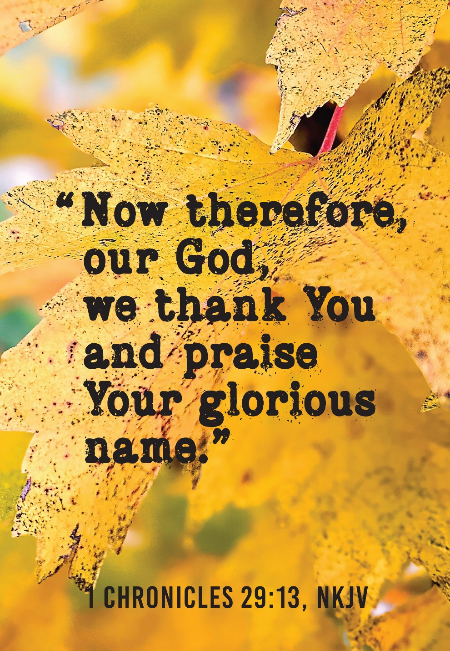
Mt. Zion Evangelical Lutheran Church
320 Mt. Zion Dr., Ripon, WI
www.mtzionripon.org
Facebook: Mt. Zion Evangelical Lutheran Church

Pastor Michael Sheppard
Pastor’s Study: 920-748-9734
E-mail: revmikesheppard@gmail.com
Pentecost 17 Sept. 29 & Oct 2, 2022

Welcome to Mt. Zion!
Handicapped accessible restrooms are located upstairs next to the Pastor’s Study and downstairs next to the elevator.
Attendance: Please remember to sign the friendship pads. Registration for communion will continue as usual at the table. If you have any questions or concerns please contact Pastor Sheppard or Mark Roeder.

Hearing Loop: Our sanctuary is equipped with a hearing loop system. Those who have compatible hearing aids (with a T-switch) will be able to hear the sound system directly into their ear(s). The two main seating areas and the choir area are looped so that you may sit in any of the three areas. We also have four receivers available for those who do not have compatible hearing aids. If you wish to use a receiver please ask the ushers. Those who wish may bring their own headphones or ear buds.

Prayer Before Worship: O Lord our Maker, Redeemer, and comforter, we assembled in your presence to hear your holy Word. We pray that you would open our hearts by your Holy Spirit, that through the preaching of your Word we may repent of our sins, believe in Jesus, and grow day by day in grace and holiness. Hear us for Jesus’ sake. Amen
Hymns: 749, 748, 751

Order of Worship: Thursday: Evening Prayer pg. 215
Sunday: Morning Prayer pg. 207

In God Alone My Soul Can find Rest and Peace Psalm 62

Reading: 2 Thessalonians 1: 1-5, 11, 12 (EHV)
Paul, Silas, and Timothy,
To the church of the Thessalonians in God our Father and the Lord Jesus Christ:
²Grace to you and peace from God our Father and the Lord Jesus Christ.
³We are always obligated to thank God for you, brothers, as is fitting, because your faith is growing more and more, and the love that each and every one of you has for one another is increasing. ⁴So we ourselves boast about you in God’s churches in regard to your patient endurance and faith in all your persecutions and in the trials that you are enduring. ⁵This is evidence of God’s righteous verdict that resulted in your being counted worthy of God’s kingdom, for which you also suffer.
¹¹For this reason, we are always praying for you, that our God will make you worthy of your calling and use his power to fulfill every good desire and work of your faith, ¹²so that the name of our Lord Jesus Christ may be glorified in you and you in him, in keeping with the grace of our God and Lord Jesus Christ.

Gospel: Luke 17: 1-10 (EHV)
Jesus said to his disciples, “Temptations to sin are sure to come, but woe to the one through whom they come! ²It would be better for that person if a millstone would be hung around his neck and he would be thrown into the sea than for him to cause one of these little ones to sin. ³Watch yourselves.
“If your brother sins, rebuke him. If he repents, forgive him. ⁴Even if he sins against you seven times in a day, and seven times returns to you and says, ‘I repent,’ forgive him.”
⁵The apostles said to the Lord, “Increase our faith.”
⁶The Lord said, “If you had faith like a mustard seed, you could tell this mulberry tree, ‘Be uprooted and planted in the sea,’ and it would obey you. ⁷Which one of you who has a servant plowing or taking care of sheep will say to him when he comes in from the field, ‘Come at once and recline at the table’? ⁸Won’t the master tell him instead, ‘Prepare my supper, and after you are properly dressed, serve me while I eat and drink. After that you may eat and drink’? ⁹He does not thank the servant because he did what he was commanded to do, does he? ¹⁰So also you, when you have done all that you were commanded, say, ‘We are unworthy servants. We have only done what we were supposed to do.’”

Choir Song: “All to Us”
This contemporary hymn of praise serves as a prayer that the glory of Christ may be at the heart of the church's mission. "Let the glory of Your Name be the passion of the church".

Sermon Text: 1 Chronicles 29: 1,2,10-18 (EHV)
King David said this to the whole assembly:
My son Solomon, the one God has chosen, is young and inexperienced. The work is great because this citadel is not for a man. It is for the Lord God. ²According to all my strength, I have provided these things for the house of my God: gold for the gold items, silver for the silver, bronze for the bronze, iron for the iron, wood for the wooden, onyx stones and settings, antimony, stones of many different colors, every kind of precious stone, and alabaster in abundance.
¹⁰David blessed the Lord in the presence of the entire assembly. He said:
Blessed are you, Lord, the God of Israel, our father, from eternity to eternity. ¹¹To you, O Lord, belong greatness, power, glory, victory, and majesty, because everything in the heavens and on the earth belongs to you. You, Lord, are exalted as head above everything. The kingdom belongs to you. ¹²Riches and honor come from you. You are ruling over everything. In your hand are power and strength. It is in your power to make anyone great and strong. ¹³Now, our God, we are thanking you and praising your glorious name.
¹⁴Who am I? Who are my people that we are able to offer willingly like this? For everything comes from you. What we have given to you came from your hand. ¹⁵We are aliens and temporary residents before you, as were all our fathers. Our days on the earth are like a shadow, and there is no hope of staying.
¹⁶Lord, our God, all this abundance, which we have provided for building a house for you, for your holy name, is from your hand. This abundance belongs to you.
¹⁷I know, my God, that you test the heart, and you take pleasure in uprightness. In the uprightness of my heart I have freely offered all these things. Now with joy I see your people, who are present here to bring the offering freely to you.
¹⁸Lord, the God of our fathers, Abraham, Isaac, and Israel, preserve forever this purpose and way of thinking in the heart of your people. Direct their heart to you.

Sermon Theme: “We Give To The Lord From What Is His.”

OFFERING: The offerings are brought forward to the altar.

Announcements

Please join us for the LWMS Beaver Dam Circuit’s fall rally at St. John’s Montello on Saturday Oct. 15th. Pastor Nate Bourman, our befriend a mission pastor for Mt. Lebanon, Milwaukee will be our speaker. We are planning to carpool to St. John’s leaving the church’s north parking at 9:00. There is a sign-up sheet on the bulletin board outside the office if you would like to carpool.
PowerPoint: We are in need of 1 or 2 more people to do the service once a month on Sunday. You do not have to be a “Techie” to do this. It can all be setup for you and all that’s needed is for you to push a button. Please let Sara Grunert know if you can help her out. Contact her at grunertfamily@charter.net.

Catechism Classes have resumed. Classes will be from 5:00 PM to 6:30 PM on Wednesdays. All 7th and 8th graders from our congregation are welcome. Please email: revmikesheppard@gmail.com, call (920) 745-0883, or text Pastor Sheppard to register. As a requirement of Catechism class this year, confirmation students are asked to also attend Sunday school regularly during the school year. Thank you.

Sound System: We are starting a fund for a new Audio/Visual system. The improvements are necessary to accommodate our recent and future technology additions. We are applying for a grant from The Antioch Foundation, if it is approved Mt Zion’s share of the cost will be approximately $16,000.00. You may use the regular church envelopes just write Audio System next to your donation. Thank you.

Red Hymnals: It was decided that whoever would like to take one or more old hymnals home may do so at no cost. They are located on the table by the entrance to the sanctuary. Please feel free to take.

Birthday Celebration: Cake will be served Sunday October 9th to celebrate the birthdays for October.
Mailbox and table: The October Forward In Christ is available and also the August 28th, 2022-November 26th, 2022 Meditations are available.
If you would like the Lord’s Supper privately, please contact Pastor Sheppard on his cell 920-745-0883, or by email revmikesheppard@gmail.com.

The Helping Hands Ministry is ready to serve the needs of our members. Please contact one of the following if you or someone you know needs assistance: Joanne Gregor at 920-896-1518, Lisa Tremore at 920-229-1297 or Tammy Niemuth at 920-299-0240.

For Your Information
Attendance 9/22 - 9/25/2022: 90
Offerings for 9/22 - 9/25/2022: $3,686.75*
*Includes $1,979 towards the new sound system
$200 was donated towards the Sound System by the family of Bob Timm

Serving Our Lord

Thank you to everyone for your service to our Lord!

Ushers:

Oct. 2 & 9: Tobin Storzer, Rick Retelle, Kelly Frank, Terry Dolderer

Oct. 16 & 23: Dennis Scott, Dave Patchett, Dawson Niemuth, Rick Niemuth

PowerPoint:

Sept 29: Jo Meeker

Oct 2: Arjeta Rushani

Oct 6: Kim Mueller

Oct 9: Jo Meeker

Oct Communion Set up: Jo Meeker

Oct Communion Clean up: Marilyn Ninneman & Tammy Niemuth

This week at Mt. Zion
Sunday (2nd) 9:00 AM Worship
10:15 AM Sunday School & Bible Study
Monday 6:30 PM Bible Study
Tuesday 9:00 AM Bible Study
Wednesday 5:00 PM Catechism Class
6:15 PM Choir Practice
Thursday 6:30 PM Worship with Communion
Sunday 8:45 AM Hymn Sing
9:00 AM Worship with Communion
10:15 AM Sunday School & Bible Study

Secretary Jo Meeker
Church Office: 920-748-5641
Office Hours: Mon. 9-12, Tues. & Wed. 9-11
E-mail: mountzionripon@gmail.com
Acknowledgments
Unless otherwise indicated, Scripture quotations are from The Holy Bible, New International Version®, NIV®. Copyright © 1973, 1978, 1984, 2011 by Biblica, Inc.TM Used by permission of Zondervan. All rights reserved worldwide.
Software distributed in partnership with Northwestern Publishing House.
Created by Christian Worship: Service Builder © 2022 Concordia Publishing House.

