SEVENTEENTH SUNDAY AFTER
PENTECOST
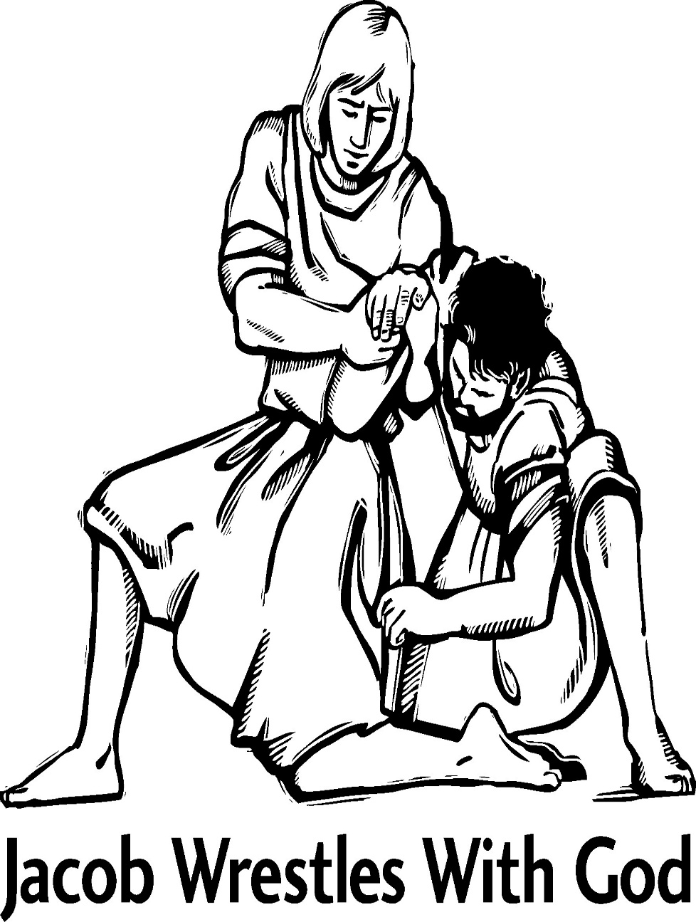
Mt. Zion Evangelical Lutheran Church

320 Mt. Zion Dr., Ripon, WI
www.mtzionripon.org
Facebook: Mt. Zion Evangelical Lutheran Church

Pastor Mark Kock
Phone 414-755-9021
mkock315@gmail.com

Pentecost 17 Sept. 20, 2026
Welcome! The Lord is with us as we gather in his name. Through his Word he brings to you the forgiving, faith-strengthening love of Jesus Christ. Come, let us worship the Lord! Please sign the friendship pads in the pews.

If you have a prayer request for a service, please speak to Pastor Kock. Perhaps a prayer of thanks for a special occasion – birthday, wedding anniversary, or a prayer of intercession for a relative or friend. Throughout the week Pastor Kock is here to serve you in Christ, counseling with the Word, and encouraging your faith. Contact him at 414-755-9021 or mkock315@gmail.com.

Handicapped accessible restrooms are located upstairs next to the Pastor’s Study and downstairs next to the elevator.
Attendance: Please remember to sign the friendship pads. Registration for communion will continue as usual at the table. If you have any questions or concerns, please contact Mike Meeker.


Hearing Loop: Our sanctuary is equipped with a hearing loop system. Those who have compatible hearing aids (with a T-switch) will be able to hear the sound system directly into their ear(s). The two main seating areas and the choir area are looped so that you may sit in any of the three areas. We also have four receivers available for those who do not have compatible hearing aids. If you wish to use a receiver please ask the ushers. Those who wish may bring their own headphones or ear buds.

Hymn Sing: Just a Closer Walk with Thee; Nearer, My God, to Thee; The Old Rugged Cross and In Christ Alone
PACKS OF COPIES ARE AVAILABLE ASK AN USHER

Hymns: 919, 446, 568 Soloists will sing vs. 1&2 and the refrain, Congregation may join on vs. 3&4 and the refrain, 927
Thank you to Sara and Doug for introducing a new song to us.

Order of Worship Setting One pg. 154

Psalm: 1b (Insert) How Truly Blest Are They

Reading: Jonah 3:10-4:11 (EHV)
When God saw their actions, that they had turned from their evil way, God relented from the disaster which he said he would bring on them, and he did not carry it out.
^{4:1}But to Jonah all this seemed very bad, and he became very angry. ²He prayed to the Lord, “Lord, wasn’t this exactly what I said when I was still in my own country? That is why I previously fled to Tarshish, because I knew that you are a gracious and merciful God, slow to anger and abounding in mercy, and you relent from sending disaster. ³So now, Lord, please take my life from me, for it is better for me to die than to live.”
⁴But the Lord replied, “Is it right for you to be angry?”
⁵Jonah went out of the city and sat down east of the city. He made a shelter for himself there and sat in the shade under it, waiting to see what would happen in the city.
⁶Then the Lord God provided a plant and made it grow up over Jonah to provide shade over his head, to relieve him from his discomfort. So Jonah was very happy about the plant. ⁷But at dawn the next day God provided a worm, and it attacked the plant so that it withered. ⁸When the sun rose, God provided a scorching east wind. The sun beat down on Jonah’s head so that he grew faint. He wanted to die, so he said, “It is better for me to die than to live.”
⁹But God said to Jonah, “Is it right for you to be angry about the plant?” Jonah said, “I do have a right to be angry—angry enough to die!”
¹⁰So the Lord said, “You have been concerned about this plant. You did not work for it or make it grow. It grew up in one night and perished after one night. ¹¹So should I not be concerned for Nineveh, the great city, in which there are more than one hundred twenty thousand people who do not know the difference between their right hand and their left—and also many animals?”

Reading: Romans 9:6-16 (EHV)
This does not mean that God’s word has failed, because not all who are descended from Israel are really Israel, ⁷and not all who are descended from Abraham are really his children. On the contrary, “Your line of descent will be traced through Isaac.” ⁸This means that it is not the children of the flesh who are God’s children, but it is the children of the promise who are counted as his descendants. ⁹For this is what the promise said: “I will arrive at this set time, and Sarah will have a son.”
¹⁰Not only that, but Rebekah also had children by one man, our forefather, Isaac. ¹¹Even before the twins were born or did anything good or bad, in order that God’s purpose in election might continue—¹²not by works but because of him who calls us—it was said to her, “The older will serve the younger.” ¹³Just as it is written: “Jacob I loved, but Esau I hated.”
¹⁴What will we say then? Does this mean that God is unjust? Absolutely not! ¹⁵For God says to Moses:
I will show mercy to whom I show mercy,
and I will have compassion on whom I have compassion.
¹⁶So then, it does not depend on human desire or effort, but on God’s mercy.

Gospel Acclamation Ephesians 2:8
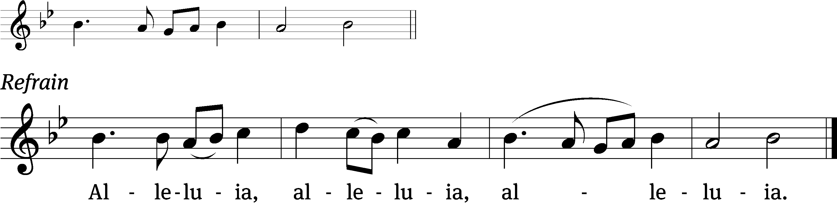
For it is by grace you have been saved, / through faith-
and this is not from yourselves, it is the / gift of God. Refrain

Gospel: Matthew 20:1-16 (EHV)
“Indeed the kingdom of heaven is like a landowner who went out early in the morning to hire workers for his vineyard. ²After agreeing to pay the workers a denarius for the day, he sent them into his vineyard. ³He also went out about the third hour and saw others standing unemployed in the marketplace. ⁴To these he said, ‘You also go into the vineyard, and I will give you whatever is right.’ So they went. ⁵Again he went out about the sixth and the ninth hour and did the same thing. ⁶When he went out about the eleventh hour, he found others standing unemployed. He said to them, ‘Why have you stood here all day unemployed?’
⁷“They said to him, ‘Because no one hired us.’
“He told them, ‘You also go into the vineyard.’ ⁸When it was evening, the owner of the vineyard said to his foreman, ‘Call the workers and pay them their wages, starting with the last group and ending with the first.’
⁹“When those who were hired around the eleventh hour came, they each received a denarius. ¹⁰When those who were hired first came, they thought they would receive more. But they each received a denarius too. ¹¹After they received it, they began to grumble against the landowner: ¹²‘Those who were last worked one hour, and you made them equal to us who have endured the burden of the day and the scorching heat!’
¹³“But he answered one of them, ‘Friend, I am doing you no wrong. Did you not make an agreement with me for a denarius? ¹⁴Take what is yours and go. I want to give to the last one hired the same as I also gave to you. ¹⁵Can’t I do what I want with my own money? Or are you envious because I am generous?’ ¹⁶In the same way, the last will be first, and the first, last.”

Sermon Text: Genesis 32: 22-32 (EHV)
²² He got up that night and took his two wives, his two maids, and his eleven sons, and crossed over the ford of the Jabbok. ²³ He took them and sent them across the stream, and he also sent his possessions across. ²⁴ Jacob was left alone, and he wrestled with a man there until daybreak. ²⁵ When the man saw that he could not defeat him, he touched the socket of his thigh, and the socket of Jacob’s thigh was dislocated as he wrestled. ²⁶ The man said, “Let me go. It’s daybreak.” Jacob said, “I will not let you go unless you bless me.” ²⁷ Then he said to him, “What is your name?” He said, “Jacob.” ²⁸ Then he said, “Your name will no longer be Jacob, but Israel, because you have fought with God and with men, and you have won.” ²⁹ Jacob asked him, “Please tell me your name.”
He said, “Why do you ask what my name is?” Then he blessed him there.
³⁰ Jacob named the place Peniel, because he said, “I have seen God face-to-face, and my life has been spared.” ³¹ The sun rose as he crossed over at Peniel, and he was limping because of his thigh. ³² For that reason, to this day the people of Israel do not eat the tendon of the hip that is on the socket of the thigh, because God touched the socket of Jacob’s thigh on the tendon of the hip.

Sermon Theme: “Jacob Wrestled with God – And Won!”
OFFERING: The offerings are brought forward to the altar.

Keep in Your Prayers: Harley Dorsey, Allan Brooks, Eric Eckert (operation), Myrtle Giese, Carol Henning, Nancy Kemnitz, Terry Loechelt (recovering from an operation), Dennis Schliepp, Joan Stibb, Kathy Strook, Ginny Verch, Gary Wichman, Sue Wichman.
Announcements
Noisy Offering: We collected $211.55 for St. Johns School in Princeton. Thank you so much.

Volunteers Needed: We are in need of drivers for some of our members who cannot get to appointments etc. There is a sign-up sheet on the podium by the library for all those who can help.

Thank You: The Dolderer family would like the congregation know that Matt Dubey has completely recovered from his illness. They want to thank us all for our prayers and well wishes.

Hymn Sing: We will be starting our hymn sing TODAY at 8:45 AM. If you have a favorite hymn you would like sung please contact Jo Meeker. Thanks Doug for offering to play.

Facebook Posts: If you have any posts for the church’s Facebook please contact Sara or Terry Grunert about a week in advance using the following email: grunertfamily99@gmail.com. Thanks to the Grunerts for taking this over.

We are offering the Lord's Supper on the 2nd and last Sunday of the month until further notice. This will be brought before the Voters in October.

Birthdays: Next celebration will be next Sunday September 27th. Please join us in the fellowship hall for cake, refreshments and fellowship.

Mailbox and table: The September Forward In Christ is available and also the Aug. 30-Nov. 28, 2026 Meditations are available. September calendars are also available.

For Your Information
Attendance 9/13/2026 97
Offerings for 9/13/2026 $11,794.00
Year to Date (thru Aug. 31st).
Income : $115,671.15
Expenses : $108,063.95
Shortfall YTD -$7,607.20
Our planned budget for this time frame was $154,633.12.

Serving Our Lord

Thank you to everyone for your service to our Lord!

Ushers:

Sept. 20 & 27: Dave Smith, Josh Niemuth, Justin Niemuth

Oct. 4 & 11: Mark Roeder, Jason Roeder

Oct. 18 & 25: Gary Quade, Travis Schmudlach, Kyle Stollfuss

PowerPoint:

Sept. 20: Jo Meeker

Sept. 27: Jo Meeker

Oct. 4: Grunert Family

We need volunteers for quite a few Sundays coming up. Please talk to Sara Grunert.

Sept. Communion Set up: Jo Meeker

Sept. Communion Clean up: Marilyn Ninneman

Sunday 20th 9:00 AM Worship Service Pastor Meier
10:15 AM Sunday School & Bible Study
Wednesday 6:15 PM Choir Practice
Sunday 9:00 AM Worship Service with Communion Pastor Kock
10:15 AM Birthday Celebration, Sunday School

UPCOMING EVENT:
October 18th Voters’ Meeting

Secretary Jo Meeker
Church Office: 920-748-5641
Office Hours: Mon. 9-12, Tues. & Wed. 9-11
E-mail: mountzionripon@gmail.com



