16th Sunday of Pentecost

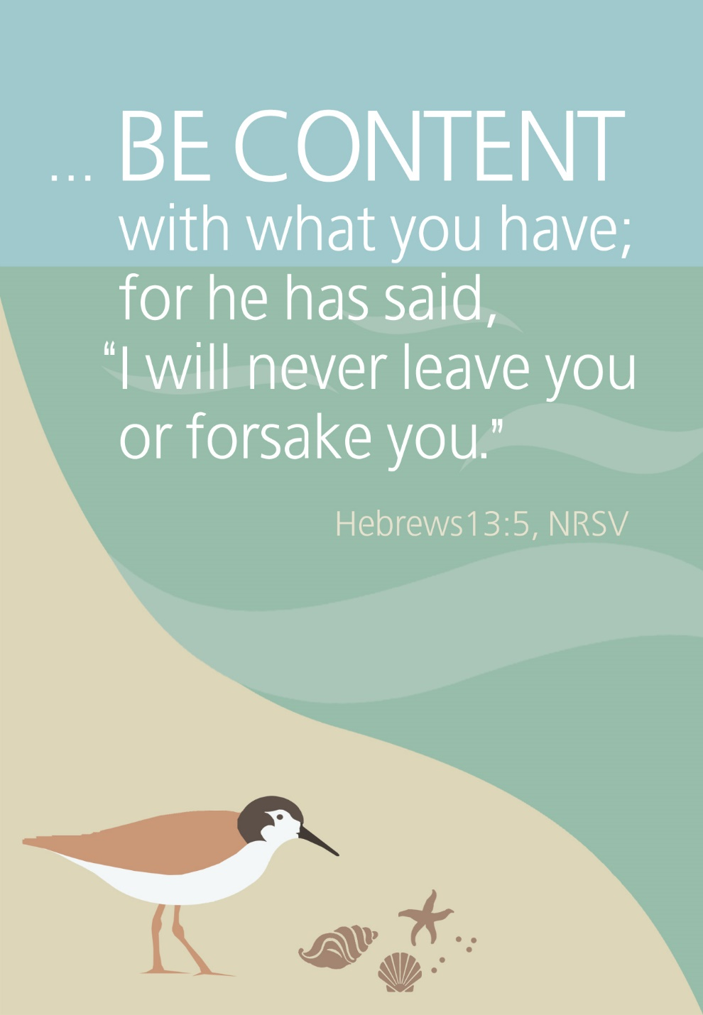
Mt. Zion Evangelical Lutheran Church
320 Mt. Zion Dr., Ripon, WI
www.mtzionripon.org
Facebook: Mt. Zion Evangelical Lutheran Church

Pastor Michael Sheppard
Pastor’s Study: 920-748-9734
E-mail: revmikesheppard@gmail.com
Pentecost 16 Sept. 22 & 25, 2022

Welcome to Mt. Zion!
Handicapped accessible restrooms are located upstairs next to the Pastor’s Study and downstairs next to the elevator.
Attendance: Please remember to sign the friendship pads. Registration for communion will continue as usual at the table. If you have any questions or concerns please contact Pastor Sheppard or Mark Roeder.

Hearing Loop: Our sanctuary is equipped with a hearing loop system. Those who have compatible hearing aids (with a T-switch) will be able to hear the sound system directly into their ear(s). The two main seating areas and the choir area are looped so that you may sit in any of the three areas. We also have four receivers available for those who do not have compatible hearing aids. If you wish to use a receiver please ask the ushers. Those who wish may bring their own headphones or ear buds.

A note for our visitors on member communion –
Out of sincere love for the truth of God’s Word and for precious human souls, we practice member communion in our synod and congregation. This teaching, as practiced by the Church for centuries, is thoroughly Scriptural. It questions the faith of no individual yet asks that there be full doctrinal agreement between those who commune. For this reason, we ask that only those who are members of a WELS or ELS congregation join us for the Lord’s Supper. If you wish to commune with us please speak with the pastor before the service.
The front row on the pulpit side is reserved for people who are unable to navigate the steps. Pastor will serve you Communion first.

Prayer Before Communion: Dearest Jesus, I marvel that you came to this earth as the Word made flesh. With similar awe I contemplate how you give me your body and blood in the bread and wine of Holy Communion. Touch me with your grace that moved you to reach out to me, a poor, miserable sinner! Use this sacred supper to bring me closer to you. Amen.

Prayer After Communion: Thank you, Lord Jesus Christ, for nourishing me in this sacrament with your body and blood. You have given me forgiveness, life, and salvation. Let me always remain in you as a branch remains in the vine. Send me out in the power of your Spirit to live and work to your praise and glory. Amen

Hymns: 807, 817, 667, 718

Order of Worship: English Hymn Setting

First Reading & Sermon Text: Amos 6: 1-7 (EHV)
Woe to you who are complacent in Zion,
you who feel secure on Mount Samaria,
you distinguished people of the leading nation,
to whom the house of Israel comes.
²Travel to Kalneh and look.
Go from there to Hamath Rabbah,
and go down to Gath of the Philistines.
Are you better than those kingdoms?
Are their territories greater than your territory?
³You who are trying to put off the evil day,
you bring near the session for violence!
⁴Those who lie on ivory beds,
sprawling upon their couches,
eating lambs from the flock
and calves straight from the stall,
⁵improvising tunes on the lyre,
composing music for themselves on musical instruments like David,
⁶drinking large bowls of wine—
they slather themselves with the most expensive perfumed oils,
but they do not grieve over the ruin of Joseph.
⁷That is why they will go into exile as the first of the exiles.
Those who sprawl out at their feasts for the dead will depart.

I Will Praise the Lord All My Life Psalm 146

Second Reading: Hebrews 13: 1-6 (EHV)
Continue to show brotherly love. ²Do not fail to show love to strangers, for by doing this some have welcomed angels without realizing it. ³Remember those in prison, as if you were fellow prisoners, and those who are mistreated, as if you yourselves were also suffering bodily.
⁴Marriage is to be held in honor by all, and the marriage bed is to be kept undefiled, for God will judge sexually immoral people and adulterers. ⁵Keep your life free from the love of money, and be content with what you have. For God has said:
I will never leave you,
and I will never forsake you.
⁶So then we say with confidence:
The Lord is my helper, and I will not be afraid.
What will man do to me?
Gospel Acclamation Luke 16:31
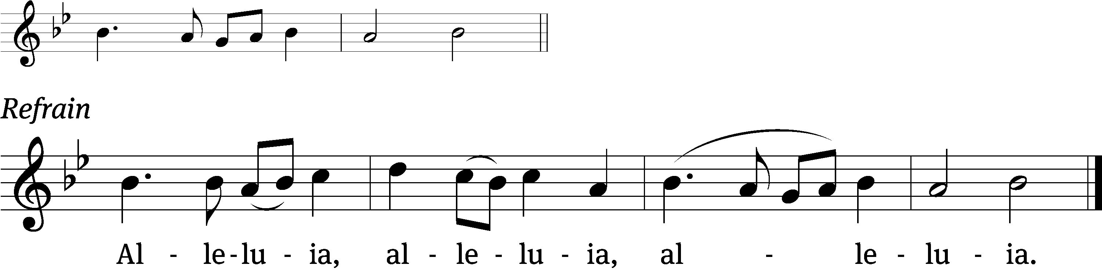
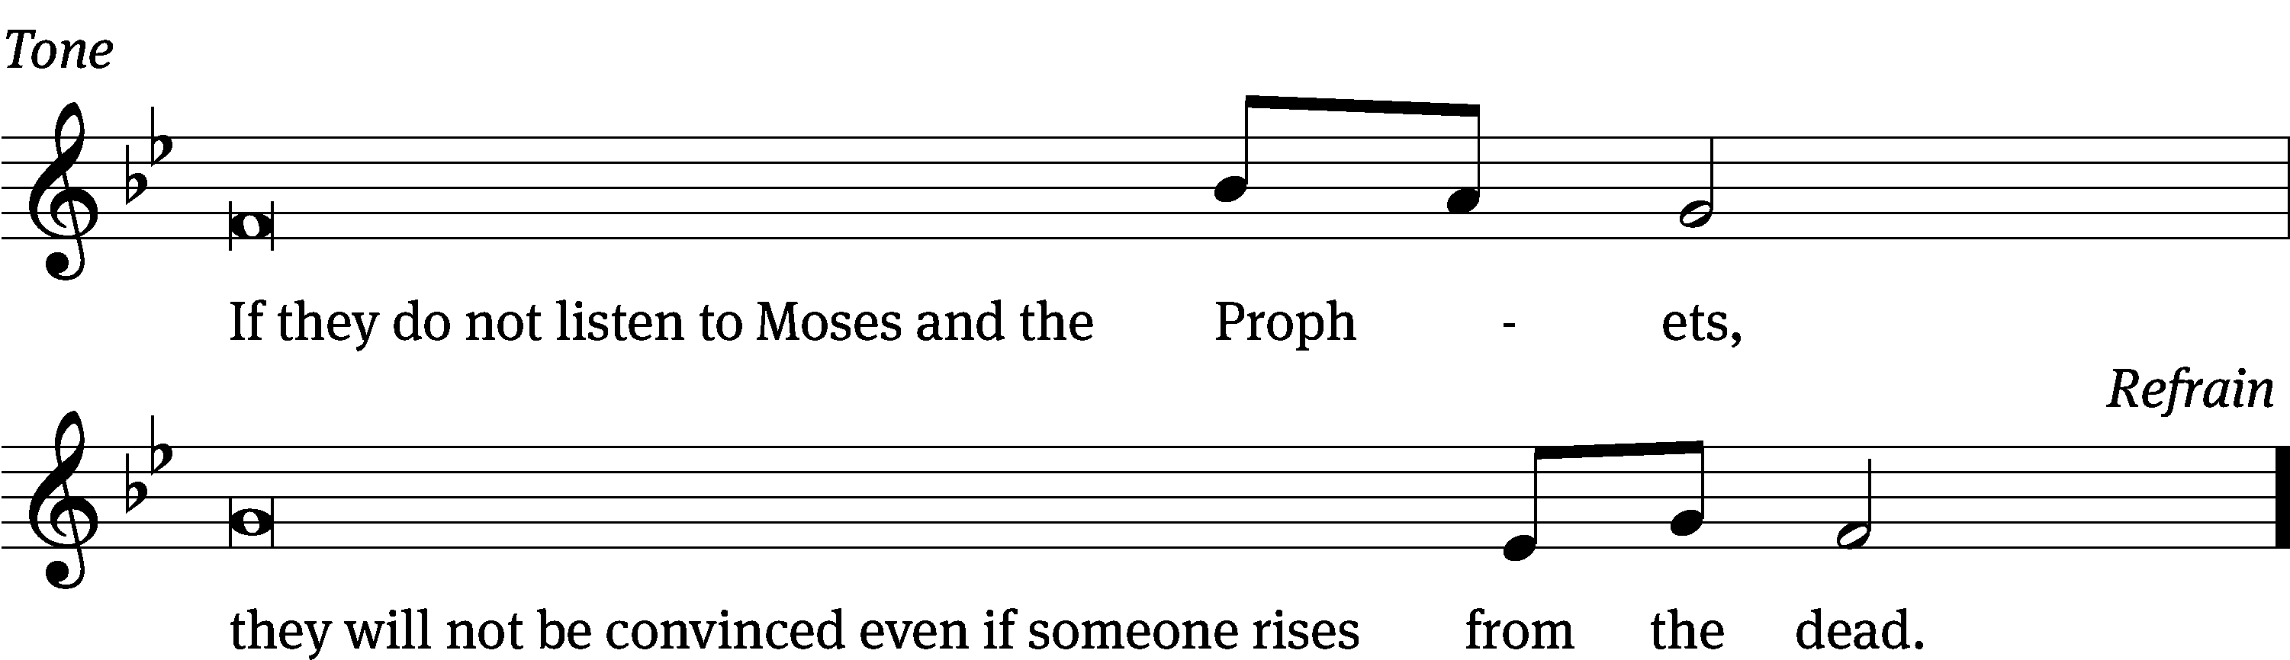
Tune: © 2021 Northwestern Publishing House. Used by permission: OneLicense no. 716381

Gospel: Luke 16: 19-31 (EHV)
“There was a rich man who was dressed in purple and fine linen, living in luxury every day. ²⁰A beggar named Lazarus had been laid at his gate. Lazarus was covered with sores and ²¹longed to be fed with what fell from the rich man’s table. Besides this, the dogs also came and licked his sores. ²²Eventually the beggar died, and the angels carried him to Abraham’s side. The rich man also died and was buried. ²³In hell, where he was in torment, he lifted up his eyes and saw Abraham far away and Lazarus at his side. ²⁴He called out and said, ‘Father Abraham, have mercy on me! Send Lazarus to dip the tip of his finger in water and cool my tongue, because I am in misery in this flame.’
²⁵“But Abraham said, ‘Son, remember that in your lifetime you received your good things, and Lazarus received bad things. But now he is comforted here, and you are in misery. ²⁶Besides all this, a great chasm has been set in place between us and you, so that those who want to cross from here to you cannot, nor can anyone cross over from there to us.’
²⁷“He said, ‘Then I beg you, father, send him to my father’s home, ²⁸because I have five brothers—to warn them, so that they will not also come to this place of torment.’
²⁹“Abraham said, ‘They have Moses and the Prophets. Let them listen to them.’
³⁰“‘No, father Abraham,’ he said, ‘but if someone from the dead goes to them, they will repent.’
³¹“Abraham replied to him, ‘If they do not listen to Moses and the Prophets, they will not be convinced even if someone rises from the dead.’”

Sermon Theme: “Complacency Brings Trouble.”

OFFERING: The offerings are brought forward to the altar.

Announcements

Flowers: The altar flowers have been placed in memory of Bob Timm.

Kids C.A.R.E.: Today, we are launching the LWMS Kids C.A.R.E. home mission project, “Mi Amigo Jesús” (My Friend Jesus), for the Family Ministry Outreach Fund–Hispanic Ministries. This Kids C.A.R.E. project will support home mission congregations that want to begin or expand outreach efforts to their Hispanic families and communities with toddler/early childhood social interactive programs, such as Mornings with Mommy. There is a display as you enter church with pictures and description of this home mission. You can support this home mission today, Sept. 18th or Sunday Sept. 25th by using the Kids C.A.R.E. basket on the offering table or by using your weekly offering envelopes. Thank you for your support. Please keep Kids C.A.R.E. in your prayers.

Please join us for the LWMS Beaver Dam Circuit’s fall rally at St. John’s Montello on Saturday Oct. 15th. Pastor Nate Bourman, our befriend a mission pastor for Mt. Lebanon, Milwaukee will be our speaker. We are planning to carpool to St. John’s leaving the church’s north parking at 9:00. There is a sign-up sheet on the bulletin board outside the office if you would like to carpool.
Catechism Classes have resumed. Classes will be from 5:00 PM to 6:30 PM on Wednesdays. All 7th and 8th graders from our congregation are welcome. Please email: revmikesheppard@gmail.com, call (920) 745-0883, or text Pastor Sheppard to register. As a requirement of Catechism class this year, confirmation students are asked to also attend Sunday school regularly during the school year. Thank you.

Sound System: We are starting a fund for a new Audio/Visual system. The improvements are necessary to accommodate our recent and future technology additions. We are applying for a grant from The Antioch Foundation, if it is approved Mt Zion’s share of the cost will be approximately $16,000.00. You may use the regular church envelopes just write Audio System next to your donation. Thank you.

Red Hymnals: It was decided that whoever would like to take one or more old hymnals home may do so at no cost. They are located on the table by the entrance to the sanctuary. Please feel free to take.

Birthday Celebration: Cake will be served Sunday October 9th to celebrate the birthdays for October.
Mailbox and table: The September Forward In Christ is available and also the August 28th, 2022-November 26th, 2022 Meditations are available.
If you would like the Lord’s Supper privately, please contact Pastor Sheppard on his cell 920-745-0883, or by email revmikesheppard@gmail.com.

The Helping Hands Ministry is ready to serve the needs of our members. Please contact one of the following if you or someone you know needs assistance: Joanne Gregor at 920-896-1518, Lisa Tremore at 920-229-1297 or Tammy Niemuth at 920-299-0240.

For Your Information
Attendance 9/15 - 9/18/2022: 94
Offerings for 9/15 - 9/18/2022: $2,766.26*
*Includes $1,776 towards the new sound system

Serving Our Lord

Thank you to everyone for your service to our Lord!

Ushers:

Sept 25: Dave Smith, Josh Niemuth, Remmington Mueller, Roman Mueller

Oct. 2 & 9: Tobin Storzer, Rick Retelle, Kelly Frank, Terry Dolderer

PowerPoint:

Sept 22: Jo Meeker

Sept 25: Grunert Family

Sept 29: Jo Meeker

Oct 2: Grunert Family

Sept Communion Set up: Jo Meeker

Sept Communion Clean up: Marilyn Ninneman

This week at Mt. Zion
Sunday (25th) 9:00 AM Worship with Communion
10:15 AM Sunday School & Bible Study
Monday 6:30 PM Bible Study
Tuesday 9:00 AM Bible Study
Wednesday 5:00 PM Catechism Class
6:15 PM Choir Practice
Thursday 6:30 PM Worship
Sunday 8:45 AM Hymn Sing
9:00 AM Worship
10:15 AM Sunday School & Bible Study

Secretary Jo Meeker
Church Office: 920-748-5641
Office Hours: Mon. 9-12, Tues. & Wed. 9-11
E-mail: mountzionripon@gmail.com
Acknowledgments
Unless otherwise indicated, Scripture quotations are from The Holy Bible, New International Version®, NIV®. Copyright © 1973, 1978, 1984, 2011 by Biblica, Inc.TM Used by permission of Zondervan. All rights reserved worldwide.
Software distributed in partnership with Northwestern Publishing House.
Created by Christian Worship: Service Builder © 2022 Concordia Publishing House.

