SIXTEENTH SUNDAY AFTER PENTECOST
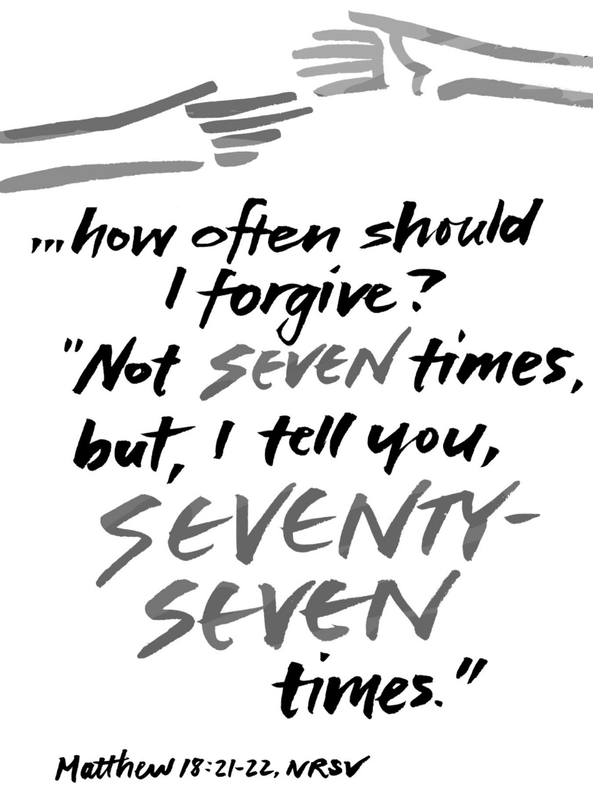
Mt. Zion Evangelical Lutheran Church

320 Mt. Zion Dr., Ripon, WI
www.mtzionripon.org
Facebook: Mt. Zion Evangelical Lutheran Church

Pastor Mark Kock (Vacancy Pastor)
Phone 414-755-9021
mkock315@gmail.com

Pentecost 16 Sept. 13, 2026
Welcome! The Lord is with us as we gather in his name. Through his Word he brings to you the forgiving, faith-strengthening love of Jesus Christ. Come, let us worship the Lord! Please sign the friendship pads in the pews.

Focus of today’s service: Forgiveness does not come naturally to human beings. Often, we stay hurt or hold grudges. On the other hand, forgiveness is the core of our God. He forgives generously and freely through the hands of his Son that were pierced for us. You are forgiven! Your response? Forgive those who have sinned against you.

If you have a prayer request for today’s service, please speak to Pastor Kock. Perhaps a prayer of thanks for a special occasion – birthday, wedding anniversary, or a prayer of intercession for a relative or friend. Throughout the week Pastor Kock is here to serve you in Christ, counseling with the Word, and encouraging your faith. Contact him at 414-755-9021 or mkock315@gmail.com.

Holy Communion is offered to Communicant members of Mount Zion and of other Wisconsin Evangelical Lutheran Synod (WELS) churches who have prepared themselves in faith to receive Jesus’ body and blood. In Communion, Jesus gives the blessings of the forgiveness of sins and intimate fellowship with him! Visitors, Pastor Kock offers a Bible Class to prepare you for this wonderful meal. Ask him about it. Members, please register for communion at the table in back. If you have any questions or concerns, please contact Mike Meeker.

The front row is reserved for people who are unable to navigate the steps to the altar. Pastor will serve them Communion first.

Handicapped accessible restrooms are located upstairs next to the Pastor’s Study and downstairs next to the elevator.
Attendance: Please remember to sign the friendship pads. Registration for communion will continue as usual at the table. If you have any questions or concerns, please contact Mike Meeker.


Hearing Loop: Our sanctuary is equipped with a hearing loop system. Those who have compatible hearing aids (with a T-switch) will be able to hear the sound system directly into their ear(s). The two main seating areas and the choir area are looped so that you may sit in any of the three areas. We also have four receivers available for those who do not have compatible hearing aids. If you wish to use a receiver please ask the ushers. Those who wish may bring their own headphones or ear buds.

Hymns: 622 vs 1-4, 583, (407), 727

Order of Worship Setting One pg. 154

Psalm: 103:1-12 Hymn 558 V. 10 Salvation unto Us Has Come
Bless the Lord, O my soul.
All that is within me, bless his holy name.
² Bless the Lord, O my soul,
and do not forget all his benefits—
³ who pardons all your guilt,
who heals all your diseases,
⁴ who redeems your life from the pit,
who crowns you with mercy and compassion,
⁵ who satisfies your life with goodness,
so that your youth is renewed like the eagle.
⁶ The Lord performs righteousness and justice for all the oppressed.
⁷ He made known his ways to Moses,
his deeds to the people of Israel.
⁸ The Lord is compassionate and gracious,
slow to anger, abounding in mercy.
⁹ He will not always accuse.
He will not keep his anger forever.
¹⁰ He does not treat us as our sins deserve.
He does not repay us according to our guilty deeds.
¹¹ Yes, as high as the heavens are above the earth,
so powerful is his mercy toward those who fear him.
¹² As distant as the east is from the west,
so far has he removed our rebellious acts from us.

Reading: Genesis 50: 15-21 (EHV)
When Joseph’s brothers saw that their father was dead, they said, “It may be that Joseph will hate us and will pay us back in full for all of the evil that we did to him.”
¹⁶They sent the following message to Joseph: “Before he died your father commanded us, ¹⁷‘You are to tell Joseph, “Please forgive the offense of your brothers and their sin, because they did evil to you.”’ Now, please forgive the offense of the servants of the God of your father.”
Joseph wept when they spoke to him.
¹⁸His brothers also came and fell down in front of him, and they said, “See now, we are your servants.”
¹⁹Joseph said to them, “Do not be afraid, for am I in the place of God? ²⁰You meant evil against me, but God meant it for good, to bring this to pass and to keep many people alive, as it is this day. ²¹Now therefore do not be afraid. I will nourish you and your little ones.” He comforted them and spoke to them in a kind way.

Reading: Ephesians 4:29-5:2 (EHV)
Do not let any unwholesome talk come from your mouths. Say only what is beneficial when there is a need to build up others, so that it will be a blessing to those who hear. ³⁰Do not grieve the Holy Spirit of God, with whom you were sealed for the day of redemption. ³¹Get rid of every kind of bitterness, rage, anger, quarreling, and slander, along with every kind of malice. ³²Instead, be kind and compassionate to one another, forgiving one another, just as God in Christ has forgiven us.
^{5:1}Therefore, be imitators of God as his dearly loved children. ²And walk in love, just as Christ loved us and gave himself for us, as a fragrant offering and sacrifice to God.

Gospel Acclamation Matthew 6:14
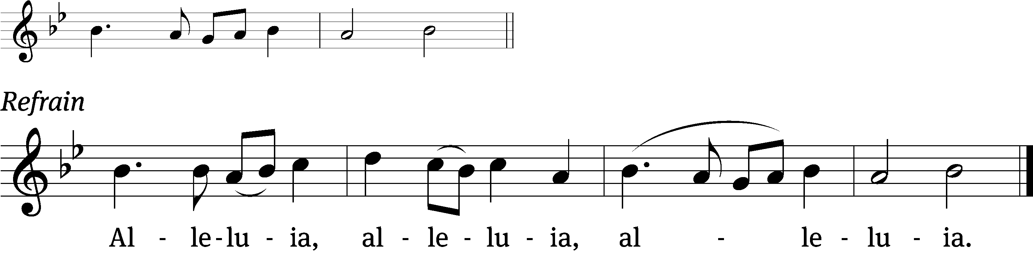
If you forgive others their / trespasses,
your heavenly Father will also / forgive you. Refrain

Gospel & Sermon Text: Matthew 18:21-35 (EHV)
Then Peter came up and asked Jesus, “Lord, how many times must I forgive my brother when he sins against me? As many as seven times?”
²²Jesus said to him, “Not seven times, but I tell you as many as seventy-seven times. ²³For this reason the kingdom of heaven is like a king who wanted to settle accounts with his servants. ²⁴When he began to settle them, a man who owed him ten thousand talents was brought to him. ²⁵Because the man was not able to pay the debt, his master ordered that he be sold, along with his wife, children, and all that he owned to repay the debt.
²⁶“Then the servant fell down on his knees in front of him, saying, ‘Master, be patient with me, and I will pay you everything!’ ²⁷The master of that servant had pity on him, released him, and forgave him the debt.
²⁸“But when that servant went out, he found one of his fellow servants who owed him one hundred denarii. He grabbed him and began choking him, saying, ‘Pay me what you owe!’
²⁹“So his fellow servant fell down and begged him, saying, ‘Be patient with me, and I will pay you back!’ ³⁰But he refused. Instead he went off and threw the man into prison until he could pay back what he owed.
³¹“When his fellow servants saw what had happened, they were very distressed. They went and reported to their master everything that had taken place.
³²“Then his master called him in and said to him, ‘You wicked servant! I forgave you all that debt when you begged me to. ³³Should you not have had mercy on your fellow servant just as I had mercy on you?’ ³⁴His master was angry and handed him over to the jailers until he could pay back everything he owed.
³⁵“This is what my heavenly Father will also do to you unless each one of you forgives his brother from his heart.”

Choir Song: “How Can I Keep from Singing”

Sermon Theme: “Jesus Means What He Says: “Forgive Your Brother Or Sister From the Heart.”

OFFERING: The offerings are brought forward to the altar.
Noisy Offering will be sent to St. Johns School at Princeton.

Keep in Your Prayers: Harley Dorsey, Allan Brooks, Eric Eckert, Myrtle Giese, Carol Henning, Nancy Kemnitz, Dennis Schliepp, Joan Stibb, Kathy Strook, Ginny Verch, Gary Wichman, Sue Wichman.

Installation of Sunday School Teachers: Kari Hielke, Dawn Toman, Caitlin Goeldi, Jo Meeker

Announcements
The church picnic is being held TODAY Sept. 13 Following the service. Games for children and adults. A good way for the children to meet their Sunday School teachers. A cornhole tournament will be held. The church council will be cooking burgers, brats, hot dogs and chicken breasts. Please bring a side dish or dessert as a potluck dish.

Thank You: The Dolderer family would like the congregation know that Matt Dubey has completely recovered from his illness. They want to thank us all for our prayers and well wishes.

Hymn Sing: We will be starting our hymn sing next Sunday at 8:45 AM. If you have a favorite hymn you would like sung please contact Jo Meeker. Thanks Doug for offering to play.

Facebook Posts: If you have any posts for the church’s Facebook please contact Sara or Terry Grunert about a week in advance using the following email: grunertfamily99@gmail.com. Thanks to the Grunerts for taking this over.

We are offering the Lord's Supper on the 2nd and last Sunday of the month until further notice. This will be brought before the Voters in October.

Sunday School: School will be starting on September 20th. PARENTS PLEASE CONTACT JO MEEKER (920-748-3058 OR 920-748-5641) IF YOU PLAN TO ENROLL YOUR CHILDEREN.

Birthdays: Next celebration September 27th. Please join us in the fellowship hall for cake, refreshments and fellowship.

Mailbox and table: The September Forward In Christ is available and also the Aug. 30-Nov. 28, 2026 Meditations are available. September calendars are also available.

For Your Information
Attendance 9/6/2026 66
Offerings for 9/6/2026 $3,031.21
Year to Date (thru Aug. 31st).
Income : $115,671.15
Expenses : $108,063.95
Shortfall YTD -$7,607.20
Our planned budget for this time frame was $154,633.12.

Serving Our Lord

Thank you to everyone for your service to our Lord!

Ushers:

Sept. 13: Ken Hielke, Todd Zellmer, Jonathan Zellmer, Dustin Zellmer

Sept. 20 & 27: Dave Smith, Josh Niemuth, Justin Niemuth

PowerPoint:

Sept. 13: Grunert Family

Sept. 20: Jo Meeker

Sept. 27: Jo Meeker

Sept. Communion Set up: Jo Meeker

Sept. Communion Clean up: Marilyn Ninneman

Sunday 13th 9:00 AM Worship Service with Communion
Noisy Offering
10:15 AM Church Picnic
Wednesday 6:15 PM Choir Practice
Sunday 9:00 AM Worship Service Pastor Meier
10:15 AM Sunday School

UPCOMING EVENTS:
Check the September Calendar for more information

Sunday School begins September 20th

October 18th Voters’ Meeting

Secretary Jo Meeker
Church Office: 920-748-5641
Office Hours: Mon. 9-12, Tues. & Wed. 9-11
E-mail: mountzionripon@gmail.com

