15th Sunday of Pentecost

Mt. Zion Evangelical Lutheran Church
320 Mt. Zion Dr., Ripon, WI
www.mtzionripon.org
Facebook: Mt. Zion Evangelical Lutheran Church

Pastor Michael Sheppard
Pastor’s Study: 920-748-9734
E-mail: revmikesheppard@gmail.com
Pentecost 15 Sept. 15 & 18, 2022

Welcome to Mt. Zion!
Handicapped accessible restrooms are located upstairs next to the Pastor’s Study and downstairs next to the elevator.
Attendance: Please remember to sign the friendship pads. Registration for communion will continue as usual at the table. If you have any questions or concerns please contact Pastor Sheppard or Mark Roeder.

Hearing Loop: Our sanctuary is equipped with a hearing loop system. Those who have compatible hearing aids (with a T-switch) will be able to hear the sound system directly into their ear(s). The two main seating areas and the choir area are looped so that you may sit in any of the three areas. We also have four receivers available for those who do not have compatible hearing aids. If you wish to use a receiver please ask the ushers. Those who wish may bring their own headphones or ear buds.

Prayer Before Worship: O Lord our Maker, Redeemer, and comforter, we assembled in your presence to hear your holy Word. We pray that you would open our hearts by your Holy Spirit, that through the preaching of your Word we may repent of our sins, believe in Jesus, and grow day by day in grace and holiness. Hear us for Jesus’ sake. Amen
Hymns: 740, 807, 737, 930

Order of Worship: The Service CW21 pg. 154

First Reading & Sermon Text: Ecclesiastes 5: 10-20 (EHV)
Anyone who loves money is never satisfied with money, and anyone who loves wealth is never satisfied with his income. This too is vanishing vapor.
¹¹When goods increase, so do those who eat them. What profit, then, does the owner get, except to see these things with his eyes?
¹²The worker’s sleep is sweet, whether he eats little or much, but a rich person’s abundant possessions allow him no sleep.
¹³I have seen a sickening evil under the sun—wealth hoarded by its owner to his own harm, ¹⁴or wealth that is lost in a bad investment. Or a man fathers a son, but he has nothing left in his hand to give him. ¹⁵As he came out from his mother’s womb, so he will go again, naked as he came. From his hard work he can pick up nothing that he can carry away in his hand. ¹⁶This too is a sickening evil: Just as he came, so he will go. So what does he gain, he who works for the wind? ¹⁷Besides this, during all his days he eats in darkness, with great frustration, sickness, and anger.
¹⁸So then, here is what I have seen to be good: It is beautiful to eat, to drink, and to look for good in all a person’s hard work which he has done under the sun, during the few days of his life that God has given him, for that is his reward. ¹⁹Likewise, for everyone to whom God has given wealth and riches, if God has also given him ability to eat from it, to enjoy his reward, and to rejoice in the results of his hard work—this is a gift of God, ²⁰for the man seldom reflects on the days of his life, since God keeps him busy with the joy in his heart.

Blest Are All Who Fear the Lord Psalm 128

Second Reading: I Timothy 6: 6-10, 17-19 (EHV)
But godliness with contentment is great gain. ⁷For we brought nothing into the world, and we certainly cannot take anything out. ⁸But if we have food and clothing, with these we will be satisfied.
⁹Those who want to get rich fall into temptation and a trap and many foolish and harmful desires, which plunge them into complete destruction and utter ruin. ¹⁰For the love of money is a root of all sorts of evils. By striving for money, some have wandered away from the faith and have pierced themselves with many pains.
¹⁷Instruct those who are rich in this present age not to be arrogant or to put their hope in the uncertainty of riches, but rather in God, who richly supplies us with all things for our enjoyment. ¹⁸Instruct them to do good, to be rich in good works, to be generous and willing to share. ¹⁹In this way they are storing up for themselves the treasure of a good foundation for the future, so that they may take hold of that which is truly life.
Gospel Acclamation Matthew 6:33
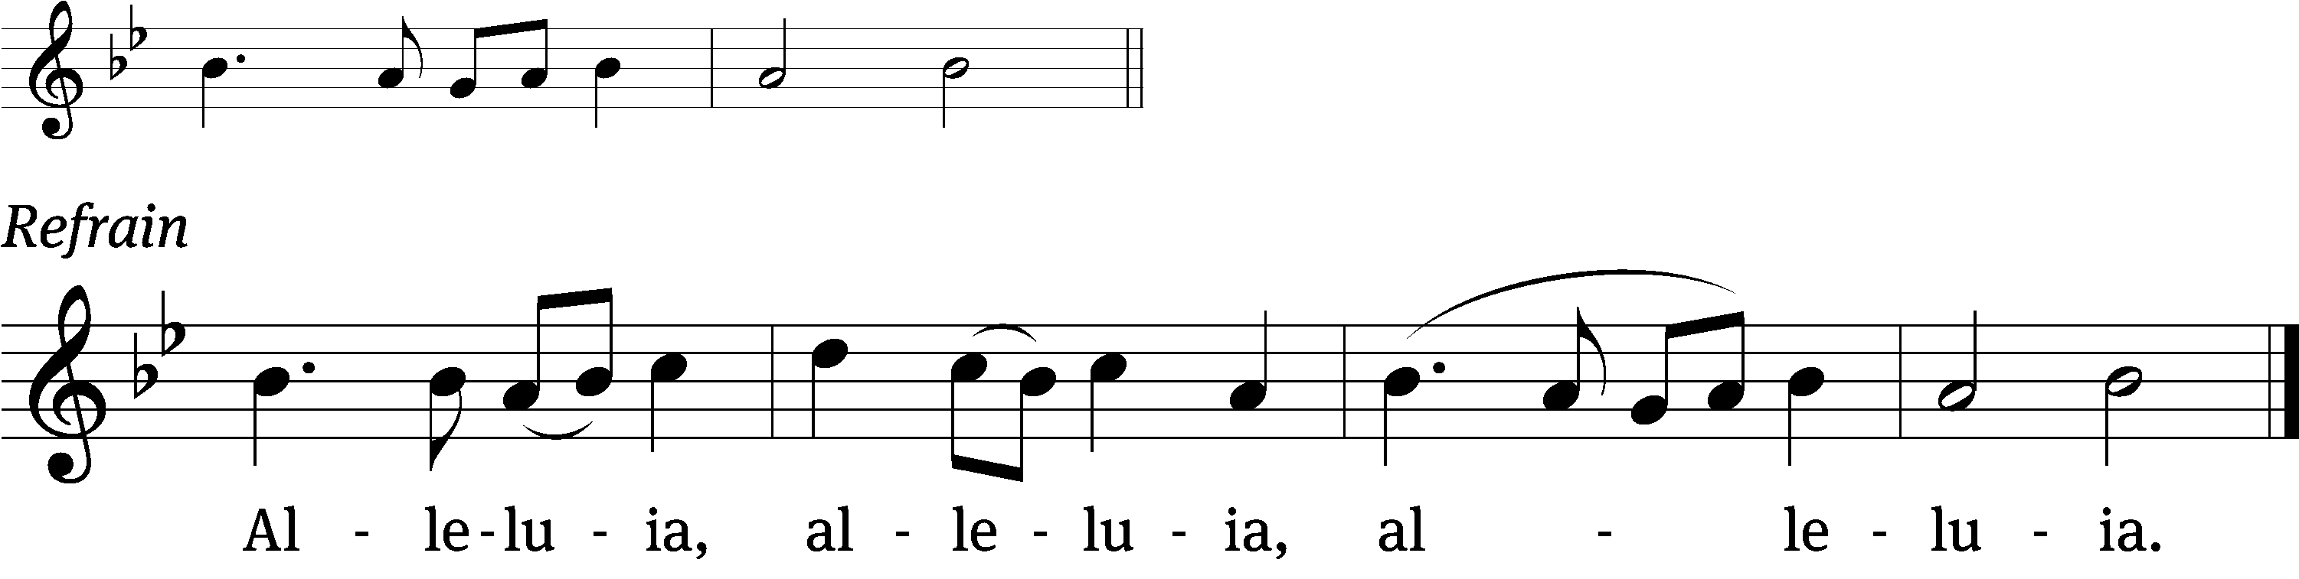
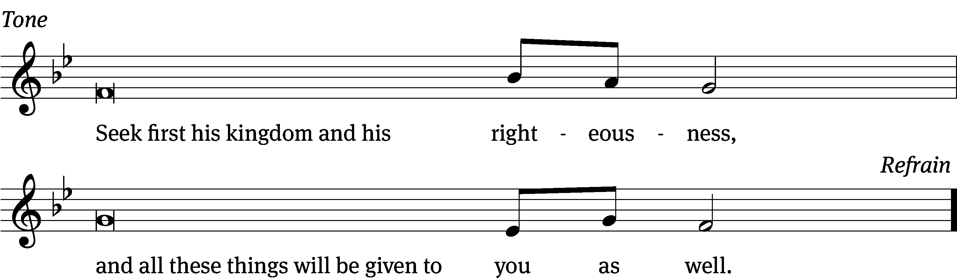
Tune: © 2021 Northwestern Publishing House. Used by permission: OneLicense no. 716381

Gospel: Luke 16: 1-13 (EHV)
Jesus also said to his disciples, “There was a rich man who had a manager who was accused of wasting his possessions. ²The rich man called him in and said to him, ‘What is this that I hear about you? Give an account of your management, because you can no longer be manager.’
³“The manager said to himself, ‘What will I do, since my master is taking away the management position from me? I am not strong enough to dig. I am ashamed to beg. ⁴I know what I will do, so that when I am removed from my position as manager, people will receive me into their houses.’
⁵“He called each one of his master’s debtors to him. He asked the first, ‘How much do you owe my master?’ ⁶He said, ‘Six hundred gallons of olive oil.’ He said to him, ‘Take your bill, sit down quickly, and write three hundred.’ ⁷Then he said to another, ‘How much do you owe?’ And he said, ‘Six hundred bushels of wheat.’ He said to him, ‘Take your bill and write four hundred and eighty.’
⁸“The master commended the dishonest manager because he had acted shrewdly. For the children of this world are more shrewd in dealing with their own generation than the children of the light. ⁹I tell you, make friends for yourselves with unrighteous so that when it runs out, they will welcome you into the eternal dwellings. ¹⁰The person who is faithful with very little is also faithful with much. And the person who is unrighteous with very little is also unrighteous with much. ¹¹So if you have not been faithful with unrighteous mammon who will entrust you with what is really valuable? ¹²If you have not been faithful with what belongs to someone else, who will give you something to be your own? ¹³No servant can serve two masters. Indeed, either he will hate the one and love the other, or he will be devoted to the one and despise the other. You cannot serve both God and mammon.”

Sermon Theme: “Find Happiness Through Serving God.”

OFFERING: The offerings are brought forward to the altar.
Announcements

Kids C.A.R.E.: Today, we are launching the LWMS Kids C.A.R.E. home mission project, “Mi Amigo Jesús” (My Friend Jesus), for the Family Ministry Outreach Fund–Hispanic Ministries. This Kids C.A.R.E. project will support home mission congregations that want to begin or expand outreach efforts to their Hispanic families and communities with toddler/early childhood social interactive programs, such as Mornings with Mommy. There is a display as you enter church with pictures and description of this home mission. You can support this home mission today, Sept. 18th or Sunday Sept. 25th by using the Kids C.A.R.E. basket on the offering table or by using your weekly offering envelopes. Thank you for your support. Please keep Kids C.A.R.E. in your prayers.

Attention: Would the person who used the new vase holder please return it to church as soon as possible. Thank you
Attention Singers: Adult Choir has started! Do you like singing just for fun? Well, there is no more fun than singing for the Lord! Singers of all abilities are welcome to join the Adult Choir. We are actively looking for more members to fill out each section. Praising God while having fun is our motto. Everyone is welcome!!!

Catechism Classes have resumed. Classes will be from 5:00 PM to 6:30 PM on Wednesdays. All 7th and 8th graders from our congregation are welcome. Please email: revmikesheppard@gmail.com, call (920) 745-0883, or text Pastor Sheppard to register. As a requirement of Catechism class this year, confirmation students are asked to also attend Sunday school regularly during the school year. Thank you.
Sound System: We are starting a fund for a new Audio/Visual system. The improvements are necessary to accommodate our recent and future technology additions. We are applying for a grant from The Antioch Foundation, if it is approved Mt Zion’s share of the cost will be approximately $16,000.00. You may use the regular church envelopes just write Audio System next to your donation. Thank you.

Sunday School: We are still in need of a teacher for the 7th and 8th grades starting this fall. Please talk to Pastor Sheppard or Jo Meeker if you are interested.

Red Hymnals: It was decided that whoever would like to take one or more old hymnals home may do so at no cost. They are located on the table by the entrance to the sanctuary. Please feel free to take.

Birthday Celebration: Cake will be served Today to celebrate the birthdays for September.
Mailbox and table: The September Forward In Christ is available and also the August 28th, 2022-November 26th, 2022 Meditations are available.
If you would like the Lord’s Supper privately, please contact Pastor Sheppard on his cell 920-745-0883, or by email revmikesheppard@gmail.com.

The Helping Hands Ministry is ready to serve the needs of our members. Please contact one of the following if you or someone you know needs assistance: Joanne Gregor at 920-896-1518, Lisa Tremore at 920-229-1297 or Tammy Niemuth at 920-299-0240.

For Your Information
Attendance 9/8 - 9/11/2022: 133
Offerings for 9/8 - 9/11/2022: $4,100.00*
*Includes $1,683 towards the new sound system
Serving Our Lord

Thank you to everyone for your service to our Lord!

Ushers:

Sept 18 & 25: Dave Smith, Josh Niemuth, Remmington Mueller, Roman Mueller

PowerPoint:

Sept 15: Kim Mueller

Sept 18: Jan Ohlrich

Sept 22:

Sept 25: Jo Meeker

Sept Communion Set up: Jo Meeker

Sept Communion Clean up: Marilyn Ninneman

This week at Mt. Zion
Sunday (18th) 9:00 AM Worship
10:15 AM Sunday School & Bible Study
10:15 AM Birthday Celebration
Monday 6:30 PM Bible Study
Tuesday 9:00 AM Bible Study
Wednesday 5:00 PM Catechism Class
6:15 PM Choir Practice
Thursday 6:30 PM Worship with Communion
Sunday 9:00 AM Worship with Communion
10:15 AM Sunday School & Bible Study

Secretary Jo Meeker
Church Office: 920-748-5641
Office Hours: Mon. 9-12, Tues. & Wed. 9-11
E-mail: mountzionripon@gmail.com

Acknowledgments
Unless otherwise indicated, Scripture quotations are from The Holy Bible, New International Version®, NIV®. Copyright © 1973, 1978, 1984, 2011 by Biblica, Inc.TM Used by permission of Zondervan. All rights reserved worldwide.
Software distributed in partnership with Northwestern Publishing House.
Created by Christian Worship: Service Builder © 2022 Concordia Publishing House.

