FIFTEENTH SUNDAY AFTER PENTECOST
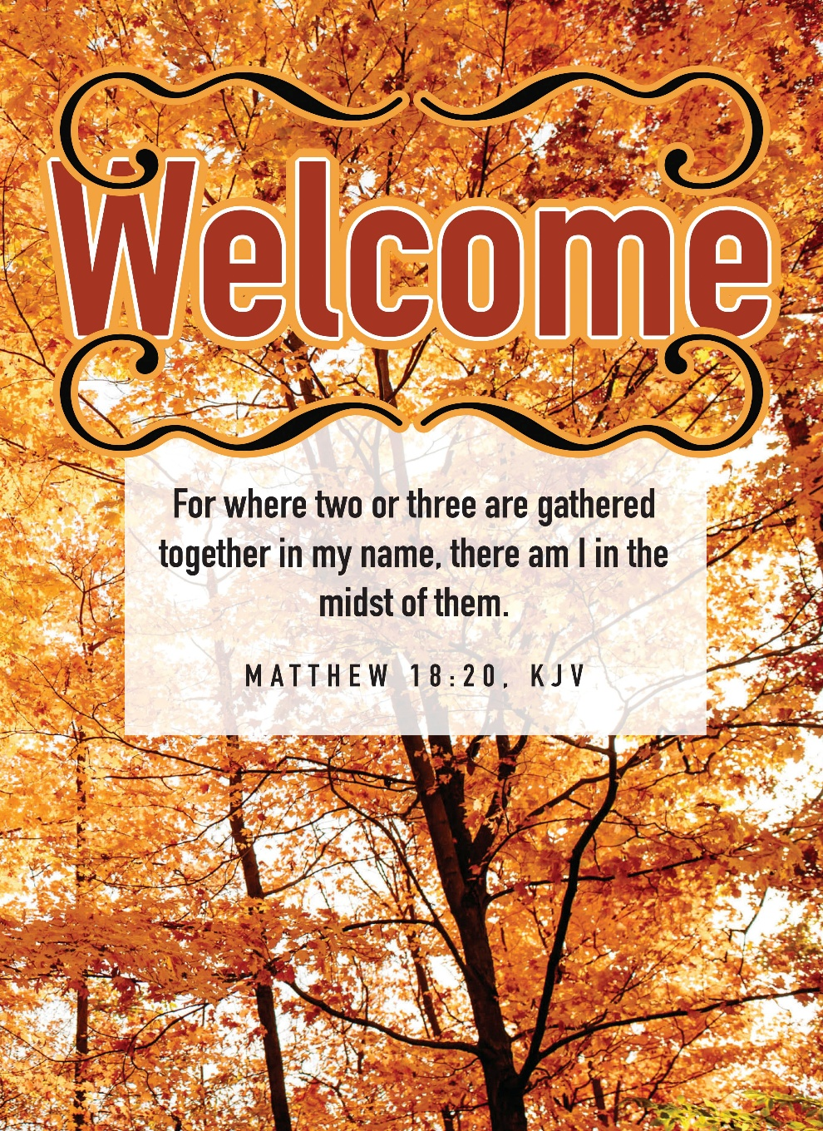
Mt. Zion Evangelical Lutheran Church

320 Mt. Zion Dr., Ripon, WI
www.mtzionripon.org
Facebook: Mt. Zion Evangelical Lutheran Church

Pastor Mark Kock (Vacancy Pastor)
Phone 414-755-9021
mkock315@gmail.com

Pentecost 15 Sept. 6, 2026
Handicapped accessible restrooms are located upstairs next to the Pastor’s Study and downstairs next to the elevator.
Attendance: Please remember to sign the friendship pads. Registration for communion will continue as usual at the table. If you have any questions or concerns, please contact Mike Meeker.


Hearing Loop: Our sanctuary is equipped with a hearing loop system. Those who have compatible hearing aids (with a T-switch) will be able to hear the sound system directly into their ear(s). The two main seating areas and the choir area are looped so that you may sit in any of the three areas. We also have four receivers available for those who do not have compatible hearing aids. If you wish to use a receiver please ask the ushers. Those who wish may bring their own headphones or ear buds.

Hymns: 918, 654 vs 1-4, 743, 617

Order of Worship Setting One pg. 154

Psalm: 51D (Insert) God, Be Merciful to Me

Reading: Ezekiel 33: 7-11 (EHV)
But I have appointed you, son of man, to be a watchman for the house of Israel. So whenever you hear a word from my mouth, you are to warn them from me. ⁸When I say to a wicked man, “Wicked man, you shall surely die,” if you do not speak to warn the wicked man against his way, that wicked man will die because of his guilt, but I will also hold you responsible for his blood. ⁹But if you do warn the wicked man to turn from his way, and he does not turn from his way, he will die because of his guilt, but you will have saved your life.
¹⁰So you, son of man, say the following to the house of Israel.
This is what you people are saying: “Certainly our rebellion and our sins weigh us down, and because of them we are rotting away. How then can we live?” ¹¹Say to them, “As I live, declares the Lord God, I take no pleasure in the death of the wicked, but rather that the wicked turn from their way and live. Turn back, turn back from your evil ways, for why should you die, O house of Israel?”

Reading: Galatians 2: 11-16 (EHV)
But when Cephas came to Antioch, I opposed him to his face, because he was clearly wrong. ¹²For before some people came from James, he ate with the Gentiles. But when those people came, he drew back and separated himself, because he feared those from the circumcision group. ¹³And the rest of the Jews joined him in his hypocrisy, with the result that even Barnabas was carried away by their hypocrisy. ¹⁴But when I saw that they were not acting according to the truth of the gospel, I said to Cephas in front of all of them, “If you, a Jew, live like the Gentiles and not like the Jews, why do you compel the Gentiles to live like the Jews?”
¹⁵“We are Jews by birth and not Gentile sinners. ¹⁶We know that a person is not justified by the works of the law but through faith in Jesus Christ. So we also believed in Christ Jesus that we might be justified by faith in Christ and not by the works of the law, because no one will be justified by the works of the law.

Gospel Acclamation I Timothy 2:4
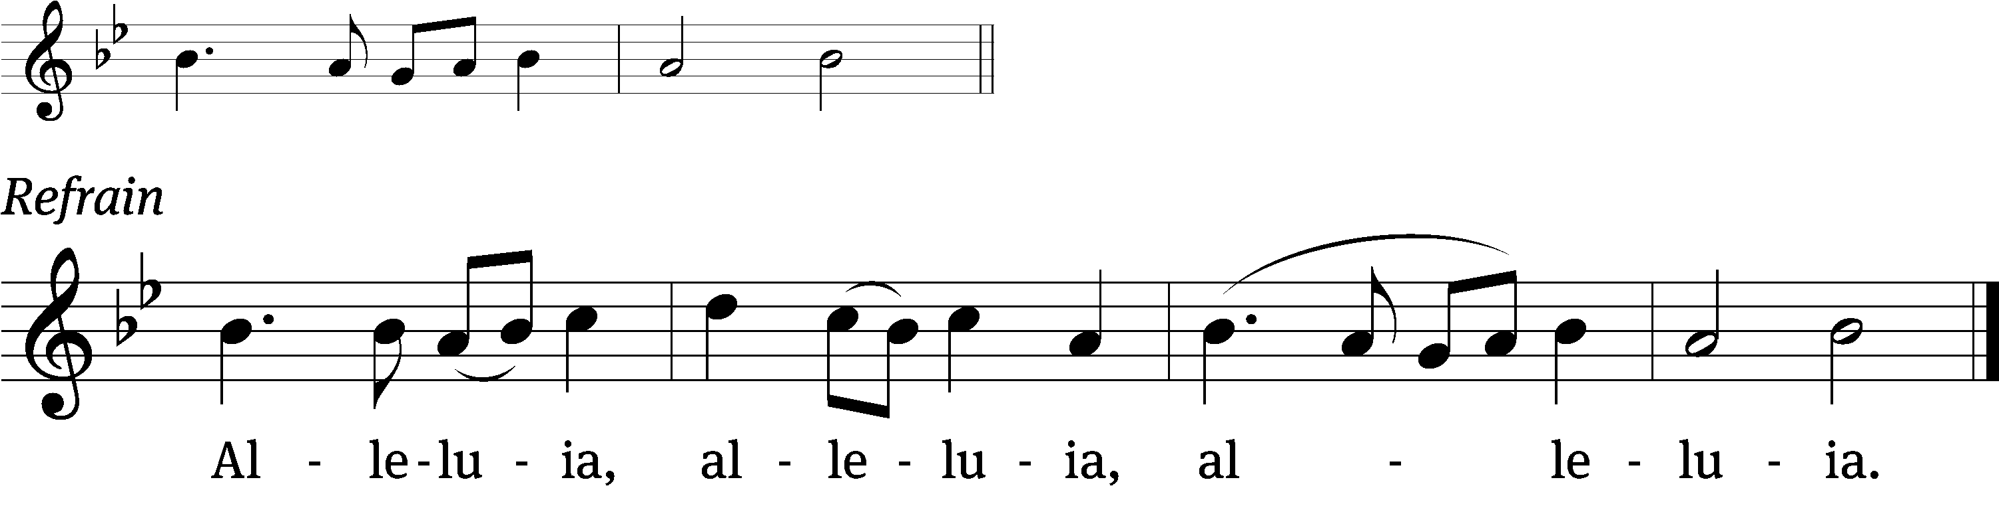
God wants all people / to be saved
and to come to a knowledge / of the truth. Refrain

Gospel & Sermon Text: Matthew 18:15-20 (EHV)
“If your brother sins against you, go and show him his sin just between the two of you. If he listens to you, you have regained your brother. ¹⁶But if he will not listen, take one or two others along with you, so that ‘every matter may be established by the testimony of two or three witnesses.’ ¹⁷If he refuses to listen to them, tell it to the church. And, if he refuses to listen even to the church, then treat him as an unbeliever or a tax collector. ¹⁸Amen I tell you: Whatever you bind on earth will be bound in heaven, and whatever you loose on earth will be loosed in heaven. ¹⁹Amen I tell you again: If two of you on earth agree to ask for anything, it will be done for them by my Father who is in heaven. ²⁰In fact where two or three have gathered together in my name, there I am among them.”

Sermon Theme: “Lost and Found”

OFFERING: The offerings are brought forward to the altar.

Keep in Your Prayers: Harley Dorsey, Allan Brooks, Matt Dubey, Eric Eckert, Myrtle Giese, Carol Henning, Nancy Kemnitz, Bob Reiser (his son passed away) Dennis Schliepp, Joan Stibb, Kathy Strook, Ginny Verch, Gary Wichman, Sue Wichman.

Announcements
The church picnic will be held NEXT SUNDAY Sept. 13 Following the service. Games for children and adults. A good way for the children to meet their Sunday School teachers. A cornhole tournament will be held. Please sign up by the library. The church council will be cooking burgers, brats, hot dogs and chicken breasts. Please bring a side dish or dessert as a potluck dish.

Hymn Sing: We will be starting our hymn sing on September 20th. If you have a favorite hymn you would like sung please contact Jo Meeker. Thanks Doug for offering to play.

We are offering the Lord's Supper on the 2nd and last Sunday of the month until further notice. There will be communion on the 30th of August. This will be brought before the Voters in October.

Sunday School: School will be starting on September 20th. PARENTS PLEASE CONTACT JO MEEKER (920-748-3058 OR 920-748-5641) IF YOU PLAN TO ENROLL YOUR CHILDEREN.

Birthdays: Next celebration September 27th. Please join us in the fellowship hall for cake, refreshments and fellowship.

Mailbox and table: The September Forward In Christ is available and also the Aug. 30-Nov. 28, 2026 Meditations are available. September calendars are also available.

For Your Information
Attendance 8/30/2026 81
Offerings for 8/30/2026 $3,149.13
Year to Date (thru Aug. 31st).
Income : $115,671.15
Expenses : $108,063.95
Shortfall YTD -$7,607.20
Our planned budget for this time frame was $154,633.12.

Serving Our Lord

Thank you to everyone for your service to our Lord!

Ushers:

Sept. 6 & 13: Ken Hielke, Todd Zellmer, Jonathan Zellmer, Dustin Zellmer

Sept. 20 & 27: Dave Smith, Josh Niemuth, Justin Niemuth

PowerPoint:

Sept. 6: Grunert Family

Sept. 13: Jo Meeker

Sept. 20: Jo Meeker

Sept. 27: Jo Meeker

Sept. Communion Set up: Jo Meeker

Sept. Communion Clean up: Marilyn Ninneman

Sunday 6th 9:00 AM Worship Service
10:15 AM Bible Study
Wednesday 6:15 PM Choir Practice
Sunday 9:00 AM Worship Service with Communion
10:15 AM Church Picnic

UPCOMING EVENTS:
Check the September Calendar for more information

Church Picnic September 13th.


Sunday School begins September 20th

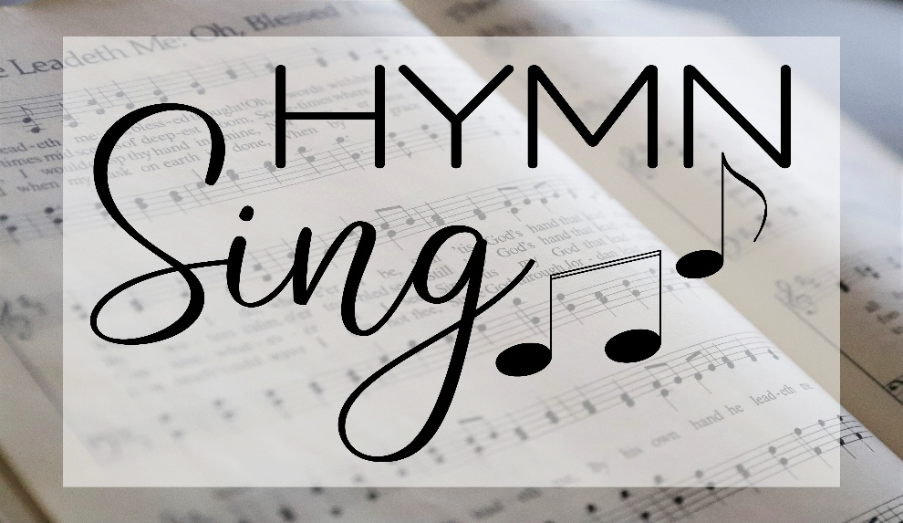
Hymn Sing on September 20th 8:45 AM

October 18th Voters’ Meeting

