15TH SUNDAY OF PENTECOST
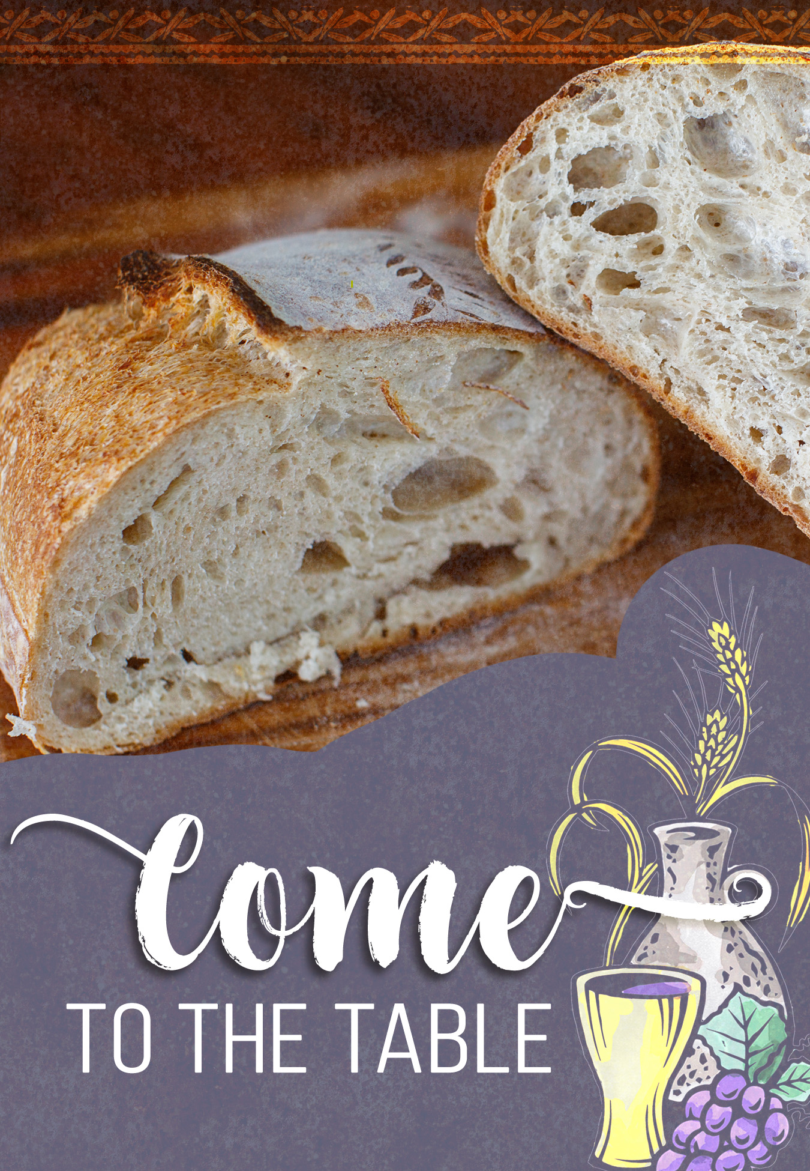
Mt. Zion Evangelical Lutheran Church

320 Mt. Zion Dr., Ripon, WI
www.mtzionripon.org
Facebook: Mt. Zion Evangelical Lutheran Church

Pastor Michael Sheppard
Pastor’s Study: 920-748-9734
E-mail: revmikesheppard@gmail.com
15th Sunday of Pentecost Sept. 14, 2025
Handicapped accessible restrooms are located upstairs next to the Pastor’s Study and downstairs next to the elevator.
Attendance: Please remember to sign the friendship pads. Registration for communion will continue as usual at the table. If you have any questions or concerns, please contact Pastor Sheppard or Mike Meeker.


Hearing Loop: Our sanctuary is equipped with a hearing loop system. Those who have compatible hearing aids (with a T-switch) will be able to hear the sound system directly into their ear(s). The two main seating areas and the choir area are looped so that you may sit in any of the three areas. We also have four receivers available for those who do not have compatible hearing aids. If you wish to use a receiver please ask the ushers. Those who wish may bring their own headphones or ear buds.

A note for our visitors on member communion –
Out of sincere love for the truth of God’s Word and for precious human souls, we practice member communion in our synod and congregation. This teaching, as practiced by the Church for centuries, is thoroughly Scriptural. It questions the faith of no individual yet asks that there be full doctrinal agreement between those who commune. For this reason, we ask that only those who are members of a WELS or ELS congregation join us for the Lord’s Supper. If you wish to commune with us please speak with the pastor before the service.
The front row on the pulpit side is reserved for people who are unable to navigate the steps. Pastor will serve you Communion first.

Prayer Before Communion: Dearest Jesus, I marvel that you came to this earth as the Word made flesh. With similar awe I contemplate how you give me your body and blood in the bread and wine of Holy Communion. Touch me with your grace that moved you to reach out to me, a poor, miserable sinner! Use this sacred supper to bring me closer to you. Amen.

Hymn Sing: 511, 612, 900, 927
Hymns: 545, 654, (667), 578

Order of Worship Setting One pg. 154

Hymn: 938 This is the Feast
(in place of Glory Be To God on High)

First Reading & Sermon Text: Hosea 3:1-5 (EHV)
The Lord said to me, “Go again. Show love to a woman who is loved by another man, a woman who keeps committing adultery. Show love just as the Lord loves the people of Israel, even though they keep turning to other gods and loving the raisin cakes.”
²So I bought her for myself for fifteen pieces of silver and nine bushels of barley. ³I said to her, “You will stay with me for many days. You must not be promiscuous. You must not be with any other man, and I will also be for you.”
⁴So the people of Israel will live many days without king or prince, without sacrifice or sacred memorial stones, and without the special vest or family idols. ⁵Afterward the people of Israel will return and seek the Lord their God and David their king. They will come trembling to the Lord and to his goodness in the latter days.

Psalm: 51A Be Merciful, O Lord

Second Reading: 2 Corinthians 2:5-11 (EHV)
Now if anyone has caused sorrow, he has not done it to me, but to all of you to some extent (not to overstate it). ⁶This punishment inflicted on such a person by the majority is enough, ⁷so that instead you should rather forgive and comfort him, or else such a person could be overwhelmed by excessive sorrow. ⁸For that reason, I urge you to reaffirm your love for him. ⁹In fact, this was also the purpose of my writing: I wanted to know the result of your being tested, that is, if you are obedient in all things.
¹⁰If you forgive anyone anything, I do too. To be sure, if I have forgiven anything, I have forgiven it in the presence of Christ for your sake, ¹¹so that Satan would not take advantage of us. We are certainly not unaware of his schemes.

Gospel Acclamation
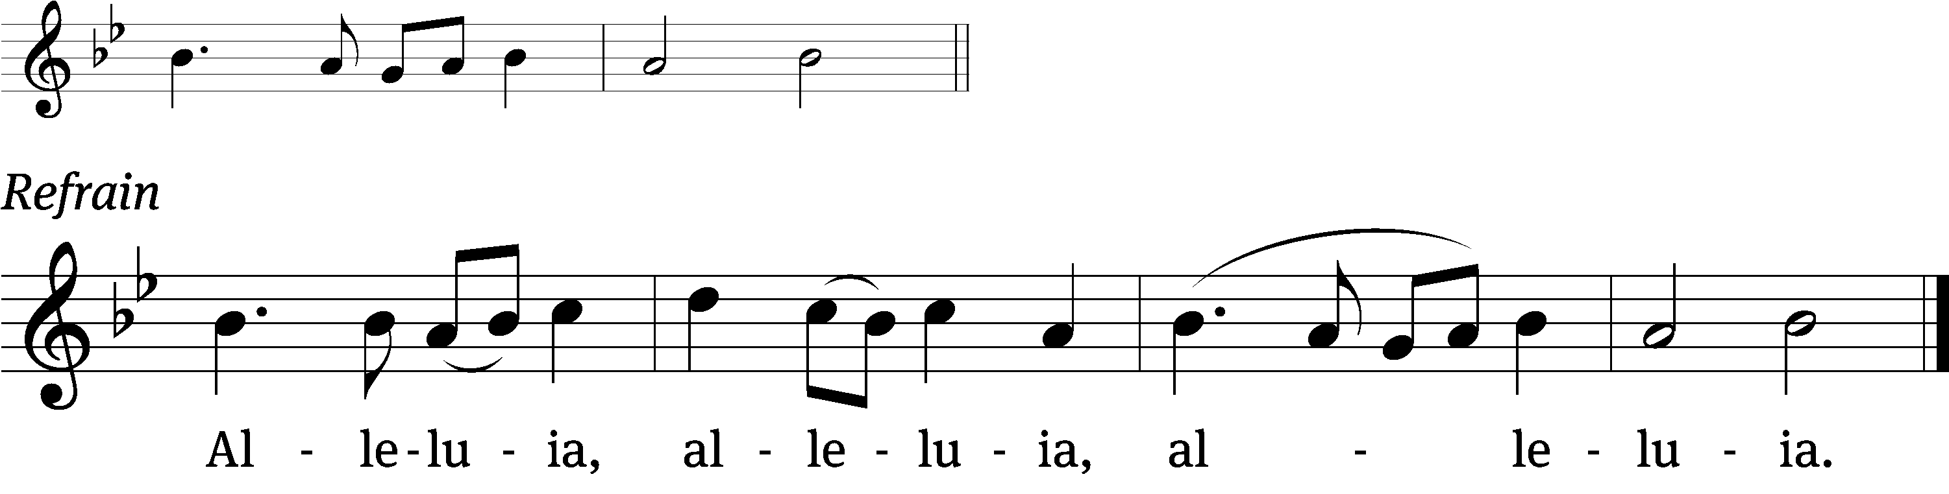
These words are written that you / may believe,
That Jesus is the Christ, the / Son of God. Refrain

Gospel: Luke 15:1-10 (EHV)
All the tax collectors and sinners were coming to Jesus to hear him. ²But the Pharisees and the experts in the law were complaining, “This man welcomes sinners and eats with them.”
³He told them this parable: ⁴“Which one of you, if you had one hundred sheep and lost one of them, would not leave the ninety-nine in the wilderness and go after the one that was lost until he finds it? ⁵And when he finds it, he joyfully puts it on his shoulders ⁶and goes home. Then he calls together his friends and his neighbors, telling them, ‘Rejoice with me, because I have found my lost sheep!’ ⁷I tell you, in the same way there will be more joy in heaven over one sinner who repents than over ninety-nine righteous people who do not need to repent.
⁸“Or what woman who has ten silver coins, if she loses one coin, would not light a lamp, sweep the house, and search carefully until she finds it? ⁹And when she finds it, she calls together her friends and neighbors and says, ‘Rejoice with me, because I have found the lost coin.’ ¹⁰In the same way, I tell you, there is joy in the presence of the angels of God over one sinner who repents.”

Choir Song: Anything Through Christ
This contemporary piece reminds us that we can do "Anything Through Christ" who is our strength.

Sermon Theme: “The Lord Turns the Unfaithful Back to Himself”

OFFERING: The offerings are brought forward to the altar.

Keep in Your Prayers: Harley Dorsey, Carol Henning, Karen Reiser, Gary Wichman and Dick Zellmer.

Announcements
Hymn Sing: Today’s hymn sing will begin at about 8:45am. If you have any requests for future hymn sings please talk to Sue Sheppard or Jo Meeker.

Bible Studies: Tuesday Bible study has begun, continuing with the study of John at 9am, and Sunday study will begin today at 10:15 in the fellowship hall viewing season 5 of The Chosen.

Junior Youth Group: Due to a funeral, the Junior Youth Group will NOT meet on Sept. 13th. The Junior Youth Activity Day has been rescheduled for Sept 20th, 9:30-11:00.

Zionfest was a huge success! It was filled with trucks and a tractor to touch, a delicious potluck lunch, games, facepainting, raffle baskets and cornhole tournament. There was lots of fun, laughter and fellowship. A special thank you to everyone that brought a vehicle for everyone to explore and even blast the horn. Also, thanks to all that came to Zionfest. We look forward to seeing you next year. Check out the bulletin board outside the office for photos.

New Member Welcome and Pine Car Derby: On October 5th, Mt. Zion will have a potluck dinner after church for our newest members. We will welcome Jim and Deb Paulus, Judy Doll, Michelle Doll and David Thiele and Matt and Ethel Behm. Mark your calendars and join us after Bible Study and Sunday School. Also that day we will be having a pine car derby for both youth and adults. A box of pine car wood blocks is outside the church office. If you have questions about the New Member Welcome or Pine car derby, please contact Dave Smith.


Cereal Donations: Mt. Zion has received a request from Shannon Wright from the Traded Treasures Community Food Pantry for donations. They are in desperate need of cereal. There is a box in the entryway for your cereal donations. This is a great opportunity for us to reach out to members of our community in need of our help. Thank you from the Evangelism committee for your support.

Birthday Celebration: The September celebration will be the 21st. Please join us for fellowship, cake and refreshments.

Friendly Reminder: Children’s offering envelopes and children’s bulletins are available on the back table. The prayer box is also there for any prayer requests.
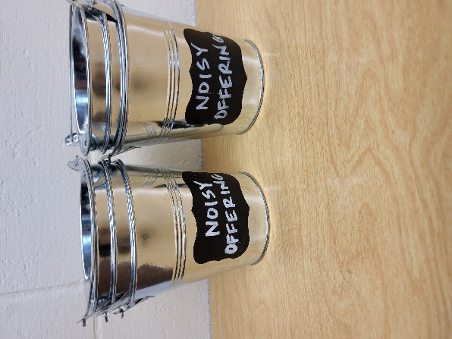
Noisy Offering: Please keep saving your spare change for our noisy offering on Oct 5th. Your offering will be given to WLA (Winnebago Lutheran Academy). We have appreciated your support for our various projects and activities. Thank you for your generosity.

Greeters: Thank you to all who have greeted so far. A new signup sheet for August through December is available. If you would like to be greeters for this year, please sign up on the sheet on the podium by the library, or talk to Mike or Jo Meeker.
Attention Singers!
Adult Choir has started again! Do you like singing just for fun? Well, there is no more fun than singing for the Lord! Singers of all abilities are welcome to join the Adult Choir. We are actively looking for more members to fill out each section, especially tenor and bass! Praising God while having fun is our motto. Call Kathy Schaub at 748-2585 if you have questions, or just be there for the first practice. You don’t have to be the world’s best singer. Everyone is welcome!!!

You are invited to Auxiliary Day at Martin Luther College!

The Ladies' Auxiliary promotes interest in Martin Luther College, provides Christian fellowship opportunities for our members, and supports students through scholarships, special non-budgeted projects, events, and your prayers.

Our Annual Auxiliary Day is Saturday, October 4, on the beautiful MLC campus in New Ulm, Minnesota. Enjoy fellowship, hear student presentations—including a sneak peek at the fall presentation of Little Women: The Broadway Musical—and help us choose the 2025-26 classroom projects we will fund. Join us and get in on the fun!

If you can't make it in person, check our website after the meeting to see what projects were selected. Visit mlc-wels.edu/ladies-auxiliary.

Mailbox and table: The September Forward In Christ is available and also the August 31, 2025-November 29, 2025 Meditations are available.

If you would like the Lord’s Supper privately, please contact Pastor Sheppard on his cell 920-745-0883, or by email revmikesheppard@gmail.com.
The Helping Hands Ministry is ready to serve the needs of our members. Please contact one of the following if you or someone you know needs assistance: Joanne Gregor at 920-896-1518, Lisa Tremore at 920-229-1297 or Tammy Niemuth at 920-299-0240.

For Your Information
Attendance 9/4 & 7/25 100
Offerings for 9/4 & 7/25 $3,887.00

Serving Our Lord

Thank you to everyone for your service to our Lord!

Ushers:

Sept. 14: Dave Smith, Josh Niemuth, Justin Niemuth

Sept. 21 & 28: Mark Roeder, Ferd Roeder, Jason Roeder

PowerPoint:

Sept. 14: Jean Lynch

Sept. 21: Jan Ohlrich

Sept. 28: Jo Meeker

Sept. Communion Set up: Jo Meeker

Sept. Communion Clean up: Marilyn Ninneman

Sunday (14th) 8:45 AM Hymn Sing
9:00 AM Worship Service with Communion
10:15 AM Sunday School; Bible Study will be held in the fellowship hall viewing Season 5 of The Chosen
5:00 PM Confirmation Class
Tuesday 9:00 AM Bible Study (book of John)
Wednesday 6:15 PM Choir Practice
Thursday 9:00 AM Women’s Bible Study (Fellowship Hall)
Saturday 9:30-11 AM Junior Youth Group Mtg
Sunday 9:00 AM Worship Service
10:15 AM Birthday Celebration, Sunday School & Bible Study
5:00 PM Confirmation Class

