14th Sunday of Pentecost

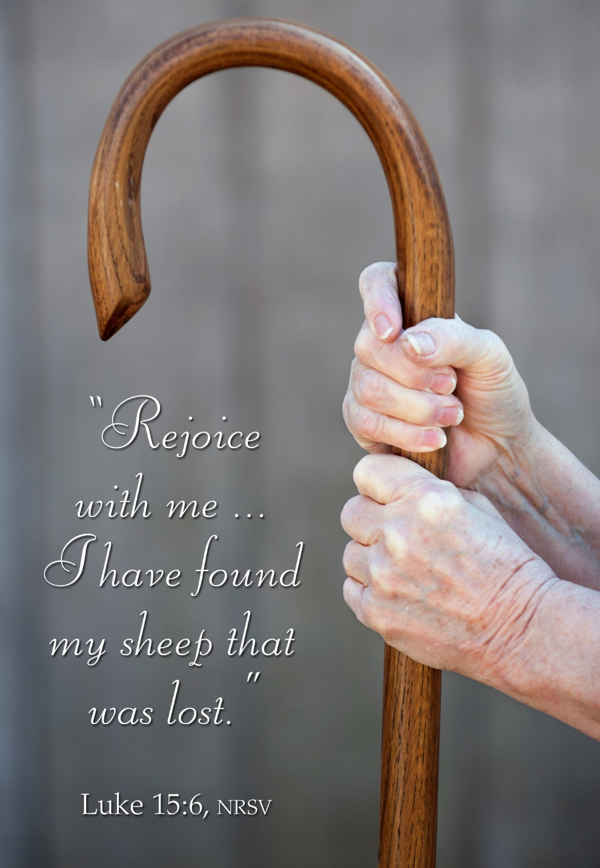
Mt. Zion Evangelical Lutheran Church
320 Mt. Zion Dr., Ripon, WI
www.mtzionripon.org
Facebook: Mt. Zion Evangelical Lutheran Church

Pastor Michael Sheppard
Pastor’s Study: 920-748-9734
E-mail: revmikesheppard@gmail.com
Pentecost 14 Sept. 8 & 11, 2022

Welcome to Mt. Zion!
Handicapped accessible restrooms are located upstairs next to the Pastor’s Study and downstairs next to the elevator.
Attendance: Please remember to sign the friendship pads. Registration for communion will continue as usual at the table. If you have any questions or concerns please contact Pastor Sheppard or Mark Roeder.

Hearing Loop: Our sanctuary is equipped with a hearing loop system. Those who have compatible hearing aids (with a T-switch) will be able to hear the sound system directly into their ear(s). The two main seating areas and the choir area are looped so that you may sit in any of the three areas. We also have four receivers available for those who do not have compatible hearing aids. If you wish to use a receiver please ask the ushers. Those who wish may bring their own headphones or ear buds.

A note for our visitors on member communion –
Out of sincere love for the truth of God’s Word and for precious human souls, we practice member communion in our synod and congregation. This teaching, as practiced by the Church for centuries, is thoroughly Scriptural. It questions the faith of no individual yet asks that there be full doctrinal agreement between those who commune. For this reason, we ask that only those who are members of a WELS or ELS congregation join us for the Lord’s Supper. If you wish to commune with us please speak with the pastor before the service.
The front row on the pulpit side is reserved for people who are unable to navigate the steps. Pastor will serve you Communion first.

Prayer Before Communion: Dearest Jesus, I marvel that you came to this earth as the Word made flesh. With similar awe I contemplate how you give me your body and blood in the bread and wine of Holy Communion. Touch me with your grace that moved you to reach out to me, a poor, miserable sinner! Use this sacred supper to bring me closer to you. Amen.

Prayer After Communion: Thank you, Lord Jesus Christ, for nourishing me in this sacrament with your body and blood. You have given me forgiveness, life, and salvation. Let me always remain in you as a branch remains in the vine. Send me out in the power of your Spirit to live and work to your praise and glory. Amen

Hymns: 576, 654, 668, 770

Order of Worship: The Service CW21 pg. 154

Be Merciful, O Lord Psalm 51

First Reading: Hosea 3: 1-5 (EHV)
The Lord said to me, “Go again. Show love to a woman who is loved by another man, a woman who keeps committing adultery. Show love just as the Lord loves the people of Israel, even though they keep turning to other gods and loving the raisin cakes.”
²So I bought her for myself for fifteen pieces of silver and nine bushels of barley. ³I said to her, “You will stay with me for many days. You must not be promiscuous. You must not be with any other man, and I will also be for you.”
⁴So the people of Israel will live many days without king or prince, without sacrifice or sacred memorial stones, and without the special vest or family idols. ⁵Afterward the people of Israel will return and seek the Lord their God and David their king. They will come trembling to the Lord and to his goodness in the latter days.

Second Reading & Sermon Text: 2 Corinthians 2: 5-11 (EHV)
Now if anyone has caused sorrow, he has not done it to me, but to all of you to some extent (not to overstate it). ⁶This punishment inflicted on such a person by the majority is enough, ⁷so that instead you should rather forgive and comfort him, or else such a person could be overwhelmed by excessive sorrow. ⁸For that reason, I urge you to reaffirm your love for him. ⁹In fact, this was also the purpose of my writing: I wanted to know the result of your being tested, that is, if you are obedient in all things.
¹⁰If you forgive anyone anything, I do too. To be sure, if I have forgiven anything, I have forgiven it in the presence of Christ for your sake, ¹¹so that Satan would not take advantage of us. We are certainly not unaware of his schemes.
Proper Luke 15:10
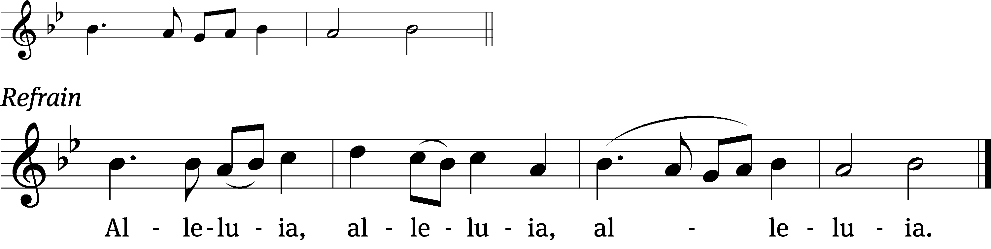
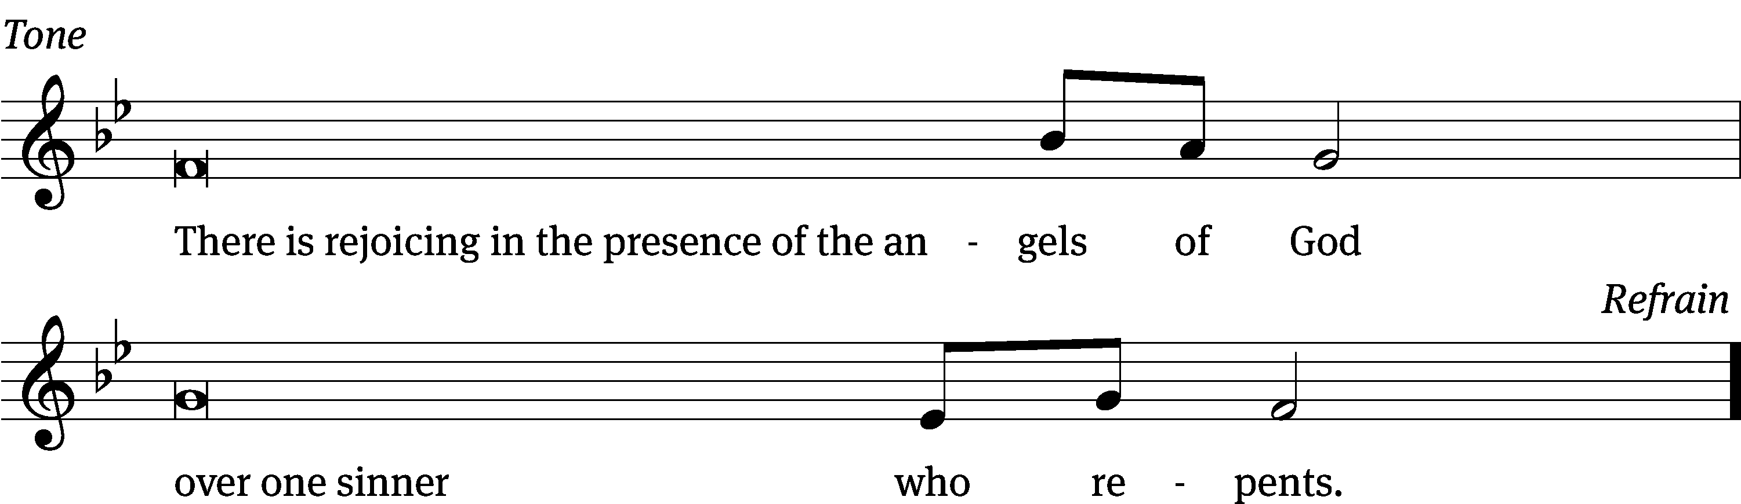
Tune: © 2021 Northwestern Publishing House. Used by permission: OneLicense no. 716381
Gospel: Luke 15: 1-10 (EHV)
All the tax collectors and sinners were coming to Jesus to hear him. ²But the Pharisees and the experts in the law were complaining, “This man welcomes sinners and eats with them.”
³He told them this parable: ⁴“Which one of you, if you had one hundred sheep and lost one of them, would not leave the ninety-nine in the wilderness and go after the one that was lost until he finds it? ⁵And when he finds it, he joyfully puts it on his shoulders ⁶and goes home. Then he calls together his friends and his neighbors, telling them, ‘Rejoice with me, because I have found my lost sheep!’ ⁷I tell you, in the same way there will be more joy in heaven over one sinner who repents than over ninety-nine righteous people who do not need to repent.
⁸“Or what woman who has ten silver coins, if she loses one coin, would not light a lamp, sweep the house, and search carefully until she finds it? ⁹And when she finds it, she calls together her friends and neighbors and says, ‘Rejoice with me, because I have found the lost coin.’ ¹⁰In the same way, I tell you, there is joy in the presence of the angels of God over one sinner who repents.”

Choir Song: “Family of Grace”
This piece focuses on Christian Unity. The accompaniment was recorded on the new Clavinova.

Sermon Theme: “Reaffirm Your Love For Christ.”

OFFERING: The offerings are brought forward to the altar.
Announcements

Attention: Would the person who used the new vase holder please return it to church as soon as possible. Thank you
Attention Singers: Adult Choir has started! Do you like singing just for fun? Well, there is no more fun than singing for the Lord! Singers of all abilities are welcome to join the Adult Choir. We are actively looking for more members to fill out each section. Praising God while having fun is our motto. Everyone is welcome!!!

Catechism Classes have resumed. Classes will be from 5:00 PM to 6:30 PM on Wednesdays. All 7th and 8th graders from our congregation are welcome. Please email: revmikesheppard@gmail.com, call (920) 745-0883, or text Pastor Sheppard to register. As a requirement of Catechism class this year, confirmation students are asked to also attend Sunday school regularly during the school year. Thank you.

Sound System: We are starting a fund for a new Audio/Visual system. The improvements are necessary to accommodate our recent and future technology additions. We are applying for a grant from The Antioch Foundation, if it is approved Mt Zion’s share of the cost will be approximately $16,000.00. You may use the regular church envelopes just write Audio System next to your donation. Thank you.

Sunday School: We are still in need of a teacher for the 7th and 8th grades starting this fall. Please talk to Pastor Sheppard or Jo Meeker if you are interested.

TODAY: This is our 1st day of Sunday School. We will be having games, the church picnic and a CORNHOLE COMPETITION. The Cornhole games are open to children and adults. There is a signup sheet on the bulletin board by the office. The Council will supply the meat, please bring a dish to pass.

Red Hymnals: It was decided that whoever would like to take one or more old hymnals home may do so at no cost. They are located on the table by the entrance to the sanctuary. Please feel free to take.

Birthday Celebration: Cake will be served Sunday September 18th to celebrate the birthdays for September.
Mailbox and table: The September Forward In Christ is available and also the August 28th, 2022-November 26th, 2022 Meditations are available.
If you would like the Lord’s Supper privately, please contact Pastor Sheppard on his cell 920-745-0883, or by email revmikesheppard@gmail.com.

The Helping Hands Ministry is ready to serve the needs of our members. Please contact one of the following if you or someone you know needs assistance: Joanne Gregor at 920-896-1518, Lisa Tremore at 920-229-1297 or Tammy Niemuth at 920-299-0240.

For Your Information
Attendance 9/1 - 9/4/2022: 91
Offerings for 9/1 - 9/4/2022: $5,578.90*
*Includes $1,660 towards the new sound system

Serving Our Lord

Thank you to everyone for your service to our Lord!

Ushers:

Sept 11: Justin Niemuth, Ed Manskke, Warren Schwandt, Derek Chitwood

PowerPoint:

Sept 8: Kim Mueller

Sept 11: Arjeta Rushani

Sept 15: Kim Mueller

Sept 18: Jan Ohlrich

Sept Communion Set up: Jo Meeker

Sept Communion Clean up: Marilyn Ninneman

This week at Mt. Zion
Sunday (11th) 9:00 AM Worship with Communion
10:15 AM Sunday School (Games)
11:15 AM Church Picnic
Monday 6:30 PM Bible Study
Tuesday 9:00 AM Bible Study
7:00 PM Ladies Aid Meeting
Wednesday 5:00 PM Catechism Class
6:15 PM Choir Practice
6:30 PM Council Meeting
Thursday 6:30 PM Worship
Sunday 9:00 AM Worship
10:15 AM Sunday School & Bible Study

Secretary Jo Meeker
Church Office: 920-748-5641
Office Hours: Mon. 9-12, Tues. & Wed. 9-11
E-mail: mountzionripon@gmail.com

Acknowledgments
Unless otherwise indicated, Scripture quotations are from The Holy Bible, New International Version®, NIV®. Copyright © 1973, 1978, 1984, 2011 by Biblica, Inc.TM Used by permission of Zondervan. All rights reserved worldwide.
Software distributed in partnership with Northwestern Publishing House.
Created by Christian Worship: Service Builder © 2022 Concordia Publishing House.

