14TH SUNDAY OF PENTECOST
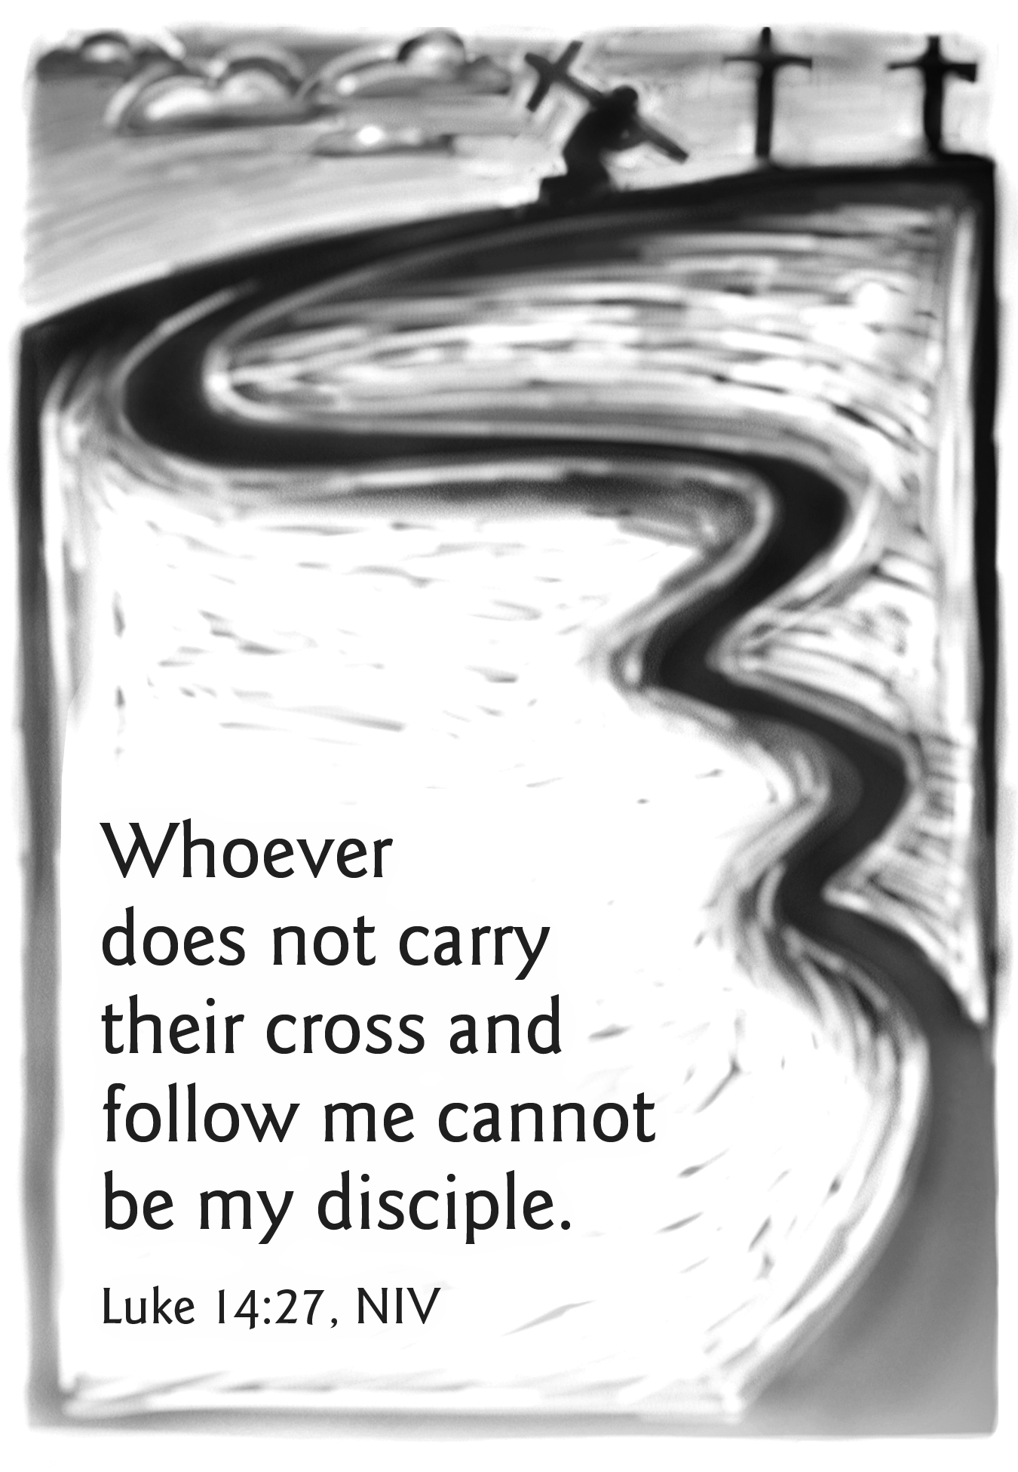
Mt. Zion Evangelical Lutheran Church

320 Mt. Zion Dr., Ripon, WI
www.mtzionripon.org
Facebook: Mt. Zion Evangelical Lutheran Church

Pastor Michael Sheppard
Pastor’s Study: 920-748-9734
E-mail: revmikesheppard@gmail.com
14th Sunday of Pentecost Sept. 4 & 7, 2025
Handicapped accessible restrooms are located upstairs next to the Pastor’s Study and downstairs next to the elevator.
Attendance: Please remember to sign the friendship pads. Registration for communion will continue as usual at the table. If you have any questions or concerns, please contact Pastor Sheppard or Mike Meeker.


Hearing Loop: Our sanctuary is equipped with a hearing loop system. Those who have compatible hearing aids (with a T-switch) will be able to hear the sound system directly into their ear(s). The two main seating areas and the choir area are looped so that you may sit in any of the three areas. We also have four receivers available for those who do not have compatible hearing aids. If you wish to use a receiver please ask the ushers. Those who wish may bring their own headphones or ear buds.

Psalm: 1A Blessed Are They

Hymns: 633, 695, 767

Order of Worship Thursday Evening Prayer pg. 215
Sunday Morning Prayer pg. 207

First Reading: Deuteronomy 30:15-20 (EHV)
See now, today I have set before you life and prosperity, death and disaster. ¹⁶This is what I am commanding you today: Love the Lord your God, walk in his ways, and keep his commandments, his statutes, and his ordinances. Then you will live and increase in number, and the Lord your God will bless you in the land that you are going to possess.
¹⁷But if your heart turns away, and you do not listen, and you are lured away, and you bow down to other gods and serve them, ¹⁸then I declare to you today that you will most certainly perish. You will not live a long life on the land that you are about to enter and possess by crossing over the Jordan.
¹⁹I call the heavens and the earth to witness against you today that I have set before you life and death, blessing and curse. Choose life so that you and your descendants may live ²⁰by loving the Lord your God, by listening to his voice, and by clinging to him, because that means life for you, and you will live a long life on your land that the Lord swore to give to your fathers, to Abraham, Isaac, and Jacob.

Second Reading: Philemon 1, 7-21 (EHV)
Paul, a prisoner of Christ Jesus, and Timothy our brother,
⁷For I have received great joy and encouragement from your love, because the hearts of the saints have been refreshed by you, brother.
⁸For that reason, even though I have plenty of boldness in Christ to order you to do what is proper, ⁹I am appealing to you, instead, on the basis of love, just as I, Paul, am an old man and now also a prisoner of Jesus Christ. ¹⁰I am appealing to you on behalf of my child Onesimus. I became his father while I was in chains. ¹¹There was a time when he was useless to you, but now he is useful both to you and to me. ¹²I have sent him (who is my very heart) back to you. Welcome him. ¹³I wanted to keep him with me, so that he might serve me in your place while I am in chains for the gospel. ¹⁴But I did not want to do anything without your consent, so that your kindness would not be the result of compulsion, but of willingness. ¹⁵Perhaps this is why he was separated from you for a while: so that you would have him back forever, ¹⁶no longer as a slave, but as more than a slave, as a dear brother. He certainly is dear to me, but he is even more of a dear brother to you, both in the flesh and in the Lord.
¹⁷So if you consider me your partner, welcome him as you would welcome me. ¹⁸And if he has wronged you in any way or owes you anything, charge it to me. ¹⁹I, Paul, have written this with my own hand: I will repay it—not to mention that you owe me your very self. ²⁰Yes, brother, I am asking for a favor from you in the Lord. Refresh my heart in Christ. ²¹Confident of your obedience, I write to you, knowing that you will do even more than I ask.

Sermon Text: Luke 14:25-35 (EHV)
Large crowds were traveling with Jesus. He turned and said to them, ²⁶“If anyone comes to me and does not hate his own father and mother, wife and children, brothers and sisters, yes, even his own life, he cannot be my disciple. ²⁷Whoever does not carry his own cross and follow me cannot be my disciple. ²⁸For which of you, if he wants to build a tower, does not first sit down and count the cost to see if he has enough to complete it? ²⁹Otherwise, when he has laid a foundation and is not able to finish, everyone who sees it will begin to ridicule him, ³⁰saying, ‘This fellow began to build, but was not able to finish.’ ³¹Or what king, as he goes out to confront another king in war, will not first sit down and consider if he is able with ten thousand to oppose the one who comes against him with twenty thousand? ³²And if he is not able, he sends out a delegation and asks for terms of peace while his opponent is still far away. ³³So then, any one of you who does not say farewell to all his own possessions cannot be my disciple. ³⁴Salt is good, but if the salt has lost its flavor, how will it become salty again? ³⁵It is not fit for the soil or for the manure pile. It is thrown away. The one who has ears to hear, let him hear.”

Sermon Theme: “What is the Cost of Following Jesus?”

OFFERING: The offerings are brought forward to the altar.

Keep in Your Prayers: Harley Dorsey, Carol Henning, Karen Reiser, Gary Wichman and Dick Zellmer.

Announcements
Worship Committee: Mt. Zion is forming a worship committee to discuss the various aspects of worship in our congregation. The first meeting will be Thursday, September 11th at 6:00pm. Please join us!
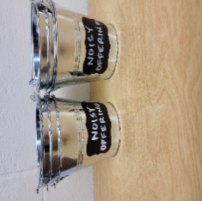
Noisy Offering: Your noisy offering donation today will go to support Christ Alone Academy, St. John’s Princeton and St. John’s Montello. We appreciate your support for our noisy offerings, for your generosity and your prayers.

Thursday Noisy Offering Pail: A noisy offering pail will be put on the back offering table and by the entrance near the organ on Sept. 4. Mark your calendars, and please continue to save your spare change. Thanks from the Evangelism Committee.

Hymn Sing: Our first hymn sing of the season will be next Sunday September 14th. If you have any requests please talk to Sue Sheppard or Jo Meeker.

Bible Studies: Tuesday Bible study will begin on September 9th at 9am, and Sunday study will begin on September 14th at 10:15.

Women’s Bible Study: The women’s Bible Study Group will resume on Thursday, September 11th from 9-10. We will be viewing and discussing Chosen Season 5 and will meet in the church’s fellowship hall to utilize the new TV and DVD player. We welcome anyone that would like to join us. If you have any questions you can contact Joanne Gregor at 920-896-5518 or gregorj12@hotmail.com. Mark your calendars, looking forward to seeing everyone again and all newcomers.

New Member Welcome and Kids Pine Car Derby: A few new members have joined Mt. Zion, and we would like to officially welcome them. October 5th will be our New Member Welcome potluck after Bible Study and Sunday School. Also that day we will be having a pine car derby for the youth. A box of pine car wood blocks is outside the church office. If you have questions about the New Member Welcome or Pine car derby, please contact Dave Smith.

Birthday Celebration: The September celebration will be the 21st.

Friendly Reminder: Children’s offering envelopes and children’s bulletins are available on the back table. The prayer box is also there for any prayer requests.
Attention Singers!
Adult Choir will be starting again! Do you like singing just for fun? Well, there is no more fun than singing for the Lord! Singers of all abilities are welcome to join the Adult Choir. We are actively looking for more members to fill out each section, especially tenor and bass! Praising God while having fun is our motto.
Call Kathy Schaub at 748-2585 if you have questions, or just be there for the first practice. You don’t have to be the world’s best singer. Everyone is welcome!!!

Cereal Donations: Mt. Zion has received a request from Shannon Wright from the Traded Treasures Community Food Pantry for donations. They are in desperate need of cereal. There is a box in the entryway for your cereal donations. This is a great opportunity for us to reach out to members of our community in need of our help. Thank you from the Evangelism committee for your support.

Mailbox and table: The September Forward In Christ is available and also the August 31, 2025-November 29, 2025 Meditations are available.
Greeters: Thank you to all who have greeted so far. A new signup sheet for August through December is available. If you would like to be greeters for this year, please sign up on the sheet on the podium by the library, or talk to Mike or Jo Meeker.

If you would like the Lord’s Supper privately, please contact Pastor Sheppard on his cell 920-745-0883, or by email revmikesheppard@gmail.com.
The Helping Hands Ministry is ready to serve the needs of our members. Please contact one of the following if you or someone you know needs assistance: Joanne Gregor at 920-896-1518, Lisa Tremore at 920-229-1297 or Tammy Niemuth at 920-299-0240.
For Your Information
Attendance 8/28 & 31/25 89
Offerings for 8/28 & 31/25 $2,763.00

Serving Our Lord

Thank you to everyone for your service to our Lord!

Ushers:

Aug. 31: Ken Hielke, Todd, Jonathan and Dustin Zellmer

Sept. 7 & 14: Dave Smith, Josh Niemuth, Justin Niemuth

PowerPoint:

Aug 28: Jo Meeker

Aug. 31: Judy Doll

Sept. 4: Jo Meeker

Sept. 7: Grunert Family

Sept. Communion Set up: Jo Meeker

Sept. Communion Clean up: Marilyn Ninneman

Sunday (7th) 9:00 AM Worship Service with Communion
Noisy Offering & Children’s Sermon
10:15 AM Mt. ZionFest
11:30 Potluck, Brats, Burgers and Chicken Breasts will be available.
Monday 6:00 PM Evangelism Committee Mtg.
Tuesday 9:00 AM Bible Study
5:30 PM Council Meeting
6:30 PM Ladies Aid Meeting
Wednesday 6:15 PM Choir Practice
Thursday 9:00 AM Women’s Bible Study (Fellowship Hall)
Sunday 9:00 AM Worship Service with Communion
10:15 AM Sunday School & Bible Study
5:00 PM Confirmation Class



