13TH SUNDAY OF PENTECOST
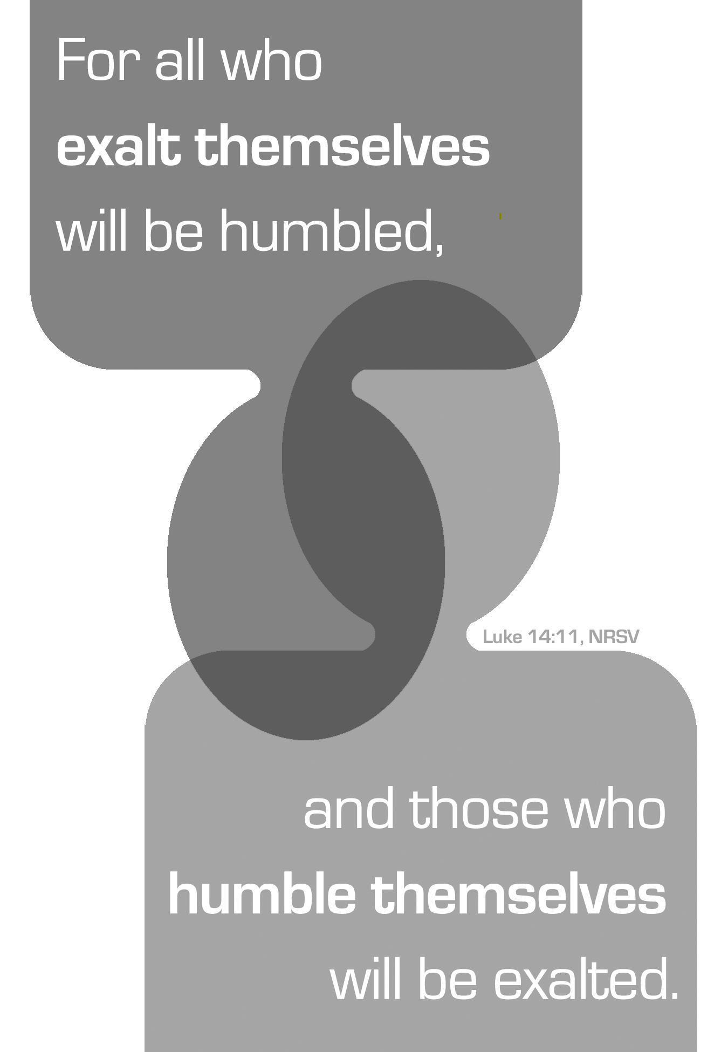
Mt. Zion Evangelical Lutheran Church

320 Mt. Zion Dr., Ripon, WI
www.mtzionripon.org
Facebook: Mt. Zion Evangelical Lutheran Church

Pastor Michael Sheppard
Pastor’s Study: 920-748-9734
E-mail: revmikesheppard@gmail.com
13th Sunday of Pentecost Aug 28& 31, 2025
Handicapped accessible restrooms are located upstairs next to the Pastor’s Study and downstairs next to the elevator.
Attendance: Please remember to sign the friendship pads. Registration for communion will continue as usual at the table. If you have any questions or concerns, please contact Pastor Sheppard or Mike Meeker.


Hearing Loop: Our sanctuary is equipped with a hearing loop system. Those who have compatible hearing aids (with a T-switch) will be able to hear the sound system directly into their ear(s). The two main seating areas and the choir area are looped so that you may sit in any of the three areas. We also have four receivers available for those who do not have compatible hearing aids. If you wish to use a receiver please ask the ushers. Those who wish may bring their own headphones or ear buds.

A note for our visitors on member communion –
Out of sincere love for the truth of God’s Word and for precious human souls, we practice member communion in our synod and congregation. This teaching, as practiced by the Church for centuries, is thoroughly Scriptural. It questions the faith of no individual yet asks that there be full doctrinal agreement between those who commune. For this reason, we ask that only those who are members of a WELS or ELS congregation join us for the Lord’s Supper. If you wish to commune with us please speak with the pastor before the service.
The front row on the pulpit side is reserved for people who are unable to navigate the steps. Pastor will serve you Communion first.

Prayer Before Communion: Dearest Jesus, I marvel that you came to this earth as the Word made flesh. With similar awe I contemplate how you give me your body and blood in the bread and wine of Holy Communion. Touch me with your grace that moved you to reach out to me, a poor, miserable sinner! Use this sacred supper to bring me closer to you. Amen.

Hymns: 766, 729, (663), 768

Order of Worship Setting Three pg. 188

First Reading: Proverbs 25: 6-7a (EHV)
Do not honor yourself in a king’s presence.
Do not stand in a place reserved for great people,
⁷because it is better to be told, “Come up here,”
than for you to be humiliated before a ruler.

Psalm: 112A Light Dawns in the Darkness

Second Reading & Sermon Tex: James 2:1-13 (EHV)
My brothers, have faith in our glorious Lord Jesus Christ without showing favoritism. ²For example, suppose a man enters your worship assembly wearing gold rings and fine clothing, and a poor man also enters wearing filthy clothing. ³If you look with favor on the man wearing fine clothing and say, “Sit here in this good place,” but you tell the poor man, “Stand over there” or “Sit down here at my feet,” ⁴have you not made a distinction among yourselves and become judges with evil opinions? ⁵Listen, my dear brothers, has not God chosen those who are poor in the world to be rich in faith and to be heirs of the kingdom, which he promised to those who love him? ⁶But you dishonored the poor man. Don’t the rich oppress you, and don’t they drag you into court? ⁷Aren’t they the ones who blaspheme the noble name that was pronounced over you? ⁸However, if you really fulfill the royal law according to the Scripture: “You shall love your neighbor as yourself,” you are doing well. ⁹But if you show favoritism, you are committing a sin, since you are convicted by this law as transgressors.
¹⁰In fact, whoever keeps the whole law but stumbles in one point has become guilty of breaking all of it. ¹¹For the one who said, “Do not commit adultery,” also said, “Do not commit murder.” Now if you do not commit adultery, but you do commit murder, you have become a transgressor of the law. ¹²So speak and act as those who are going to be judged by the law of freedom. ¹³For there will be judgment without mercy on the one who has not shown mercy. Mercy triumphs over judgment.

Gospel Acclamation
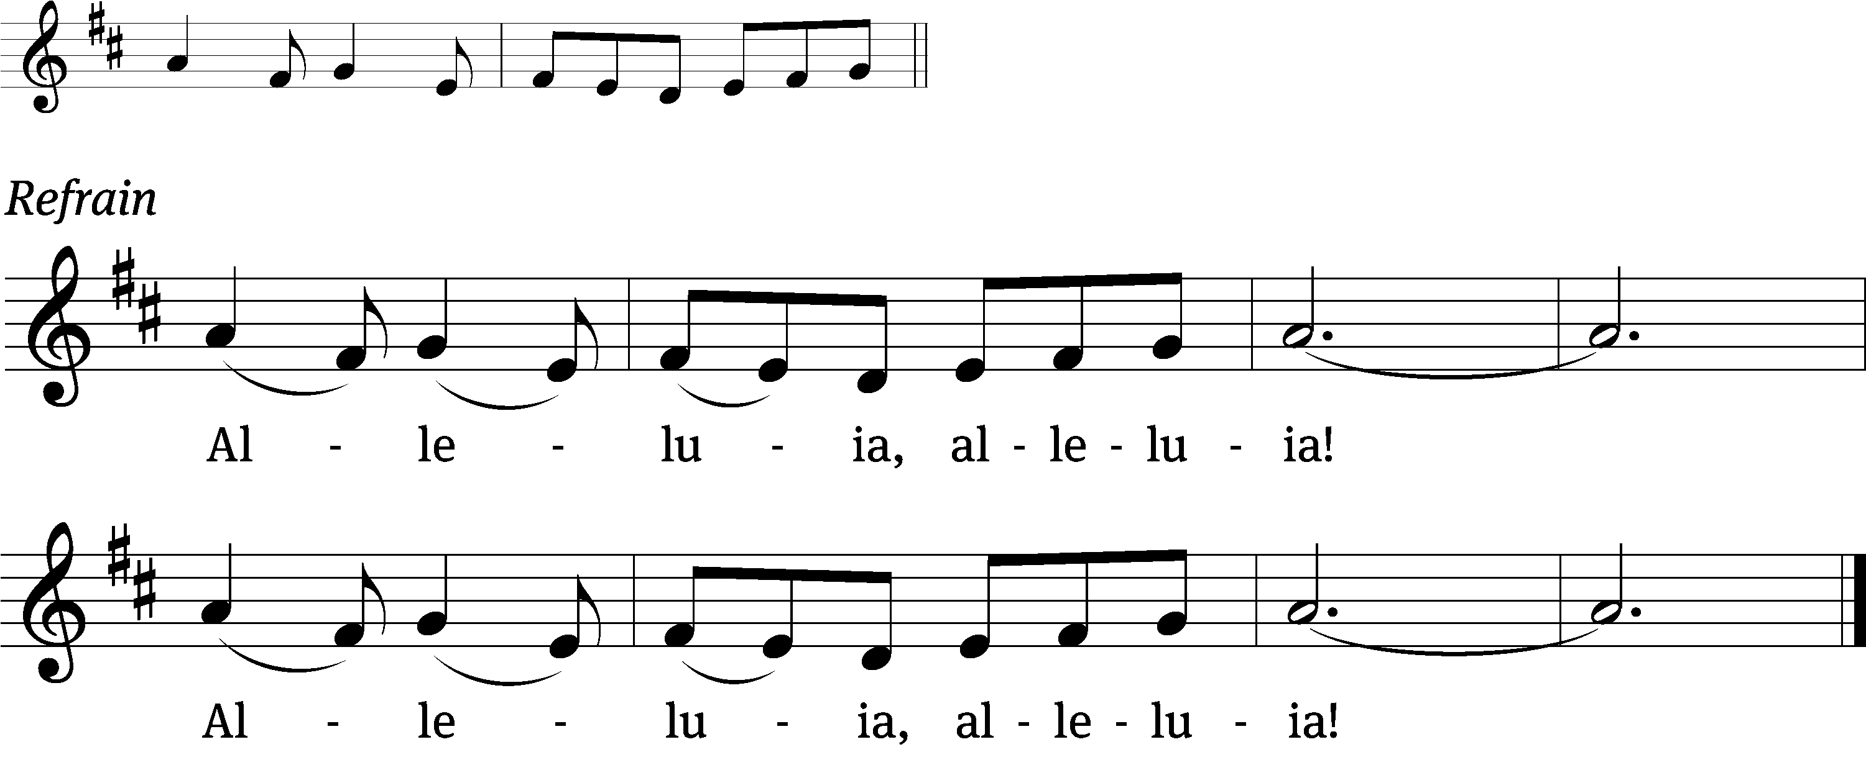
These words are written that you / may believe,
That Jesus is the Christ, the / Son of God. Refrain

Gospel: Luke 14:1,7-14 (EHV)
One Sabbath day, when Jesus went into the house of a leader of the Pharisees to eat bread, they were watching him closely.
⁷When he noticed how they were selecting the places of honor, he told the invited guests a parable. ⁸“When you are invited by someone to a wedding banquet, do not recline in the place of honor, or perhaps someone more distinguished than you may have been invited by him. ⁹The one who invited both of you may come and tell you, ‘Give this man your place.’ Then you will begin, with shame, to take the lowest place.
¹⁰“But when you are invited, go and recline in the lowest place, so that when the one who invited you comes, he will tell you, ‘Friend, move up to a higher place.’ Then you will have honor in the presence of all who are reclining at the table with you.
¹¹“Yes, everyone who exalts himself will be humbled, and whoever humbles himself will be exalted.”
¹²He also said to the one who had invited him, “When you make a dinner or a supper, do not invite your friends, or your brothers, or your relatives, or rich neighbors, so that perhaps they may also return the favor and pay you back.
¹³“But when you make a feast, invite the poor, the crippled, the lame, the blind, ¹⁴and you will be blessed, because they cannot repay you. Certainly, you will be repaid in the resurrection of the righteous.”

Sermon Theme: “Love Each Other Without Favoritism!”

OFFERING: The offerings are brought forward to the altar.

Keep in Your Prayers: Harley Dorsey, Carol Henning, Karen Reiser, Gary Wichman and Dick Zellmer.

Announcements
Worship Committee: Mt. Zion is forming a worship committee to discuss the various aspects of worship in our congregation. The first meeting will be Thursday, September 11th at 6:00pm. Please join us!
New Address for Pastor Ziebell: 618 Jupiter Dr., Apt 1022, Madison, WI 53718. His new email is revrez65@gmail.com.

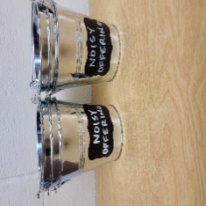
Noisy Offering: Please keep saving your spare change for our noisy offering on Sept. 7th. Your donation will go to support Christ Alone Academy, St. John’s Princeton and St. John’s Montello. We appreciated your support for our noisy offerings, for your generosity and your prayers.

Thursday Noisy Offering Pail: A noisy offering pail will be put on the back offering table and by the entrance near the organ on the last Thursday of the month (August 28th). Mark your calendars, and please continue to save your spare change. Thanks from the Evangelism Committee.

Thursday Services: The last Thursday service for this year will be on September 4th.

Friendly Reminder: Children’s offering envelopes and children’s bulletins are available on the back table. The prayer box is also there for any prayer requests.
Items in the Church Garage: There are still a number of items in the church garage from when the downstairs classrooms were cleaned out. These items are free for the taking, and include 2 overhead projectors, notebooks, 2 chairs, 2 large bulletin boards, a small filing cabinet, and several small shelving units. If these items are not taken by the end of August, they will be donated.

Attention Singers!
Adult Choir will be starting again! Do you like singing just for fun? Well, there is no more fun than singing for the Lord! Singers of all abilities are welcome to join the Adult Choir. We are actively looking for more members to fill out each section, especially tenor and bass! Praising God while having fun is our motto.
We will have our first rehearsal Wed. Sept. 3 at 6:15 pm. Call Kathy Schaub at 748-2585 if you have questions, or just be there for the first practice. You don’t have to be the world’s best singer. Everyone is welcome!!!

Cereal Donations: Mt. Zion has received a request from Shannon Wright from the Traded Treasures Community Food Pantry for donations. They are in desperate need of cereal. There is a box in the entryway for your cereal donations. This is a great opportunity for us to reach out to members of our community in need of our help. Thank you from the Evangelism committee for your support.

Women’s Bible Study: The women’s Bible Study Group will resume on Thursday, September 11th from 9-10. We will be viewing and discussing Chosen Season 5 and will meet in the church’s fellowship hall to utilize the new TV and DVD player. We welcome anyone that would like to join us. If you have any questions you can contact Joanne Gregor at 920-896-5518 or gregorj12@hotmail.com. Mark your calendars, looking forward to seeing everyone again and all newcomers.

Mailbox and table: The August Forward In Christ is available and also the August 31, 2025-November 29, 2025 Meditations are available.
Greeters: Thank you to all who have greeted so far. A new signup sheet for August through December is available. If you would like to be greeters for this year, please sign up on the sheet on the podium by the library, or talk to Mike or Jo Meeker.

Birthday Celebration: The September celebration is TBD.

Hymn Sing: The next hymn will be Sunday September 14th. If you have any requests please talk to Sue Sheppard or Jo Meeker.

If you would like the Lord’s Supper privately, please contact Pastor Sheppard on his cell 920-745-0883, or by email revmikesheppard@gmail.com.
The Helping Hands Ministry is ready to serve the needs of our members. Please contact one of the following if you or someone you know needs assistance: Joanne Gregor at 920-896-1518, Lisa Tremore at 920-229-1297 or Tammy Niemuth at 920-299-0240.
For Your Information
Attendance 8/21 & 24/25 99
Offerings for 8/21 & 24/25 $3,266.00

Serving Our Lord

Thank you to everyone for your service to our Lord!

Ushers:

Aug. 31: Ken Hielke, Todd, Jonathan and Dustin Zellmer

Sept. 7 & 14: Dave Smith, Josh Niemuth, Justin Niemuth

PowerPoint:

Aug 28: Jo Meeker

Aug. 31: Judy Doll

Sept. 4: Jo Meeker

Sept. 7: Grunert Family

Sept. Communion Set up: Jo Meeker

Sept. Communion Clean up: Marilyn Ninneman

Sunday (31st) 9:00 AM Worship Service with Communion
Thursday 6:30 PM Worship Service (Final)
Sunday 9:00 AM Worship Service
Noisy Offering, Children’s Sermon
10:15 AM Mt. Zionfest Begins, Potluck dinner will be served from 11:30 – 12:30.

SUNDAY SCHOOL: Will begin on September 14th at 10:15 AM. We welcome all children from age 3 -Grade 8.

