12TH SUNDAY OF PENTECOST
St. Bartholomew
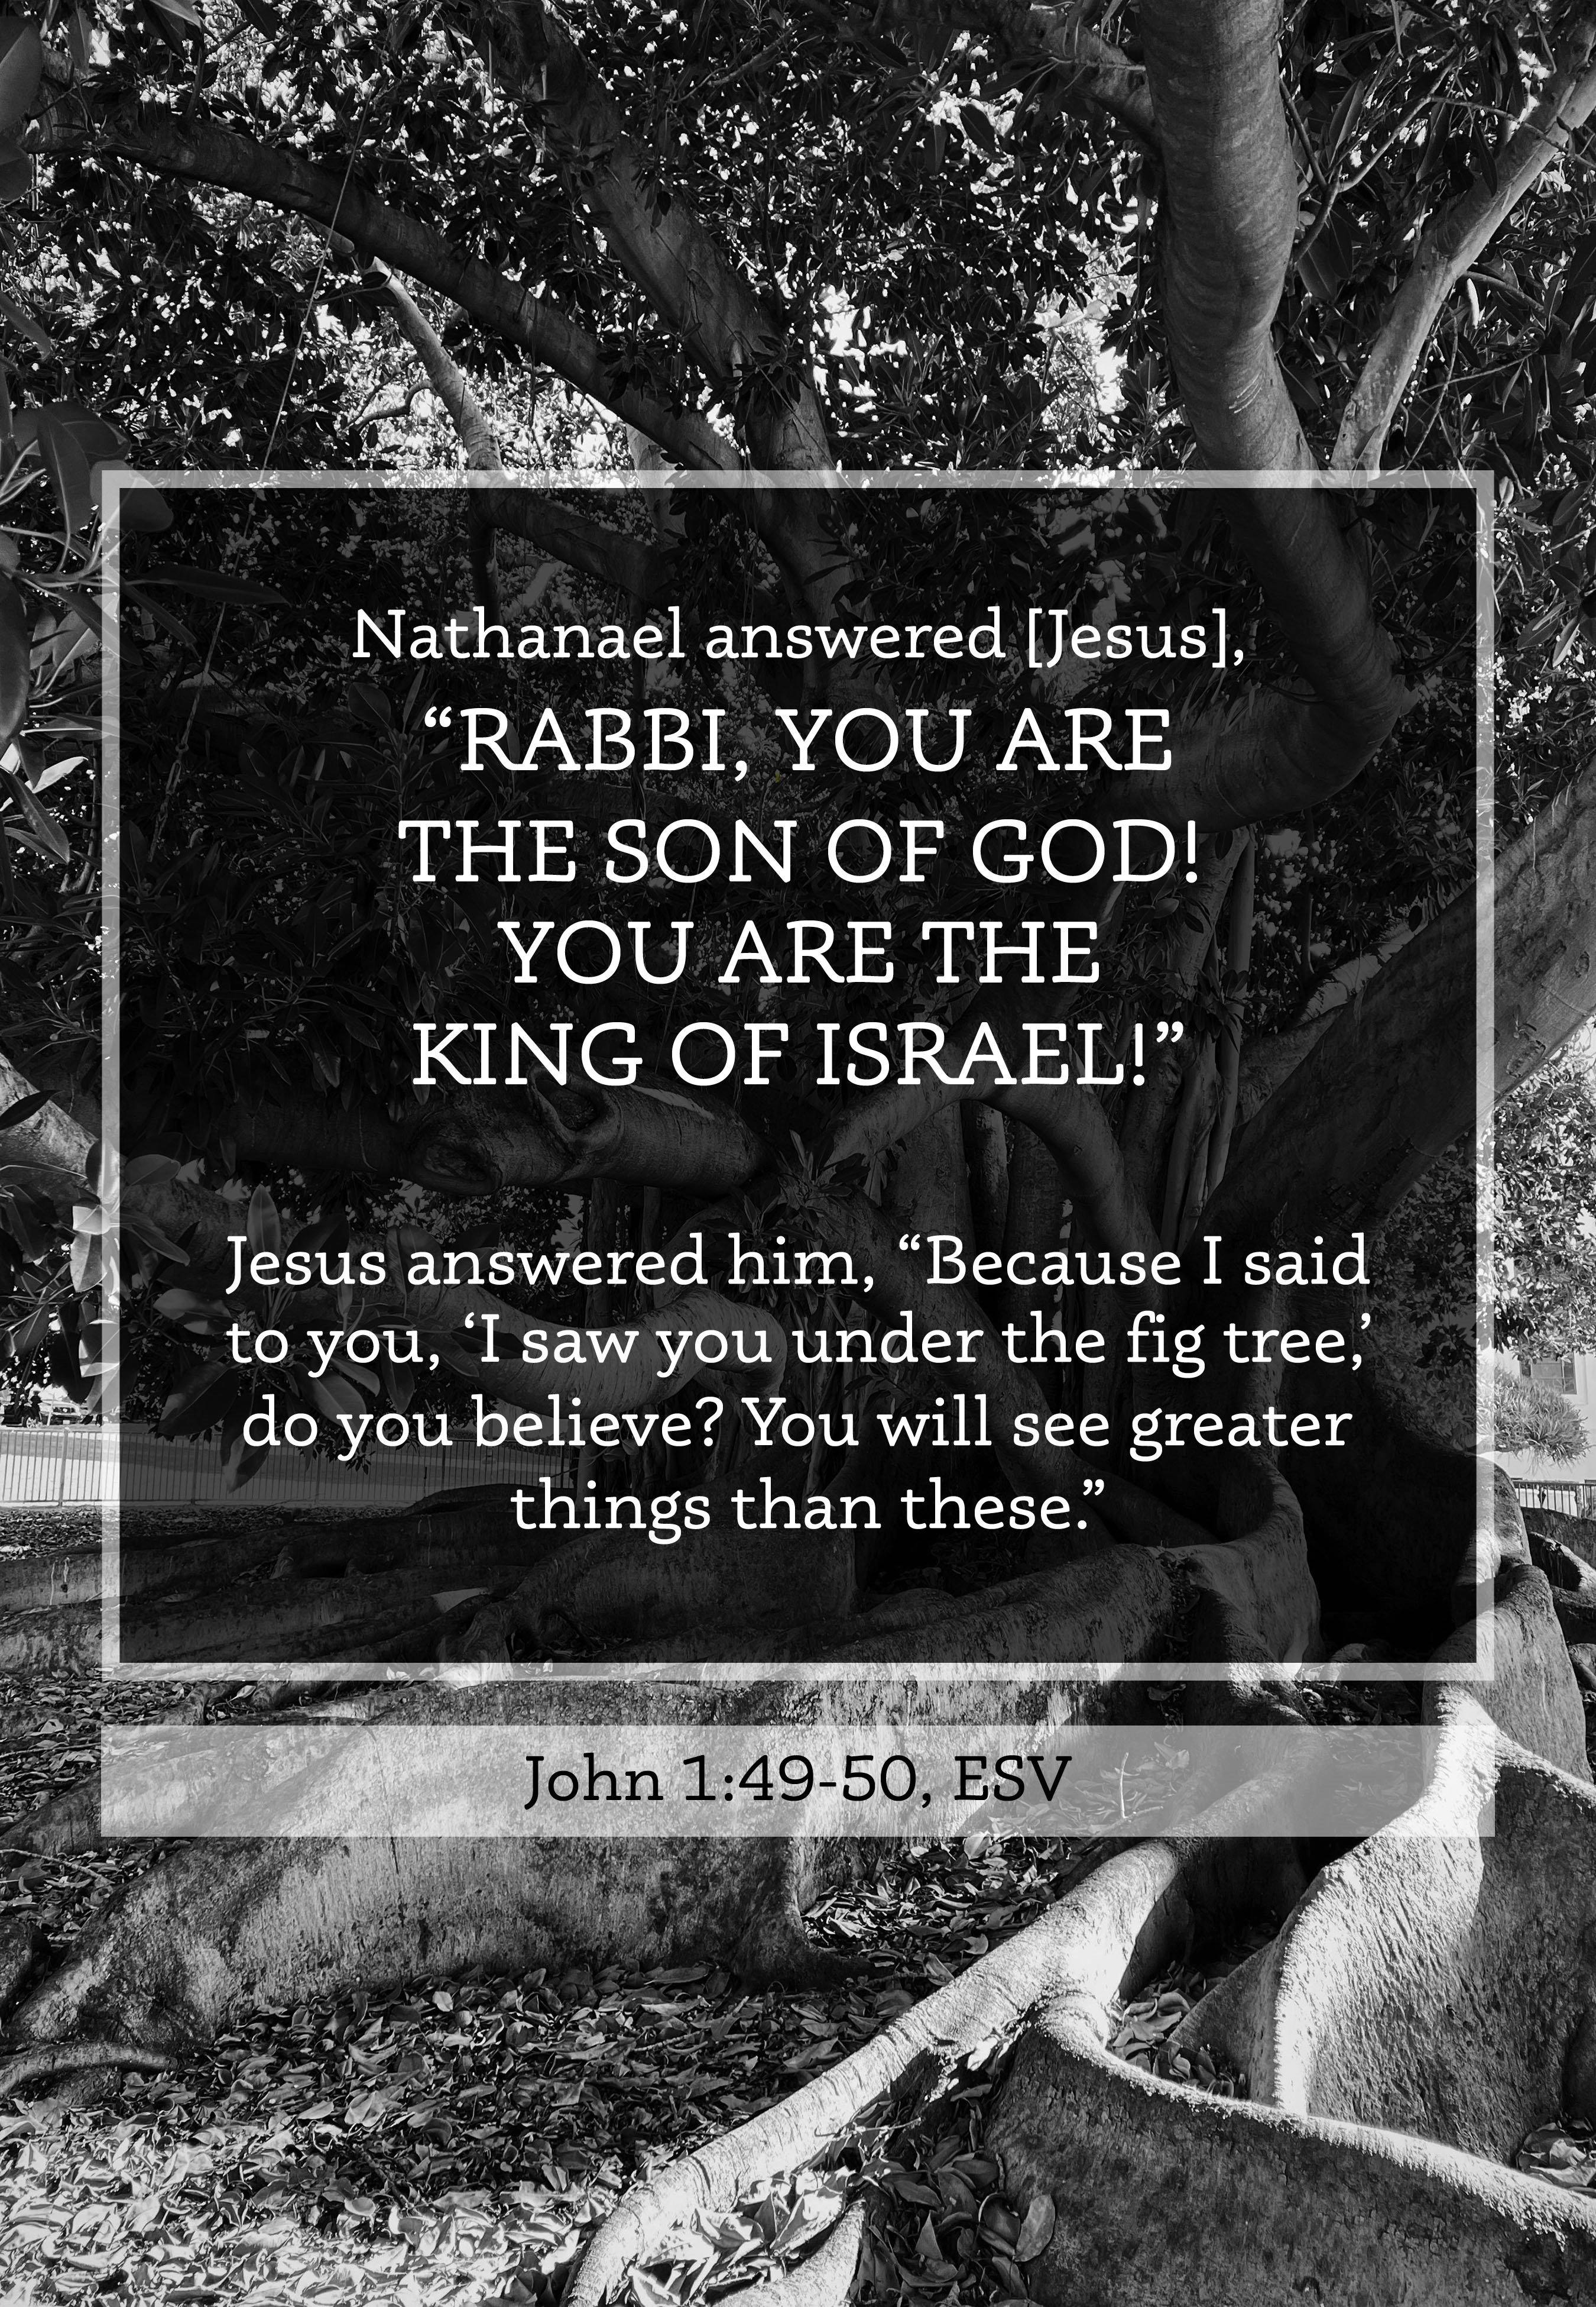
Mt. Zion Evangelical Lutheran Church

320 Mt. Zion Dr., Ripon, WI
www.mtzionripon.org
Facebook: Mt. Zion Evangelical Lutheran Church

Pastor Michael Sheppard
Pastor’s Study: 920-748-9734
E-mail: revmikesheppard@gmail.com
Festival of St. Bartholomew Aug 21& 24, 2025
Handicapped accessible restrooms are located upstairs next to the Pastor’s Study and downstairs next to the elevator.
Attendance: Please remember to sign the friendship pads. Registration for communion will continue as usual at the table. If you have any questions or concerns, please contact Pastor Sheppard or Mike Meeker.


Hearing Loop: Our sanctuary is equipped with a hearing loop system. Those who have compatible hearing aids (with a T-switch) will be able to hear the sound system directly into their ear(s). The two main seating areas and the choir area are looped so that you may sit in any of the three areas. We also have four receivers available for those who do not have compatible hearing aids. If you wish to use a receiver please ask the ushers. Those who wish may bring their own headphones or ear buds.

Hymns: 892 vs. 1,23,3; 639, 702, 716

Order of Worship Setting Three pg. 188

First Reading: Proverbs 3: 1-8 (EHV)
My son, do not forget my teaching.
Let your heart keep my commands,
²because they will add long days and many years to your life,
and peace and prosperity will come to you.
³Do not allow mercy and truth to leave you.
Fasten them around your neck.
Write them on the tablet of your heart.
⁴Then you will find favor and approval
in the eyes of God and man.
⁵Trust in the Lord with all your heart,
and do not rely on your own understanding.
⁶In all your ways acknowledge him,
and he will make your paths straight.
⁷Do not consider yourself wise.
Fear the Lord, and turn away from evil.
⁸Then your body will be healed,
and your bones will be refreshed.

Psalm: 139D (Soloists) In You, O LORD, I Am Found

Second Reading: I Timothy 3:1-7 (EHV)
This saying is trustworthy: If anyone aspires to become an overseer, he desires a noble task. ² It is necessary, then, for the overseer to be above reproach, the husband of only one wife, temperate, self-controlled, respectable, hospitable, able to teach, ³ not a drunkard, not a violent man but gentle, not quarrelsome, not a lover of money. ⁴ It is necessary that he manage his own household well, with all dignity making sure that his children obey him. ⁵ (If a man does not know how to manage his own household, how will he take care of God’s church?) ⁶ He must not be a recent convert, or he might become conceited and fall into the same condemnation as the Devil. ⁷ In addition, he must have a good reputation with those outside the church, so that he may not fall into disgrace and the Devil’s trap.

Gospel Acclamation
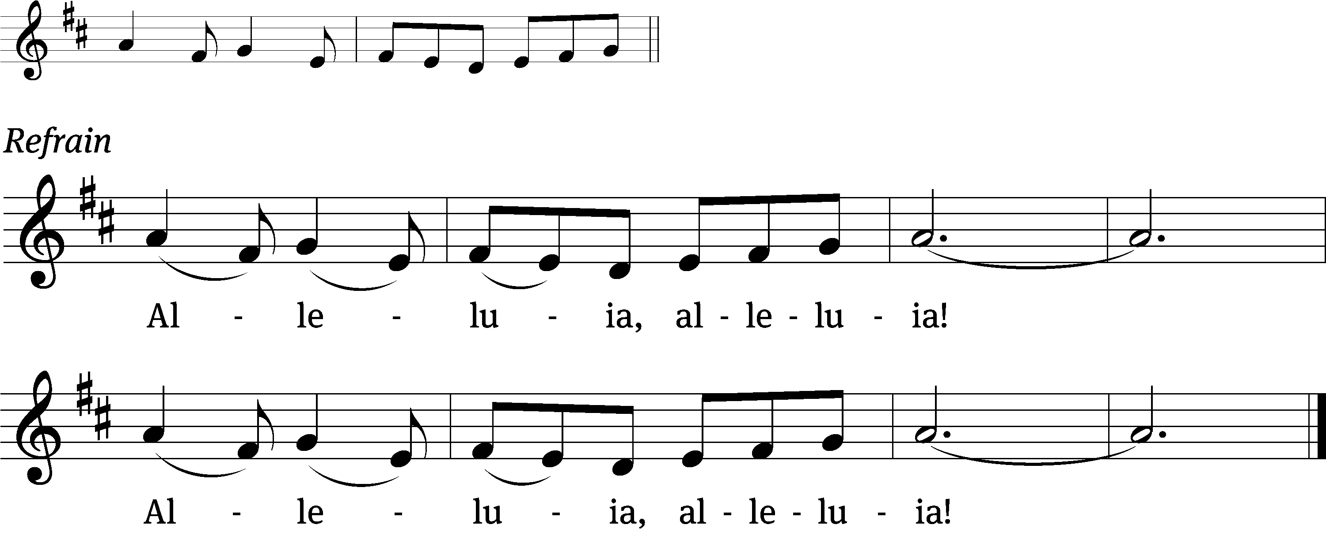
These words are written that you / may believe,
That Jesus is the Christ, the / Son of God. Refrain

Gospel & Sermon Text: John 1:43-51 (EHV)
The next day, Jesus wanted to leave for Galilee. He found Philip and said to him, “Follow me.” ⁴⁴ Now Philip was from Bethsaida, the hometown of Andrew and Peter.
⁴⁵ Philip found Nathanael and told him, “We have found the one Moses wrote about in the Law, and about whom the prophets also wrote—Jesus of Nazareth, the son of Joseph.”
⁴⁶ Nathanael said to him, “Nazareth! Can anything good come from there?”
“Come and see!” Philip told him.
⁴⁷ Jesus saw Nathanael coming toward him and said about him, “Truly, here is an Israelite in whom there is no deceit.”
⁴⁸ Nathanael asked him, “How do you know me?”
Jesus answered, “Before Philip called you, while you were under the fig tree, I saw you.”
⁴⁹ Nathanael answered him, “Rabbi, you are the Son of God! You are the King of Israel!”
⁵⁰ Jesus replied, “You believe because I told you that I saw you under the fig tree. You will see greater things than that!” ⁵¹ Then he added, “Amen, Amen, I tell you: You will see heaven opened and the angels of God ascending and descending on the Son of Man.”

Sermon Theme: “We Have Found the Christ.”

OFFERING: The offerings are brought forward to the altar.

Keep in Your Prayers: Harley Dorsey, Carol Henning, Karen Reiser, Gary Wichman and Dick Zellmer.

Announcements
New Address for Pastor Ziebell: 618 Jupiter Dr., Apt 1022, Madison, WI 53718. His new email is revrez65@gmail.com.

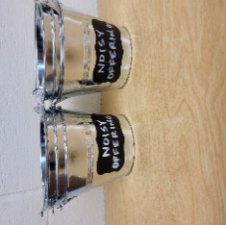
Noisy Offering: Please keep saving your spare change for our noisy offering on Sept. 7th. Your donation will go to support Christ Alone Academy, St. John’s Princeton and St. John’s Montello. We appreciated your support for our noisy offerings, for your generosity and your prayers.

Thursday Noisy Offering Pail: A noisy offering pail will be put on the back offering table and by the entrance near the organ on the last Thursday of the month (August 28th). Mark your calendars, and please continue to save your spare change. Thanks from the Evangelism Committee.

Thursday Services: The last Thursday service for this year will be on September 4th.

Friendly Reminder: Children’s offering envelopes and children’s bulletins are available on the back table. The prayer box is also there for any prayer requests.

Items in the Church Garage: There are still a number of items in the church garage from when the downstairs classrooms were cleaned out. These items are free for the taking, and include 2 overhead projectors, notebooks, 2 chairs, 2 large bulletin boards, a small filing cabinet, and several small shelving units. If these items are not taken by the end of August, they will be donated.

Attention Singers!
Adult Choir will be starting again! Do you like singing just for fun? Well, there is no more fun than singing for the Lord! Singers of all abilities are welcome to join the Adult Choir. We are actively looking for more members to fill out each section, especially tenor and bass! Praising God while having fun is our motto.
We will have our first rehearsal Wed. Sept. 3 at 6:15 pm. Call Kathy Schaub at 748-2585 if you have questions, or just be there for the first practice. You don’t have to be the world’s best singer. Everyone is welcome!!!
Women’s Bible Study: The women’s Bible Study Group will resume on Thursday, September 11th from 9-10. We will be viewing and discussing Chosen Season 5 and will meet in the church’s fellowship hall to utilize the new TV and DVD player. We welcome anyone that would like to join us. If you have any questions you can contact Joanne Gregor at 920-896-5518 or gregorj12@hotmail.com. Mark your calendars, looking forward to seeing everyone again and all newcomers.
Mailbox and table: The August Forward In Christ is available and also the August 31, 2025-November 29, 2025 Meditations are available.
Greeters: Thank you to all who have greeted so far. A new signup sheet for August through December is available. If you would like to be greeters for this year, please sign up on the sheet on the podium by the library, or talk to Mike or Jo Meeker.

Birthday Celebration: The September celebration is TBD.

Hymn Sing; The next hymn will be Sunday September 14th. If you have any requests please talk to Sue Sheppard or Jo Meeker.

If you would like the Lord’s Supper privately, please contact Pastor Sheppard on his cell 920-745-0883, or by email revmikesheppard@gmail.com.
The Helping Hands Ministry is ready to serve the needs of our members. Please contact one of the following if you or someone you know needs assistance: Joanne Gregor at 920-896-1518, Lisa Tremore at 920-229-1297 or Tammy Niemuth at 920-299-0240.

For Your Information
Attendance 8/14 & 17/25 102
Offerings for 8/14 & 17/25 $1,865.35

Serving Our Lord

Thank you to everyone for your service to our Lord!

Ushers:

Aug. 24 & 31: Ken Hielke, Todd, Jonathan and Dustin Zellmer

PowerPoint:

August 21: Sara Retelle

August 24: Kari Hielke

Aug 28: Jo Meeker

Aug. 31: Judy Doll

Aug. Communion Set up: Mary Clement

Aug. Communion Clean up: Sue Sheppard

Sunday (24th) 9:00 AM Worship Service
Thursday 6:30 PM Worship Service with Communion (Noisy Offering buckets will be out)
Sunday 9:00 AM Worship Service with Communion

COMING UP: Mt. Zionfest Sept 7th starting immediately after church. Potluck dinner will be served from 11:30 – 12:30.

SUNDAY SCHOOL: Will begin on September 14th at 10:15 AM. We welcome all children from age 3 -Grade 8.

