TWELFTH SUNDAY AFTER PENTECOST
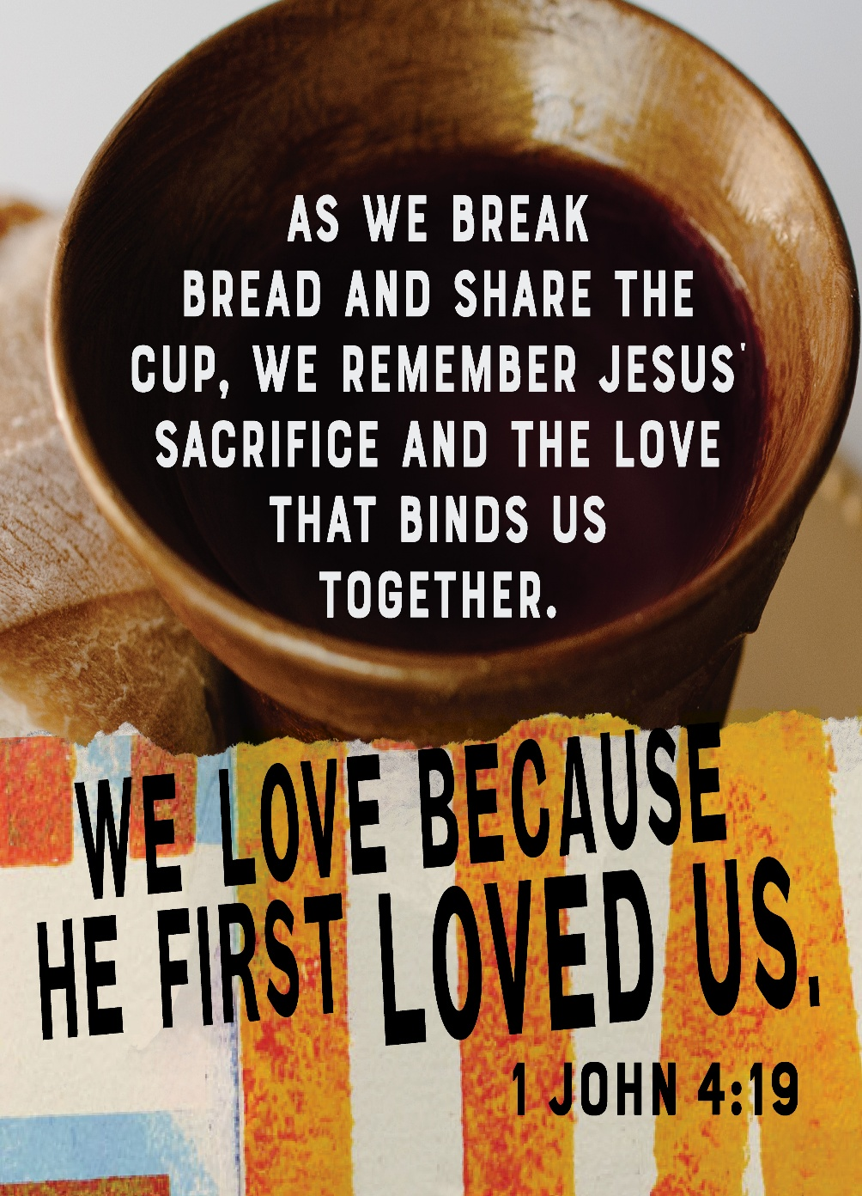
Mt. Zion Evangelical Lutheran Church

320 Mt. Zion Dr., Ripon, WI
www.mtzionripon.org
Facebook: Mt. Zion Evangelical Lutheran Church

Pastor Mark Kock (Vacancy Pastor)
Phone 414-755-9021
mkock315@gmail.com

Pentecost 12 Aug. 16, 2026
Handicapped accessible restrooms are located upstairs next to the Pastor’s Study and downstairs next to the elevator.
Attendance: Please remember to sign the friendship pads. Registration for communion will continue as usual at the table. If you have any questions or concerns, please contact Mike Meeker.


Hearing Loop: Our sanctuary is equipped with a hearing loop system. Those who have compatible hearing aids (with a T-switch) will be able to hear the sound system directly into their ear(s). The two main seating areas and the choir area are looped so that you may sit in any of the three areas. We also have four receivers available for those who do not have compatible hearing aids. If you wish to use a receiver please ask the ushers. Those who wish may bring their own headphones or ear buds.

A note for our visitors on member communion –
Out of sincere love for the truth of God’s Word and for precious human souls, we practice member communion in our synod and congregation. This teaching, as practiced by the Church for centuries, is thoroughly Scriptural. It questions the faith of no individual yet asks that there be full doctrinal agreement between those who commune. For this reason, we ask that only those who are members of a WELS or ELS congregation join us for the Lord’s Supper. If you wish to commune with us please speak with the pastor before the service. The Lord’s Supper will be celebrated for those who desire it. The front row on the pulpit side is reserved for people who are unable to navigate the steps. Pastor will serve you Communion first.
Prayer Before Communion: Lord Jesus, I thank you for the gift of your Holy Supper. As I come to your table, work true repentance in my heart. Teach me to confess my sins and to believe that I am forgiven for your sake. May your body and blood, in and with the bread and wine, nourish my faith and strengthen my will to live in a way that is pleasing to you. Help me see what a blessing your sacrament is for my soul, and lead me to your altar often to receive your forgiveness. Amen.

Hymns: 842, 849, (661), 869

Order of Worship Setting One pg. 154

Psalm: 67B (Insert) God of Mercy, God of Grace

Reading: Isaiah 56:1,6-8 (EHV)
This is what the Lord says.
Protect justice, and carry out righteousness,
because my salvation is coming very soon.
My righteousness is ready to be revealed.
⁶Then the foreigners who join themselves to the Lord,
to minister to him and to love the name of the Lord
and to become his servants,
every one of them who keeps the Sabbath and does not profane it,
those who take hold of my covenant—
⁷I will bring them to my holy mountain,
and I will make them glad in my house of prayer.
Their whole burnt offerings and their sacrifices will be
acceptable on my altar.
For my house will be called a house of prayer for all the peoples of the world.
⁸This is the declaration of God the Lord,
who gathers Israel’s dispersed people:
“I will gather still more people to my house besides
the ones already gathered.”

Reading: Ephesians 2:13-22 (EHV)
But now in Christ Jesus, you who once were far away have been brought near by the blood of Christ. ¹⁴For he himself is our peace. He made the two groups one by destroying the wall of hostility that divided them ¹⁵when he abolished the law of commandments and regulations in his flesh. He did this to create in himself one new person out of the two, in this way making peace. ¹⁶And he did this to reconcile both to God in one body through the cross by putting the hostility to death on it. ¹⁷He also came and preached peace to you who were far away and peace to those who were near. ¹⁸For through him we both have access to the Father by one Spirit.
¹⁹So then, you are no longer foreigners and strangers, but you are fellow citizens with the saints and members of God’s household. ²⁰You have been built on the foundation of the apostles and prophets, with Christ Jesus himself as the Cornerstone. ²¹In him the whole building is joined together and grows into a holy temple in the Lord. ²²In him you too are being built together into a dwelling place for God by the Spirit.

Gospel Acclamation Ephesians 2:13
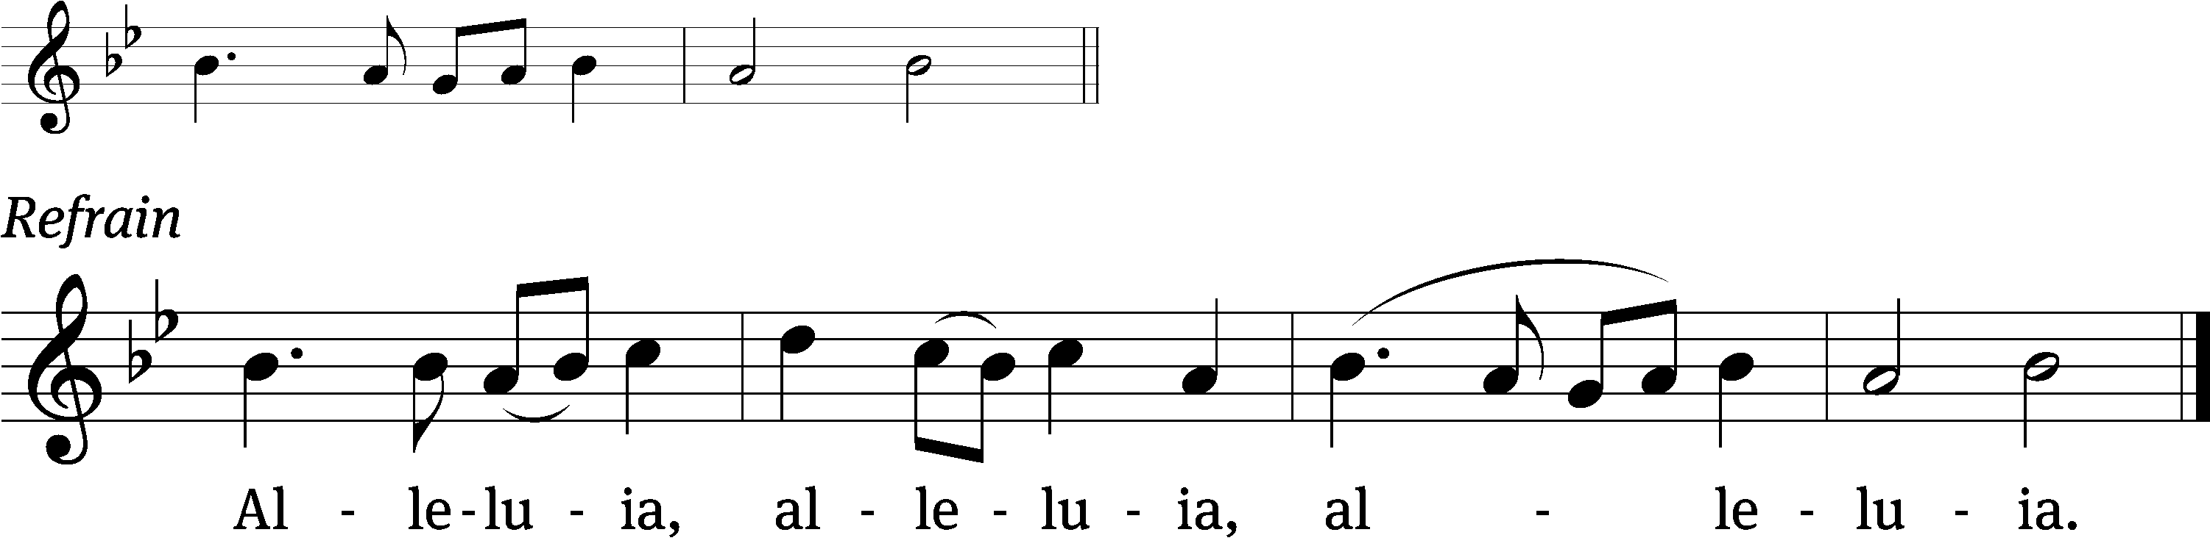
But now in Christ Jesus you who once were / far away
have been brought near by the / blood of Christ. Refrain

Gospel: Matthew 15:21-28 (EHV)
Jesus left that place and withdrew into the region of Tyre and Sidon. ²²There a Canaanite woman from that territory came and kept crying out, “Have mercy on me, Lord, Son of David! A demon is severely tormenting my daughter!” ²³But he did not answer her a word. His disciples came and pleaded, “Send her away, because she keeps crying out after us.”
²⁴He answered, “I was sent only to the lost sheep of the house of Israel.” ²⁵But she came and knelt in front of him, saying, “Lord, help me.”
²⁶He answered her, “It is not good to take the children’s bread and throw it to their little dogs.” ²⁷“Yes, Lord,” she said, “yet their little dogs also eat the crumbs that fall from their masters’ table.” ²⁸Then Jesus answered her, “Woman, your faith is great! It will be done for you, just as you desire.” And her daughter was healed at that very hour.

Sermon Text: Judges 7: 1-8 (EHV)
Then Jerubbaal (that is, Gideon) and all the people who were with him set out and camped by the Spring of Harod. The Midianite camp was north of him, in the valley below the Hill of Moreh.
² The Lord said to Gideon, “There are too many people with you for me to give Midian into your hands. If I did that, Israel would glorify itself at my expense and say, ‘My own hand has delivered me.’ ³ So then, make an announcement for the people to hear: ‘Whoever is trembling with fear can return home and fly away from Mount Gilead.’’’ Twenty-two thousand people turned and left. Only ten thousand remained.
⁴ The Lord said to Gideon, “There are still too many people. Lead them down to the water, and there I will refine them further for you. If I tell you, ‘This one will go with you,’ he may go with you, but if I say to you, ‘This one will not go with you,’ he must not go.” ⁵ So Gideon led the people down to the water, and the Lord said to Gideon, “Place everyone who laps water with his tongue, as a dog would lap, to one side. Place everyone who kneels down to drink on the other side.” ⁶ The number of those who lapped—those who put their hands to their mouths—was three hundred men, while all the rest of the people knelt down to drink water. ⁷ The Lord said to Gideon, “With the three hundred men who lapped, I will deliver you, and I will give Midian into your hand. As for all the other people, let each man go back to his place.” ⁸ The men who had been chosen took provisions in hand, along with their ram’s horns, but Gideon sent every other Israelite man back to his own tent. He kept only the three hundred men. The camp of Midian lay below him in the valley.

Sermon Theme: “The 300”

OFFERING: The offerings are brought forward to the altar.

Keep in Your Prayers: Harley Dorsey, Allan Brooks, Matt Dubey, Eric Eckert, Myrtle Giese, Carol Henning, Nancy Kemnitz, Dennis Schliepp, Joan Stibb, Kathy Strook, Ginny Verch, Gary Wichman.

Announcements
TODAY!! Sundaes on Sunday Ice cream and all the toppings will be served after church in the fellowship hall. Please Join Us! Free Will Offering for LWMS.

Thank you to Adam Covach and family for donating new children’s play equipment and a new stand with drawers containing books and stuffed animals in our quiet room. Check it out!
Pastor Meier’s Bible Study: Pastor Meier is having a Bible Study on the 100 words from the Bible we should know. It is only a few minutes weekly Bible Study that will last a few Weeks. We are meeting in the fellowship hall.
Attention Singers!
Adult Choir will be starting again! Do you like singing just for fun? Well, there is no more fun than singing for the Lord! Singers of all abilities are welcome to join the Adult Choir. We are in need of more members to fill out each section, especially tenor and bass! Praising God while having fun is our motto. We will have our first rehearsal Wed. Sept. 2 at 6:15 pm. Call Kathy Schaub at 920-369-6915 if you have questions, or just be there for the first practice. You don’t have to be the world’s best singer. Everyone is welcome!!!

We are offering the Lord's Supper weekly until further notice. The purpose for this is that those souls who long for Jesus' comfort and forgiveness may have it for their very own, and may find strength, joy, and peace where Jesus wants us to: in receiving His body and blood. It's good to remember that celebrating or offering the Lord's Supper is different than receiving it. No one is forced to take the Lord's Supper - this goes against the very nature of what the Sacrament is. However, if it is not offered, no one can have it. Limiting a fellow Christian's freedom in this way, by making the choice for another Christian, is neither loving nor scriptural. By offering the Lord's Supper more often, each individual Christian who is able to receive it can decide for themselves if they want to come to the Lord's Table. In an uncertain time for Mount Zion, where attendance is a primary concern, I think we can all agree we need Jesus more than ever. If anyone has any questions, please don't hesitate to reach out and contact me directly.

NEW STORE UPDATES
Second Impressions, the local thrift store that supports WLA, is moving across town this fall. Our faithful Volunteers, along with some local contractors, are finishing up a lot of the remodeling and updates at the new location. Lighting, painting and flooring should be complete by the end of August. Then the real fun starts! We will continue to accept donations at our current location (325 Winnebago Drive, FdL) from now until August 31. Starting SEPTEMBER 1, please drop off your donations at the new location, N6650 N. Rolling Meadows Drive, FdL. (It is right next door to Aldi, the former Ally's Furniture store.) Donations can be dropped off by entering the SOUTH entrance and driving around to the back. Signage should be in place by SEPTEMBER 1. Our Facebook page is very active. If you would like to see photos and updates of the new store, daily sales, fresh inventory...and more, please follow our page. We will also announce many of our clearance sales here as we get closer to moving. Blessings on your week ahead...and See you Soon at Second Impressions!

Sunday School: School will be starting on September 20th, the Sunday after Mt. Zion Fest. We now have all our teachers lined up. Thank you to our volunteers: Caitlin Goeldi, Kari Hielke, Sue Wichman, Dawn Toman and Jo Meeker.

Birthdays: Next celebration TBD.

Mailbox and table: The August Forward In Christ is available and also the Aug. 30-Nov. 28, 2026 Meditations are available. August calendars are also available.
For Your Information
Attendance 8/9/2026 80
Offerings for 8/9/2026 $9,047.60
Year to Date (thru July 31st).
Income : $93,393.97
Expenses : $97,580.71
Shortfall YTD -$4,186.74
Our planned budget for this time frame was $115,974.84.
Serving Our Lord

Thank you to everyone for your service to our Lord!

Ushers:

Aug. 16: TJ Sitter, Adam Covach, Lyle Strook

Aug. 23 & 30: Mike Schaub, Kevin Schenning, Eric Eckert

PowerPoint:

Aug. 16: Jo Meeker

Aug. 23: Jo Meeker

Aug. Communion Set up: Kathy Schaub

Aug. Communion Clean up: Jan Ohlrich, Deb Picciotino

Sunday 16th 9:00 AM Worship Service with Communion
10:15 AM Bible Study Fellowship Hall
Sunday 9:00 AM Worship Service with Communion
10:15 AM Bible Study Fellowship Hall

UPCOMING EVENTS:
Saturday Aug. 29th: Bratfry at Hy-Vee 9-1
Check the August Calendar for more information

Zionfest Sunday Sept. 13 Following the service. The annual church picnic will be held, Games for children and adults. A bag tournament will be held. Please sign up by the library.

