ELEVENTH SUNDAY AFTER PENTECOST

Mt. Zion Evangelical Lutheran Church

320 Mt. Zion Dr., Ripon, WI
www.mtzionripon.org
Facebook: Mt. Zion Evangelical Lutheran Church

Pastor Kurt Hagen (Vacancy Pastor)
Phone 651-764-3901
pastorhagen@gmail.com

Pentecost 11 Aug. 9, 2026
Handicapped accessible restrooms are located upstairs next to the Pastor’s Study and downstairs next to the elevator.
Attendance: Please remember to sign the friendship pads. Registration for communion will continue as usual at the table. If you have any questions or concerns, please contact Mike Meeker.


Hearing Loop: Our sanctuary is equipped with a hearing loop system. Those who have compatible hearing aids (with a T-switch) will be able to hear the sound system directly into their ear(s). The two main seating areas and the choir area are looped so that you may sit in any of the three areas. We also have four receivers available for those who do not have compatible hearing aids. If you wish to use a receiver please ask the ushers. Those who wish may bring their own headphones or ear buds.

A note for our visitors on member communion –
Out of sincere love for the truth of God’s Word and for precious human souls, we practice member communion in our synod and congregation. This teaching, as practiced by the Church for centuries, is thoroughly Scriptural. It questions the faith of no individual yet asks that there be full doctrinal agreement between those who commune. For this reason, we ask that only those who are members of a WELS or ELS congregation join us for the Lord’s Supper. If you wish to commune with us please speak with the pastor before the service. The Lord’s Supper will be celebrated for those who desire it. The front row on the pulpit side is reserved for people who are unable to navigate the steps. Pastor will serve you Communion first.

Prayer Before Communion: Lord Jesus, I thank you for the gift of your Holy Supper. As I come to your table, work true repentance in my heart. Teach me to confess my sins and to believe that I am forgiven for your sake. May your body and blood, in and with the bread and wine, nourish my faith and strengthen my will to live in a way that is pleasing to you. Help me see what a blessing your sacrament is for my soul, and lead me to your altar often to receive your forgiveness. Amen.

Hymns: 847, 804, (667), 783 vs1,2,6,7

Order of Worship Setting One pg. 154

Psalm: 73A God Is the Strength of My Heart

Reading: I Kings 19:9-18 (EHV)
He came to a cave and spent the night there.
Then the word of the Lord suddenly came to him, saying, “Why are you here, Elijah?”
¹⁰He said, “I have been very zealous for the Lord, the God of Armies, but the people of Israel have abandoned your covenant. They have torn down your altars and killed your prophets with the sword. I alone am left, and they are seeking to take my life.”
¹¹Then the Lord said, “Go out and stand on the mountain in the presence of the Lord, for the Lord is passing by.” Then a great and powerful wind tore the mountains and shattered rocks before the Lord, but the Lord was not in the wind.
After the wind came an earthquake, but the Lord was not in the earthquake.
¹²After the earthquake there was a fire, but the Lord was not in the fire. After the fire there was a soft, whispering voice.
¹³When Elijah heard it, he wrapped his face in his cloak, and he went out and stood at the entrance to the cave. Then a voice came to him and said, “Why are you here, Elijah?”
¹⁴He said, “I have been very zealous for the Lord, the God of Armies, but the people of Israel have abandoned your covenant. They have torn down your altars and killed your prophets with the sword. I alone am left, and they are seeking to take my life.”
¹⁵Then the Lord said to him, “Go back the way you came and go to the Wilderness of Damascus. When you get there, you are to anoint Hazael as king over Aram. ¹⁶You will also anoint Jehu son of Nimshi as king over Israel and Elisha son of Shaphat from Abel Meholah as prophet in your place. ¹⁷Whoever escapes the sword of Hazael, Jehu will kill, and whoever escapes the sword of Jehu, Elisha will kill. ¹⁸But I have preserved in Israel seven thousand whose knees have not bent to Baal and whose lips have not kissed him.”

Reading: Romans 8:28-39 (EHV)
We know that all things work together for the good of those who love God, for those who are called according to his purpose, ²⁹because those God foreknew, he also predestined to be conformed to the image of his Son, so that he would be the firstborn among many brothers. ³⁰And those he predestined, he also called. Those he called, he also justified. And those he justified, he also glorified.
³¹What then will we say about these things? If God is for us, who can be against us? ³²Indeed, he who did not spare his own Son, but gave him up for us all—how will he not also graciously give us all things along with him?
³³Who will bring an accusation against God’s elect? God is the one who justifies! ³⁴Who is the one who condemns? Christ Jesus, who died and, more than that, was raised to life, is the one who is at God’s right hand and who is also interceding for us! ³⁵What will separate us from the love of Christ? Will trouble or distress or persecution or famine or nakedness or danger or sword? ³⁶Just as it is written:
For your sake we are being put to death all day long.
We are considered as sheep to be slaughtered.
³⁷No, in all these things we are more than conquerors through him who loved us.
³⁸For I am convinced that neither death nor life, neither angels nor rulers, neither things present nor things to come, nor powerful forces, ³⁹neither height nor depth, nor anything else in creation, will be able to separate us from the love of God in Christ Jesus our Lord.

Gospel Acclamation
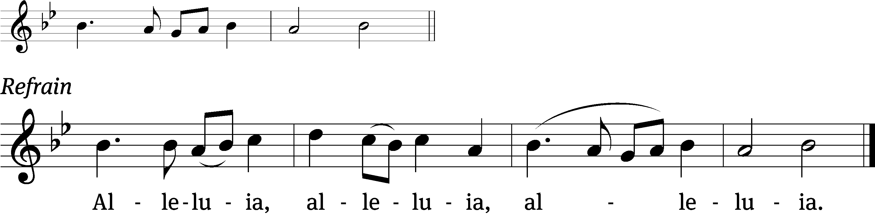
Now faith is confidence in what we / hope for
and assurance about what we / do not see.. Refrain

Gospel & Sermon Text: Matthew 14:22-33 (EHV)
Immediately Jesus urged the disciples to get into the boat and to go ahead of him to the other side, while he dismissed the crowd. ²³After he had dismissed the crowd, he went up onto the mountain by himself to pray. When evening came, he was there alone. ²⁴By then the boat was quite a distance from shore, being pounded by the waves because the wind was against it. ²⁵In the fourth watch of the night, Jesus came toward them, walking on the sea. ²⁶When the disciples saw him walking on the sea, they were terrified and cried out in fear, “It’s a ghost!” ²⁷But Jesus spoke to them at once, saying, “Take heart! It is I! Do not be afraid.”
²⁸Peter answered him and said, “Lord, if it is you, command me to come to you on the water.”
²⁹Jesus said, “Come!”
Peter stepped down from the boat, walked on the water, and went toward Jesus. ³⁰But when he saw the strong wind, he was afraid. As he began to sink, he cried out, “Lord, save me!”
³¹Immediately Jesus stretched out his hand, took hold of him, and said to him, “You of little faith, why did you doubt?” ³²When they got into the boat, the wind stopped. ³³Those who were in the boat worshipped him, saying, “Truly you are the Son of God!”

Sermon Theme: “Fraidycat!”

OFFERING: The offerings are brought forward to the altar.

Keep in Your Prayers: Harley Dorsey, Allan Brooks, Matt Dubey, Eric Eckert, Myrtle Giese, Carol Henning, Nancy Kemnitz, Dennis Schliepp, Joan Stibb, Kathy Strook, Ginny Verch, Gary Wichman.

Announcements
We are offering the Lord's Supper weekly, beginning today. The purpose for this is that those souls who long for Jesus' comfort and forgiveness may have it for their very own, and may find strength, joy, and peace where Jesus wants us to: in receiving His body and blood. It's good to remember that celebrating or offering the Lord's Supper is different than receiving it. No one is forced to take the Lord's Supper - this goes against the very nature of what the Sacrament is. However, if it is not offered, no one can have it. Limiting a fellow Christian's freedom in this way, by making the choice for another Christian, is neither loving nor scriptural. By offering the Lord's Supper more often, each individual Christian who is able to receive it can decide for themselves if they want to come to the Lord's Table. In an uncertain time for Mount Zion, where attendance is a primary concern, I think we can all agree we need Jesus more than ever. If anyone has any questions, please don't hesitate to reach out and contact me directly. Your servant in Christ, Pastor Hagen (651-764-3901)

Pastor Meier’s Bible Study: Pastor Meier is having a Bible Study on the 100 words from the Bible we should know. It is only a few minutes weekly Bible Study that will last a few Weeks. We are meeting in the fellowship hall.

Birthdays: Celebration will be TODAY in the fellowship hall. Please join us for cake, refreshments and fellowship.

NEW STORE UPDATES
Second Impressions, the local thrift store that supports WLA, is moving across town this fall. Our faithful Volunteers, along with some local contractors, are finishing up a lot of the remodeling and updates at the new location. Lighting, painting and flooring should be complete by the end of August. Then the real fun starts!
We will continue to accept donations at our current location (325 Winnebago Drive, FdL) from now until August 31. Starting SEPTEMBER 1, please drop off your donations at the new location, N6650 N. Rolling Meadows Drive, FdL. (It is right next door to Aldi, the former Ally's Furniture store.) Donations can be dropped off by entering the SOUTH entrance and driving around to the back. Signage should be in place by SEPTEMBER 1.
Our Facebook page is very active. If you would like to see photos and updates of the new store, daily sales, fresh inventory...and more, please follow our page. We will also announce many of our clearance sales here as we get closer to moving. Blessings on your week ahead...and See you Soon at Second Impressions!

Sunday School: School will be starting on September 20th, the Sunday after Mt. Zion Fest. We now have all our teachers lined up. Thank you to our volunteers: Kari Hielke, Sue Wichman, Dawn Toman and Jo Meeker.

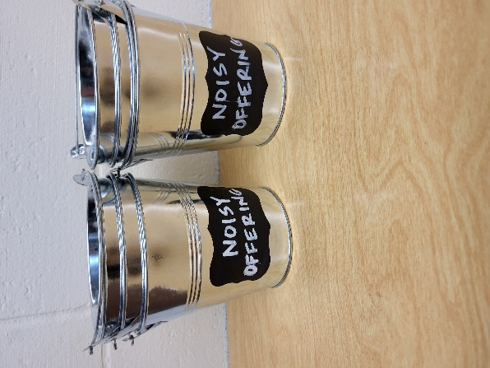
Noisy Offering: Please keep saving your spare change for our noisy offering on August 9th. Your offering will be given to Peace Lutheran School. The purpose of Peace Lutheran School is to provide Christ-centered education for our children. The school is a full-time educational institution, affording to every student a program which feeds the soul, the mind, and the body. We believe that an education without Christ is an education without foundation and purpose We have appreciated your support for our various projects and activities.

Mailbox and table: The August Forward In Christ is available and also the Aug. 30-Nov. 28, 2026 Meditations are available. August calendars are also available.
For Your Information
Attendance 8/2/2026 81
Offerings for 8/2/2026 $5,977.80
Year to Date (thru July 31st).
Income : $93,393.97
Expenses : $97,580.71
Shortfall YTD -$4,186.74
Our planned budget for this time frame was $115,974.84.

Serving Our Lord

Thank you to everyone for your service to our Lord!

Ushers:

Aug. 9 & 16: TJ Sitter, Adam Covach, Lyle Strook

Aug. 23 & 30: Mike Schaub, Kevin Schenning, Eric Eckert

PowerPoint:

Aug. 9: Jo Meeker

Aug. 16: Jo Meeker

Aug. 23: Jo Meeker

Aug. Communion Set up: Kathy Schaub

Aug. Communion Clean up: Jan Ohlrich, Deb Picciotino

Sunday 9th 9:00 AM Worship Service with Communion
Noisy Offering
10:15 AM Bible Study Fellowship Hall
Tuesday 5:30 PM Council Meeting
6:30 PM Ladies Aid
Sunday 9:00 AM Worship Service with Communion
10:15 AM Bible Study Fellowship Hall

UPCOMING EVENTS:
Sunday Aug. 16 Sundaes on Sunday Ice cream and all the toppings will be served after church. Free Will Offering for LWMS
Saturday Aug. 29th: Bratfry at Hy-Vee 9-1
Check the August Calendar for more information

Zionfest Sunday Sept. 13 Following the service. The annual church picnic will be held, Games for children and adults. A bag tournament will be held. Please sign up by the library.

