TENTH SUNDAY AFTER PENTECOST
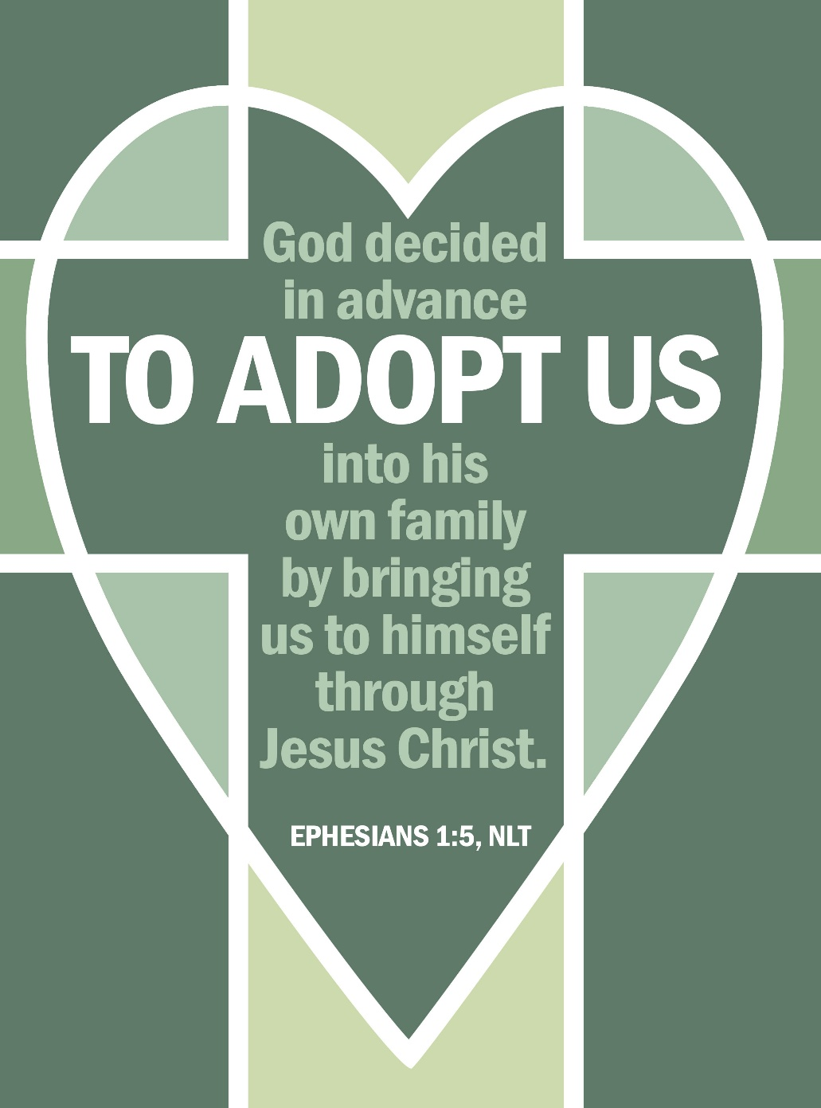
Mt. Zion Evangelical Lutheran Church

320 Mt. Zion Dr., Ripon, WI
www.mtzionripon.org
Facebook: Mt. Zion Evangelical Lutheran Church

Pastor Kurt Hagen (Vacancy Pastor)
Phone 651-764-3901
pastorhagen@gmail.com

Pentecost 10 Aug. 2, 2026
Handicapped accessible restrooms are located upstairs next to the Pastor’s Study and downstairs next to the elevator.
Attendance: Please remember to sign the friendship pads. Registration for communion will continue as usual at the table. If you have any questions or concerns, please contact Mike Meeker.


Hearing Loop: Our sanctuary is equipped with a hearing loop system. Those who have compatible hearing aids (with a T-switch) will be able to hear the sound system directly into their ear(s). The two main seating areas and the choir area are looped so that you may sit in any of the three areas. We also have four receivers available for those who do not have compatible hearing aids. If you wish to use a receiver please ask the ushers. Those who wish may bring their own headphones or ear buds.

Thank you to our guest minister today Pastor R. Dietsche.

Hymns: 614, 624, 738, 617

Order of Worship Setting One pg. 154

Psalm: 136C (Insert) We Thank You, LORD, for You Are Good

Reading: I Kings 17:1-6 (EHV)
17 Elijah from Tishbe, one of the settlers in Gilead, said to Ahab, “As surely as the Lord lives, the God of Israel before whom I stand, there will be no dew or rain during the coming years, except at my word.” ² Then the word of the Lord came to him: ³ “Leave this place and turn east. Hide yourself by the Kerith Ravine, east of the Jordan. ⁴ You will drink from the stream, and I will command the ravens to provide for you there.” ⁵ So Elijah went and did just as the Lord had said. He lived in the Kerith Ravine, east of the Jordan. ⁶ The ravens brought him bread and meat in the morning and in the evening, and he drank from the stream.

Reading & Sermon Text: Ephesians 1: 3-10 (EHV)
³ Blessed be the God and Father of our Lord Jesus Christ, who has blessed us in Christ with every spiritual blessing in the heavenly places. ⁴ He did this when he chose us in Christ before the foundation of the world, so that we would be holy and blameless in his sight. In love ⁵ he predestined us to be adopted as his sons through Jesus Christ. He did this in accordance with the good purpose of his will, ⁶ and for the praise of his glorious grace, which he has graciously given us in the one he loves.⁷ In him we also have redemption through his blood, the forgiveness of sins, in keeping with the riches of his grace, ⁸ which he lavished on us in all wisdom and insight. ⁹ He made known to us the mystery of his will in keeping with his good purpose, which he planned in Christ. ¹⁰ This was to be carried out when the time had fully come, in order to bring all things together in Christ, things in heaven and things on earth.

Gospel Acclamation
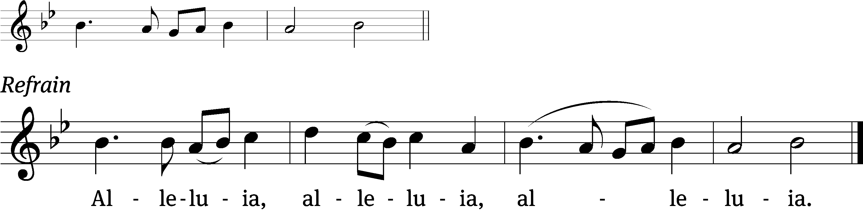
He who did not spare his own Son, but gave him up / for us all
how will he not also, along with him, graciously give us / all things. Refrain

Gospel Matthew 14:31-21 (EHV)
¹³ When Jesus heard this, he withdrew from there in a boat to a deserted place to be alone. When the crowds heard this, they followed him on foot from the towns. ¹⁴ When Jesus got out of the boat, he saw a large crowd. He had compassion on them and healed their sick. ¹⁵ When evening came, his disciples came to him and said, “This is a deserted place and the hour is already late. Send the crowds away, so that they can go into the villages and buy food for themselves.” ¹⁶ But Jesus said to them, “They do not need to go away. You give them something to eat.”
¹⁷ They told him, “We have here only five loaves and two fish.”
¹⁸ “Bring them here to me,” he replied. ¹⁹ Then he instructed the people to sit down on the grass. He took the five loaves and the two fish. After looking up to heaven, he blessed them. He broke the loaves and gave them to the disciples. The disciples gave the food to the people. ²⁰ They all ate and were filled. They picked up twelve basketfuls of what was left over from the broken pieces. ²¹ Those who ate were about five thousand men, not even counting women and children.

Sermon Theme: “Praise God for Revealing the Mystery of His Grace.”

OFFERING: The offerings are brought forward to the altar.

Keep in Your Prayers: Harley Dorsey, Allan Brooks, Matt Dubey, Eric Eckert, Myrtle Giese, Carol Henning, Nancy Kemnitz, Dennis Schliepp, Joan Stibb, Kathy Strook, Ginny Verch, Gary Wichman.

Announcements
Per Pastor Hagen we will begin having communion every Sunday starting August 9th . Any questions please contact Pastor Hagen.

Pastor Meier’s Bible Study: Pastor Meier is having a Bible Study on the 100 words from the Bible we should know. It is only a few minutes weekly Bible Study that will last a few Weeks. We are meeting in the fellowship hall.

Birthdays: Our next birthday celebration TBD.

Sunday School: School will be starting on September 20th, the Sunday after Mt. Zion Fest. We now have all our teachers lined up. Thank you to our volunteers: Kari Hielke, Sue Wichman, Dawn Toman and Jo Meeker.

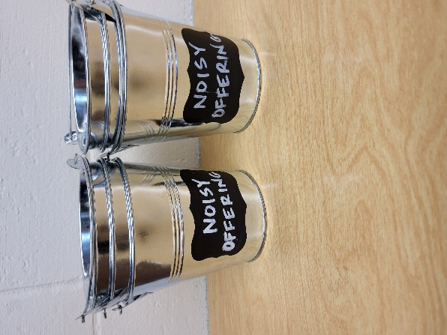
Noisy Offering: Please keep saving your spare change for our noisy offering on August 9th. Your offering will be given to Peace Lutheran School. The purpose of Peace Lutheran School is to provide Christ-centered education for our children. The school is a full-time educational institution, affording to every student a program which feeds the soul, the mind, and the body. We believe that an education without Christ is an education without foundation and purpose We have appreciated your support for our various projects and activities.

Mailbox and table: The August Forward In Christ is available and also the Aug. 30-Nov. 28, 2026 Meditations are available. August calendars are also available.

For Your Information
Attendance 7/26/2026 75
Offerings for 7/26/2026 $3,175.80
Year to Date (thru June 30th).
Income : $95,902.17
Expenses : $87,946.43
Our planned budget for this time frame was $115,974.84.

Serving Our Lord

Thank you to everyone for your service to our Lord!

Ushers:

Aug. 2: Tobin Storzer, Rick Retelle, Kelly Frank

Aug. 9 & 16: TJ Sitter, Adam Covach, Lyle Strook

PowerPoint:

Aug 2: Jo Meeker

Aug. 9: Jan Ohlrich

Aug. 16: Jo Meeker

Aug. Communion Set up: Kathy Schaub

Aug. Communion Clean up: Jan Ohlrich, Deb Picciotino

Sunday 2nd 9:00 AM Worship Service
10:15 AM No Bible Study this week
Monday 6:00 PM Evangelism Committee Meeting
Friday 1:00 PM Movie “God’s Not Dead: We the People”

Saturday 9:30-11 AM Junior Youth Group
Sunday 9:00 AM Worship Service with Communion
Noisy Offering
10:15 AM Bible Study Fellowship Hall

UPCOMING EVENTS:
Sunday Aug. 16 Sundaes on Sunday Ice cream and all the toppings will be served after church. Free Will Offering for LWMS
Saturday Aug. 29th: Bratfry at Hy-Vee 9-1
Zionfest Sunday Sept. 13 Following the service (More Information on the way.)
Check the August Calendar for more information





