Mt. Zion Evangelical Lutheran Church

320 Mt. Zion Dr., Ripon, WI
www.mtzionripon.org
Facebook: Mt. Zion Evangelical Lutheran Church

Pastor Michael Sheppard
Pastor’s Study: 920-748-9734
E-mail: revmikesheppard@gmail.com
March 24, 2024 Welcome to Mt. Zion!
Handicapped accessible restrooms are located upstairs next to the Pastor’s Study and downstairs next to the elevator.
Attendance: Please remember to sign the friendship pads. Registration for communion will continue as usual at the table. If you have any questions or concerns please contact Pastor Sheppard or Mike Meeker.

Hearing Loop: Our sanctuary is equipped with a hearing loop system. Those who have compatible hearing aids (with a T-switch) will be able to hear the sound system directly into their ear(s). The two main seating areas and the choir area are looped so that you may sit in any of the three areas. We also have four receivers available for those who do not have compatible hearing aids. If you wish to use a receiver please ask the ushers. Those who wish may bring their own headphones or ear buds.

Prayer Before Worship: Lord Jesus Christ, each day I face enemies that war against my soul, and on my own I cannot defeat them. The devil attacks me with his lies, the sinful world tempts me with pleasures that lead away from you, and my own sinful nature desires to believe the lies and participate in the sin. Only you can defeat my enemies, and – what grace!- you have. This was the reason for your cross. Only through you do I have victory. Keep my eyes focused on you and your cross this Lenten season, that I might never lose sight of the victory you have won for me. Amen.
Hymns: 413, 411, 524, 414
Order of Worship CW21 pg. 188

First Reading & Sermon Text: Zechariah 9:9-12 (EHV)
Rejoice greatly, Daughter of Zion!
Shout, Daughter of Jerusalem!
Look! Your King is coming to you.
He is righteous and brings salvation.
He is humble and is riding on a donkey,
on a colt, the foal of a donkey.
¹⁰I will cut off the chariot from Ephraim
and the horse from Jerusalem.
The battle bow will be taken away,
and he will proclaim peace to the nations.
His kingdom will extend from sea to sea,
from the River to the ends of the earth.
¹¹As for you,
because of the blood of my covenant with you,
I will release your prisoners from the waterless pit.
¹²Return to the stronghold, you prisoners who have hope.
This very day I declare that I will restore double to you.

Psalm: 24C Insert Lift Up Your Heads
Second Reading: Hebrews 12:1-3 (EHV)
Therefore, since we are surrounded by such a great cloud of witnesses, let us get rid of every burden and the sin that so easily ensnares us, and let us run with patient endurance the race that is laid out for us. ²Let us keep our eyes fixed on Jesus, who is the author of our faith and the one who brings it to its goal. In view of the joy set before him, he endured the cross, disregarding its shame, and has taken his seat at the right hand of God’s throne. ³Carefully consider him who endured such hostility against himself from sinful people, so that you do not grow weary and lose heart.
Gospel Acclamation John 12:23
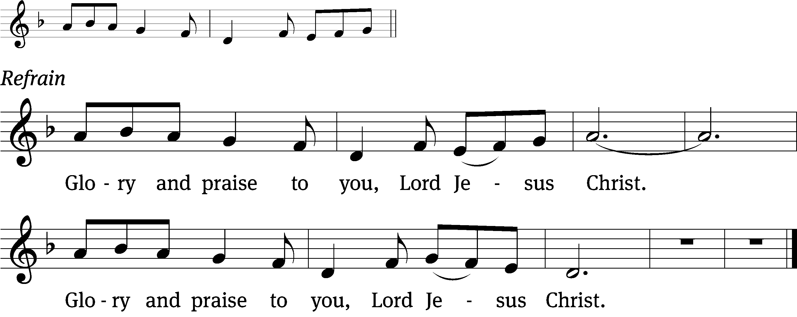
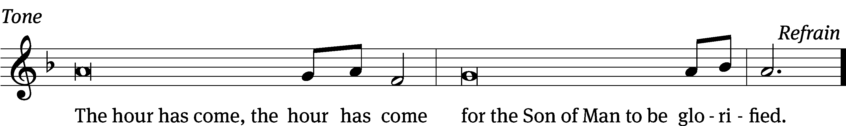
Tune: © 2010, 2021 GFTSMUSIC Publishing Company, Inc., admin. Music Services. Used by permission: OneLicense no. 716381

Gospel: Mark 11:1-10 (EHV)
As they approached Jerusalem, at Bethphage and Bethany, on the Mount of Olives, he sent two of his disciples ²and told them, “Go into the village ahead of you. As soon as you enter it, you will find a colt tied there, on which no one has ever sat. Untie it and bring it here. ³If anyone asks you, ‘Why are you doing this?’ say, ‘The Lord needs it, and he will send it back here without delay.’”
⁴They left and found a colt on the street, tied at a door; and they untied it. ⁵Some who were standing there asked them, “What are you doing, untying that colt?” ⁶The disciples answered them just as Jesus had instructed them, and the men let them go.
⁷They brought the colt to Jesus, threw their garments on it, and Jesus sat on it. ⁸Many people spread their garments on the road. Others spread branches that they had cut from the fields. ⁹Those who went in front and those who followed were crying out,
Hosanna!
Blessed is he who comes in the name of the Lord!
¹⁰Blessed is the coming kingdom of our father David!
Hosanna in the highest!

Sermon Theme: “The King Has Arrived As Foretold.”

OFFERING: The offerings are brought forward to the altar.

Announcements
Voter’s Meeting: A special voter’s meeting is scheduled for April 7th at 10:15 AM.

Women’s Bible Study: A signup sheet is by the library door. We put 2 dates and times that seemed to work best. Please sign up as soon as possible so we can get started.

Easter Lilies: A sign-up sheet has been posted on the flower chart for those who would like to purchase Easter lilies for the services. The price for lilies has gone up to $13.00 ($12.99 each). Checks should be made out to Websters. Please give cash or a check to Marilyn Ninneman. If you have any questions or if you are purchasing as a memorial let her know. Marilyn’s number is 748-6474.

LWMS Update: THANK YOU THANK YOU!!!!!!
With your generous offering Mt Zion Congregation is sending $500.00 to Children’s Ministry Outreach and New World Mission Fields. In addition,
$350.00 will be sent to Native Christian Ministries, Our Savior’s Lutheran School, Peridot, AZ.
Come to the spring rally.
DATE: Saturday, April 27, 2024
Time 9:30 registration
RALLY SITE: Zion Lutheran Church, KINGSTON
326 Vine Street Kingston WI
Featured speaker at the Beaver Dam Spring Rally will be Pastor Daniel Sims, Director of WELS Christian Aid and Relief. His talk will be about God sending us to serve in a volatile world to people in need of compassionate care and spiritual nurturing. Learn how you can support this mission.

SUNDAY SCHOOL KIDS: Just a quick reminder that your Kids C.A.R.E. mission boxes supporting Missionary Kids Retreat project sponsored by LWMS are due by April 28th . Thanks for donations to Kids C.A.R.E.

Birthday Celebration: The next birthday celebration will be April 7.

Hymn Sing: The next hymn sing is TBD.

Greeters: We have started the greeter program again. Thank you to all who have greeted so far. If you would like to be greeters for this year, please sign up on the sheet on the podium by the library.

Student Needs Closet THANK YOU: Mt. Zion has done an amazing job of donating supplies to the Ripon Area School District Student Needs Closet. When you support the needs of students, you are serving the Lord in our community. Your donations are greatly appreciated. Please continue to check the supply list outside the church office by the tiger boxes. As new needs arise, the list will be updated.

Mailbox and table: The April Forward In Christ is available and also the March 3, 2024 – June 4 Meditations are available.
If you would like the Lord’s Supper privately, please contact Pastor Sheppard on his cell 920-745-0883, or by email revmikesheppard@gmail.com.
The Helping Hands Ministry is ready to serve the needs of our members. Please contact one of the following if you or someone you know needs assistance: Joanne Gregor at 920-896-1518, Lisa Tremore at 920-229-1297 or Tammy Niemuth at 920-299-0240.
For Your Information
Attendance 3/13-3/17/2024 147
Offerings for 3/13-3/17/24 $5,770.00

Serving Our Lord

Thank you to everyone for your service to our Lord!

Ushers:

March 20, 24, 28: Tobin Storzer, Rick Retelle, Kelly Frank, Terry Dolderer

PowerPoint:

March 20: Jo Meeker

March 24: Sara Retelle

March 28: Grunert Family

March 31: Jo Meeker SONrise Service

March 31: Grunert Family Easter Festival Service

March Communion Set up: Rhonda Schwandt

March Communion Clean up: Marilyn Ninneman

Secretary Jo Meeker
Church Office: 920-748-5641
Office Hours: Mon. 9-12, Tues. & Wed. 9-11
E-mail: mountzionripon@gmail.com
Sunday (24th) 9:00 AM Palm Sunday Worship Service
10:15 AM Bible Study and Sunday School
Monday 6:30 PM Bible Study
Tuesday 9:00 AM Bible Study
Wednesday 6:15 PM CHOIR PRACTICE FOR EASTER
Thursday 6:30 PM Holy Thursday Worship with Communion
Friday 1:00 PM Good Friday Worship with Communion
6:30 PM Tenebrae Service
Sunday 7:00 AM Easter Sunday SONrise Service (No Communion)
8:00 AM Easter Breakfast
9:00 AM Easter Festival Service with Communion
NO Sunday School or Bible Study

