Palm Sunday,
the Sixth Sunday in Lent
28 March + 2026 + A.D.

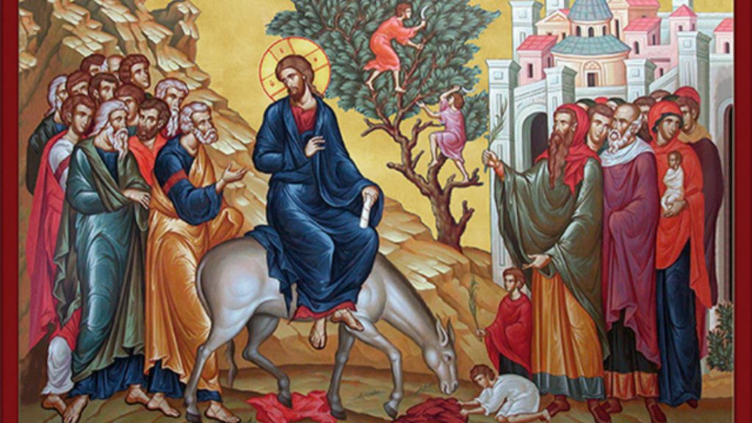
Mount Zion Evangelical Lutheran Church, Ripon, WI
+
Rev. Kurt Hagen, vacancy pastor 651-764-3901
Palm Sunday (the Sixth Sunday in Lent)
28 March, 2026 A+D

Welcome to our visitors! We are so glad you have joined us for worship. Please do us the honor of signing our guestbook, providing your full address. We ask that you speak with Pastor before the service if you would like to take Holy Communion. Let us know if we can be of any spiritual service to you in the future.

Preparation for Holy Communion (CW, page 295)
The practice of examining yourself before communing is a Scriptural directive. Dr. Martin Luther’s Christian Questions on p. 295 in the front of the hymnal will help you prepare yourself to come to the Lord’s Table.

Ringing of the bells

Procession with palms, as CW 412 All Glory, Laud, and Honor (vv.1-3) is sung

STAND
M: The grace of our Lord  Jesus Christ and the love of God and the fellowship of the Holy Spirit be with you.
C: And also with you.
M: Dear friends in Christ, for five weeks of Lent we have been preparing for the celebration of our Lord’s paschal mystery. Today we come together to begin the solemn celebration of Holy Week. Christ entered in triumph into His own city to complete His work as our Messiah: to suffer, to die, and to rise again. Let us remember with devotion His entry that culminated at the empty tomb and follow Him with a lively faith. United with Him by Baptism, we share in His resurrection and new life.
M: Blessed is He who comes in the name of the Lord!
C: Hosanna in the highest!

PRAYER OF THE DAY
M: Let us pray.
Almighty and everlasting God, You sent Your Son, our Savior Jesus Christ, to take upon Himself our flesh and to suffer death upon the cross. Mercifully grant that we may follow the example of His great humility and patience and be made partakers of His resurrection; through the same Jesus Christ, our Lord, who lives and reigns with You and the Holy Spirit, one God, now and forever.
C: Amen.

HYMN -- CW 412 All Glory, Laud, and Honor (vv.4-5)

First Lesson: Zechariah 9:9-12
Rejoice greatly, Daughter of Zion!
Shout, Daughter of Jerusalem!
Look! Your King is coming to you.
He is righteous and brings salvation.
He is humble and is riding on a donkey,
on a colt, the foal of a donkey.
¹⁰I will cut off the chariot from Ephraim
and the horse from Jerusalem.
The battle bow will be taken away,
and he will proclaim peace to the nations.
His kingdom will extend from sea to sea,
from the River to the ends of the earth.
¹¹As for you, because of the blood of my covenant with you,
I will release your prisoners from the waterless pit.
¹²Return to the stronghold, you prisoners who have hope.
This very day I declare that I will restore double to you.

The Word of the Lord.
Thanks be to God.

Psalm of the Day: Psalm 118 (p.118)

Second Lesson: Philippians 2:5-11
⁵Indeed, let this attitude be in you, which was also in Christ Jesus. ⁶Though he was by nature God, he did not consider equality with God as a prize to be displayed, ⁷but he emptied himself by taking the nature of a servant. When he was born in human likeness, and his appearance was like that of any other man, ⁸he humbled himself and became obedient to the point of death—even death on a cross. ⁹Therefore God also highly exalted him and gave him the name that is above every name, ¹⁰so that at the name of Jesus every knee will bow, in heaven and on earth and under the earth, ¹¹and every tongue will confess that Jesus Christ is Lord, to the glory of God the Father.

The Word of the Lord.
Thanks be to God.

Hymn – 413 Hosanna, Loud Hosanna
Gospel: St. Matthew 21:1-9
As they approached Jerusalem and came to Bethphage on the Mount of Olives, Jesus sent two disciples, ² saying to them, “Go to the village ahead of you, and at once you will find a donkey tied there, with her colt by her. Untie them and bring them to me. ³ If anyone says anything to you, say that the Lord needs them, and he will send them right away.”
⁴ This took place to fulfill what was spoken through the prophet:
⁵ “Say to Daughter Zion,
‘See, your king comes to you,
gentle and riding on a donkey,
and on a colt, the foal of a donkey.’”
⁶ The disciples went and did as Jesus had instructed them. ⁷ They brought the donkey and the colt and placed their cloaks on them for Jesus to sit on. ⁸ A very large crowd spread their cloaks on the road, while others cut branches from the trees and spread them on the road. ⁹ The crowds that went ahead of him and those that followed shouted,
“Hosanna to the Son of David!”
“Blessed is he who comes in the name of the Lord!”
“Hosanna in the highest heaven!”

The gospel of the Lord.
Praise be to you, O Christ!

Hymn of the Day:
# 411 Ride On, Ride On in Majesty

Sermon – Zechariah 9:9-12 Victory Forever

The Nicene Creed (p.162)

Prayer of the Church
O Father, most merciful, in the beginning you created us, and by the passion of your only Son you created us anew.
Work in us now, both to will and to do what pleases you.
Since we are weak and can do no good thing by ourselves, grant us your grace and heavenly blessing, that in whatever work we engage we may do all to your honor and glory.
Keep us from sin and empower us daily to do good works. As long as we live in the body may we always perform service to you.

Special prayer requests may be offered, concluding with –
Since you have given us pardon of all our sins, after our departure receive us to eternal life; through him who lives and reigns with you and the Holy Spirit, now and for ever.
Amen.

Thank Offering

Service of the Sacrament: CW p. 165

Distribution hymn – CW 396 Christ, the Life of All the Living

Closing Hymn – CW 414 No Tramp of Soldiers’ Marching Feet

+ + +
Announcements
Catechism Class: Catechism instruction will be Saturdays from 3:30-4:30 PM here at Mt. Zion. The Cong. is invited to attend.

Easter Lilies: A sign-up sheet has been posted on the flower chart for those who would like to purchase Easter lilies for the services. The price this year is $13.00. If you have any questions or if you are purchasing as a memorial let her know. Marilyn’s number is 748-6474.

LWMS: We are putting out offering baskets again today. The money we collect will go towards the 316NOW Spring Project. See the inserts for more information.

LWMS: Beaver Dam Circuit LWMS Talent Sheets are available on the table by the office. We would like to have this information so we have a bank of helpers to call on when a need arises. Please fill one out and give to Diane Olsen.

Communion setup and cleanup: Since communion is every week we are in need of more help. None of it is hard to do and does not take long. If you are interested please sign up on the sheet by the library. If you have questions please talk to Jo Meeker.

Mailbox and table: The April Forward In Christ is available and also the March 1, 2026-May 30, 2026 Meditations are available. April calendars are also available.

If you would like the Lord’s Supper privately, please contact Pastor Kurt Hagen at 651-764-3901, or by email pastorkhagen@gmail.com.

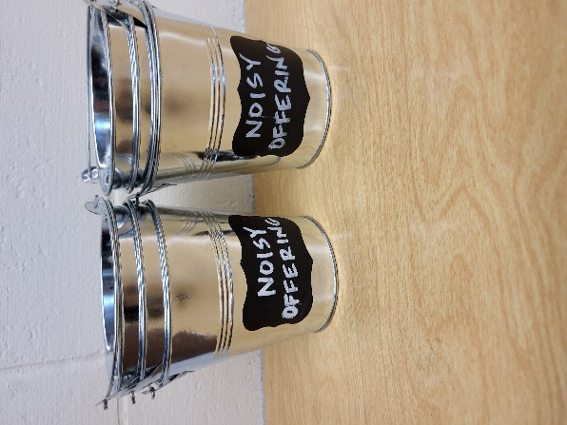
Noisy Offering: Please keep saving your spare change for our noisy offering on Apr. 11th the Saturday after Easter. The February WELS Connections shared information about a Martin Luther College program called Congregational Grant Program. We are going to do a similar program to support Gracie Niemuth a member of our congregation and a junior at Lutheran Prep School in Watertown WI. Your donation will help Gracie with school expenses. We have appreciated your support for our various projects and activities.

The Helping Hands Ministry is ready to serve the needs of our members. Please contact one of the following if you or someone you know needs assistance: Joanne Gregor at 920-896-1518 and Lisa Tremore at 920-229-1297.

For Your Information
Attendance 3/18-21/2026 126
Offerings for 3/18-21/2026 $2,396.25

Serving Our Lord

Thank you to everyone for your service to our Lord!

Ushers:

March 28 & April 2: Terry Dolderer, Dawson Niemuth, Rick Niemuth

April 5 & 12: Tim Lynch, TJ Sitter

PowerPoint:

March 28: Jan Ohlrich

April 2: No Slides Thursday)

April 3: No Slides (Good Friday)

April 5: No Slides

April Communion Set up: Rhonda Schwandt

April Communion Clean up: Marilyn Ninneman

Saturday (28th) 5:00 PM Worship with Communion Palm Sunday Service with Palm Procession
Thursday NO Women’s Bible Study
6:30 PM Maundy Thursday with Communion– Pastor Meier
April 3 6:30 PM Good Friday – Pastor Meier One Service Only at 6:30 PM (No Communion)
Saturday (4/5) Easter Breakfast served from 7:45 – 9:00 AM
Easter Egg Hunt at 8:15
Easter Sunday – Pastor Meier 9:00 AM (No “Sonrise” Service)

