19th SUNDAY OF PENTECOST
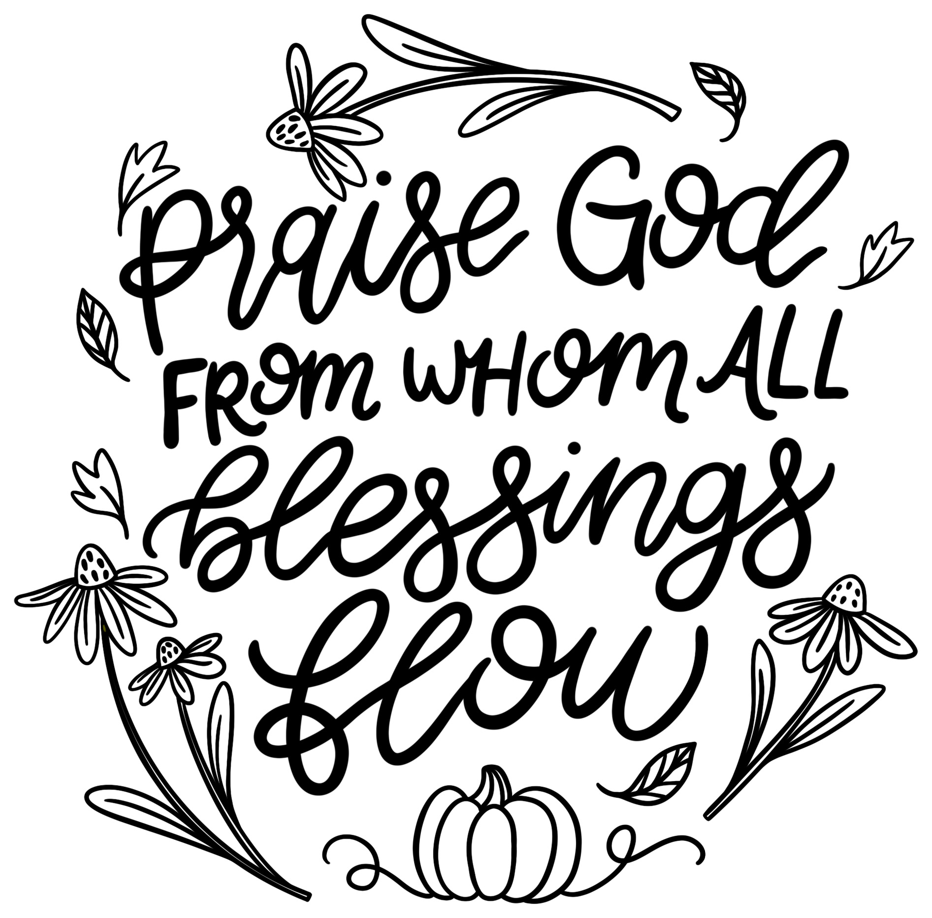
Mt. Zion Evangelical Lutheran Church

320 Mt. Zion Dr., Ripon, WI
www.mtzionripon.org
Facebook: Mt. Zion Evangelical Lutheran Church

Pastor Michael Sheppard
Pastor’s Study: 920-748-9734
E-mail: revmikesheppard@gmail.com
19th Sunday of Pentecost Oct. 12, 2025
Handicapped accessible restrooms are located upstairs next to the Pastor’s Study and downstairs next to the elevator.
Attendance: Please remember to sign the friendship pads. Registration for communion will continue as usual at the table. If you have any questions or concerns, please contact Pastor Sheppard or Mike Meeker.


Hearing Loop: Our sanctuary is equipped with a hearing loop system. Those who have compatible hearing aids (with a T-switch) will be able to hear the sound system directly into their ear(s). The two main seating areas and the choir area are looped so that you may sit in any of the three areas. We also have four receivers available for those who do not have compatible hearing aids. If you wish to use a receiver please ask the ushers. Those who wish may bring their own headphones or ear buds.

A note for our visitors on member communion –
Out of sincere love for the truth of God’s Word and for precious human souls, we practice member communion in our synod and congregation. This teaching, as practiced by the Church for centuries, is thoroughly Scriptural. It questions the faith of no individual yet asks that there be full doctrinal agreement between those who commune. For this reason, we ask that only those who are members of a WELS or ELS congregation join us for the Lord’s Supper. If you wish to commune with us please speak with the pastor before the service.
The front row on the pulpit side is reserved for people who are unable to navigate the steps. Pastor will serve you Communion first.

Prayer Before Communion: Dearest Jesus, I marvel that you came to this earth as the Word made flesh. With similar awe I contemplate how you give me your body and blood in the bread and wine of Holy Communion. Touch me with your grace that moved you to reach out to me, a poor, miserable sinner! Use this sacred supper to bring me closer to you. Amen.

Hymn Sing: 814, 522, 847, 931
Hymns: 920, 820, (675), 673

Order of Worship Setting One pg. 154

Hymn: 938 This is the Feast (in place of Glory Be to God on High)

First Reading Genesis 8:15-22 (EHV)
God spoke to Noah. He said, ¹⁶“Go out of the ark—you, your wife, your sons, and your sons’ wives with you. ¹⁷Bring out with you every living thing of every sort that is with you, all flesh, including birds, livestock, and every creeping thing that creeps on the earth, so that they may swarm over the earth, and be fruitful and multiply on the earth.”
¹⁸Noah went out with his sons, his wife, and his sons’ wives along with him. ¹⁹Every animal, every creeping thing, every bird, and whatever swarms on the earth went out of the ship, species by species.
²⁰Noah built an altar to the Lord and took from every clean animal and every clean bird and offered burnt offerings on the altar. ²¹The Lord smelled the pleasant aroma. The Lord said in his heart, “I will never again curse the soil anymore because of man, for the thoughts he forms in his heart are evil from his youth. Neither will I ever again strike every living thing, as I have done. ²²While the earth remains, seedtime and harvest, cold and heat, summer and winter, and day and night shall not cease.”

Psalm: 111A LORD, I Must Praise You
(Congregation may sing along with the soloists)

Second Reading & Sermon Text: Romans 5:8-10 (EHV)
But God shows his own love for us in this: While we were still sinners, Christ died for us.
⁹ Therefore, since we have now been justified by his blood, it is even more certain that we will be saved from God’s wrath through him. ¹⁰ For if, while we were enemies, we were reconciled to God by the death of his Son, it is even more certain that, since we have been reconciled, we will be saved by his life.

Gospel Acclamation
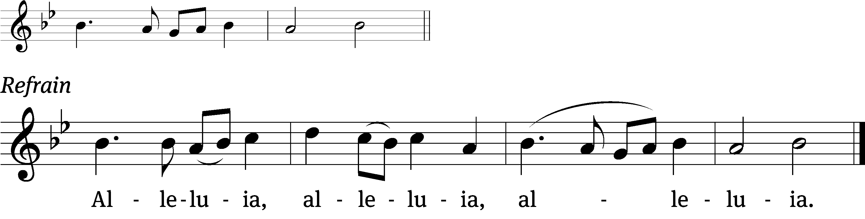
These words are written that you / may believe,
That Jesus is the Christ, the / Son of God. Refrain

Gospel: John 1:9-14
The real light that shines on everyone was coming into the world. ¹⁰ He was in the world, and the world was made through him, yet the world did not recognize him. ¹¹ He came to what was his own, yet his own people did not accept him. ¹² But to all who did receive him, to those who believe in his name, he gave the right to become children of God. ¹³ They were born, not of blood, or of the desire of the flesh, or of a husband’s will, but born of God.
¹⁴ The Word became flesh and dwelled^{[a]} among us. We have seen his glory, the glory he has as the only-begotten from the Father, full of grace and truth.

Sermon Theme: “Christ Died For Us to Reconcile Us to God.”

OFFERING: The offerings are brought forward to the altar.

Keep in Your Prayers: Harley Dorsey, Carol Henning, Karen Reiser, Gary Wichman and Dick Zellmer.

Announcements
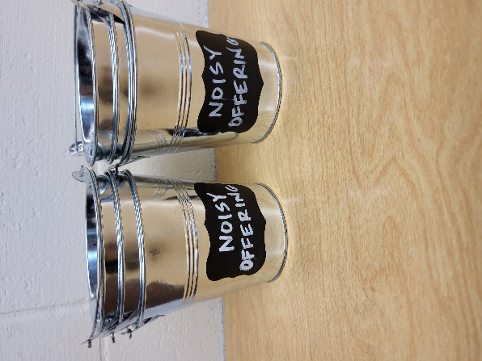
Noisy Offering: Please keep saving your spare change for our noisy offering on Nov. 2nd. Your offering will be given to the LWMS Kids C.A.R.E. project Academia Cristo, through the One Latin America Team. Academia Cristo is a multi-faceted effort that seeks to make disciples by sharing the message of God’s grace and to build small groups of believers throughout Latin America. We have appreciated your support for our various projects and activities. Thank you for your generosity.
Hymn Sing: This morning’s hymn sing will begin at about 8:45am. If you have any requests for future hymn sings please talk to Sue Sheppard or Jo Meeker.

Pre-Voters’ Meeting: The quarterly pre-voters’ meeting will be held after church today near the choir section.

LWMS Rally: On October 18th St. Stephens of Beaver Dam will be hosting the Fall Rally. To those women who have been working on the plastic crosses for LWMS, please return them to the church by Oct. 16th. There is a basket on the table outside the office. They do not have to be completed with the ribbon; we will take them along to the Fall Rally. A signup sheet is by the library for ride share to Beaver Dam. We will be leaving the lower level parking lot at 8:15.

Mission Festival: On October 19th Pastor Abram Degner will be here to preach on the WELS 175th Anniversary, Christ THROUGH Us. Following the service, he will make a presentation in the fellowship hall. We will then join in a potluck dinner. No Sunday School or Bible Study will be held that Sunday.

Birthday Celebration: The October birthday celebration will be October 26th, in the fellowship hall.

The Tapestry is Back: Carol Kapp’s Lord Supper Tapestry has been moved back to the fellowship hall and is ready for volunteers to work on it again. Starting Oct. 7th there will be someone to help with the tapestry on Tuesday afternoons from 1-3 and on Thursday mornings from 10:30-12. If these times don’t work for you, you can come in the mornings when Jo is working (Mon., Tues., Wed.,) using the front entrance. Please be sure to let Jo know you are there to work on the tapestry. Finally, if you have a key, you can work on the tapestry whenever it works into your schedule. We are looking for more volunteers. If you don’t know how to latch hook, Sue Sheppard or Joanne Gregor would be willing to help you learn. Looking forward to working with you to complete the Lord Supper tapestry Carol Kapp started. God’s Blessings!

Advent By Candlelight – Unwrapping the Names of Jesus
Jesus, King of kings, Immanuel, Prince of Peace—we hear these names referring to God’s Son often during this time of year. They’re in the hymns we sing, the passages preached, the words on our lips. Do we ever stop to consider what they mean? In fact, each name reveals to us truth. They remind us of what God has accomplished. Each name confesses something uniquely special that he has done for you and for me.

This Advent by Candlelight program seeks to focus our attention right on Jesus by taking a deeper look—through Scripture, narrative, and song—at the names we hear him often called during Advent. Each name reveals a priceless gift just waiting to be opened and treasured for a lifetime. Each name is a perfect gift to unwrap. We are planning this event for November 30th, the first Sunday in Advent. More information will be posted soon. Contact Jo Meeker or Kari Hielke with any questions.

Friendly Reminder: Children’s offering envelopes and children’s bulletins are available on the back table. The prayer box is also there for any prayer requests.

Greeters: Thank you to all who have greeted so far. A new signup sheet for August through December is available. If you would like to be greeters for this year, please sign up on the sheet on the podium by the library.

Mailbox and table: The October Forward In Christ is available and also the August 31, 2025-November 29, 2025 Meditations are available.
If you would like the Lord’s Supper privately, please contact Pastor Sheppard on his cell 920-745-0883, or by email revmikesheppard@gmail.com.
The Helping Hands Ministry is ready to serve the needs of our members. Please contact one of the following if you or someone you know needs assistance: Joanne Gregor at 920-896-1518, Lisa Tremore at 920-229-1297 or Tammy Niemuth at 920-299-0240.

For Your Information
Attendance 10/5 147
Offerings for 10/5 $2,697.00

Serving Our Lord

Thank you to everyone for your service to our Lord!

Ushers:

Oct. 12: Gary Quade, Travis Schmudlach, Kyle Stollfuss

Oct. 19 & 26: Steve Ohlrich, Derek Chitwood, Alex Kranz

PowerPoint:

October 12: Jean Lynch

Oct.19: Jan Ohlrich

Oct. 26: Judy Doll

November 2: Grunert Family

Oct. Communion Set up: Jo Meeker

Oct. Communion Clean up: Marilyn Ninneman & Tammy Niemuth

Sunday (12th) 8:45 AM Hymn Sing
9:00 AM Worship Service with Communion
10:15 AM Sunday School; Bible Study and Pre-Voter’s Meeting
5:00 PM Confirmation Class
Monday 6:30 PM Sunday School Teachers Mtg.
Tuesday 9:00 AM Bible Study (book of John)
5:30 PM Council Mtg.
6:30 PM Ladies Aid Mtg.
Thursday 9:00 AM Women’s Bible Study (Fellowship Hall)
Saturday LWMS Fall Rally at St. Stephens Beaver Dam
Sunday 9:00 AM Worship Service (Mission Festival)
10:15 AM Presentation in the fellowship hall by Pastor Abram Degner
11:15 AM Pot Luck Dinner
NO SUNDAY SCHOOL, BIBLE STUDY OR CONFIRMATION CLASS.

