NEW YEAR’S EVE

Mt. Zion Evangelical Lutheran Church
320 Mt. Zion Dr., Ripon, WI
www.mtzionripon.org
Facebook: Mt. Zion Evangelical Lutheran Church

Pastor Michael Sheppard
Pastor’s Study: 920-748-9734
E-mail: revmikesheppard@gmail.com
New Year’s Eve December 31, 2025
Welcome to Mt. Zion!
Handicapped accessible restrooms are located upstairs next to the Pastor’s Study and downstairs next to the elevator.
Attendance: Please remember to sign the friendship pads. Registration for communion will continue as usual at the table. If you have any questions or concerns please contact Pastor Sheppard or Mark Roeder.


Hearing Loop: Our sanctuary is equipped with a hearing loop system. Those who have compatible hearing aids (with a T-switch) will be able to hear the sound system directly into their ear(s). The two main seating areas and the choir area are looped so that you may sit in any of the three areas. We also have four receivers available for those who do not have compatible hearing aids. If you wish to use a receiver please ask the ushers. Those who wish may bring their own headphones or ear buds.

A note for our visitors on member communion –
Out of sincere love for the truth of God’s Word and for precious human souls, we practice member communion in our synod and congregation. This teaching, as practiced by the Church for centuries, is thoroughly Scriptural. It questions the faith of no individual yet asks that there be full doctrinal agreement between those who commune. For this reason, we ask that only those who are members of a WELS or ELS congregation join us for the Lord’s Supper. If you wish to commune with us please speak with the pastor before the service.
The front row on the pulpit side is reserved for people who are unable to navigate the steps. Pastor will serve you Communion first.

Prayer Before Communion: Dearest Jesus, I marvel that you came to this earth as the Word made flesh. With similar awe I contemplate how you give me your body and blood in the bread and wine of Holy Communion. Touch me with your grace that moved you to reach out to me, a poor, miserable sinner! Use this sacred supper to bring me closer to you. Amen.

Prayer After Communion: Thank you, Lord Jesus Christ, for nourishing me in this sacrament with your body and blood. You have given me forgiveness, life, and salvation. Let me always remain in you as a branch remains in the vine. Send me out in the power of your Spirit to live and work to your praise and glory. Amen

Hymns: 678, 367, (677), 502

Order of Worship: Setting One pg. 154

First Reading: Ecclesiastes 3:1-8 (EHV)
For everything there is an appointed time.
There is an appropriate time for every activity under heaven:
²a time to give birth and a time to die,
a time to plant and a time to uproot plants,
³a time to kill and a time to heal,
a time to tear down and a time to build,
⁴a time to weep and a time to laugh,
a time to mourn and a time to dance,
⁵a time to scatter stones and a time to gather stones,
a time to embrace and a time not to embrace,
⁶a time to search and a time to stop searching,
a time to keep and a time to throw away,
⁷a time to rip and a time to sew,
a time to be silent and a time to speak,
⁸a time to love and a time to hate,
a time for war and a time for peace.

Psalm 90A Fill Us with Your Love, O Lord

Second Reading & Sermon Text: Hebrews 13: 5-8, 14 (EHV)
Keep your life free from the love of money, and be content with what you have. For God has said:
I will never leave you,
and I will never forsake you.
⁶So then we say with confidence:
The Lord is my helper, and I will not be afraid.
What will man do to me?
⁷Remember your leaders, who spoke the word of God to you. Carefully consider the outcome of their way of life and imitate their faith. ⁸Jesus Christ is the same yesterday and today and forever.
¹⁴For we do not have a permanent city here, but we are looking for the city that is coming.
Gospel Acclamation Psalm 90:1
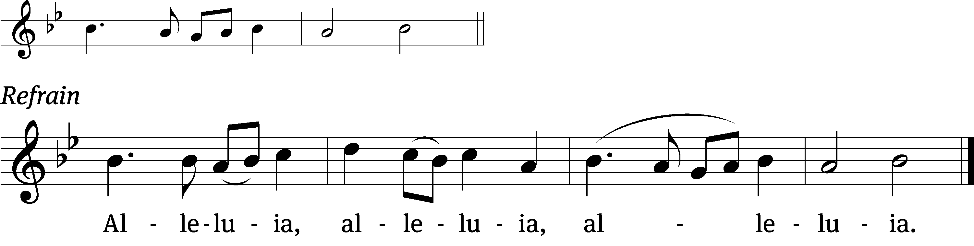
Lord, you have been our / dwelling place
throughout all gener-/ ations.
Refrain
Tune: © 2021 Northwestern Publishing House. Used by permission: OneLicense no. 716381

Gospel: Matthew 25:1-13 (EHV)
“At that time the kingdom of heaven will be like ten virgins who took their lamps and went out to meet the bridegroom. ²Five of them were foolish, and five were wise. ³When the foolish ones took their lamps, they did not take any oil with them; ⁴but the wise took oil in their containers with their lamps. ⁵While the bridegroom was delayed, they all became drowsy and fell asleep. ⁶But at midnight there was a shout, ‘Look, the bridegroom! Come out to meet him!’ ⁷Then all those virgins got up and trimmed their lamps. ⁸The foolish ones said to the wise, ‘Give us some of your oil because our lamps are going out.’ ⁹But the wise answered, ‘No, there may not be enough for us and for you. Instead, go to those who sell oil and buy some for yourselves.’ ¹⁰But while they were away buying oil, the bridegroom came. Those who were ready went in with him to the wedding banquet, and the door was shut. ¹¹Later, the other virgins also came and said, ‘Lord, Lord, let us in.’ ¹²But he answered, ‘Amen I tell you: I do not know you.’ ¹³Therefore, keep watch, because you do not know the day or the hour.”

Sermon Theme: “We Are Looking for the City That Is Coming.”

OFFERING: The offerings are brought forward to the altar.

Keep in Your Prayers: Harley Dorsey, Karen Reiser, Ginny Verch, Gary Wichman and Dick Zellmer.

Announcements

Thank You: Pastor & Sue Sheppard would like to thank the members for their generous gifts this Christmas.

Pre-Call Survey: A pre-call survey form is available on the table at the back of the church. Please take one home to fill out and return by Jan. 4th. This will help our District President understand our situation and pastoral needs.

Offering envelopes for 2026 are now available. PLEASE DO NOT USE UNTIL JANUARY AS YOUR NUMBER MAY HAVE CHANGED.
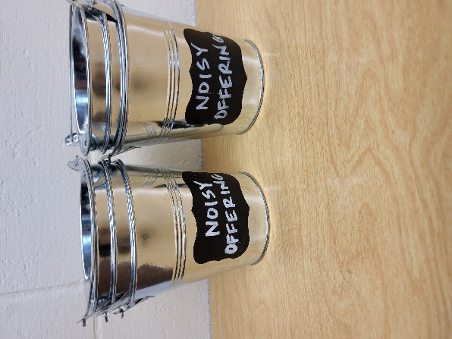
Noisy Offering: Please keep saving your spare change for our noisy offering Sunday Jan. 4th. Your offering will be given to our Befriend a Mission the Vine Lutheran Church in Coeur d’Alene ID. Their mission is “Connecting people to Jesus and growing together in his Word.”

Birthday Celebration: Sunday Jan. 4th. Join us for fellowship, cake and refreshments.

Hymn Sing: The next hymn sing will be January 18th. If you have any requests for January hymn sing please talk to Sue Sheppard or Jo Meeker.


Cereal Request: Mount Zion has received a request from Shannon Wright from the Traded Treasures Community Food Pantry for donations. They are in desperate need for cereal. There is a box in the entryway for your cereal donations. This is a great opportunity for us to reach out to members of our community in need of our help. Thank you for your support. The Evangelism Committee
Shut-in Visits: We are hoping to start a program to make sure all our shut-ins are receiving consistent visits from members here at church. If you would like to coordinate a schedule to plan monthly visits or if you would like to volunteer to visit a shut-in please see the sign-up sheet on the podium by the library.

Mailbox and table: The January Forward In Christ is available and also the Nov. 30 2025-Feb. 28, 2026 Meditations are available.
If you would like the Lord’s Supper privately, please contact Pastor Sheppard on his cell 920-745-0883, or by email revmikesheppard@gmail.com.
The Helping Hands Ministry is ready to serve the needs of our members. Please contact one of the following if you or someone you know needs assistance: Joanne Gregor at 920-896-1518 and Lisa Tremore at 920-229-1297.
For Your Information
Attendance 12/21-28/2025: 462
Offerings for 12/21-28/2025: $10389.00

Serving Our Lord

Thank you to everyone for your service to our Lord!

Ushers:

Dec. 31: Mike Schaub, Kevin Schenning, Eric Eckert, Adam Covach

Jan. 7: Ken Hielke, Todd Zellmer, Jonathan Zellmer, Dustin Zellmer

PowerPoint:

Dec. 31: Jo Meeker (Evening)

Jan. 4: Grunert Family

Jan. 11: Jo Meeker

Jan. 18: Jan Ohlrich

Jan. Communion Set up: Joanne Gregor

Jan. Communion Clean up: Donna Mueller

Sunday (4th) 9:00 AM Worship, Children’s Sermon & Noisy Offering
Installation of Church Council
10:15 AM Sunday School
5:00 PM Confirmation Class
Monday 6:00 PM Evangelism Committee Mtg.
Wednesday 6:15 PM Choir Practice
Thursday 9:00 AM Women’s Bible Study
Friday 1:00 PM Movie: “A Case for Christ”
Saturday 9:30 – 11 AM Junior Youth Group
Sunday 9:00 AM Worship Service

Secretary Jo Meeker
Church Office: 920-748-5641
Office Hours: Mon. 9-12, Tues. & Wed. 9-11
E-mail: mountzionripon@gmail.com

