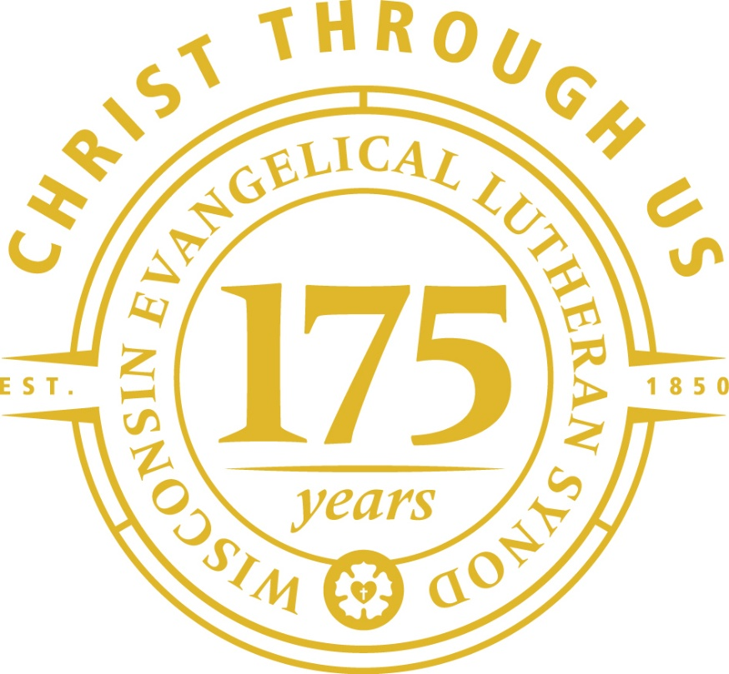

Mount Zion Ev. Lutheran Church
Ripon, WI
Mission Festival

Christ Through Us
Mission Festival Service
Mission Festival 9:00AM October 19, 2025
Hymn O Christ, Our True and Only Light #904
Invocation
M: In the name of the Father and Son (X) and Holy Spirit.
C: Amen
Call to Worship
M: Sing to the Lord, praise his name;
C: proclaim his salvation day after day.
M: Declare his glory among the nations,
C: his marvelous deeds among all peoples.
M: Worship the Lord in the splendor of his holiness;
C: tremble before him, all the earth.
Prayer of the Day
M: O God, you have made of one blood all the peoples of the earth and have sent your messengers to preach peace to those who are far off and to those who are near. Grant that by the witness of your Church many may be brought into your kingdom and worship you, the only true God; through your Son, Jesus Christ our Lord.
C: Amen
First Lesson Joshua 4:1-9 (EHV)
¹When the whole nation had finished crossing the Jordan, the Lord told Joshua, ² “Take twelve men from the people, one man from each tribe, ³ and give them the following orders: ‘Pick up twelve stones from here in the middle of the Jordan, from the place where the feet of the priests are standing securely. Carry them over with you and put them at the place where you will stay tonight.’”
⁴ So Joshua called the twelve men whom he had selected from the people of Israel—a man from each tribe. ⁵ Joshua said to them, “Go to the middle of the Jordan in front of the Ark of the Lord your God. There each man is to lift up one stone on his shoulder. The number will correspond to the number of the tribes descended from the sons of Israel, ⁶ so that this may be a sign among you when your children ask in the future, ‘What do these stones mean for you?’ ⁷ Then you shall respond to them that the waters of the Jordan were cut off in front of the Ark of the Covenant of the Lord. When the ark passed through the Jordan, the waters of the Jordan were cut off. These stones will serve as a permanent memorial for the people of Israel.”
⁸ So the people of Israel did just as Joshua had ordered. They picked up twelve stones from the middle of the Jordan, corresponding to the number of the tribes descended from the sons of Israel, as the Lord had instructed Joshua. They carried the stones over with them to their lodging place and deposited them there. ⁹ Joshua also set up twelve stones in the middle of the Jordan at the spot where the feet of the priests carrying the Ark of the Covenant had stood. They are there to this day.
Psalm of the Day Psalm 98A
Second Lesson Revelation 3:7-13 (EHV)
⁷ To the messenger of the church in Philadelphia write:
The Holy One, the one who is true, the one who has the key of David, the one who opens and no one can shut, and who shuts and no one can open, says this:
⁸ I know your works. Look, I have set before you an open door, which no one can shut. I know that you have little strength, and yet you have kept my word and have not denied my name. ⁹ Look, I will make those who are from the synagogue of Satan, who say they are Jews and are not but are lying—look, I will make them come and bow down at your feet, and make them realize that I have loved you. ¹⁰ Because you have kept my word about patient endurance, I will also keep you from the hour of testing, which is about to come over the whole inhabited world, to test those who dwell on the earth.
¹¹ I am coming soon. Hold on to what you have so that no one takes your crown.
¹² The one who is victorious I will make a pillar in the temple of my God, and he will never leave it again. I will also write on him the name of my God and the name of the city of my God—the new Jerusalem, which is coming down out of heaven from my God—and my new name.
¹³ Whoever has an ear, let him hear what the Spirit says to the churches.
Gospel Acclamation (spoken)
Alleluia. Cast all your anxiety on him because he cares for you. Alleluia.
Gospel John 8:31-36 (EHV)
³¹ So Jesus said to the Jews who had believed him, “If you remain in my word, you are really my disciples. ³² You will also know the truth, and the truth will set you free.”
³³ “We are Abraham’s descendants,” they answered, “and we have never been slaves of anyone. How can you say, ‘You will be set free’?”
³⁴ Jesus answered, “Amen, Amen, I tell you: Everyone who keeps committing sin is a slave to sin. ³⁵ But a slave does not remain in the family forever. A son does remain forever. ³⁶ So if the Son sets you free, you really will be free.
Hymn O Christ, Who Called the Twelve #716
Sermon Text: Isaiah 49:1-6
Sermon Theme: “A Great Savior is Worthy of a Great Mission”
Apostles’ Creed
I believe in God, the Father almighty,
maker of heaven and earth.
I believe in Jesus Christ, his only Son, our Lord,
who was conceived by the Holy Spirit,
born of the virgin Mary,
suffered under Pontius Pilate,
was crucified, died, and was buried.
He descended into hell.
The third day he rose again from the dead.
He ascended into heaven
and is seated at the right hand of God the Father almighty.
From there he will come to judge the living and the dead.
I believe in the Holy Spirit,
the holy Christian Church, the communion of saints,
the forgiveness of sins, the resurrection of the body,
and the life everlasting. Amen.
Prayer of the Church
M: May God be gracious to us and bless us and make his face shine on us, that his way may be known on earth, his salvation among all nations. May the nations be glad and sing for joy, for you rule the peoples justly and guide the nations of the earth.
C: May the peoples praise you, O God. May all the peoples praise you.
M: Lord God, King of the universe, direct the governments of the world so that we may live quiet and peaceful lives. Protect us from crime and war. Let freedom of religion flourish, that the gospel may be freely preached throughout the world. Cast down rulers who oppress their people. Remove governments who oppose the gospel. Bring relief to persecuted Christians.
C: Then the earth will yield its harvest, and God, our God, will bless us.
M: Bless our church with pastors and teachers who faithfully proclaim your Word. Lead many young men and women to study for the preaching and teaching ministries. By the power of your gospel, motivate them so that they do not become discouraged but continue in the course you have set before them.
C: Then the earth will yield its harvest, and God, our God, will bless us.
M: Hear us as we pray for a family member, a friend, or for others who do not yet believe in you.
Silent prayer.
M: Make us the answer to our prayers for others. Move us to share the gospel with those for whom we have just prayed. Bless the preaching of the gospel everywhere, here among us and in the far corners of the world. Let your kingdom come to us and to many others.
C: Then the earth will yield its harvest, and God, our God, will bless us. God will bless us, and all the ends of the earth will fear him. Amen.
© 1999 Northwestern Publishing House. Reprinted by permission.
Lord’s Prayer
Our Father in heaven, hallowed be your name, your kingdom come, your will be done on earth as in heaven. Give us today our daily bread. Forgive us our sins, as we forgive those who sin against us. Lead us not into temptation, but deliver us from evil. For the kingdom, the power, and the glory are yours now and forever. Amen.
Offering
Hymn The Church’s One Foundation #855
Responsive
M: Let the heavens rejoice, let the earth be glad;
C: let the sea resound, and all that is in it;
M: let the fields be jubilant, and everything in them.
C: Then all the trees of the forest will sing for joy;
M: for he comes to judge the world in righteousness
C: and the peoples in his truth.
Benediction
M: Brothers and sisters, go in peace. Live in harmony with one another. Serve the Lord with gladness.
The Lord bless you and keep you.
The Lord make his face shine on you and be gracious to you.
The Lord look on you with favor and (X) give you peace.
C: Amen.
Closing Hymn God’s Word Is Our Great Heritage #640
X X X X X X X

