HOLY THURSDAY
March 28, 2024
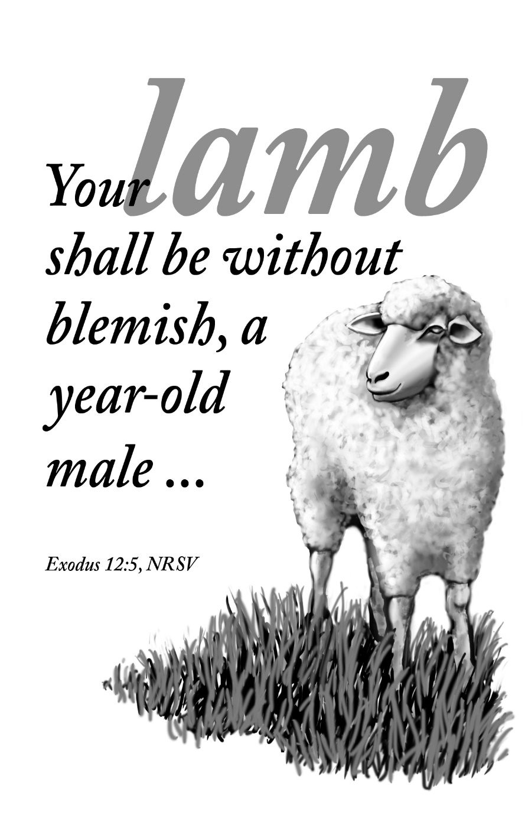
Mt. Zion Evangelical Lutheran Church
320 Mt. Zion Dr., Ripon, WI
www.mtzionripon.org
Facebook: Mt. Zion Evangelical Lutheran Church

Pastor Michael Sheppard
Pastor’s Study: 920-748-9734
Cell: 920-745-0883
E-mail: revmikesheppard@gmail.com
Holy Thursday March 28, 2024
Welcome to Mt. Zion!
Handicapped accessible restrooms are located upstairs next to the Pastor’s Study and downstairs next to the elevator.
Hearing Loop: Our sanctuary is equipped with a hearing loop system. Those who have compatible hearing aids (with a T-switch) will be able to hear the sound system directly into their ear(s). The two main seating areas and the choir area are looped so that you may sit in any of the three areas. We also have four receivers available for those who do not have compatible hearing aids. Those who wish may bring their own headphones or ear buds. If you wish to use a receiver please ask the ushers.

A note for our visitors on member communion –
Out of sincere love for the truth of God’s Word and for precious human souls, we practice member communion in our synod and congregation. This teaching, as practiced by the Church for centuries, is thoroughly Scriptural. It questions the faith of no individual yet asks that there be full doctrinal agreement between those who commune. For this reason, we ask that only those who are members of a WELS or ELS congregation join us for the Lord’s Supper. If you wish to commune with us please speak with the pastor before the service.
The front row on the pulpit side is reserved for people who are unable to navigate the steps. Pastor will serve you Communion first.

Order of Service: Setting One CW 21 pg 154

Today’s Hymns: 404, 660, (659), 672

First Lesson & Sermon Text: Exodus 12:21-30 (EHV)

Then Moses summoned all the elders of Israel and said to them, “Go and take lambs for yourselves according to your family size, and slaughter the Passover lamb. ²²You shall take a bundle of hyssop, dip it in the blood that is in the basin, and paint the lintel and the two doorposts with the blood that is in the basin. None of you are to go out of the door of your house until morning. ²³When the Lord passes through to strike Egypt and sees the blood on the lintel and the two doorposts, the Lord will pass over that door and will not allow the destroyer to enter your houses to strike you.
²⁴“You shall observe these instructions as a perpetual regulation for you and your descendants. ²⁵When you enter the land that the Lord will give you just as he said he would, you shall observe this ceremony. ²⁶So when your children ask you, ‘What does this ceremony mean to you?’ ²⁷you will say, ‘It is the sacrifice of the Passover to the Lord, who passed over the houses of the Israelites in Egypt. When he struck the Egyptians, he spared our houses.’”
The people bowed down and worshipped. ²⁸The Israelites went and did all this. They did just as the Lord had commanded Moses and Aaron.
²⁹At midnight the Lord struck down all the firstborn in the land of Egypt, from the firstborn of Pharaoh, who sat on his throne, to the firstborn of the prisoner who was in the dungeon, even all the firstborn of the livestock. ³⁰During the night Pharaoh got up—he, all his servants, and all the Egyptians—and there was a loud outcry in Egypt, for there was not a house where there was not someone dead.
I Will Walk in the Presence of the Lord (Insert) Psalm 116B
(During Lent we will not be singing the “Glory Be To The Father…”)

Second Lesson 1 Corinthians 10:16,17 (EHV)
The cup of blessing that we bless, is it not a communion of the blood of Christ? The bread that we break, is it not a communion of the body of Christ? ¹⁷Because there is one bread, we, who are many, are one body, for we all partake of the one bread.

Gospel Acclamation 1 Corinthians 11:26
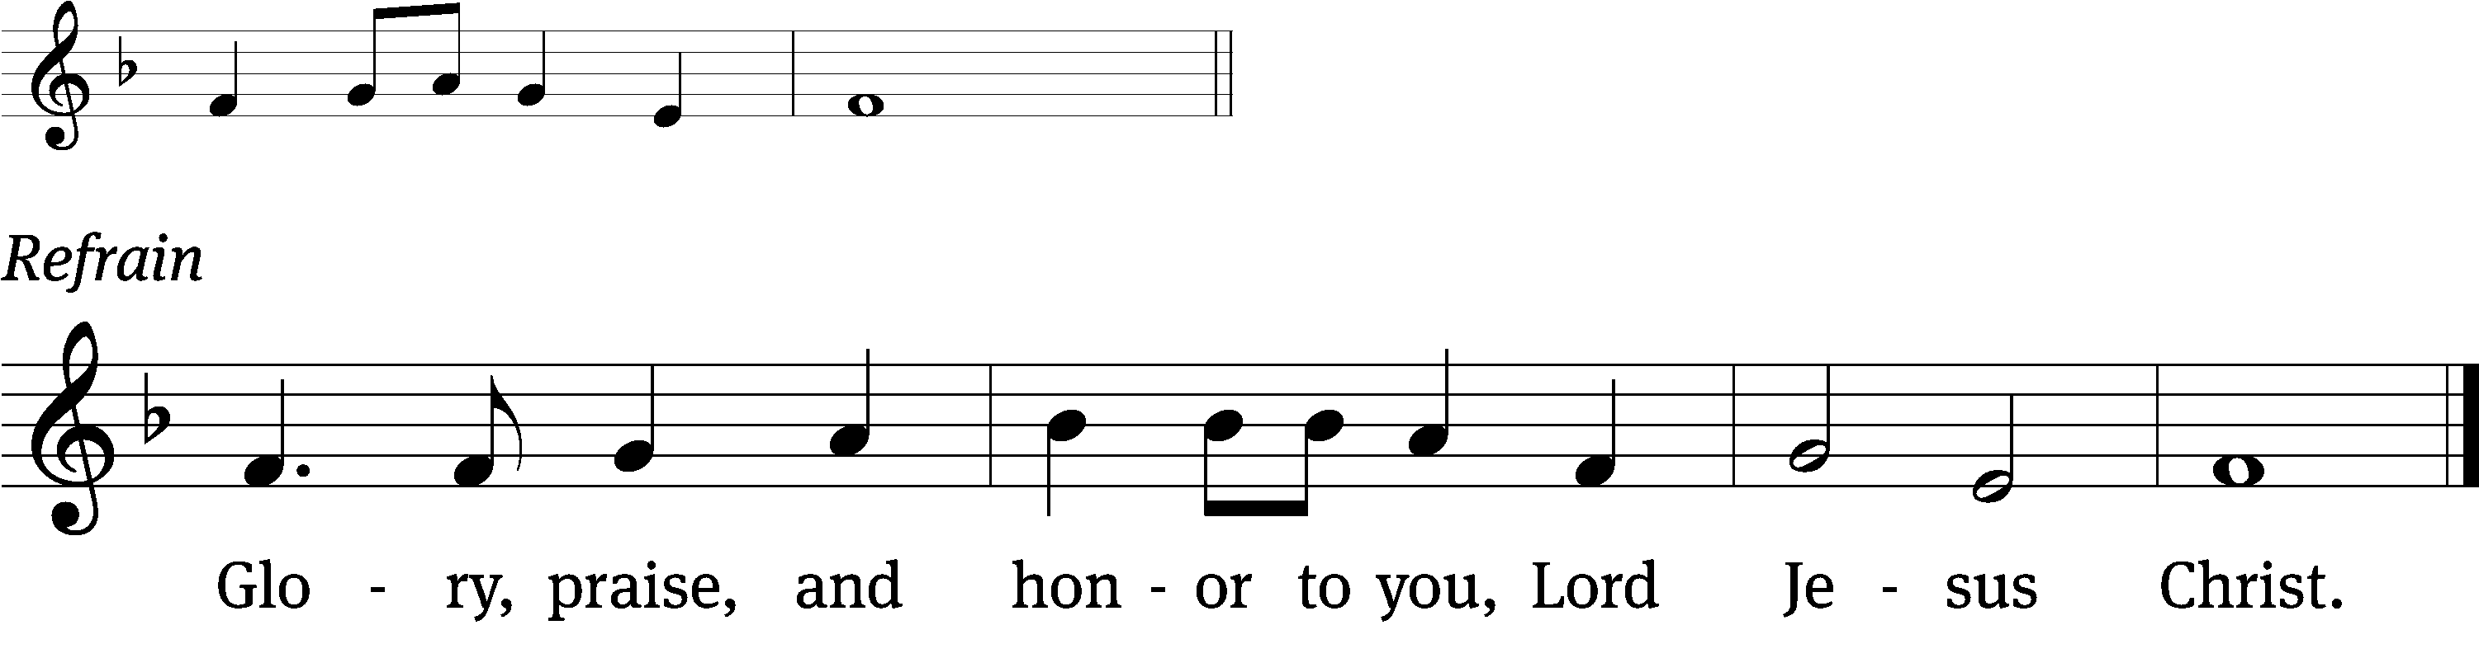
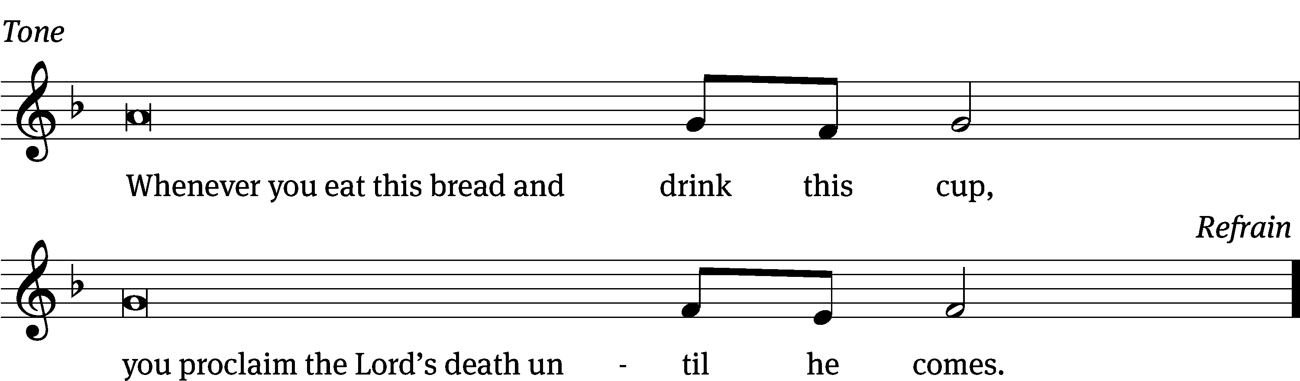
Tune: © 2021 Northwestern Publishing House. Used by permission: OneLicense no. 716381

Gospel Lesson Mark 14:12-26 (EHV)
On the first day of the Festival of Unleavened Bread, when the Passover lamb is sacrificed, his disciples asked him, “Where do you want us to go and prepare for you to eat the Passover?” ¹³He sent two of his disciples and said to them, “Go into the city, and there a man carrying a jar of water will meet you. Follow him. ¹⁴Wherever he enters, tell the owner of the house that the Teacher says, ‘Where is my guest room, where I may eat the Passover with my disciples?’ ¹⁵He will show you a large upper room, furnished and ready. Make preparations for us there.”
¹⁶His disciples left and went into the city and found things just as he had told them; and they prepared the Passover.
¹⁷When it was evening, he arrived with the Twelve.
¹⁸While they were reclining and eating, Jesus said, “Amen I tell you: One of you will betray me, one who is eating with me.”
¹⁹They began to be sorrowful and said to him one by one, “Surely not I?”
²⁰He said to them, “It is one of the Twelve, one who is dipping bread with me in the dish. ²¹Indeed, the Son of Man is going to go just as it has been written about him, but woe to that man by whom the Son of Man is betrayed! It would have been better for that man if he had not been born.”
²²While they were eating, Jesus took bread. When he had blessed it, he broke it and gave it to them, saying, “Take it. This is my body.”
²³Then he took the cup, gave thanks, and gave it to them. They all drank from it. ²⁴He said to them, “This is my blood of the new testament, which is poured out for many. ²⁵Amen I tell you: I will certainly not drink again of the fruit of the vine until that day when I drink it new in the kingdom of God.” ²⁶After they sang a hymn, they went out to the Mount of Olives.

Sermon Theme: “The Blood of the Lamb Stayed the Lord’s Hand.”

OFFERING: The offerings are brought forward to the altar.

Following the closing hymn the stripping of the altar will take place.

HOLY WEEK SCHEDULE
Friday 1:00 PM Good Friday Worship with Communion
6:30 PM Tenebrae Service
Sunday 7:00 AM Easter Sunday SONrise Service (No Communion)
8:00 AM Easter Breakfast
9:00 AM Easter Festival Service with Communion
NO Sunday School or Bible Study

