Maundy Thursday

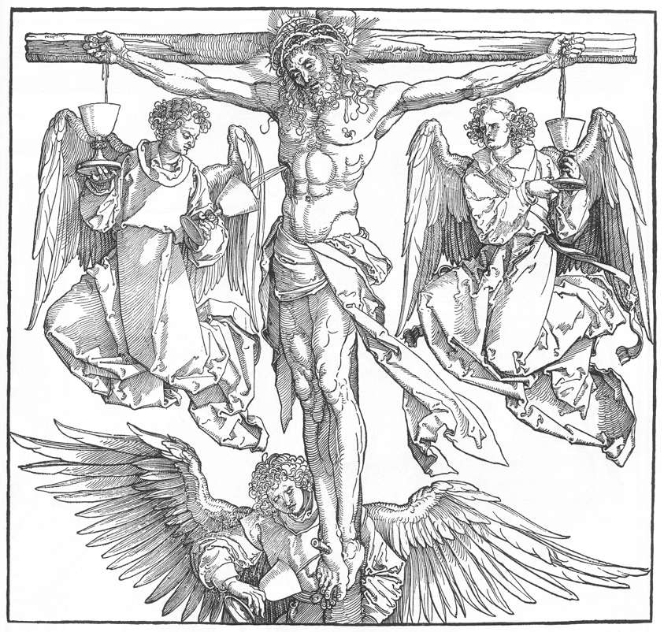
2 April 2026
Mt Zion Lutheran Church
320 Mt. Zion Dr. Ripon, WI

Rev. Dennis Meier
WELCOME! Today is called “Maundy Thursday.” It is the night Jesus gave his disciples a new command (mandate) to love one another. Tonight we close the penitential season of Lent and begin our celebration of the suffering, death, burial and resurrection of Our Lord. The services of Holy Week (Maundy Thursday, Good Friday, and Easter morning) form a single devotional unit. Plan to attend each day.

  

Preparation for Holy Communion (CW, page 295)
The practice of examining yourself before communing is a Scriptural directive. Dr. Martin Luther’s Christian Questions on p. 295 in the front of the hymnal will help you prepare yourself to come to the Lord’s Table.

Opening Hymn – 417 It Was a Dark and Dismal Night
Stand for the last stanza.

Instruction for the End of Lent
In this Lenten season we have heard again how our Lord walked the path of suffering which led Him to the cross for our salvation. We have also heard our Lord’s call to intensify our struggle against sin, death, and the devil — all that keeps us from loving God and one another. This is the struggle to which we were committed at Baptism; God’s forgiveness and the power of His Spirit to amend our lives continue with us because of His love for us in Jesus our Savior.

Within the family of the Church, God never wearies of giving peace and new life. In the absolution, we receive forgiveness as from God himself. This absolution we should not doubt but firmly believe that our sins are thus forgiven before God in heaven, for it comes to us in the name and by the command of our Lord.

We who receive God’s love in Jesus Christ are called to love one another, to be servants to each other, as Jesus became our servant.

In Holy Communion the members of Christ’s body participate very personally in His love. Remembering our Lord’s Last Supper with His disciples, we eat the bread and drink the cup of this meal. Together we receive the Lord’s gift of His body and blood for forgiveness and participate in that new covenant that makes us one with Him and one another. The Lord’s Supper is the promise of the great banquet we will share with all the faithful when our Lord returns, the joyous culmination of our reconciliation with God and each other.

Confession and Absolution
Let us confess our sins to God and ask for His forgiveness.

Almighty God, merciful Father,
I confess to you that I have not loved you with all my heart.
In what I have done and left undone,
I have pursued my ways instead of your ways.
I have not loved my brothers and sisters as myself.
For this I deserve your punishment both now and in eternity.
I am truly sorry for my sins.
I repent of them.
I beg for your mercy, O Lord.

Silence for meditation
Forgive us for the sake of Jesus Christ who suffered and died for us.

Cleanse me from my sins.
Release me from my guilt.
Grant me your Holy Spirit to amend my sinful life.

The almighty God has been merciful to us and has sent His Son to die for all. For His sake, God forgives our sins and calls us from darkness to His marvelous light.

Therefore, as a called servant of Christ and by His authority, I forgive you all your sins in the name of the Father and of the Son  and of the Holy Spirit.
Amen.

Our Lord Jesus Christ has forgiven us and reconciled us to God and has promised us the power to forgive and love each other. Relying on His promise, therefore, be reconciled with one another.
Brothers and sisters, may the peace of Christ rule in our hearts, in our words, and in our actions.

Let us pray.

Prayer of the Day
Lord Jesus Christ, in the sacrament of Holy Communion You give us Your true body and blood as a remembrance of Your suffering and death on the cross. Grant us so firmly to believe Your words and promises that we may always partake of this sacrament to our eternal good; for You live and reign with the Father and the Holy Spirit, one God, now and forever.
(spoken) Amen.

First Lesson – Exodus 12:1-14
In the Exodus, God reveals His divine template for our redemption and union with Him.

The Lord told Moses and Aaron this in the land of Egypt: ² This month is to be the beginning of your calendar. It is to be the first month of the year for you. ³ Tell the entire Israelite community that on the tenth day of this month, they are to take a lamb or a young goat for themselves, according to their fathers’ households, one lamb per household. ⁴ But if the household is too small for a whole lamb, then that person and his neighbor next door to him must select one, based on the number of people. Determine what size lamb is needed according to how much each person will eat. ⁵ Your lamb must be unblemished, a year-old male. You may take it from the sheep or the goats. ⁶ You are to keep it until the fourteenth day of this month. Then the whole assembly of the Israelite community is to slaughter the lambs at sunset. ⁷ They shall take some of the blood and put it on the two doorposts and the lintel of the houses where they eat the lamb. ⁸ That night they shall eat the meat that has been roasted over a fire, along with unleavened bread. They shall eat it with bitter herbs. ⁹ Do not eat it raw or boiled in water, but roasted over a fire—with its head, its legs, and its internal organs. ¹⁰ You shall not leave any of it until the morning. Whatever remains until the morning, you shall burn in the fire. ¹¹ This is how you are to eat it: with your cloak tucked into your belt ready for travel, your sandals on your feet, and your staff in your hand. Eat it in haste. It is the Lord’s Passover. ¹² For on that night I will pass through the land of Egypt. I will strike down every firstborn in the land of Egypt, both people and animals. Against all the gods of Egypt I will execute judgment. I am the Lord. ¹³ The blood will be a sign for you on the houses where you are. When I see the blood, I will pass over you. There will be no plague among you to destroy you when I strike down the land of Egypt.
¹⁴ This day shall be a memorial for you, and you are to celebrate it as a festival to the Lord. Throughout your generations you must celebrate it as a permanent regulation.

This is the Word of the Lord.
Thanks be to God.

Psalm 116A (CW, page 116)

Second Lesson – I Corinthians 11:23-32
St. Paul catechizes us in the proper use of the Lord’s Supper.

For I received from the Lord what I also delivered to you: The Lord Jesus, on the night when he was betrayed, took bread, ²⁴ and when he had given thanks, he broke it and said, “This is my body, which is for you. Do this in remembrance of me.” ²⁵ In the same way, after the meal, he also took the cup, saying, “This cup is the new testament in my blood. Do this, as often as you drink it, in remembrance of me.” ²⁶ For as often as you eat this bread and drink the cup, you proclaim the Lord’s death until he comes. ²⁷ Therefore whoever eats the bread or drinks the cup of the Lord in an unworthy manner will be guilty of sinning against the Lord’s body and blood. ²⁸ Instead, let a person examine himself and after doing so, let him eat of the bread and drink from the cup. ²⁹ For if anyone eats and drinks in an unworthy way because he does not recognize the Lord’s body, he eats and drinks judgment on himself. ³⁰ Because of this, many among you are weak and sick, and quite a few have fallen asleep. ³¹ But if we judged ourselves, we would not be undergoing judgment. ³² However, when we undergo judgment, we are being disciplined by the Lord so that we may not be condemned with the world.

This is the Word of the Lord.
Thanks be to God.

Gospel Acclamation Hebrews 12:2

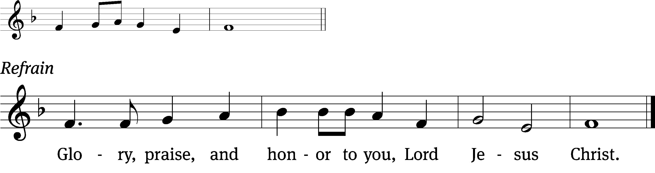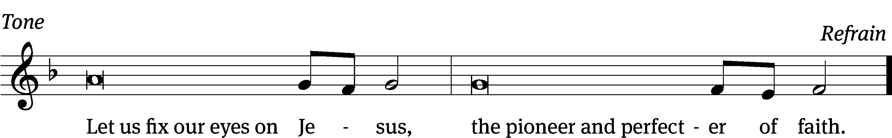
Tune: © 2021 Northwestern Publishing House. Used by permission: OneLicense no. 716381

Gospel – St. John 13:1-15
Jesus gives His people a marvelous gift of love: His very Body and Blood, in the Lord’s Supper.

Before the Passover Festival, Jesus knew that the time had come for him to leave this world and go to the Father. Having loved those who were his own in the world, he loved them to the end. ² By the time the supper took place, the Devil had already put the idea into the heart of Judas, son of Simon Iscariot, to betray Jesus.

³ Jesus knew that the Father had given all things into his hands, and that he had come from God and was going back to God. ⁴ He got up from the supper and laid aside his outer garment. He took a towel and tied it around his waist. ⁵ Then he poured water into a basin and began to wash his disciples’ feet, drying them with the towel that was wrapped around him. ⁶ He came to Simon Peter, who asked him, “Lord, are you going to wash my feet?” ⁷ Jesus answered him, “You do not understand what I am doing now, but later you will understand.” ⁸ Peter told him, “You will never, ever, wash my feet!”

Jesus replied, “If I do not wash you, you have no part with me.”

⁹ “Lord, not just my feet,” Simon Peter replied, “but also my hands and my head!” ¹⁰ Jesus told him, “A person who has had a bath needs only to wash his feet, but his body is completely clean. And you are clean, but not all of you.” ¹¹ Indeed, he knew who was going to betray him. That is why he said, “Not all of you are clean.”

¹² After Jesus had washed their feet and put on his outer garment, he reclined at the table again. “Do you understand what I have done for you?” he asked them. ¹³ “You call me Teacher and Lord. You are right, because I am. ¹⁴ Now if I, your Lord and Teacher, have washed your feet, you also ought to wash one another’s feet. ¹⁵ Yes, I have given you an example so that you also would do just as I have done for you.

M: The gospel of the Lord.
(spoken) Praise be to you, O Christ!

Hymn – CW 659 Jesus Christ, Our Blessed Savior

Sermon Text – Zechariah 13:1-3

On that day a fountain will be opened for the house of David and for the inhabitants of Jerusalem, for sin and for uncleanness.

²In that day, declares the Lord of Armies, I will cut off the names of the idols from the land, and they will no longer be remembered. I will also remove the prophets and the impure spirit from the land. ³If anyone still prophesies, his father and his mother who gave birth to him will tell him, “You shall not live, because you have spoken lies in the

Sermon Theme: “It Feels Good to be Clean.”

Prayer of the Church for Maundy Thursday: The Great Litany

(Prayer of Approach to God)
M: O God the Father, Creator of heaven and earth,
C: Have mercy on us.
M: O God the Son, Redeemer of the world,
C: Have mercy on us.
M: O God the Holy Spirit, advocate and guide,
C: Have mercy on us.
M: Holy, blessed, and glorious Trinity, three persons in one God,
C: Have mercy on us.
(Prayer for Deliverance)
M: Remember not, Lord Christ, our offenses nor the offenses of our forebears. Spare us, good Lord; spare your people, whom you have redeemed with your precious blood.
C: Spare us, good Lord.
M: From all spiritual blindness; from pride, vainglory, and hypocrisy; from envy, hatred, and malice; and from all lack of charity,
C: Good Lord, deliver us.
M: From all deadly sin and from the deceits of the world, the flesh, and the devil,
C: Good Lord, deliver us.
M: From all false doctrine, heresy, and schism; from hardness of heart and contempt for your Word and your will,
C: Good Lord, deliver us.
M: From earthquake and tempest; from drought, fire, and flood; from civil strife and violence; from war and murder; and from dying suddenly and unprepared,
C: Good Lord, deliver us.
(Prayer Recalling Christ’s Saving Work)
M: By the mystery of your holy incarnation; by your baptism, fasting, and temptation; and by your proclamation of the kingdom,
C: Good Lord, deliver us.
M: By your bloody sweat and bitter grief, by your cross and suffering, and by your precious death and burial,
C: Good Lord, deliver us.
M: By your mighty resurrection, by your glorious ascension, and by the coming of the Holy Spirit,
C: Good Lord, deliver us.
M: In our times of trouble, in our times of prosperity, in the hour of death, and on the day of judgment,
C: Good Lord, deliver us.
M: Receive our prayers, O Lord our God.
C: Hear us, good Lord.
(Prayer for the Church)
M: Govern and direct your holy Church, fill it with love and truth, and grant it that unity which is according to your will.
C: Hear us, good Lord.
M: Enlighten all ministers with true knowledge and understanding of your Word, that by their preaching and living they may declare it clearly and show its truth.
C: Hear us, good Lord.
M: Encourage and prosper your servants who spread the gospel in all the world, and send out laborers into the harvest.
C: Hear us, good Lord.
M: Bless and keep your people, that all may find and follow their true vocation and ministry.
C: Hear us, good Lord.
M: Give us hearts to love and revere you, that we may diligently live according to your commandments.
C: Hear us, good Lord.
M: To all your people, give grace to hear and receive your Word and to bring forth the fruits of the Spirit.
C: Hear us, good Lord.
M: Strengthen those who stand firm in the faith, encourage the fainthearted, raise up those who fall, and finally give us the victory.
C: Hear us, good Lord.
(Prayer for Our Country)
M: Rule the hearts of your servants, the president of the United States, and all others in authority, that they may do justice, love mercy, and walk in the ways of truth.
C: Hear us, good Lord.
M: Bless and defend all who strive for our safety and protection, and shield them in all dangers and adversities.
C: Hear us, good Lord.
M: Grant wisdom and insight to those who govern us and to judges and magistrates the grace to execute justice with mercy.
C: Hear us, good Lord.
(Prayer for All People)
M: To all nations grant unity, peace, and concord, and to all people give clothing, food, and shelter.
C: Hear us, good Lord.
M: Grant us abundant harvests, strength and skill to conserve the resources of the earth, and wisdom to use them well.
C: Hear us, good Lord.
M: Enlighten with your Spirit all who teach and all who learn.
C: Hear us, good Lord.
M: Come to the help of all who are in danger, necessity, and trouble; protect all who travel by land, air, or water; and show your pity on all prisoners and captives.
C: Hear us, good Lord.
M: Strengthen and preserve all women who are in childbirth and all young children, and comfort the aged, the bereaved, and the lonely.
C: Hear us, good Lord.
M: Defend and provide for the widowed and the orphaned, the refugees and the homeless, the unemployed, and all who are desolate and oppressed.
C: Hear us, good Lord.
M: Heal those who are sick in body or mind, and give skill and compassion to all who care for them.
C: Hear us, good Lord.
M: Grant us true repentance, forgive our sins, and strengthen us by your Holy Spirit to amend our lives according to your Holy Word.
C: Hear us, good Lord.
(Concluding Prayer)
M: Son of God, we ask you to hear us.
C: Son of God, we ask you to hear us.
M: Lamb of God, you take away the sin of the world;
C: Have mercy on us.
M: Lamb of God, you take away the sin of the world;
C: Have mercy on us.
M: Lamb of God, you take away the sin of the world;
C: Grant us peace.
M: Lord, have mercy on us.
C: Christ, have mercy on us.
M: Lord, have mercy on us.

The Litany concludes with the following:

M: Almighty God, You have given us grace at this time with one accord to make our common supplication to You, and You have promised through Your beloved Son that when two or three are gathered together in His name, You will be with them. Fulfill now, O Lord, our desires and petitions as may be best for us, granting us in this world knowledge of Your truth and in the ages to come, life everlasting.
C: Amen.

Gathering of the Thank Offering

The Sacrament is celebrated according to Setting One in your hymnal (CW, page 165).

Distribution Hymn – CW 808 Drawn to the Cross
“O Living Bread from Heaven” (CW93 314)

1 O living Bread from heaven, How well you feed your guest!
The gifts that you have given Have filled my heart with rest.
Oh, wondrous food of blessing, Oh, cup that heals our woes!
My heart, this gift possessing, With praises overflows.

2 My Lord, you here have led me Within your holiest place
And here have kindly fed me With treasures of your grace,
For you have freely given What earth could never buy,
The bread of life from heaven, That now I shall not die.

3 You gave me all I wanted—This food can death destroy—
And you have freely granted The cup of endless joy.
My Lord, I do not merit The favor you have shown,
And all my soul and spirit Bow down before your throne.

4 Lord, grant me then, thus strengthened With heav’nly food, while here
My course on earth is lengthened, To serve with holy fear.
And when you call my spirit To leave this world below,
I enter, through your merit, Where joys unmingled flow.

Text: Johann Rist, 1607–67, abr.; tr. Catherine Winkworth, 1827–78, alt.

This is an excellent time for meditation. Reading through some communion hymns (660-677) and taking some time to ponder Jesus’ great love for you can be spiritually fruitful.

Hymn of Thanksgiving – O Jesus, Blessed Lord, to Thee (tune: Old Hundredth)

1 O Jesus, blessed Lord, to Thee
My heartfelt thanks forever be,
Who hast so lovingly bestowed
On me Thy body and Thy blood.

2 Break forth, my soul, for joy and say:
What wealth is come to me this day!
My Savior dwells within me now:
How blest am I! How good art Thou!

Stripping of the Altar
As the Minister reads Psalm 88 and the altar is solemnly stripped, the congregation is invited to meditate on the words of Psalm 88 as the words of Christ Himself, to think on His abandonment and the betrayal He endured in the Garden, and to ponder His great love for us sinners in willingly enduring such scorn and shame.

O Lord, the God who saves me, by day I cry out.
At night I cry before you.
² May my prayer come before you.
Turn your ear to my cry.
³ Indeed, my soul has had its fill of troubles,
and my life has arrived at the grave.
⁴ I am treated like those who go down to the pit.
I am like someone without strength.
⁵ I am turned loose with the dead.
I am like the slain who lie in the grave,
like the ones you do not remember anymore,
like those who are cut off from your hand.
⁶ You have put me in the lowest pit,
in dark places, in the depths.
⁷ Your wrath presses against me. Interlude
You have battered me with all your breakers.
⁸ You have distanced my acquaintances from me.
You have made me repulsive to them.
I am shut in and I cannot get out.
⁹ My eyesight grows dim from affliction.
I call to you, O Lord, every day.
I spread out my hands to you.
¹⁰ Is it for the dead that you do a miracle? Interlude
Do the spirits of the dead rise up and praise you?
¹¹ Is your mercy declared in the tomb,
your faithfulness in decay?
¹² Is your wonderful work known in the darkness?
Is your righteousness known in the land of forgetfulness?
¹³ But I cry to you, O Lord,
and in the morning my prayer comes before you.
¹⁴ Why, O Lord, do you reject my soul?
Why do you hide your face from me?
¹⁵ I have been afflicted
and I have been close to death since my youth.
I have endured your terrors.
I am in despair.
¹⁶ Your rage has swept over me.
Your terrors have destroyed me.
¹⁷ All day long they surround me like water.
They have battered me completely.
¹⁸ You have distanced my loved one and friend from me.
My only friend is darkness.

Corrected April calendars are available

April 3 Good Friday – Pastor Meier One Service Only at 6:30 PM (No Communion)
Sunday (4/5) Easter Breakfast served from 7:45 – 9:00 AM
Easter Egg Hunt at 8:15
Easter Sunday with Communion – Pastor Meier 9:00 AM (No “Sonrise” Service)

