Mt. Zion Ev. Lutheran Church
320 Mt. Zion Dr.
Ripon, WI 54971

The Sheppard’s Pen
This Photo by Unknown Author is licensed under CC BY-NC-ND

June 2022

Psalm 67

¹ May God be gracious to us and bless us.
May his face shine on us—
² so that your way may be known on earth,
your salvation among all nations.
³ May the peoples praise you, O God.
May the peoples praise you—all of them.
⁴ May the countries be glad and sing for joy,
because you rule the peoples with fairness,
and you guide the countries of the earth.
⁵ May the peoples praise you, O God.
May the peoples praise you—all of them.
⁶ The earth will yield its harvest.
God, our God, will bless us.
⁷ God will bless us,
and all the ends of the earth will fear him.

The Lord God guides the countries of the earth bringing praise.
Praise of the Lord comes to our lips as we hear of his goodness and mercy. Praise flows out of a heart trusting in the faithfulness of the Lord God to keep his promises. Praise describing the good deeds of the Lord and his promises kept are spoken and sung by his people. We bring our hymns, songs, and prayers to God in thankfulness for all he promises and does for us. We praise him by living according to his commands.
How easily praise of our God comes from thankful joyful hearts! However, we do not always display the joy we have in Christ Jesus. Praise falters on our lips before the physical pain that assaults our bodies and before the spiritual pain resulting from our guilt and sin. Our lives – our words and deeds – do not always produce a life that glorifies God. We sin, we rebel against the Lord, and we disobey him.
As we watch the news and consider all that goes on in this sinful world, we easily forget that the Lord still rules. The Lord God does not cause anyone to sin or tempt anyone. But he does work these evil things for the good of his people. He doesn’t make leaders in a government do wicked things; when they are wicked it is their own doing. He does use such things for the good of those who believe in him and those who have yet to come to faith. Wars, corruption, greed, and destruction wrought by sinful human beings brings hardship. Joy is muted in such times.
As the psalmist says in Psalm 67, May his face shine on us—² so that your way may be known on earth, your salvation among all nations. … May the countries be glad and sing for joy, because you rule the peoples with fairness, and you guide the countries of the earth (Psalm 67:1,2,4 EHV). Why does the psalmist ask for the Lord’s blessing upon his people? So that the Lord and his salvation may be known. The blessings which the Lord provides to his people result in occasions where his people may speak of his goodness and salvation. Although a country’s leaders may live sinfully or make poor decisions, the Lord still brings blessings to his people. It is true that a government can act against the Triune God and his people.
The Lord’s people live in many countries and God is with his people. He rules and guides. He blesses his people. We praise God for all his goodness. We praise him regardless of what a government or country may have occur. We praise him for his salvation and ask with the psalmist that God bless his people, that his name be known on earth, and sinners be granted the gift of faith in our Savior Jesus Christ.

General Announcements

Private Communion
Pastor Sheppard is happy to offer private communion to those who prefer it; simply email him (revmikesheppard@gmail.com) or call him (920-745-0883) to schedule a time.

Altar Flowers
If you wish to have flowers put on the altar in the future, please contact Marilyn Ninneman at 748-6474 in addition to signing up on the flower chart.

Online Streaming
We are livestreaming on Facebook Live Sundays at 9:00am. Services will also be uploaded to Rumble (Mt. Zion’s channel is mtzionripon) and the link will be posted on the church website in the VIDEOS subheading under the MEDIA tab. Services will still be available on DVD. Please feel free to contact Pastor Sheppard with questions.

Christian Family Solutions
Christian Family Solutions is a WELS affiliated organization providing counselling services to the hurting. Both in person and video appointments are available for those in need by contacting CFS directly. Mt. Zion is a partner with them through the Member Assistance Program (MAP). Our church has a fund dedicated to assisting our members with the cost of these services. If financial assistance is needed, Pastor Sheppard notifies Christian Family Solutions and assistance will be given towards the cost of appointments. Video counseling by computer may be conducted at the church when necessary. For more information, visit https://christianfamilysolutions.org.

Kitchen & Church Cleaning
2 cleaning lists have been created - one is on the bulletin board upstairs and includes everything except kitchen tasks. Another list is in the kitchen for tasks to complete there. This is open to anyone in the congregation who is willing to help. When you complete a task, please write your name and date completed by that task. Thank you for your help!

Helping Hands
If you are interested in helping someone with technology, helping give rides to appointments in Ripon, Berlin, Oshkosh, or Fond du Lac, please let Joanne Gregor know. If you or someone you know needs assistance, please contact Lisa Tremore at 920-229-1297, Tammy Niemuth at 920-299-0240 or Joanne Gregor at 920-896-1518. If you need assistance of any kind, please do not feel like you are imposing; this is why Helping Hands exists!

Confirmands 2022

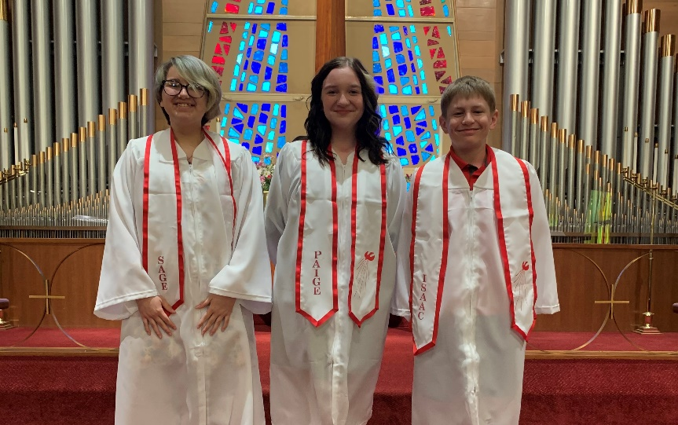

Left to Right: Sage Sutton, Paige Wichman, and Isaac Stollfuss.

Congratulations to our Graduates
Kayla Tremore graduated from Concordia University on May 14th with a bachelor of science degree with an emphasis in Event Management.

Congratulations to Riley Baranczyk as he graduates from Ripon High School. One of Riley's main passions is motorbike racing, and he will be entering the workforce full time after high school. Lord's blessings Riley!

Congratulations to Christian Grunert on his graduation from Ripon High School. He will be attending Ripon College in the fall, and has won numerous scholarships in preparation for his time there. He plans to major in Math and Sports Management.

LWMS
Mark your calendar for Sunday, June 12th

Who: All members of Mt. Zion
What: Pie and ice cream social
When: After church on Sunday June 12th
Where: Church fellowship hall

You may eat in the fellowship hall or take the wonderful dessert home and enjoy at your leisure. Please stop down and have a piece of pie with or without ice cream. Yum!!!!!!!
A Free will offering will be accepted for the Lutheran Women’s Missionary Society Send One Sister (SOS) Fund. Send One Sister (SOS) was designed to give a woman, who might not otherwise be able to attend a national convention because of financial reasons, a chance to attend her first convention by using SOS funds. Mt Zion ladies would like to help the Beaver Dam LWMS Circuit send a few women to the convention in La Crosse in 2023.

Kids C.A.R.E.
The 2021-2022 Kids C.A.R.E. project, Outreach to Roma, has come to an end. Mt. Zion contributed $564. Thank you so much for your generosity which will help our Bulgarian missionaries share the gospel message with the Roma people. Please continue to keep Kids C.A.R.E. in your prayers.

Kids C.A.R.E. The 2021-2022 Kids C.A.R.E. project, Outreach to Roma, has
come to an end. Mt. Zion contributed $564. Thank you so much for your
generosity which will help our Bulgarian missionaries share the gospel
message with the Roma people. Pleas continue to keep Kids C.A.R.E. in your
prayers
Kids C.A.R.E. The 2021-2022 Kids C.A.R.E. project, Outreach to Roma, has
come to an end. Mt. Zion contributed $564. Thank you so much for your
generosity which will help our Bulgarian missionaries share the gospel
message with the Roma people. Pleas continue to keep Kids C.A.R.E. in your
prayers
On the Lighter Side!

Lynch, June |  |  |  | 6/1/1934
Viertel, Cindy |  |  |  | 6/1/1961
Quade, Gary |  |  |  | 6/2/1961
Schliepp, Linda |  |  |  | 6/2/1951
Newcomb, Conner |  |  |  | 6/3/2008
Niemuth, Raylee |  |  |  | 6/3/2021
Scott, Benjamin |  |  |  | 6/3/1985
Sitter, Thomas (TJ) |  |  |  | 6/3/1958
Bradley, Blake |  |  |  | 6/4/2009
Frank, Kaitlin |  |  |  | 6/7/1993
Hollatz, Jordan |  |  |  | 6/8/1995
Sanchez, Easton |  |  |  | 6/8/2014
Hilke, Melissa |  |  |  | 6/9/1973
Strook, Lyle |  |  |  | 6/14/1953
Beier, Christopher |  |  |  | 6/15/1980
Niemuth, Rick |  |  |  | 6/15/1957
Mack, Lily |  |  |  |  | 6/17/2007
Samuelson, Crystal |  |  |  |  | 6/17/1992
Ewald, Debra |  |  |  |  | 6/21/1962
Kutz, Zachary |  |  |  |  | 6/23/1995
Roeder, Mark |  |  |  |  | 6/23/1962
Sprague, Kathleen |  |  |  |  | 6/23/1950
Martinez, Bodie |  |  |  |  | 6/24/2020
Toman, Dawn |  |  |  |  | 6/24/1971
Wichman, Susan |  |  |  |  | 6/24/1958
Mann, Lonnie |  |  |  |  | 6/26/1948
Rivera, Susan |  |  |  |  | 6/28/1962
Giese, Myrtle |  |  |  |  | 6/29/1924
Kemnitz, Nancy |  |  |  |  | 6/29/1942
Sanchez, Krista |  |  |  |  | 6/29/1990
Zellmer, Dustin |  |  |  |  | 6/29/2002

Ronald and Carrielee Chappa 6/2/2007
Harley and Kathleen Dorsey Jr. 6/3/1961
Jonathon and Barbara Stansfield 6/5/1982
Kurt and Lisa Schwandt 6/6/1998
Rick and Sara Retelle 6/9/2012
Lyndon and June Lynch 6/14/1952
Dennis and Lynne Hartman 6/15/1963
Jeff and Vicky Dickerson 6/16/2018
Norbert and Diane Gratton 6/16/1973
Raymond and Bernice Ziebell 6/17/1967
Ben and Sarah Isaac 6/18/2016
Jerome and Dianne Witkowski 6/24/1973
John and Cherie Anderson 6/30/1978

10
Mt. Zion Messenger
June, 2022

Mt. Zion Evangelical Lutheran Church
320 Mt. Zion Dr. Ripon, WI 54971
Pastor Michael Sheppard

Church Email: mountzionripon@gmail.com
Church Website: www.mtzionripon.org

Pastor’s Office: 920-748-9734
Pastor’s Email: revmikesheppard@gmail.com

Newsletter Articles
Since there will be more than one person assembling the newsletter, please email the church office with news/articles. Deadline for articles for the July edition is June 17th, 2022. Please either give news/articles to Jo Meeker or email them to the church office at mountzionripon@gmail.com.

We are always looking for human interest news from our members! If there is any incorrect information, please let us know that as well.

11

