Mt. Zion Ev. Lutheran Church
320 Mt. Zion Dr.
Ripon, WI 54971

The Sheppard’s Pen
This Photo by Unknown Author is licensed under CC BY-NC-ND
I Am Tired!
I’ve known very few nights where I slept from bedtime until morning without waking up. Most nights I wake up three or four times at least. I wake from strange dreams. I wake with the urge to get up and visit the bathroom. I wake to the meows of a cat outside the bedroom door. On those few nights when I sleep through the whole night without waking, I don’t remember dreaming.
Sometimes we can be restless at night. At other times we can’t seem to wake up, even with our alarm clock, when we need to get up for church or for work. Some days we work so hard physically and/or mentally that we sleep deeply and not much would wake us from our slumber. Why do we get tired? What makes you tired? English dictionaries define “tired” as being “exhausted” or “sleepy.” (For those of us who are wiseacres, the word “tired” also can mean “having tires”.) Being tired does mean being exhausted. We may use this word to express our frustration as we endure difficulty for a long time. Like when we carry a heavy box and our arms start to ache, we carry emotional or spiritual burdens that cause us to be tired.
We carry our crosses as we follow our Savior. We struggle with the weight of temptations to disobey our God. As we sin, we carry the burden of guilt. We struggle as we think we don’t deserve to have a particular struggle. We endure aches and loss. We struggle with the measure or lack of wealth the Lord gives us, failing to be content. We wrestle with ourselves as we want to serve God but fail to be perfect as he requires.
Wouldn’t it be a relief to put down the burden of our crosses? One day we will when our Savior Jesus Christ relieves us of this burden as his angels carry us to heaven. Jesus carried his cross and was nailed to it as he fulfilled his Father’s promise to redeem all sinners. Jesus bore a weight we can’t fully imagine as he suffered under his Father’s justice because he took upon himself our sin and guilt. Because he bore his cross, we have relief from our guilt and we have relief from our burdens fully in heaven.
How do we continue with the crosses we each carry everyday of our lives as Christians? We can’t do it alone. We bear our burdens with the Lord who gives us strength. We go to sleep at night with the peace of our God’s forgiveness. We go to sleep trusting that our God doesn’t abandon us. We can sleep restful sleep knowing when the Lord wills, he will give us strength for each day and relieve our burdens for eternity in heaven. With this certainty and often in weariness, Christians have sung the following hymn:
Müde Bin Ich (Literally, Tired Am I)
(A German hymn and lullaby. Sung to the tune of Now the Light Has Gone Away which is an English translation of the German hymn: CW21 #784, CW93 #593, and TLH #653)
German | English
1. Müde bin ich, geh zur Ruh,  schließe meine Aueglein zu.  Vater, laß die Augen dein  über meinem Bette sein!  2. Hab' ich Unrecht heut getan,  sieh es, lieber Gott nicht an.  Deine Gnad und Christi Blut  macht ja allen Schaden gut.  3. Alle, die mir sind verwandt,  Gott, laß ruhn in deiner Hand;  Alle Menschen, groß und klein  sollen dir befohlen sein.  4. Kranken herzen sende Ruh',  nasse Augen schließe zu;  laß uns fest in Glauben stehn  bis wir ein zum Himmel gehn. | I am tired and go to sleep  I close my little eyes  Father, let Your eyes  Watch over my bed.  What I did wrong today  Don't look at it, Loving God.  Your grace and Christ’s blood  Change every harm to good.  Let all my relatives  Rest in Your hand  All people, old and young,  Should to you be commended.  Send rest to hurting hearts  Close crying eyes  Let us each firm in faith stand  Until we to heaven go.

January 2023
General Announcements

Private Communion
Pastor Sheppard is happy to offer private communion to those who prefer it; simply email him (revmikesheppard@gmail.com) or call him (920-745-0883) to schedule a time.

Online Streaming
We are livestreaming on Facebook Live Sundays at 9:00am. Services will also be uploaded to Rumble (Mt. Zion’s channel is mtzionripon) and the link will be posted on the church website in the VIDEOS subheading under the MEDIA tab. Services will still be available on DVD. Please feel free to contact Pastor Sheppard with questions.

Christian Family Solutions
Christian Family Solutions is a WELS affiliated organization providing counselling services to the hurting. Both in person and video appointments are available for those in need by contacting CFS directly. Mt. Zion is a partner with them through the Member Assistance Program (MAP). Our church has a fund dedicated to assisting our members with the cost of these services. If financial assistance is needed, Pastor Sheppard notifies Christian Family Solutions and assistance will be given towards the cost of appointments. Video counseling by computer may be conducted at the church when necessary. For more information, visit https://christianfamilysolutions.org.

Altar Flowers
If you wish to have flowers put on the altar in the future, please contact Marilyn Ninneman at 748-6474 in addition to signing up on the flower chart.

Kitchen & Church Cleaning
2 cleaning lists have been created - one is on the bulletin board upstairs and includes everything except kitchen tasks. Another list is in the kitchen for tasks to complete there. This is open to anyone in the congregation who is willing to help. When you complete a task, please write your name and date completed by that task. Thank you for your help!
Helping Hands
If you are interested in helping someone with technology, helping give rides to appointments in Ripon, Berlin, Oshkosh, or Fond du Lac, please let Joanne Gregor know. If you or someone you know needs assistance, please contact Lisa Tremore at 920-229-1297, Tammy Niemuth at 920-299-0240 or Joanne Gregor at 920-896-1518. If you need assistance of any kind, please do not feel like you are imposing; this is why Helping Hands exists!

Kids C.A.R.E.:
In September, we launched the LWMS Kids C.A.R.E. home mission project, “Mi Amigo Jesús” (My Friend Jesus), for the Family Ministry Outreach Fund–Hispanic Ministries. This Kids C.A.R.E. project will support home mission congregations that want to begin or expand outreach efforts to their Hispanic families and communities with toddler/early childhood social interactive programs, such as Mornings with Mommy. You can support this home mission by using your weekly offering envelopes. Thank you for your support. Please keep Kids C.A.R.E. in your prayers.

2023 Men of His Word Conference
– MAN UP: in a man down world --
This year’s theme states succinctly what Christian men are supposed to do (Man Up!) and how the world/society is treating men (a man down world).

Joshua 24:14a encourages us, “Fear the Lord and serve him wholeheartedly and faithfully” (EHV). Joshua was delivering his "farewell sermon" to the Israelites, encouraging them to "man up" by honoring the LORD, removing spiritual distractions and keeping focused on a life of grateful, devoted service to God. Joshua urged the people to make God-pleasing use of their sanctified freewill by choosing to serve the LORD, not false gods, and by being faithful to the LORD, not foolishly pursuing their sinful whims of the past. Without being prideful, Joshua directed the people to observe himself and his own family as examples, by saying, "As for me and my household - we will serve the LORD!" Join us to learn how you can MAN UP in this man down world.

The 14th Annual MOHW Conference will be held at the Best Western Premier Waterfront Convention Center in Oshkosh on Saturday, February 18 2023. Additional details and online registration are available at www.menofhisword.org . The registration fee is $60 for adults and $30 for youth – these rates increase to $75 and $37 respectively after January 29th. Please join us for a day of worship, praise and fellowship in God’s Word!
100 Missions in 10 Years

At the 2021 Synod Convention, delegates enthusiastically approved a WELS Home Missions initiative to plant 100 home mission churches and enhance 75 ministires in 10 years beginning in 2023. During the same time, we want to support 75 enhancement grants to help existing congregations reah more souls, often in other cultures. This is a BIG challenge. An impossible one you might say. But this initiative isn’t as much about planting more churches but about sharing the gospel of Jesus Christ. It’s about aggressively reaching lost souls. We pray that God will bless our efforts, trusing that he is able to do immeasurably more than all we ask or imagine. Learn more about this initiative, stay up to date on progress, and learn how you can get involved in this synod-wide church planting effort at wels100in10.net.

On The Lighter Side
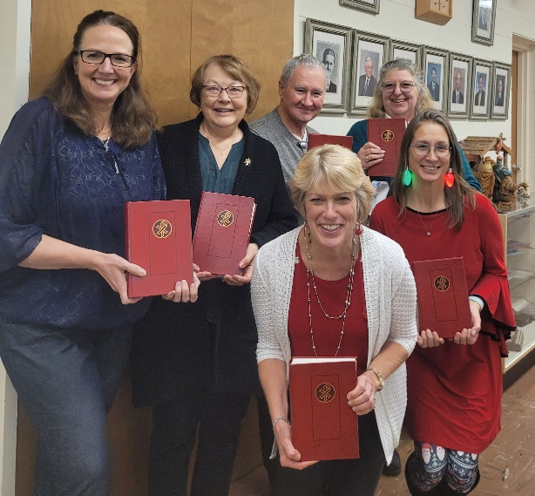

Winners of the 2022 Christmas Party Games. Everyone enjoyed an evening of fellowship and a delicious meal catered by Websters. Hope to see you there next year!

Robert Kranz | 1/1/1972 |  | Janet Brooks | 1/16/1945
Kyle Hilke | 1/2/2001 |  | David Patchett | 1/16/1944
Vicky Dickerson | 1/4/1971 |  | Jan Ohlrich | 1/24/1954
Bennett Gonzales | 1/5/2009 |  | Caitlin Goeldi | 1/25/1989
Joelitta Meeker | 1/7/1953 |  | Vincent Goeldi | 1/25/2020
Lincoln Chitwood | 1/8/2020 |  | Brittany Taylor | 1/25/1996
Jenna Williams | 1/8/2000 |  | Julius Zrinsky | 1/25/2002
Dennis Timm | 1/10/1952 |  | Lisa Schwandt | 1/26/1968
Edward Manske | 1/11/1964 |  | Sara Grunert | 1/28/1978
Randal Revels | 1/11/1964 |  | Helen Timm | 1/28/1929
Richard Zellmer | 1/12/1945 |  | Michael Jung Sr. | 1/30/1973

Gary and Katherine Gitzel 1/3/1986
Allen E. and Linda Judas 1/14/2000
Ferd A. and Mildred Roeder 1/19/2014
Larry R. and Sally A. Ehrenberg 1/23/1960

Mt. Zion Messenger
January, 2023

Mt. Zion Evangelical Lutheran Church
320 Mt. Zion Dr. Ripon, WI 54971
Pastor Michael Sheppard

Church Email: mountzionripon@gmail.com
Church Website: www.mtzionripon.org

Pastor’s Office: 920-748-9734
Pastor’s Email: revmikesheppard@gmail.com

Newsletter Articles
Since there will be more than one person assembling the newsletter, please email the church office with news/articles. Deadline for articles for the February edition is January 21st, 2023. Please either give news/articles to Jo Meeker or email them to the church office at mountzionripon@gmail.com.

We are always looking for human interest news from our members! If there is any incorrect information, please let us know that as well.

