Mt. Zion Ev. Lutheran Church
320 Mt. Zion Dr.
Ripon, WI 54971

The Sheppard’s Pen
This Photo by Unknown Author is licensed under CC BY-NC-ND

January, 2024

The Epiphany of our Lord and the Epiphany Season
Epiphany
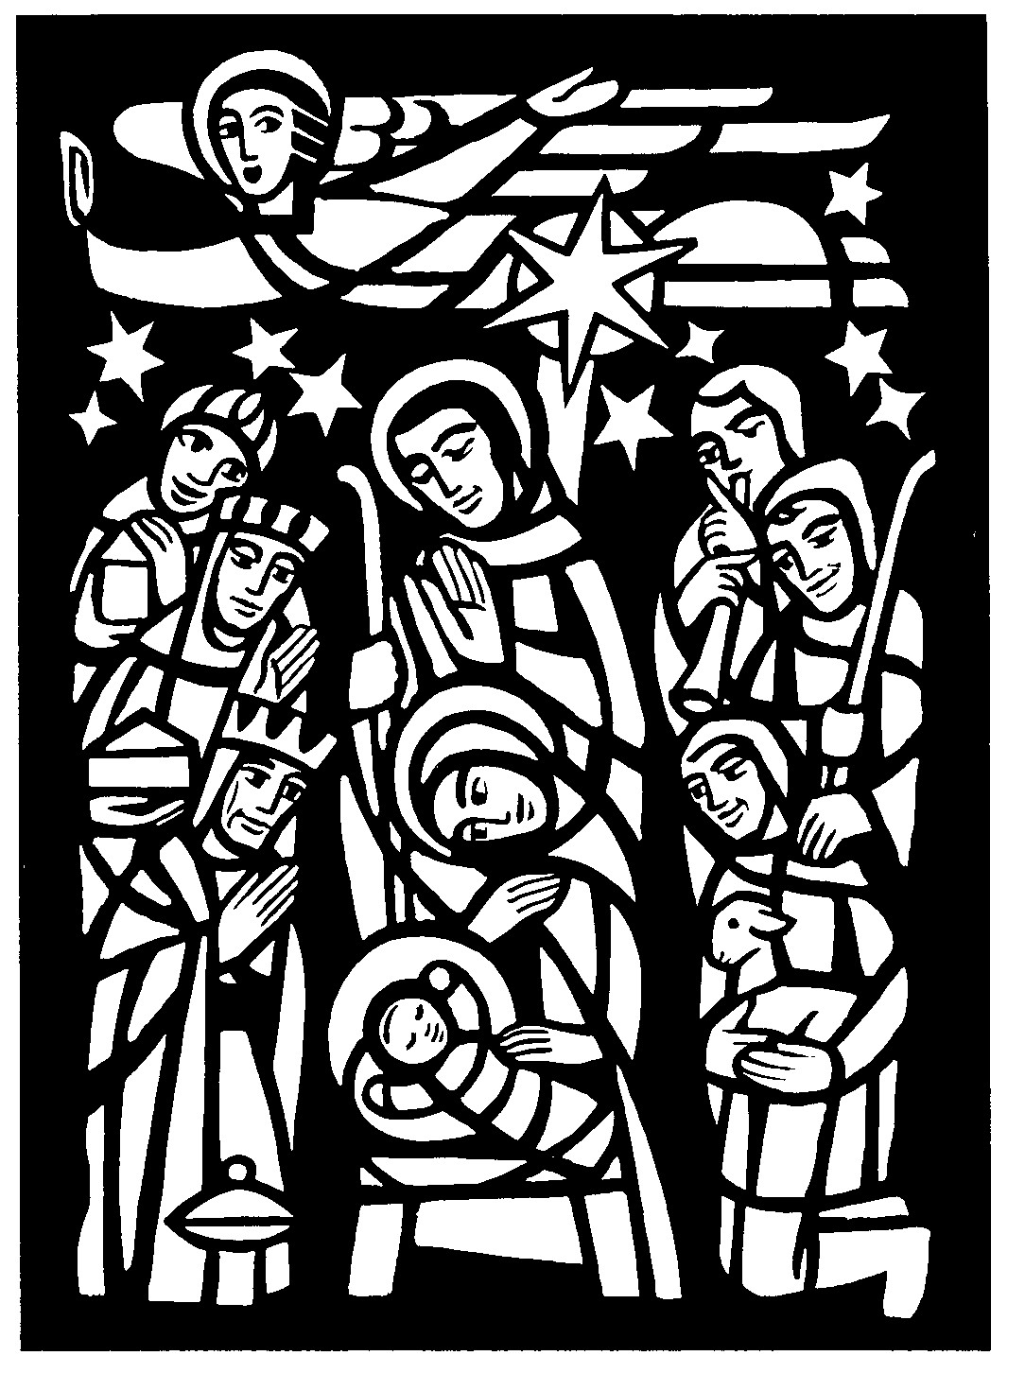
(1) : a usually sudden manifestation or perception of the essential nature or meaning of something
(2) : an intuitive grasp of reality through something (such as an event) usually simple and striking
(3) : an illuminating discovery, realization, or disclosure
(https://www.merriam-webster.com/dictionary/epiphany)

The word “epiphany” conveys the concept of something being shown or made known. Christians have chosen this word to describe the season after Christmas. What has been made known? To what do the gospels and other lessons direct our attention?
The Epiphany of our Lord always falls on January 6th, although it may be celebrated on the closest Sunday to that date. The Gospel reading for Epiphany lays the theme for the season of Epiphany. In Matthew chapter two, Matthew recounts for us the wise men who traveled far from the East to worship the Christ. These men were gentiles who had known of the coming Savior. The Savior came to redeem all mankind - both Jews and Gentiles. Often included at Christmas, the account of the Magi reveals that it was some time after Jesus’ birth that they came to the house where the child was.
Throughout the Epiphany Season, we see in the gospel readings events in the life of Jesus demonstrating that he is the Savior. The first Sunday after Epiphany is the Baptism of our Lord where the Holy Spirit and the Father showed John the Baptist that his cousin is indeed the Christ, the Son of God. In this season we are brought to the wedding at Cana where our Lord Jesus turned water into wine. The final Sunday of the season is called the last Sunday after Epiphany, the Transfiguration of our Lord. There on the mountain Peter, James, and John glimpsed the glory of the Lord as Jesus was transfigured before their eyes.
The Epiphany season starts with the Magi on January 6th and ends on the mount of transfiguration. The length of the season flexes. Easter falls at the time of the Passover. The dates for the Passover celebration follow the lunar calendar so that Passover and Easter move each year within a certain timeframe. The Epiphany season can be as long as nine Sundays or as short as it is this year with only six Sundays.
The Epiphany of our Lord, the Baptism of our Lord, and the Transfiguration of our Lord customarily have the color white, which is a symbol of holiness. Green is the color of the rest of the Sundays after Epiphany, conveying the thought of growing and life.
The Last Sunday of Epiphany is also often a day when the congregation says a temporary goodbye to Alleluia. We will discuss this more in the next newsletter as we focus on Lent.
As we continue through the Season of Epiphany, read the readings for each Sunday and answer the question, “How do these lessons focus on our Savior being made known as the Savior of all people?”

General Announcements

Pictorial Directory Update
We will be taking the photos and addresses in January to Good Impressions here in Ripon to make our church directory. Cost estimate is approximately $5 per book. The final cost will be determined once the directories are finished. If anyone would like a digital copy of your picture that Miya Grunert took of you with the background, please contact Miya at miyagrunert@gmail.com.
Pancake Breakfast
A pancake breakfast will be served on Sunday January 14th after the service. The free will offering money will go to the LWMS Send One Sister program.

Bible Studies
Monday evenings at 6:30pm we are looking at Luther’s Large Catechism; Tuesday mornings at 9:00am we are studying the book of Revelation; and Sunday mornings at around 10:15am is yet to be determined. Please join us for one or more of the classes!

Sound System
The components we ordered have now been installed. They include a mixer with monitor, a few new speakers to supplement the current ones, new microphones, and a new CD player. We have options for additional components if we need them in the future. Thank you for your contributions.

End of Year Statements
The 2023 offering statements will be done in January. Watch the bulletin and newsletter for updates.

Private Communion
Pastor Sheppard is happy to offer private communion to those who prefer it; simply email him (revmikesheppard@gmail.com) or call him (920-745-0883) to schedule a time.

Online Streaming
We are livestreaming our services on Facebook Live Sundays at 9:00am. Services will also be uploaded to Rumble (Mt. Zion’s channel is mtzionripon) and the link will be posted on the church website in the VIDEOS subheading under the MEDIA tab. Services will still be available on DVD. Please feel free to contact Pastor Sheppard with questions.

Christian Family Solutions
Christian Family Solutions is a WELS affiliated organization providing counselling services to the hurting. Both in person and video appointments are available for those in need by contacting CFS directly. Mt. Zion is a partner with them through the Member Assistance Program (MAP). Our church has a fund dedicated to assisting our members with the cost of these services. If financial assistance is needed, Pastor Sheppard notifies Christian Family Solutions and assistance will be given towards the cost of appointments. Video counseling by computer may be conducted at the church when necessary. For more information, visit https://christianfamilysolutions.org.

Helping Hands
If you are interested in helping someone with technology, helping give rides to appointments in Ripon, Berlin, Oshkosh, or Fond du Lac, please let Joanne Gregor know. If you or someone you know needs assistance, please contact Lisa Tremore at 920-229-1297, Tammy Niemuth at 920-299-0240 or Joanne Gregor at 920-896-1518. If you need assistance of any kind, please do not feel like you are imposing; this is why Helping Hands exists!

Here is an opportunity to actively help:
Currently Pastor and Bernice Ziebell’s health have created challenges for them. Hopefully as a congregation, we can provide them with the necessary support they need for household chores such as light housekeeping, laundry and running errands. Also, there are times when they need transportation to doctors’ appointments. When Pastor has an appointment, Bernice needs someone to stay with her.
If you could help them with household jobs once or twice a month, take them to appointments or stay with Bernice it would be greatly appreciated.
Please let us know what you would be willing to do for the Ziebells indicating which day of the week and time that would best work for you by emailing Mt. Zion (mountzionripon@gmail.com), calling Jo at church (920-748-5641) or through Helping Hands (Joanne Gregor at 920-896-1518, Lisa Tremore at 920-229-1297 or Tammy Niemuth at 920-299-0240.) After hearing from you, a schedule will be created. You will be contacted to confirm the scheduled date and time.
Thank you for supporting the Ziebells during this challenging time.
God’s blessings,
Mt. Zion’s Helping Hands

Since 2005, children have been supporting the Lutheran Women’s Missionary Society (LWMS) Kids C.A.R.E. (care about reaching everyone with the gospel) program. Through Kids C.A.R.E. our children learn about and support our synod’s home and world mission projects. Mt. Zion has participated in Kids C.A.R.E. since 2013. This year’s Kids C.A.R.E. project will be a home mission program, Missionary Kids Retreats. This year we will support our WELS missionary kids with our prayers and offerings to help them attend these much-needed annual retreats. You can donate to this mission using the blank line on your offering envelopes. Please consider giving an offering to Missionary Kids Retreat as well as keeping this year’s Kid C.A.R.E. project in your prayers.

Second Impressions

Store Hours
Tuesday thru Friday 9 AM – 6 PM
Monday and Saturday 9 AM – 3 PM

Donation Accepted Times
Monday 10 AM – 3 PM
Tuesday thru Friday 10 AM – 4 PM
Saturday 10 AM – 3 PM

New Items Arrive Daily...Come Over And Check Them Out!

Brand new for the winter season are handmade children’s mittens for $3. They are made of fleece in many delightful patterns.

Donations: Thank you to everyone who has so generously donated to our store! We can always use any type of donation. Items ACCEPTED include, but are not limited to: Furniture (Please call ahead before donating large furniture!), In-Season Clothing, Purses, Shoes, Jewelry, Tools & Hardware, Pictures & Frames, Home Décor, Christmas & Seasonal/Holiday Items, Arts & Crafts, Toys, Kitchen & Glassware, Books, Linens/Towels/Sheets.

Student Needs Closet
The Ripon Area School District has a Student Needs Closet to help all students in grades 4K to 12 have access to hygiene products such as soap, shampoo, toothbrushes, combs/brushes, and hair ties just to name a few items. These items are available to them that they may not have access to them at home. Under Ripon Area School District’s Director of Pupil Services, Emmy Jess, Miya Grunert has volunteered her time organizing the closet and found that there is a need for several items. Mt. Zion can help support the Student Needs Closet with donations.

There are two boxes near the water fountain (by the office) where donations can be placed. Each month there will be a list of items that are needed for the closet. Information about the items for the closet will be in the weekly bulletins, as well as the monthly newsletter.

By supporting and collecting donations for The Student Needs Closet, we can help the students of the Ripon Area School District, help Emmy Jess (and Miya) maintain and stock the closet; along with using this as an opportunity to serve the Lord in our community.
Thanks so much for your support and donations to the Ripon Area School District Students Needs Closet.

Items needed for the Ripon Area School District Student Needs Closet

High Priority:
Mens’ shampoo
Mens’ body wash
Mens’ deodorant
Womens’ deodorant
Bar soap

Also need:
Girls’ shampoo
Feminine products
Body wipes and/or baby wipes
Toothbrushes
Chapstick
Fabric freshener (travel size)
Band-aids

Could also use:
Kleenex
Toothpaste
Combs/brushes
Body mist/spray
Travel size laundry detergent

Pathways to Christ: Jesus Christ is the same yesterday and today and forever. Hebrews 13:8 This is the theme passage for the 2024 Pathways to Christ Women's Retreat held in Oshkosh, WI on March 1-3, 2024. We are pleased to announce that registration for 2024 Pathways to Christ Retreat is now open! Please go to our website https://pathwaystochrist.org/ for more information about speakers, topics, accommodations, and more! On our website you have the choice to download and print a PDF registration form to mail in, or there is an additional link to our eventbrite link to register online. Please reach out via email at pathwaystochristretraet@gmail.com with any questions.

Men of His Word Conference
This year’s theme – Built To Serve - is based off of Galatians 5:13 You, my brothers and sisters, were called to be free. But do not use your freedom to indulge the flesh; rather, serve one another humbly in love.

Do you ever wonder if you’re the right man for the job? I think I’ve spent most of my life trying to figure out what I’m good at doing. We all want to be good at something. Whether we realize it or not, God has given each of us the exact abilities we need to do the work he has planned out for us. And, Galatians 5:13 reminds us that Christ has set us free so that we can use those abilities to serve one another in love. Join us at Men of His Word to learn how you are Built to Serve in all of the different vocations to which God has called you.

The 15th Annual MOHW Conference will be held at the Oshkosh Waterfront Convention Center in Oshkosh on Saturday, February 17, 2024. Additional details and online registration are available at www.menofhisword.org . The registration fee is $65 for adults and $35 for youth – these rates increase to $80 and $40 respectively after January 29th. Please join us for a day of worship, praise and fellowship in God’s Word!

On The lighter Side
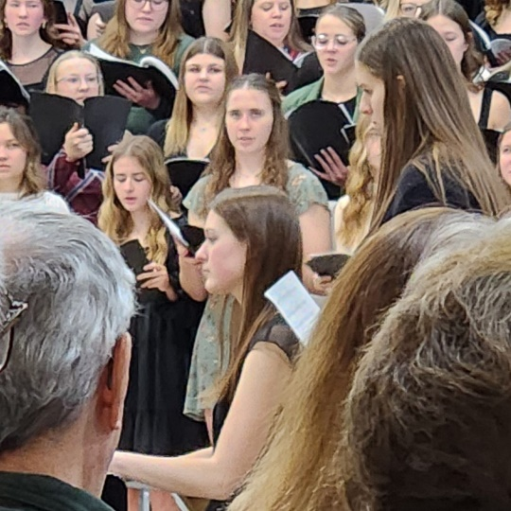
Pictured at the piano at WLA’s Christmas concert is Abby Pieper. She is the granddaughter of Laurel (Semesnke) Behm, and therefore the great-granddaughter of Pastor and Irene Semenske. She played the piano and clarinet when WLA was here at Mt. Zion on December 3rd. She also sang in the choir with her brother Colin.
Gary and Kathy Gitzel 1/3/1986
Allen and Linda Judas 1/14/2000
Ferd and Mildred Roeder 1/19/2014
Larry and Sally Ehrenberg 1/23/1960

Robert Kranz 1/1
Vicky Dickerson 1 / 4
Bennett Gonzalez 1/5
Jo Meeker 1/7
Lincoln Chitwood 1/8
Dennis Timm 1/10
Ed Manske 1/11
Randy Revels 1/11
Dick Zellmer 1/12
Dave Patchett 1/16
Janet Brooks 1/16
Jan Ohlrich 1/24
Brittany Taylor 1/25
Caitlin Goeldi 1/25
Vincent Goeldi 1/25
Lisa Schwandt 1/26
Sara Grunert 1/28
Mike Jung, Sr. 1/30

Mt. Zion Messenger
January, 2024

Mt. Zion Evangelical Lutheran Church
320 Mt. Zion Dr. Ripon, WI 54971
Pastor Michael Sheppard

Church Email: mountzionripon@gmail.com
Church Website: www.mtzionripon.org

Pastor’s Office: 920-748-9734
Pastor’s Email: revmikesheppard@gmail.com

Newsletter Articles
Deadline for articles for the February edition is January 26, 2024. Please either give news/articles to Jo Meeker or email them to the church office at mountzionripon@gmail.com.

We are always looking for human interest news from our members! If there is any incorrect information, please let us know that as well.

