Good Friday
March 29, 2024 1:00 PM
Hymn Stricken, Smitten and Afflicted CW 430
Stand
In the name of the Father and of the T Son and of the Holy Spirit.
Amen.
If we claim to be without sin, we deceive ourselves and the truth is not in us.
If we confess our sins, God is faithful and just
and will forgive us our sins
and purify us from all unrighteousness.
Let us confess our sins to the Lord.
Holy God, gracious Father,
I am sinful by nature
and have sinned against you in my thoughts, words, and actions.
I have not loved you with my whole heart;
I have not loved others as I should.
I deserve your punishment both now and forever.
But Jesus, my Savior, paid for my sins
with his innocent suffering and death.
Trusting in him, I pray: God, have mercy on me, a sinner.
Silence for meditation and reflection
Our gracious Father in heaven has been merciful to us. He sent his only Son, Jesus Christ, who gave his life as the atoning sacrifice for the sins of the whole world. Therefore, as a called servant of Christ and by his authority, I forgive you all your sins in the name of the Father and of the T Son and of the Holy Spirit.
Amen.
In peace let us pray to the Lord.
Lord, have mercy.
For the peace from above and for our salvation, let us pray to the Lord.
Lord, have mercy.
For the peace of the whole world, for the well-being of the Church of God, and for the unity of all, let us pray to the Lord.
Lord, have mercy.
For this holy house and for all who offer here their worship and praise, let us pray to the Lord.
Lord, have mercy.
Help, save, comfort, and defend us, gracious Lord.
Amen.
The Lord be with you.
And also with you.
Let us pray.
God Most Holy, look with mercy on this, your family, for whom our Lord Jesus Christ was willing to be betrayed, be given over into the hands of the wicked, and suffer death upon the cross. Keep us always faithful to him, our only Savior, who now lives and reigns with you and the Holy Spirit, one God, forever and ever.
Amen.
Be seated
First Reading Isaiah 52:13—53:12
Look, my servant will succeed.
He will rise. He will be lifted up. He will be highly exalted.
¹⁴Just as many were appalled at him—
his appearance was so disfigured that he did not look like a man,
and his form was disfigured more than any other person—
¹⁵so he will sprinkle many nations,
and kings will shut their mouths because of him,
because they will see something they had never been told before,
and they will understand something they had never heard before.
^{53:1}Who has believed our report,
and to whom has the arm of the Lord been revealed?
²He grew up before him like a tender shoot
and like a root from dry ground.
He had no attractiveness and no majesty.
When we saw him, nothing about his appearance made us desire him.
³He was despised and rejected by men,
a man who knew grief,
who was well acquainted with suffering.
Like someone whom people cannot bear to look at,
he was despised,
and we thought nothing of him.
⁴Surely he was taking up our weaknesses,
and he was carrying our sufferings.
We thought it was because of God
that he was stricken, smitten, and afflicted,
⁵but it was because of our rebellion that he was pierced.
He was crushed for the guilt our sins deserved.
The punishment that brought us peace was upon him,
and by his wounds we are healed.
⁶We all have gone astray like sheep.
Each of us has turned to his own way,
but the Lord has charged all our guilt to him.
⁷He was oppressed, and he was afflicted,
yet he did not open his mouth.
Like a lamb he was led to the slaughter,
and like a sheep that is silent in front of its shearers,
he did not open his mouth.
⁸He was taken away without a fair trial and without justice,
and of his generation, who even cared?
So, he was cut off from the land of the living.
He was struck because of the rebellion of my people.
⁹They would have assigned him a grave with the wicked,
but he was given a grave with the rich in his death,
because he had done no violence,
and no deceit was in his mouth.
¹⁰Yet it was the Lord’s will to crush him
and allow him to suffer.
Because you made his life a guilt offering, he will see offspring.
He will prolong his days,
and the Lord’s gracious plan will succeed in his hand.
¹¹After his soul experiences anguish, he will see the light of life.
He will provide satisfaction.
Through their knowledge of him, my just servant will justify the many,
for he himself carried their guilt.
¹²Therefore I will give him an allotment among the great,
and with the strong he will share plunder,
because he poured out his life to death,
and he let himself be counted with rebellious sinners.
He himself carried the sin of many,
and he intercedes for the rebels.
The Word of the Lord.
Thanks be to God.
Psalm O Sacred Head, Now Wounded Psalm 22A
Second Reading & Sermon Text: Hebrews 7:26–28
This is certainly the kind of high priest we needed: one who is holy, innocent, pure, separated from sinners, and exalted above the heavens. ²⁷Unlike the other high priests, he does not need to offer sacrifices on a daily basis, first for his own sins and then for the sins of the people. In fact, he sacrificed for sins once and for all when he offered himself. ²⁸For the law appoints as high priests men who have weaknesses. But the word of the oath, which came after the law, appointed the Son, who has been brought to his goal forever.

The Word of the Lord.
Thanks be to God.
Stand
Gospel Acclamation
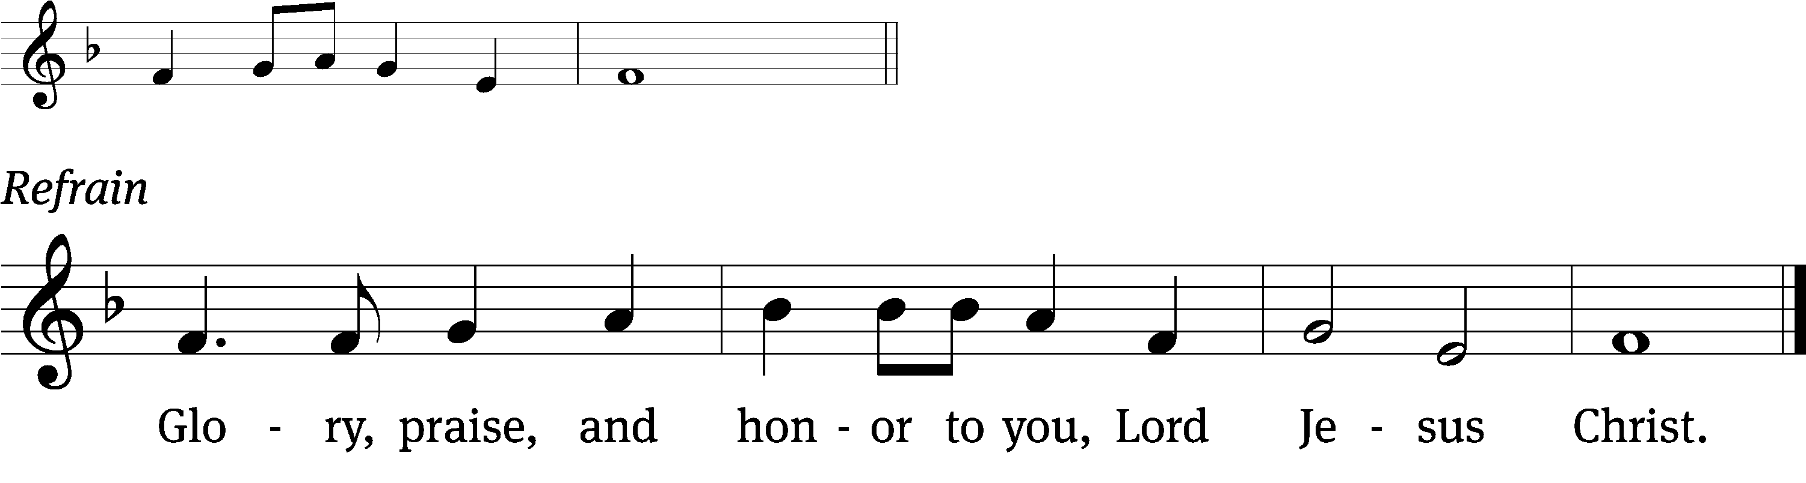
The reason the Son of / God appeared
Was to destroy the / devil’s work. Refrain

Gospel John 19:17–30
Carrying his own cross, he went out to what is called the Place of a Skull, which in Aramaic is called Golgotha. ¹⁸There they crucified him with two others, one on each side, and Jesus in the middle.
¹⁹Pilate also had a notice written and fastened on the cross. It read, “Jesus the Nazarene, the King of the Jews.”
²⁰Many of the Jews read this notice, because the place where Jesus was crucified was near the city, and it was written in Aramaic, Latin, and Greek.
²¹So the chief priests of the Jews said to Pilate, “Do not write, ‘The King of the Jews,’ but that ‘this man said, “I am the King of the Jews.”’”
²²Pilate answered, “What I have written, I have written.”
²³When the soldiers crucified Jesus, they took his clothes and divided them into four parts, one part for each soldier. They also took his tunic, which was seamless, woven in one piece from top to bottom. ²⁴So they said to one another, “Let’s not tear it. Instead, let’s cast lots to see who gets it.” This was so that the Scripture might be fulfilled which says:
They divided my garments among them
and cast lots for my clothing.
So the soldiers did these things.
²⁵Jesus’ mother, his mother’s sister, Mary the wife of Clopas, and Mary Magdalene were standing near the cross.
²⁶When Jesus saw his mother and the disciple whom he loved standing nearby, he said to his mother, “Woman, here is your son!” ²⁷Then he said to the disciple, “Here is your mother!” And from that time this disciple took her into his own home.
²⁸After this, knowing that everything had now been finished, and to fulfill the Scripture, Jesus said, “I thirst.”
²⁹A jar full of sour wine was sitting there. So they put a sponge soaked in sour wine on a hyssop branch and held it to his mouth.
³⁰When Jesus had received the sour wine, he said, “It is finished!” Then, bowing his head, he gave up his spirit.
The Gospel of the Lord.
Thanks be to God.
Be seated
Hymn A Lamb Goes Uncomplaining Forth CW422
Sermon “Our High Priest Fits Our Needs”
Stand
Nicene Creed
We believe in one God, the Father, the Almighty,
maker of heaven and earth,
of all that is,
seen and unseen.
We believe in one Lord, Jesus Christ, the only Son of God,
eternally begotten of the Father,
God from God, Light from Light, true God from true God,
begotten, not made,
of one being with the Father.
Through him all things were made.
For us and for our salvation, he came down from heaven,
was incarnate of the Holy Spirit and the Virgin Mary,
and became truly human.
For our sake he was crucified under Pontius Pilate.
He suffered death and was buried.
On the third day he rose again in accordance with the Scriptures.
He ascended into heaven
and is seated at the right hand of the Father.
He will come again in glory to judge the living and the dead,
and his kingdom will have no end.
We believe in the Holy Spirit,
the Lord, the giver of life,
who proceeds from the Father and the Son,
who in unity with the Father and the Son
is worshiped and glorified,
who has spoken through the prophets.
We believe in one holy Christian and apostolic Church.
We acknowledge one baptism for the forgiveness of sins.
We look for the resurrection of the dead
and the life of the world to come. Amen.
Prayer for Good Friday
Be seated

OFFERING: The offerings are brought forward to the altar.
The Sacrament
Stand
The Lord be with you.
And also with you.
Lift up your hearts.
We lift them up to the Lord.
Let us give thanks to the Lord our God.
It is right to give him thanks and praise.
It is truly good and right that we should at all times and in all places give you thanks, O Lord, holy Father, almighty and everlasting God, through Jesus Christ our Lord, who brought the gift of salvation to all people by his death on the tree of the cross so that the devil, who overcame us by a tree, would in turn by a tree be overcome. Therefore, with all the saints on earth and hosts of heaven, we praise your holy name and join their glorious song:
Holy, Holy, Holy CW 167
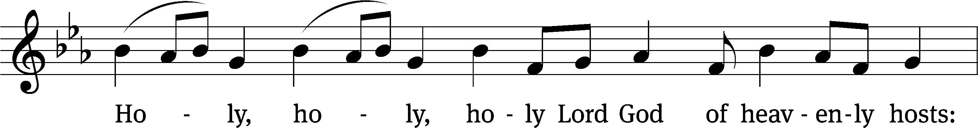
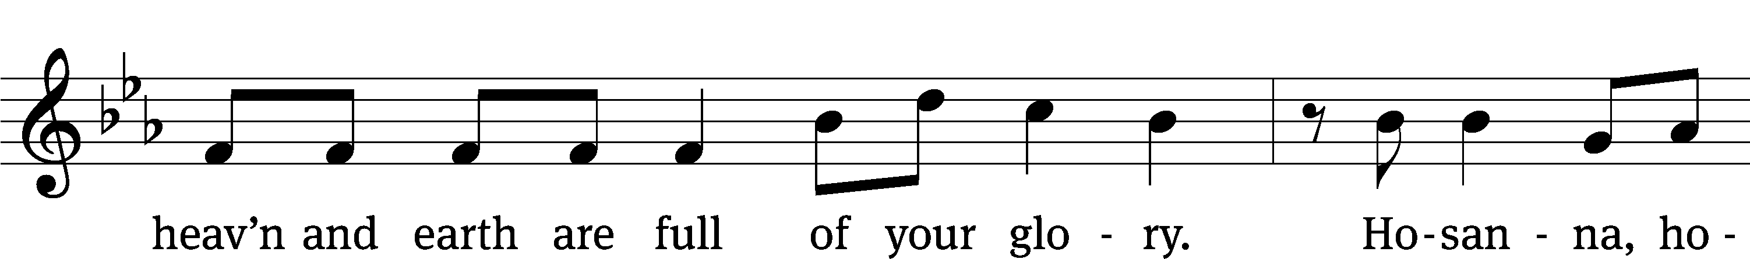
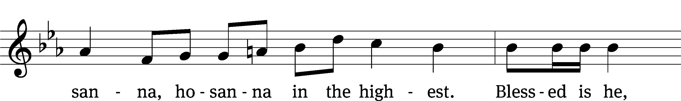
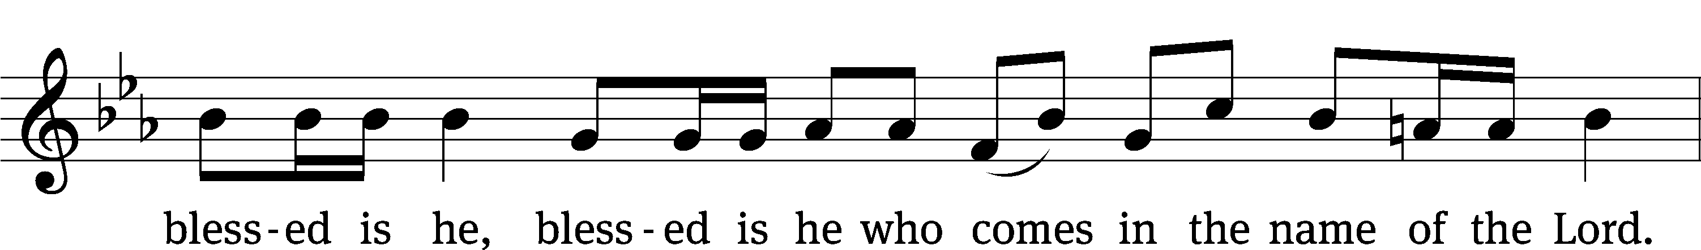
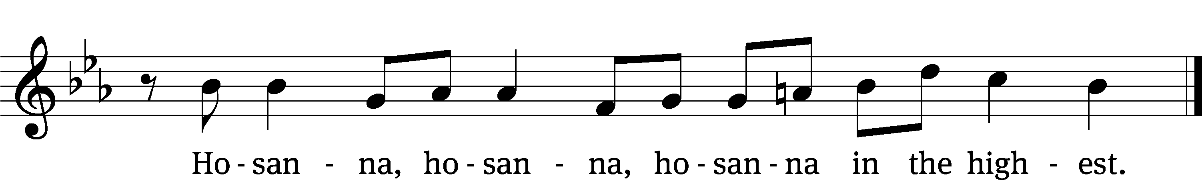

Prayer of Thanksgiving
We give thanks to you, O God, through your dear Son, Jesus Christ, whom you sent to be our Savior, our Redeemer, and the messenger of your grace. Through him you made all things; in him you are well pleased. He is the incarnate Word, conceived by the Holy Spirit and born of the Virgin Mary. To fulfill your promises, he stretched out his hands on the cross and released from eternal death all who believe in you.
As we remember Jesus’ death and resurrection, we thank you that you have gathered us together to receive your Son’s body and blood. Send us your Spirit, unite us as one, and strengthen our faith so that we may praise you in your Son, Jesus Christ. Through him, we glorify and honor you, O God our Father, with the Holy Spirit, one God, now and forever.
Amen.
Lord’s Prayer
Our Father in heaven, hallowed be your name, your kingdom come, your will be done on earth as in heaven. Give us today our daily bread. Forgive us our sins, as we forgive those who sin against us. Lead us not into temptation, but deliver us from evil. For the kingdom, the power, and the glory are yours now and forever. Amen.
Words of Institution
Our Lord Jesus Christ, on the night he was betrayed, took bread; and when he had given thanks, he broke it and gave it to his disciples, saying, “Take and eat; this is my T body, which is given for you. Do this in remembrance of me.”
Then he took the cup, gave thanks, and gave it to them, saying, “Drink from it, all of you; this is my T blood of the new covenant, which is poured out for you for the forgiveness of sins. Do this, whenever you drink it, in remembrance of me.”
The peace of the Lord be with you always.
Amen.

O Christ, Lamb of God CW 169
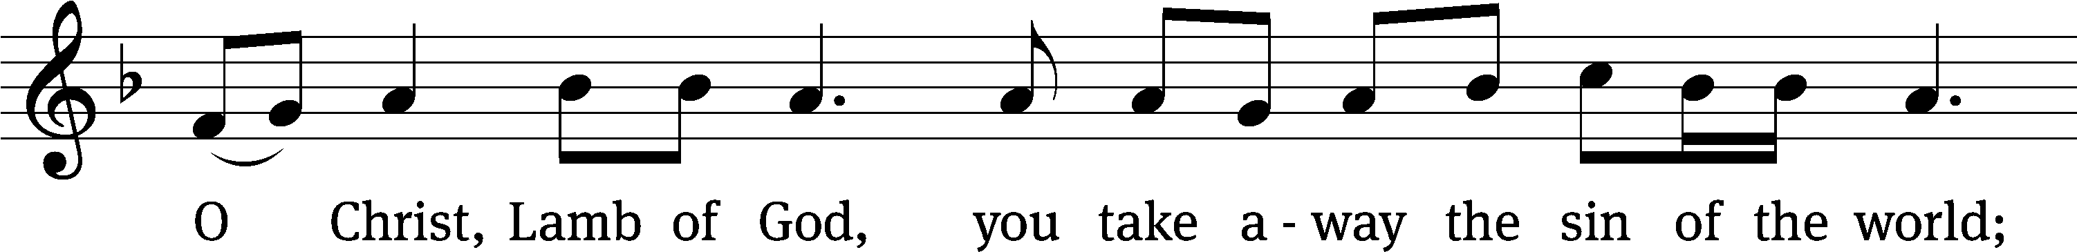
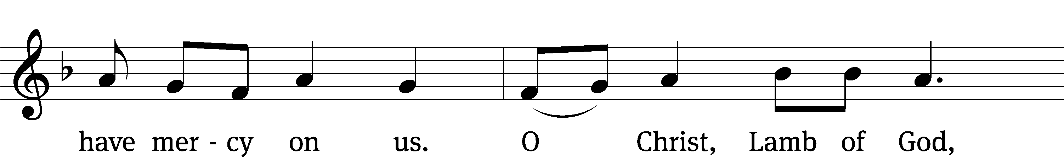
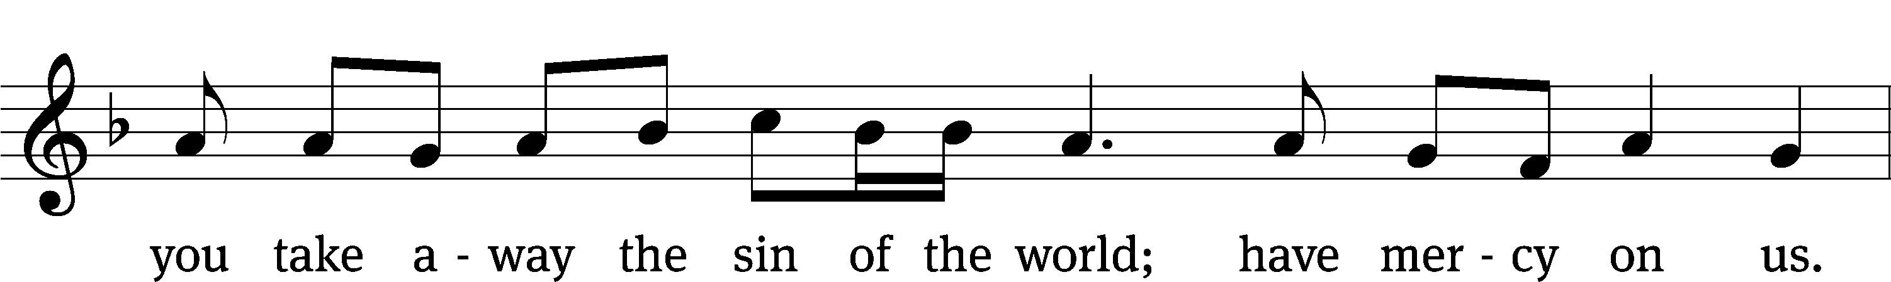
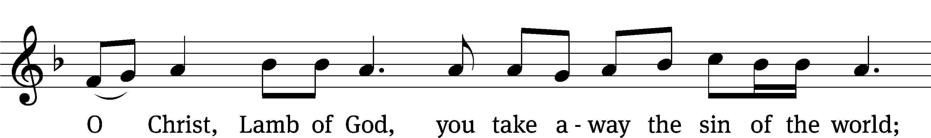
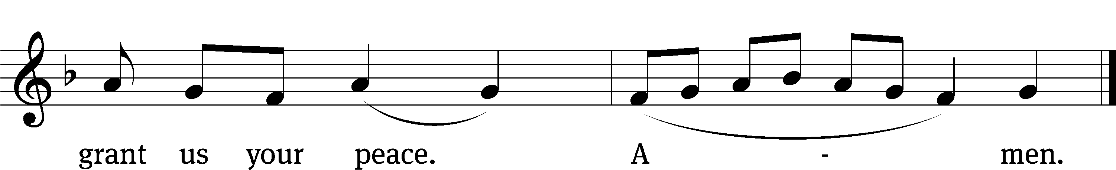

Be seated
Distribution Hymn I Come, O Savior, to Your Table CW 670
Stand
Give thanks to the Lord, for he is good;
his mercy endures forever.
Whenever we eat this bread and drink this cup,
we proclaim the Lord’s death until he comes.
We give thanks, almighty God, that you have refreshed us with this saving gift. We pray that through it you will strengthen our faith in you and increase our love for one another. We ask this in the name of Jesus Christ our Lord, who lives and reigns with you and the Holy Spirit, one God, now and forever.
Amen.

The Lord bless you and keep you.
The Lord make his face shine on you and be gracious to you.
The Lord look on you with favor and T give you peace.
Amen.
Hymn Upon the Cross Extended CW 434

