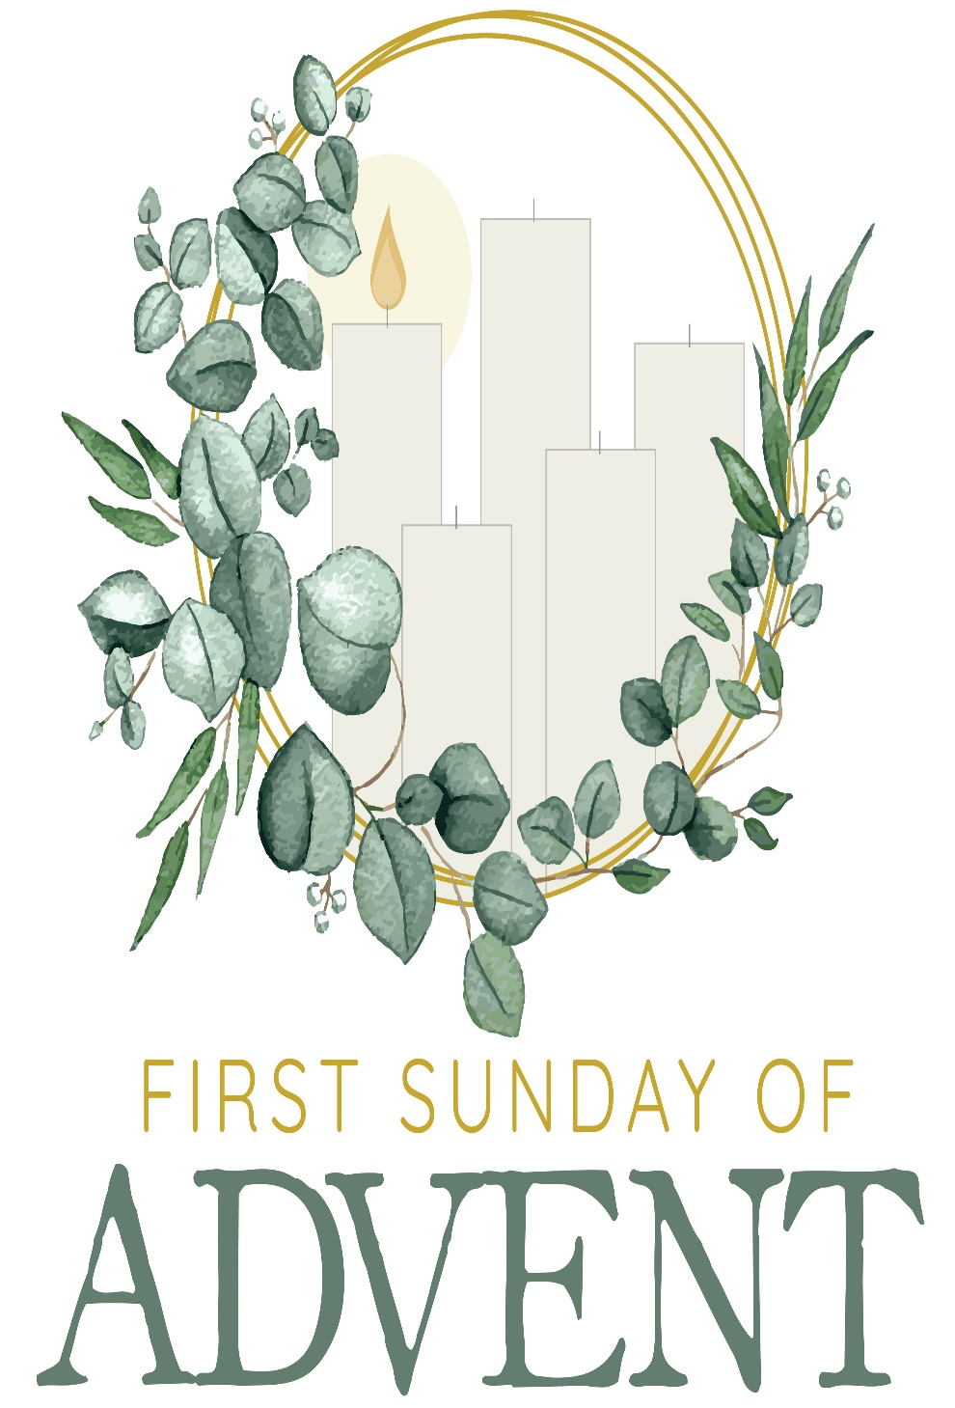

Mt. Zion Evangelical Lutheran Church
320 Mt. Zion Dr., Ripon, WI
www.mtzionripon.org
Facebook: Mt. Zion Evangelical Lutheran Church

Pastor Michael Sheppard
Pastor’s Study: 920-748-9734
E-mail: revmikesheppard@gmail.com
First Sunday of Advent Nov. 27, 2022

Welcome to Mt. Zion!
Handicapped accessible restrooms are located upstairs next to the Pastor’s Study and downstairs next to the elevator.
Attendance: Please remember to sign the friendship pads. Registration for communion will continue as usual at the table. If you have any questions or concerns please contact Pastor Sheppard or Mark Roeder.

Hearing Loop: Our sanctuary is equipped with a hearing loop system. Those who have compatible hearing aids (with a T-switch) will be able to hear the sound system directly into their ear(s). The two main seating areas and the choir area are looped so that you may sit in any of the three areas. We also have four receivers available for those who do not have compatible hearing aids. If you wish to use a receiver please ask the ushers. Those who wish may bring their own headphones or ear buds.

A note for our visitors on member communion –
Out of sincere love for the truth of God’s Word and for precious human souls, we practice member communion in our synod and congregation. This teaching, as practiced by the Church for centuries, is thoroughly Scriptural. It questions the faith of no individual yet asks that there be full doctrinal agreement between those who commune. For this reason, we ask that only those who are members of a WELS or ELS congregation join us for the Lord’s Supper. If you wish to commune with us please speak with the pastor before the service.
The front row on the pulpit side is reserved for people who are unable to navigate the steps. Pastor will serve you Communion first.

Prayer Before Communion: Dearest Jesus, I marvel that you came to this earth as the Word made flesh. With similar awe I contemplate how you give me your body and blood in the bread and wine of Holy Communion. Touch me with your grace that moved you to reach out to me, a poor, miserable sinner! Use this sacred supper to bring me closer to you. Amen.

Prayer After Communion: Thank you, Lord Jesus Christ, for nourishing me in this sacrament with your body and blood. You have given me forgiveness, life, and salvation. Let me always remain in you as a branch remains in the vine. Send me out in the power of your Spirit to live and work to your praise and glory. Amen

Hymns: 314, 301, 676, 515

Order of Worship: American Hymn Setting with Communion

First Reading & Sermon Text: Isaiah 2: 1-5 (EHV)
This is the message that Isaiah son of Amoz saw concerning Judah and Jerusalem.
²This will take place in the latter days:
The mountain of the Lord’s house will be established
as the chief of the mountains.
It will be raised above the hills,
and all nations will stream to it like a river.
³Many peoples will come and say,
“Come, let us go up to the mountain of the Lord,
to the house of the God of Jacob.
Then he will instruct us about his ways,
and we will walk in his paths.”
For from Zion the law will go out,
and the Lord’s word will go out from Jerusalem.
⁴He will judge between the nations,
and he will mediate for many peoples.
Then they will beat their swords into plowshares,
and their spears into pruning hooks.
Nation will not lift up sword against nation,
nor will they learn war anymore.
⁵O house of Jacob, come,
and let us walk in the light of the Lord.

To You, O LORD, I Lift My Soul Psalm 25

Second Reading: Romans 13: 11-14 (EHV)
And do this since you understand the present time. It is already the hour for you to wake up from sleep, because our salvation is nearer now than when we first believed. ¹²The night is almost over, and the day is drawing near. So let us put away the deeds of darkness and put on the weapons of light. ¹³Let us walk decently as in the daytime, not in carousing and drunkenness, not in sexual sin and wild living, not in strife and jealousy. ¹⁴Instead, clothe yourselves with the Lord Jesus Christ, and do not give any thought to satisfying the desires of your sinful flesh.
Gospel Acclamation Philippians 2:10
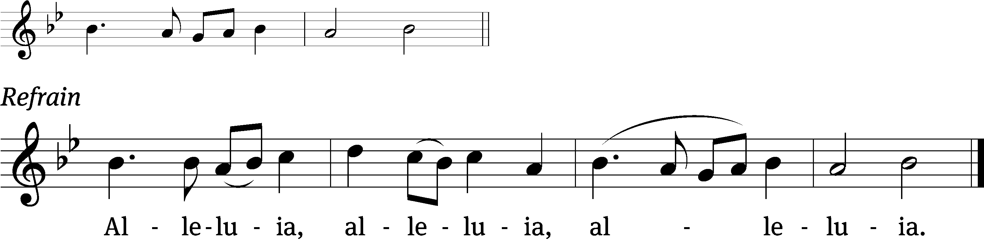
At the name of Jesus every / knee should bow,
in heaven and on earth and un/der the earth.

Refrain
Tune: Kevin Becker
Tune: © 2021 Northwestern Publishing House. Used by permission: OneLicense no. 716381

Gospel: Matthew 24:36-44 (EHV)
“No one knows when that day and hour will be, not the angels of heaven, not even the Son, but only the Father. ³⁷“Just as it was in the days of Noah, so it will be when the Son of Man returns. ³⁸In fact, in the days before the flood people were eating and drinking, marrying and giving in marriage, until the very day that Noah entered the ark. ³⁹And they did not realize what was coming until the flood came and took them all away. That is how it will be when the Son of Man returns.
⁴⁰“At that time two men will be in the field; one will be taken and one will be left. ⁴¹Two women will be grinding at the mill; one will be taken and one will be left. ⁴²So be alert, because you do not know on what day your Lord is coming. ⁴³But understand this: If the master of the house had known at what time of night the thief was coming, he would have stayed awake and would not have let his house be broken into. ⁴⁴You also need to be ready for this reason: The Son of Man is coming at an hour when you do not expect him.”

Sermon Theme: “Let Us Walk In The Light Of The Lord.”

OFFERING: The offerings are brought forward to the altar.

Prayer list: Please remember in your prayers our Befriend A Mission and our missionaries,
Pastor Jonathan Bauer Good Nes Lutheran, Mt. Horeb, Pastor Nathaniel Bourman Mt. Lebanon
Lutheran, Milwaukee and Luke Wolfgramm our “WELS Ministry Partner” for the
European CELC churches.

Door Offering: We will have a door offering today and next Sunday, Dec 4th, for Pastor Ziebell to thank him for his help during the year. Baskets are located at each door as you leave the church.
Announcements
Advent Devotions: Free booklets entitled “Word Made Flesh” are available on the tables to use each day through the Advent Season. These are made available to us as a gift from the Martin Luther College campus family. They will make nice Advent calendars. Please help yourself.

Thank you: Thanks to all of you that sent Ruth Schwark a card. She was very appreciative that you were thinking about her during this difficult time. Also, knowing she was in your prayers gave her comfort.

Christmas Party: All members of the congregation are invited to the annual Ladies Aid Christmas Party. It will be held in the church fellowship hall on December 13th at 6:00 PM. There is a signup sheet on the bulletin board by the office. Please sign up by Sunday November 27th. $14.00 per person please pay Jo Meeker. Catering by Webster’s.

Poinsettias are now available for purchase to help beautify our church again this year. The price is $12.00 and the plants were grown in Wisconsin. A sign-up sheet is on the wall by the flower chart. Also, you may designate a plant as a memorial if you wish. Checks should be made out to Webster’s and given to Marilyn Ninneman. Cash is also acceptable. Any questions, please call her at 748-6474.
Befriend A Missionary (BAM): During November LWMS encourages congregations to remember our missionaries with cards that show our support and gives them needed encouragement. Mt. Zion has participated in this project for several years and will do so again this year from Nov. 1st to November 30th. We are asking our members to write cards to Pastor Jonathan Bauer, Pastor Nathaniel Bourman, and Luke Wolfgramm). As you enter church, you will see a display table with information about each of our missionaries. There will be paper bags with cards that you can take with you to write to each of our missionaries, or if you would prefer to use your own cards that is another option. Please return your cards to Mt. Zion by Nov. 28th, so they can be mailed to our missionaries for Christmas. Thank you for taking a moment to send our missionaries cards.

Favorite Hymn Service: We need your help. In January we will have a favorite hymn service and would like to know your favorite hymns. After we tally your suggestions, we will include the favorite hymns in a special service. Please include your favorite hymns on the form and return it to us today.

Hymn Sing: Our next hymn sing will be Sunday December 11th.

Sound System: We have started a fund for a new Audio/Visual system. The improvements are necessary to accommodate our recent and future technology additions. We have applied for a grant from The Antioch Foundation, if it is approved Mt Zion’s share of the cost will be approximately $16,000.00. You may use the regular church envelopes just write Audio System next to your donation. Thank you.

Birthday Celebration: Cake will be served Sunday Dec. 4th to celebrate the birthdays for December.

Mailbox and table: The NOVEMBER Forward In Christ is available and also the November 27th, 2022-February 25th, 2023 Meditations are available.
If you would like the Lord’s Supper privately, please contact Pastor Sheppard on his cell 920-745-0883, or by email revmikesheppard@gmail.com.
The Helping Hands Ministry is ready to serve the needs of our members. Please contact one of the following if you or someone you know needs assistance: Joanne Gregor at 920-896-1518, Lisa Tremore at 920-229-1297 or Tammy Niemuth at 920-299-0240.

Red Hymnals: It was decided that whoever would like to take one or more old hymnals home may do so at no cost. They are located on the table by the entrance to the sanctuary. Please feel free to take.

For Your Information
Attendance 11/20/2022: 60
Offerings for 11/20/2022: $2,914.00*
*Cumulative amount since 7/28/22 is $8,001 towards the new sound system*

Serving Our Lord

Thank you to everyone for your service to our Lord!

Ushers:

Nov. 27 & Dec. 4: Tim Lynch, Logan Lynch, TJ Sitter, Travis Schmudlach

Dec. 11 & 18: Ken Hielke, Todd, Jonathan and Dustin Zellmer

PowerPoint:

Nov 27: Jo Meeker

Dec 4: Arjeta Rushani

Dec 11: Jan Ohlrich

Dec 18: Jo Meeker

Dec. Communion Set up: Jo Meeker

Dec. Communion Clean up: Janet & Al Brooks and Sue Sheppard

This week at Mt. Zion
Sunday (27th) 9:00 AM Worship with Communion
10:15 AM Bible Study & Sunday School WITH CHRISTMAS PRACTICE
Monday 6:30 PM Bible Study
Tuesday 9:00 AM Bible Study
Wednesday 5:00 PM Catechism Class
6:15 PM Choir Practice
Sunday 9:00 AM Worship
10:15 AM Bible Study & Sunday School WITH CHRISTMAS PRACTICE
Birthday Cake

Secretary Jo Meeker
Church Office: 920-748-5641
Office Hours: Mon. 9-12, Tues. & Wed. 9-11
E-mail: mountzionripon@gmail.com

Acknowledgments
Unless otherwise indicated, Scripture quotations are from The Holy Bible, New International Version®, NIV®. Copyright © 1973, 1978, 1984, 2011 by Biblica, Inc.TM Used by permission of Zondervan. All rights reserved worldwide.
Software distributed in partnership with Northwestern Publishing House.
Created by Christian Worship: Service Builder © 2022 Concordia Publishing House.

