St. Matthew, Apostle and Evangelist
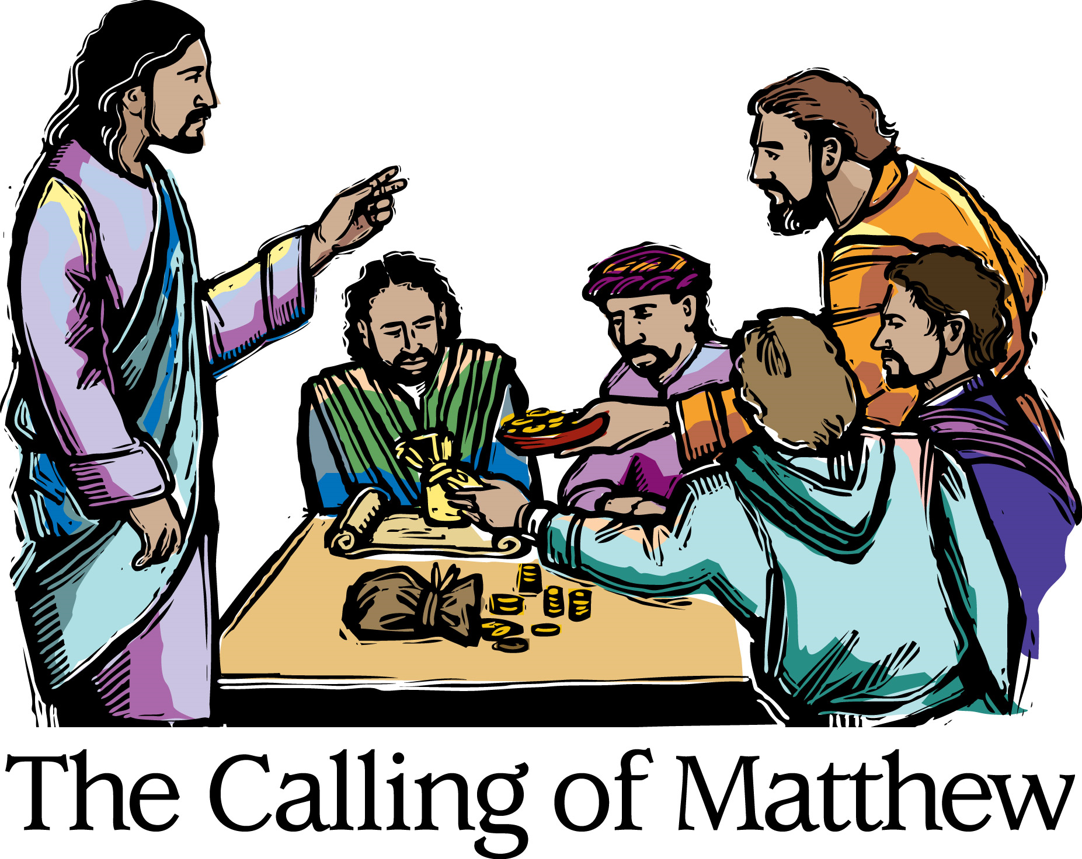
Mt. Zion Evangelical Lutheran Church

320 Mt. Zion Dr., Ripon, WI
www.mtzionripon.org
Facebook: Mt. Zion Evangelical Lutheran Church

Pastor Michael Sheppard
Pastor’s Study: 920-748-9734
E-mail: revmikesheppard@gmail.com
Festival of St. Matthew Sept. 21, 2025
Handicapped accessible restrooms are located upstairs next to the Pastor’s Study and downstairs next to the elevator.
Attendance: Please remember to sign the friendship pads. Registration for communion will continue as usual at the table. If you have any questions or concerns, please contact Pastor Sheppard or Mike Meeker.


Hearing Loop: Our sanctuary is equipped with a hearing loop system. Those who have compatible hearing aids (with a T-switch) will be able to hear the sound system directly into their ear(s). The two main seating areas and the choir area are looped so that you may sit in any of the three areas. We also have four receivers available for those who do not have compatible hearing aids. If you wish to use a receiver please ask the ushers. Those who wish may bring their own headphones or ear buds.

Hymns: 639, 717, 560, 895

Order of Worship Setting One pg. 154

First Reading & Sermon Text: Ezekiel 2:8-3:11 (EHV)
But you, son of man, listen to what I am telling you. Do not be rebellious like that rebellious house. Open your mouth and eat what I am giving you.”
⁹Then I looked, and I saw a hand stretched out toward me, and in it there was a rolled-up scroll. ¹⁰He unrolled it in front of me, and there was writing on both sides. Written on it was: Laments, Groaning, and Woe.
^{3:1}Then he said to me, “Son of man, eat what you have received. Eat this scroll, and then go, speak to the house of Israel.” ²I opened my mouth, and he fed me the scroll.
³Then he said to me, “Son of man, feed your stomach and fill your belly with this scroll that I am giving you.” I ate, and in my mouth it was sweet like honey.
⁴He then said to me, “Son of man, go now to the house of Israel and speak my words to them. ⁵For you are not being sent to a people who have incomprehensible speech or a difficult language, but you are being sent to the house of Israel. ⁶Nor are you being sent to many peoples who have incomprehensible speech and difficult languages, whose words you cannot understand. Certainly, if I were to send you to such people, they would listen to you. ⁷But the house of Israel will not be willing to listen to you because they are not willing to listen to me, because the whole house of Israel is hard-headed and hard-hearted. ⁸Look, I have made your face just as hard as their faces and your forehead just as hard as their foreheads. ⁹I have made your forehead like the hardest stone, harder than flint. Do not fear them, and do not be intimidated by their looks, for they are a rebellious house.”
¹⁰Then he said to me, “Son of man, receive into your heart all my words that I will speak to you, and hear them with your ears. ¹¹Go now to the exiles, to your own people. You shall speak to them and say to them, ‘This is what the Lord God says,’ whether they listen or they do not.”

Psalm: 119B (Insert) Teach Me, O LORD

Second Reading: Ephesians 2:4-10 (EHV)
But God, because he is rich in mercy, because of the great love with which he loved us, ⁵made us alive with Christ even when we were dead in trespasses. It is by grace you have been saved! ⁶He also raised us up with Christ and seated us with him in the heavenly places in Christ Jesus. ⁷He did this so that, in the coming ages, he might demonstrate the surpassing riches of his grace in kindness toward us in Christ Jesus. ⁸Indeed, it is by grace you have been saved, through faith—and this is not from yourselves, it is the gift of God—⁹not by works, so that no one can boast.
¹⁰For we are God’s workmanship, created in Christ Jesus for good works, which God prepared in advance so that we would walk in them.

Gospel Acclamation
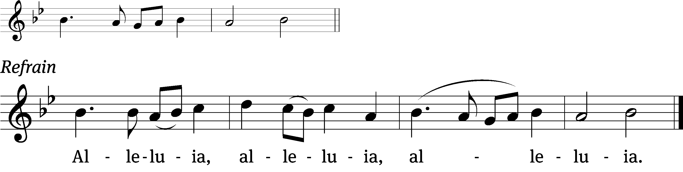
These words are written that you / may believe,
That Jesus is the Christ, the / Son of God. Refrain

Gospel: Matthew 9:9-13 (EHV)
As Jesus went on from there, he saw a man named Matthew sitting in the tax collector’s booth. He said to him, “Follow me.” Matthew got up and followed him.
¹⁰As Jesus was reclining at the table in Matthew’s house, many tax collectors and sinners were actually there too, eating with Jesus and his disciples. ¹¹When the Pharisees saw this, they said to his disciples, “Why does your teacher eat with tax collectors and sinners?”
¹²When Jesus heard this, he said to them, “The healthy do not need a physician, but the sick do. ¹³Go and learn what this means: ‘I desire mercy, and not sacrifice.’ In fact, I did not come to call the righteous, but sinners.”

Sermon Theme: “Fill Up with God’s Word”

OFFERING: The offerings are brought forward to the altar.

Keep in Your Prayers: Harley Dorsey, Carol Henning, Karen Reiser, Gary Wichman and Dick Zellmer.

Announcements
Message from Pastor Ziebell: I would first of all like to thank the congregation for the restaurant gift cards. I’m enjoying using them. I would further like to thank Joanne Gregor, Jan Ohlrich, Darlene Patchett and Rhonda Schwandt for their much needed help in downsizing my home and packing things for moving. I would also like to thank Pastor and Sue Sheppard for hauling things away for me in their truck. As you know I could not have done it without your help. In appreciation I’m giving a monetary gift to be used at their discretion.

Birthday Celebration: Please join us for fellowship, cake and refreshments after the service today


Cereal Donations: Mt. Zion has received a request from Shannon Wright from the Traded Treasures Community Food Pantry for donations. They are in desperate need of cereal. There is a box in the entryway for your cereal donations. This is a great opportunity for us to reach out to members of our community in need of our help. Thank you from the Evangelism committee for your support.

Peace Children Sing October 5th: The children from Peace Lutheran School will be here on Sunday October 5th to beautify our service.

New Member Welcome and Pine Car Derby: On October 5th, Mt. Zion will have a potluck dinner after church for our newest members. We will welcome Jim and Deb Paulus, Judy Doll, Michelle Doll and David Thiele and Matt and Ethel Behm. Mark your calendars and join us after Bible Study and Sunday School. Also, that day we will be having a pine car derby for both youth and adults. A box of pine car wood blocks is outside the church office. If you have questions about the New Member Welcome or Pine car derby, please contact Dave Smith.

LWMS Rally: On October 18th St. Stephens of Beaver Dam will be hosting the Fall Rally. More information is upcoming.

Mission Festival: On October 19th Pastor Abram Degner will be here to preach on the WELS 175th Anniversary, Christ THROUGH Us. Following the service, he will make a presentation in the fellowship hall. We will then join in a potluck dinner. No Sunday School or Bible Study will be held that Sunday.

Friendly Reminder: Children’s offering envelopes and children’s bulletins are available on the back table. The prayer box is also there for any prayer requests.
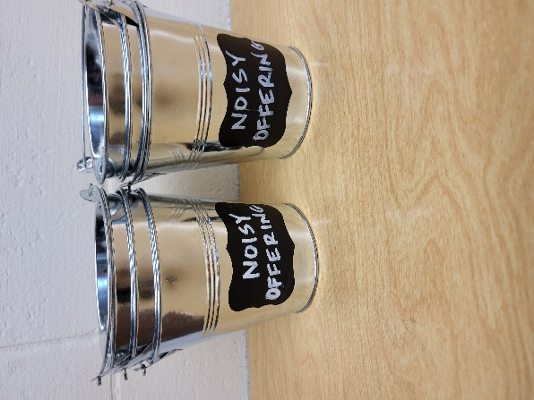
Noisy Offering: Please keep saving your spare change for our noisy offering on Oct 5th. Your offering will be given to WLA (Winnebago Lutheran Academy). We have appreciated your support for our various projects and activities. Thank you for your generosity.

Greeters: Thank you to all who have greeted so far. A new signup sheet for August through December is available. If you would like to be greeters for this year, please sign up on the sheet on the podium by the library, or talk to Mike or Jo Meeker.

You are invited to Auxiliary Day at Martin Luther College!

The Ladies' Auxiliary promotes interest in Martin Luther College, provides Christian fellowship opportunities for our members, and supports students through scholarships, special non-budgeted projects, events, and your prayers.

Our Annual Auxiliary Day is Saturday, October 4, on the beautiful MLC campus in New Ulm, Minnesota. Enjoy fellowship, hear student presentations—including a sneak peek at the fall presentation of Little Women: The Broadway Musical—and help us choose the 2025-26 classroom projects we will fund. Join us and get in on the fun!

If you can't make it in person, check our website after the meeting to see what projects were selected. Visit mlc-wels.edu/ladies-auxiliary.

Hymn Sing: The next hymn sing will be October 12th. If you have any requests for future hymn sings please talk to Sue Sheppard or Jo Meeker.

Mailbox and table: The September Forward In Christ is available and also the August 31, 2025-November 29, 2025 Meditations are available.

If you would like the Lord’s Supper privately, please contact Pastor Sheppard on his cell 920-745-0883, or by email revmikesheppard@gmail.com.
The Helping Hands Ministry is ready to serve the needs of our members. Please contact one of the following if you or someone you know needs assistance: Joanne Gregor at 920-896-1518, Lisa Tremore at 920-229-1297 or Tammy Niemuth at 920-299-0240.
For Your Information
Attendance 914 98
Offerings for 9/14 $8,291.72

Serving Our Lord

Thank you to everyone for your service to our Lord!

Ushers:

Sept. 21 & 28: Mark Roeder, Ferd Roeder, Jason Roeder

Oct. 5 & 12: Gary Quade, Travis Schmudlach, Kyle Stollfuss

PowerPoint:

Sept. 21: Jan Ohlrich

Sept. 28: Jo Meeker

October 5: Grunert Family

October 12: Jean Lynch

Sept. Communion Set up: Jo Meeker

Sept. Communion Clean up: Marilyn Ninneman

Sunday (21st) 9:00 AM Worship Service
10:15 AM Sunday School; Bible Study will be held in the fellowship hall viewing Season 5 of The Chosen
10:15 AM Birthday Celebration
5:00 PM Confirmation Class
Tuesday 9:00 AM Bible Study (book of John)
Wednesday 6:15 PM Choir Practice
Thursday 9:00 AM Women’s Bible Study (Fellowship Hall)
Sunday 9:00 AM Worship Service with Communion
School & Bible Study
5:00 PM Confirmation Class

