Mt. Zion Ev. Lutheran Church
320 Mt. Zion Dr.
Ripon, WI 54971

The Sheppard’s Pen
This Photo by Unknown Author is licensed under CC BY-NC-ND

February, 2022

The year 2021 has ended. What new things have you learned? What old things have you remembered? This past year has brought its share of difficulties. Every year and even each day contains good and bad. The bad things flow out of the sinfulness of mankind. Hearts that contain unbelief in the Triune God and controlled by the sinful flesh put forth sinful deeds and words. Christians who have hope through the forgiveness of sins and the redemption of Christ also disobey our Creator.
Being quick to speak and slow to listen displays itself in all its terribleness all the more readily on social media. “Jumping to conclusions” is what it is often called. This is when the facts and evidence is quickly passed over to come to a conclusion that may or may not be correct. Haven’t we seen this in the past year? Have we come to conclusions about anything for which we did not have proper information? Whose reputation have we tarnished or joined in ruining? Doing this, we fail to take the words and actions of others in the kindest possible way. We disobey the Eighth Commandment.
But from where do the good things come? All good things come from above, from our God - from him who does not change like the shadows change during the daytime. Every good thing that has come to us in the past year both individually and congregationally is from God. Our Creator provides all that we need and often more than we need to sustain our body and life. God’s mercy does not come from within us or by something we do. The ransom for our sins has been paid upon the cross of our Lord Jesus Christ. God’s forgiveness and mercy come from him alone through faith in the Son of God. It is he who justified the world and credits that justification to each of us through faith. The word that has been planted in us gives salvation.
Despite some of the difficulties we have seen in the last year, our congregation has been blessed by the Lord. A number of souls were welcomed into God’s family through Baptism. We have continued to be edified by the Word of God both at home and as we gather together encouraging each other in faith in public worship. In Christ’s forgiveness, we live our lives producing fruits of repentance and faith. We follow our Lord’s commands glorifying him. The Apostle James wrote in his epistle:
¹⁶ Do not be deceived, my dear brothers. ¹⁷ Every good act of giving and every perfect gift is from above, coming down from the Father of the lights, who does not change or shift like a shadow. ¹⁸ Just as he planned, he gave us birth by the word of truth so that we would be a kind of firstfruits of his creations.
¹⁹ Remember this, my dear brothers: Let everyone be quick to listen, slow to speak, and slow to become angry. ²⁰ Certainly, a man’s anger does not bring about what is right before God. ²¹ So after getting rid of all moral filthiness and overflowing wickedness, receive with humility the word planted in you. It is able to save your souls.
²² Be people who do what the word says, not people who only hear it. Such people are deceiving themselves. ²³ In fact, if anyone hears the word and does not do what it says, he is like a man who carefully looks at his own natural face in a mirror. ²⁴ Indeed, he carefully looks at himself; then, he goes away and immediately forgets what he looked like. ²⁵ But the one who looks carefully into the perfect law, the law of freedom, and continues to do so—since he does not hear and forget but actually does what it says—that person will be blessed in what he does. James 1:16-25 EHV

Church Council and Elders 2022

President – Mark Roeder
Vice President – Ken Hielke
Secretary Terry Dolderer
Treasurer – Todd Zellmer
Worship Elder – Tim Lynch
Member Nurture Elder – Paul Walkowicz
Family Nurture Elder – Rick Niemuth
Evangelism Elder – Justen Niemuth
Support Elder – Rick Retelle

General Announcements

Bible Studies
In the Sunday Bible study hour we are watching the second season of “The Chosen.” Monday’s Bible study continues to discuss the book “More Prepared to Answer.” Please join us!

Private Communion
Pastor Sheppard is happy to offer private communion to those who prefer it; simply email him (revmikesheppard@gmail.com) or call him (920-745-0883) to schedule a time.

Online Streaming
We are livestreaming on Facebook Live Sundays at 9:00am. Services will also be uploaded to Rumble (Mt. Zion’s channel is mtzionripon) and the link will be posted on the church website in the VIDEOS subheading under the MEDIA tab. Services will still be available on DVD. Please feel free to contact Pastor Sheppard with questions.

Clavinova
We have collected $8,465 of the $9,934 needed to purchase a new Clavinova piano for our sanctuary. Thank you to all who have contributed so far! We will likely be ordering it soon, as it will take about 6 months to receive.

Christian Family Solutions
Christian Family Solutions is a WELS affiliated organization providing counselling services to the hurting. Both in person and video appointments are available for those in need by contacting CFS directly. Mt. Zion is a partner with them through the Member Assistance Program (MAP). Our church has a fund dedicated to assisting our members with the cost of these services. If financial assistance is needed, Pastor Sheppard notifies Christian Family Solutions and assistance will be given towards the cost of appointments. Video counseling by computer may be conducted at the church when necessary. For more information, visit https://christianfamilysolutions.org.

Kids C.A.R.E.
In September the Sunday School children were given mission boxes to support this year’s Kids C.A.R.E. mission project, Outreach to Roma. It is time for children to return the mission boxes. Please give boxes to your child’s teacher or drop them off at church. Thank you for supporting Kids C.A.R.E.

Kitchen & Church Cleaning
2 fall/winter cleaning lists have been created. One is on the bulletin board upstairs and includes everything except kitchen tasks. Another list is in the kitchen for tasks to complete there. This is open to anyone in the congregation who is willing to help. When you complete a task, please write your name and date completed by that task. Thank you for your help!

Helping Hands
If you are interested in helping someone with technology, helping give rides to appointments in Ripon, Berlin, Oshkosh, or Fond du Lac, please let Joanne Gregor know. If you or someone you know needs assistance, please contact Lisa Tremore at 920-229-1297, Tammy Niemuth at 920-299-0240 or Joanne Gregor at 920-896-1518. If you need assistance of any kind, please do not feel like you are imposing; this is why Helping Hands exists!

WLA Capital Campaign
Winnebago Lutheran Academy is planning to build a new campus within the next 7-10 years. A new campus will provide a new and updated school facility that will benefit all the curricular and co-curricular activities at WLA. In September, 2020, land was purchased on the north side of Hwy 23 one mile west of I-41. The property extends from Hwy 23 to Hwy OOO, nearest to Streblow Dr. and the Community Church. Recently, Tom Schermerhorn came to Mt. Zion on two Sundays to give updates on the land purchase, and to introduce our members to the capital campaign. This capital campaign will look to raise funds to eliminate WLA’s current capital debt, provide funds for the purchase of the new land, and to create a fund for minor improvements that need to occur to provide a safe learning environment on the current campus.

Please contact Kevin Ehlke with any questions you may have at 920-539-4041 or kehlke@wlavikings.org. If you would like to give in support of WLA’s current capital campaign, you can obtain a brochure from Mt. Zion, or go to forward.wlavikings.org/donate. Gifts can be mailed to WLA or given online at our website. Thank you for your continued support of WLA!

New Member Potluck
Please join us as we welcome the new members that joined Mt. Zion in 2020 and 2021. The new member welcome potluck will be held on Sunday February 20th. Please watch the bulletin, website, and Facebook page for further updates.

Altar Flowers
If you wish to have flowers put on the altar in the future, please contact Marilyn Ninneman at 748-6474 in addition to signing up on the flower chart.

Tshirt Sale
The deadline to sign up to purchase a Mt. Zion T-shirt is Sunday, February 6th. If you would like to purchase one but are unable to sign up at church, please contact Sue Sheppard at sheppwoman52602@yahoo.com or 608-799-1330 (call or text).
A signup sheet will be posted on the bulletin board by the office.

2022 MOHW
The 13th annual Men of His Word Conference (Theme: MORE THAN CONQUERORS) will be held at the Best Western Premier Waterfront Convention Center in Oshkosh on Saturday, February 19, 2022. Please go online at www.menofhisword.org to register and get details about schedule, breakout sessions, keynote speaker, cost, etc.

Lutheran Women’s Missionary Society
Lutheran Women’s Missionary Society News about our Befriend a Mission church in Mt. Horeb WI. Praise to the Lord !!!!!

Good News Lutheran Church, a home mission congregation in Mt. Horeb, Wis., held a ceremonial “groundbreaking” for their new church this past weekend after cold weather forced them indoors. With God's blessing, their new church home will be completed by the end of 2022.

Good News purchased a six-acre piece of land in April 2021 with assistance from WELS Church Extension Fund. They received a loan and matching land and facility grants totaling $747,914 for their building project. Your investment with WELS Church Extension Fund helps provide financing so mission congregations can purchase land and either build or renovate a worship facility.

Pioneers Beginning at St. John’s, Princeton
Attention Youth: St. John’s in Princeton is starting up a Pioneers group.
If anyone is interested in joining either let Jo Meeker know or call Adam Burk at 920-229-2459 for more information.

Daddy Daughter Dance
St. John's Princeton is once again hosting a Daddy Daughter Dance. Join us Saturday February 5th from 6-8pm. The Dance will be held in the school gym; please enter on the Clinton Street entrance. Girls may be escorted by dads, grandpas, uncles, or any other person that fits that role. Please register by calling (920) 295-4400; by sending an email to sjlprinceton@gmail.com; or by filling out this form:
https://forms.gle/H4Wrti7eF14hAjds6

17th Annual Women's Retreat
The 17th annual Women’s Retreat will be held at St. Lucas Lutheran School in Kewaskum on Saturday March 12, 2022 from 8:30 am to 3:00 pm. Registration forms are available from church; you may also register on your own at eventbrite.com. The cost is $25. If you register by mail, please send the registration form and a check for $25 made payable to St. Lucas Women's Ministry by March 4 to: Lynn Garvey, 809 Pleasant Dr., Kewaskum, WI 53040.

On the Lighter Side!

Maurice and Deb Picchiottino 2/3/1984

Joan Stibb 2/1/1943
Julia Luther 2/3/1949
Emma Kranz 2/3/2009
Heidi Eilertson 2/4/1978
Myles Pierce 2/6/2002
Jerome Witkowski 2/6/1953
Alicia Bradley 2/7/1984
Mary Clement 2/7/1941 Samuel Jung 2/7/2006
Todd Zellmer 2/7/1970
Corissa Revels 2/9/1991
Shirley Erdmann-Schroeder
2/10/1945
Miya Grunert 2/10/2006
Samantha Storzer 2/11/1997
Dianne Olsen 2/13/1950
Arjeta Rushani 2/13/2007
Coral Chappa 2/14/1998
Bernice Ziebell 2/14/1936
Cassandra Beier 2/15/1982
Elaine Schmudlach 2/15/1940
Megan Storzer 2/16/2001
Linda Huelsman 2/17/1949
Kody Ramsey 2/18/1997
Eunice Lemmiesz 2/19/1940
Ronald Lemmiesz 2/22/1973
Ben Isaac 2/23/1990
Derek Chitwood 2/24/1987
Kenneth Hilke 2/25/1962
Carolyn Miller 2/25/1954
Avis Lindemann 2/29/1936

Cherish the Memories!
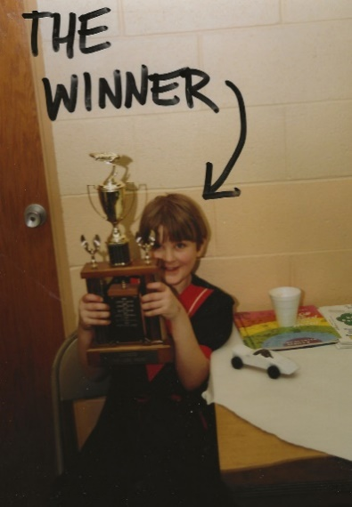
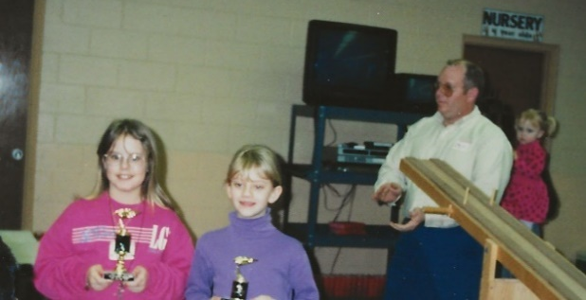
Do you remember any of these people in these pictures from Pine-car Derbies long ago? Enjoy reminiscing!
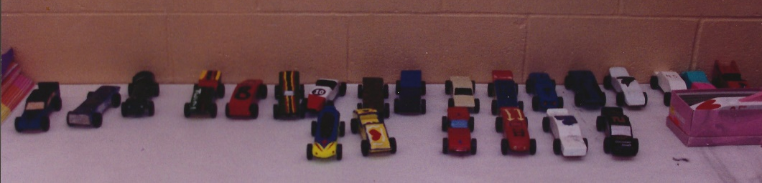

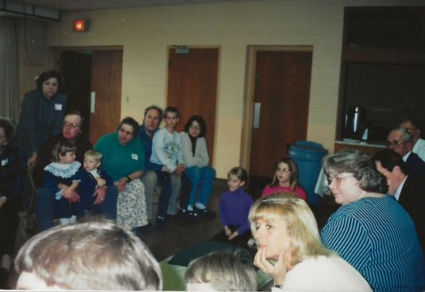

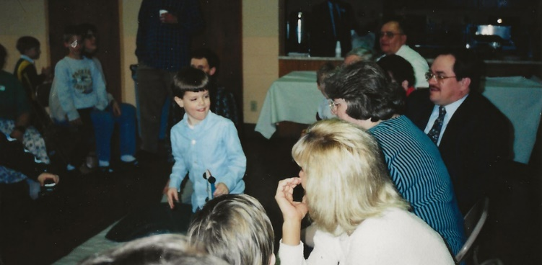

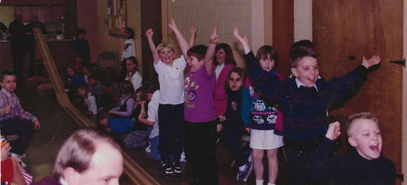

Mt. Zion Messenger
February, 2022

Mt. Zion Evangelical Lutheran Church
320 Mt. Zion Dr. Ripon, WI 54971
Pastor Michael Sheppard

Church Email: mountzionripon@gmail.com
Church Website: www.mtzionripon.org

Pastor’s Office: 920-748-9734
Pastor’s Email: revmikesheppard@gmail.com

Newsletter Articles
Since there will be more than one person assembling the newsletter, please email the church office with news/articles. Deadline for articles for the March edition is February 18th, 2022. please either give news/articles to Jo Meeker or email them to the church office at mountzionripon@gmail.com.

We are always looking for human interest news from our members! If there is any incorrect information, please let us know that as well.

